**HEAT, WORK, AND THE FIRST LAW  
OF THERMODYNAMICS**

**Exercises**

**Section 18.1 The First Law of Thermodynamics**

**15. Interpret** We identify the system as the water in the insulated container. The problem involves calculating the work done to raise the temperature of a system, so the first law of thermodynamics comes into play.

**Develop** Because the container is a perfect thermal insulator, no heat enters or leaves the water inside of it. Thus, *Q* = 0 and the first law of thermodynamics in Equation 18.1 gives 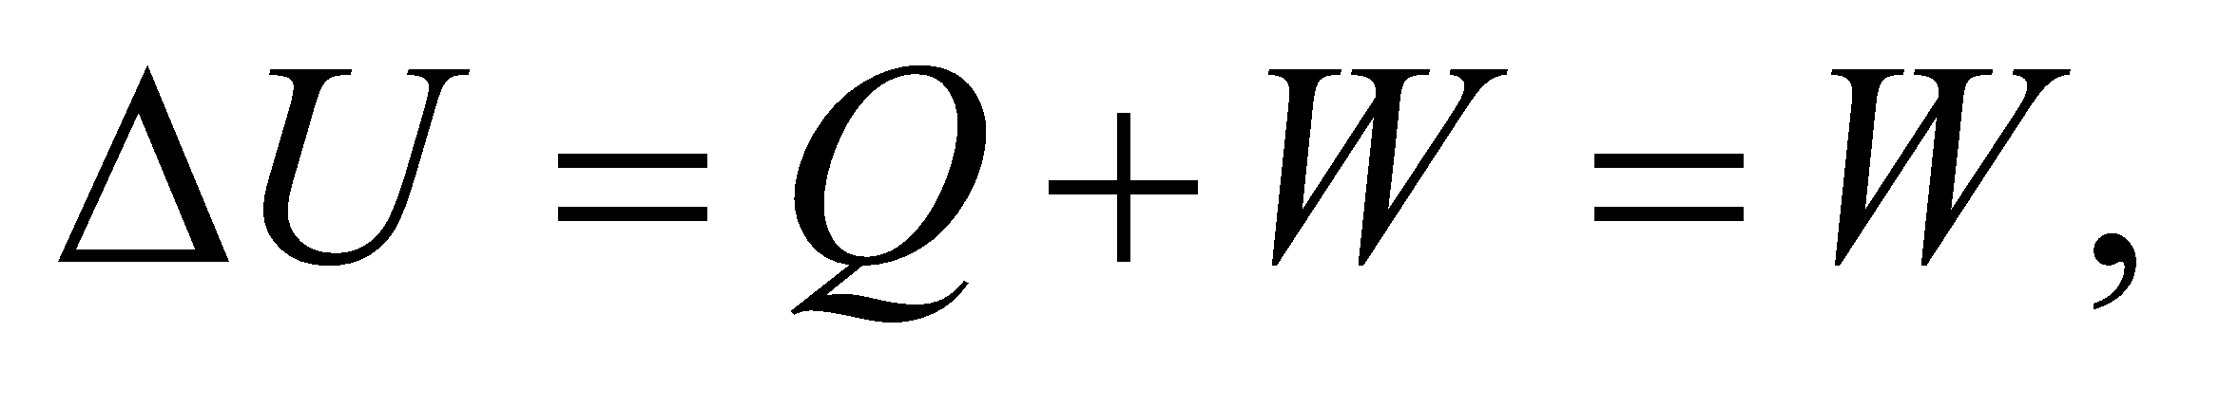 where *W* is the work done by shaking the container. The change in the internal energy of the water is determined from its temperature rise, 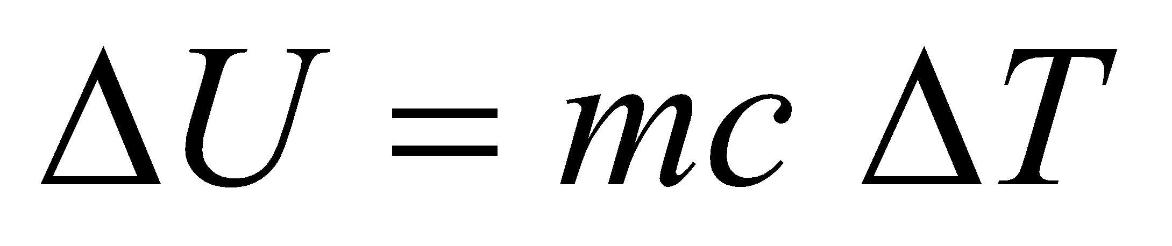 (see comments in Section 16.1 on internal energy). Combining these two expressions for the internal energy change allows us to find the work done.

**Evaluate** The work done on the water is

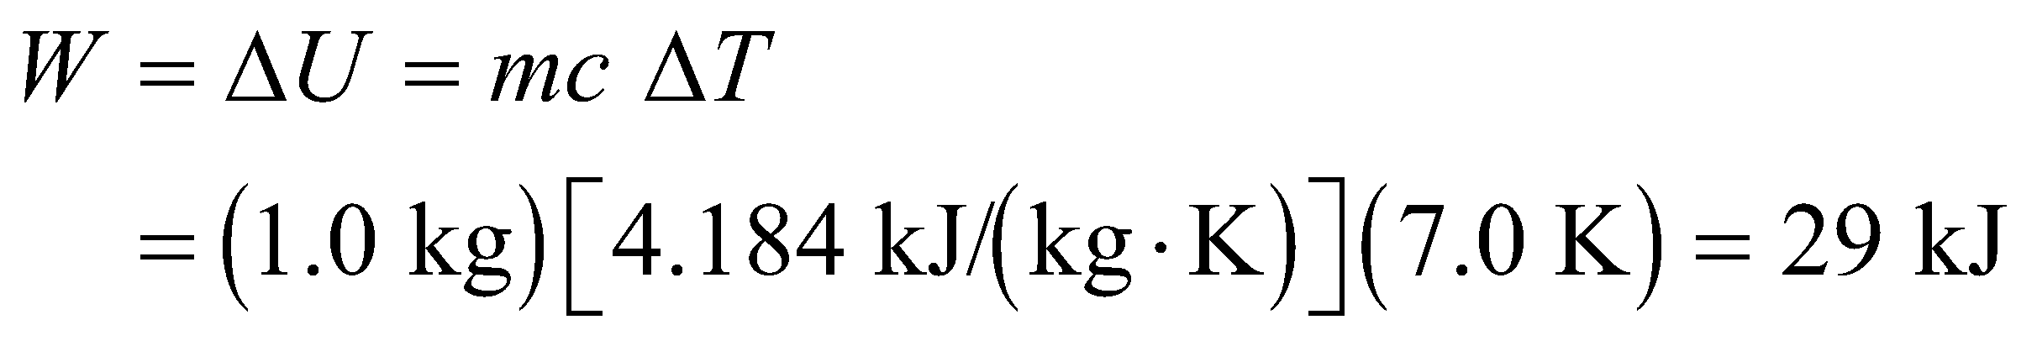

**Assess** According to the convention adopted for the first law of thermodynamics, positive work signifies that work is done on the water.

**16.** **Interpret** This problem involves finding the mechanical work that is required to raise the given mass of water by 3.0°C, which we can calculate by using the first law of thermodynamics.

**Develop** The change in the internal energy of the water is 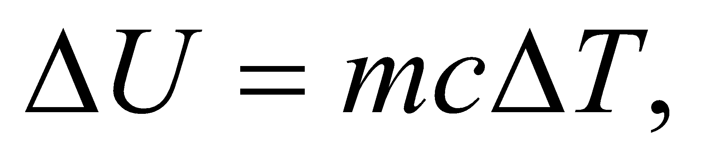 where *ΔT* = 3.0°C = 3.0 K and the work done on it is W = 9.0 kJ. Inserting this into the first law of thermodynamics (Equation 18.1) gives *Q* = *ΔU* − *W* = *mcΔT* − *W*. For part (b), note that if the water had been in perfect thermal isolation, no heat would have been transferred, so *Q*′ = 0 and we can solve for the work *W*′ as for part (a).

**Evaluate** (a) Inserting the given quantities into the expression for the heat transferred gives



(b) If Q = 0, then the work needed is



**Assess** The fact that *Q* < 0 for part (a) indicates that heat is transferred from the water to the environment, as expected.

**17. Interpret**  The system of interest is the gas that undergoes expansion. The problem involves calculating the change in internal energy of a system, so the first law of thermodynamics comes into play.

**Develop** The heat added to the gas is 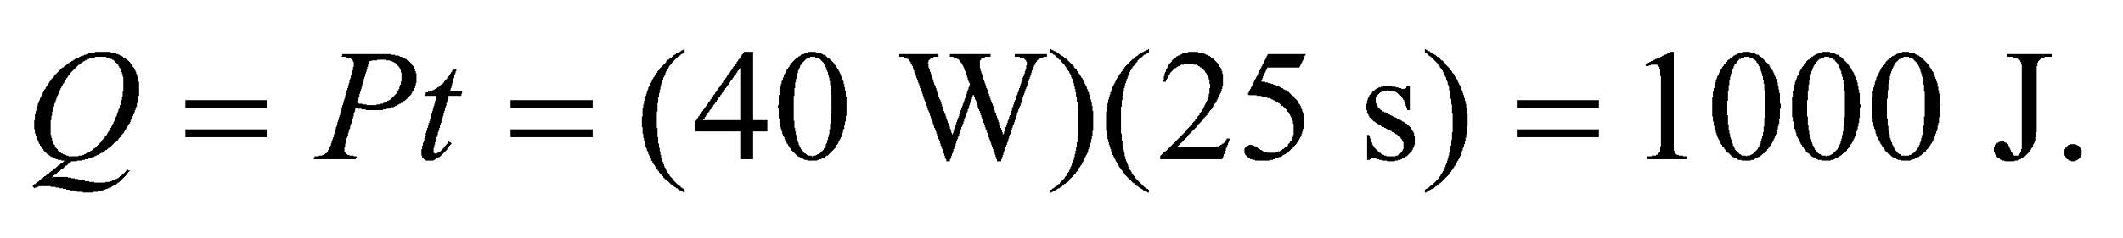 In addition, the system does 750 J of work on its surroundings, so the work done by the surroundings on the system is  The change in internal energy can be found by using the first law of thermodynamics given in Equation 18.1.

**Evaluate** Using Equation 18.1 we find



**Assess** Since 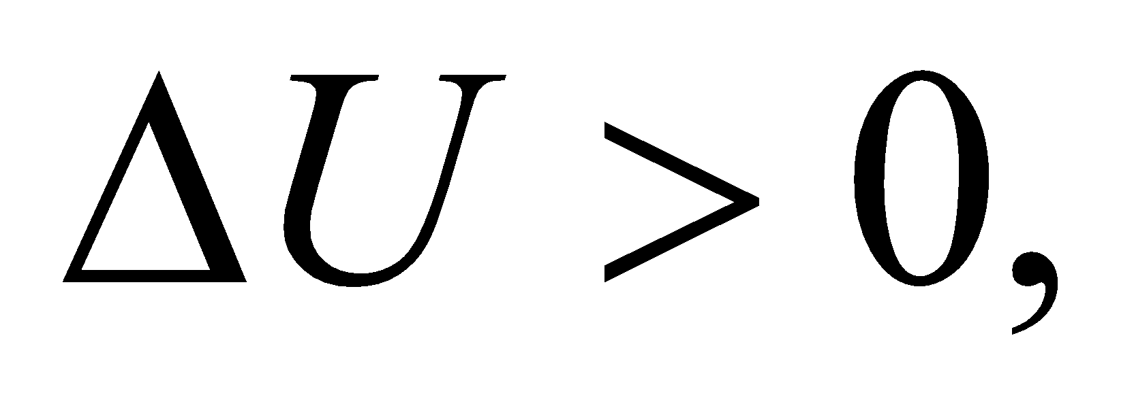 we conclude that the internal energy has increased.

**18.** **Interpret** This problem involves calculating the rate of heat flow into the system given the rate at which the internal energy is increasing and the rate at which the system is doing work on its surroundings.

**Develop** The dynamic form of the first law of thermodynamics (Equation 18.2) is

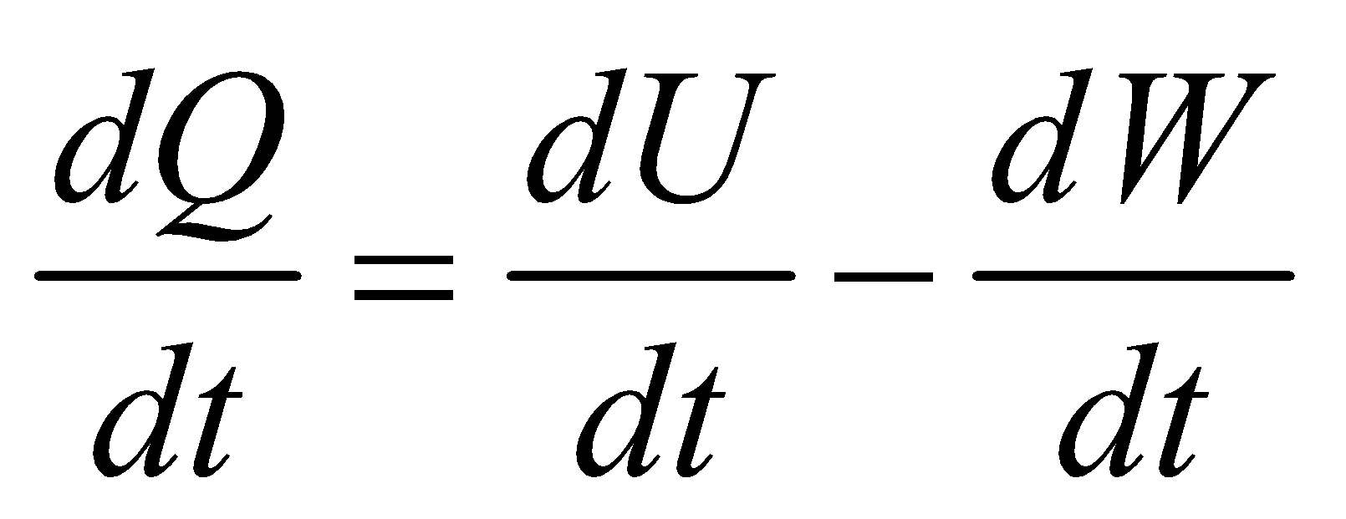

The problem states that *dU*/*dt* = 45 W and *dW*/*dt* = −165 W (where the negative sign is appropriate because the system is doing work).

**Evaluate** Inserting the given quantities gives

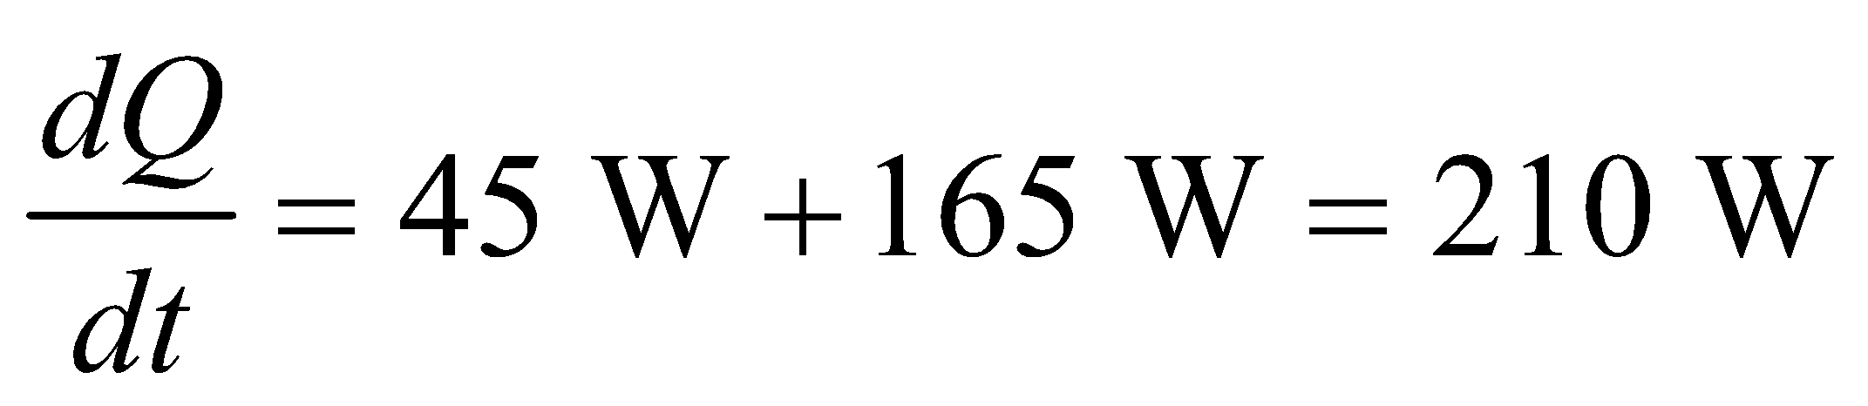

**Assess** The rate of heat flow into the system is positive because the system is doing work on its surroundings and increasing its internal energy.

**19. Interpret** This problem is about heat and mechanical energy, which are related by the first law of thermodynamics. The system of interest is the automobile engine.

**Develop** Since we are dealing with rates, we make use of the dynamic form of the first law of thermodynamics, Equation 18.2:

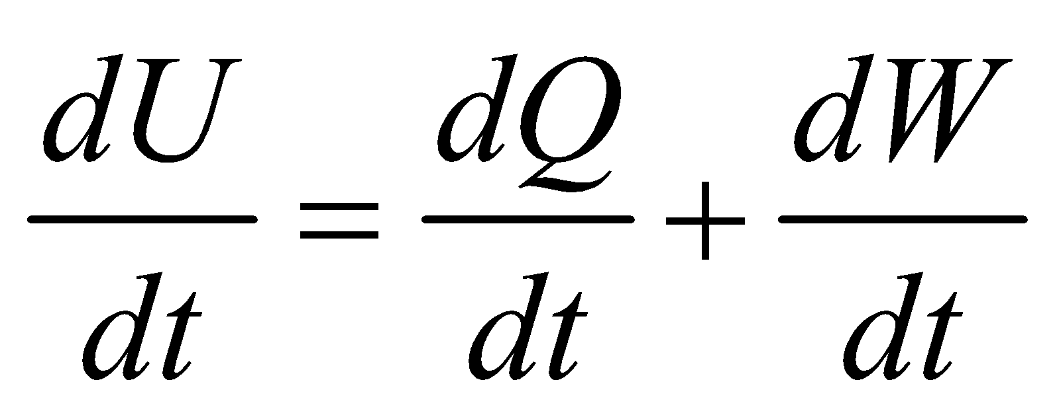

If we assume that the engine system operates in a cycle, then 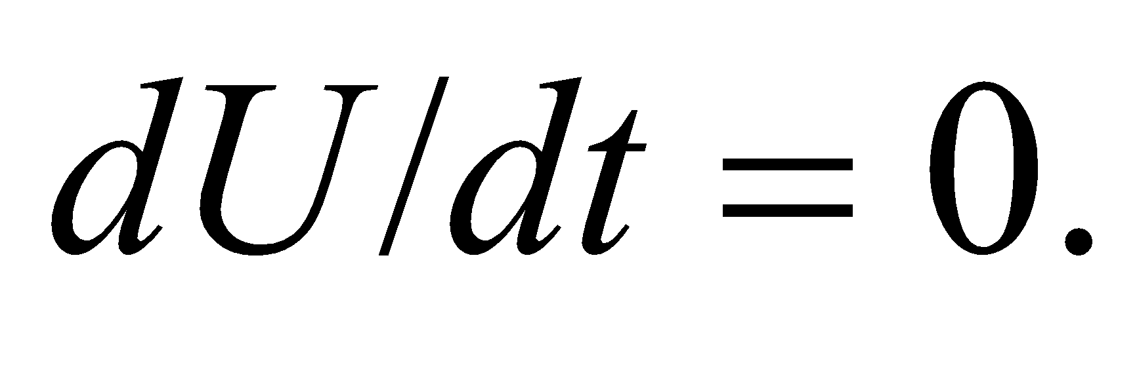 The engine's mechanical power output *dW*/*dt* can then be calculated once the heat output is known.

**Evaluate** The above conditions yield 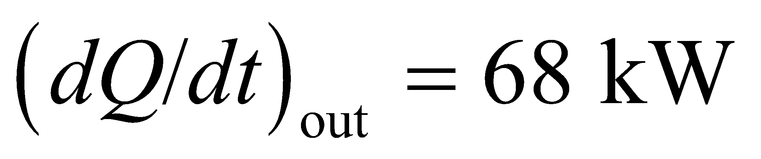 and 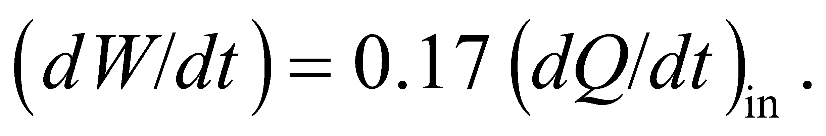 Equation 18.2 then gives

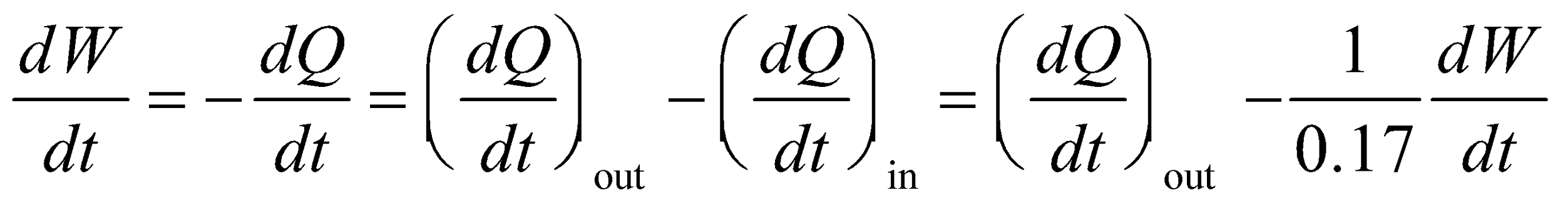

or

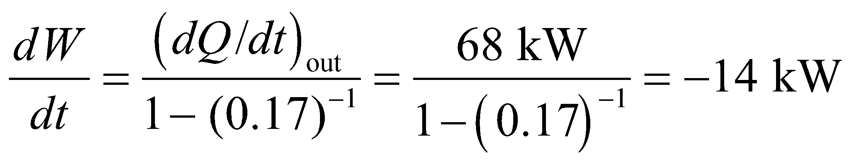

**Assess** We find the mechanical power output 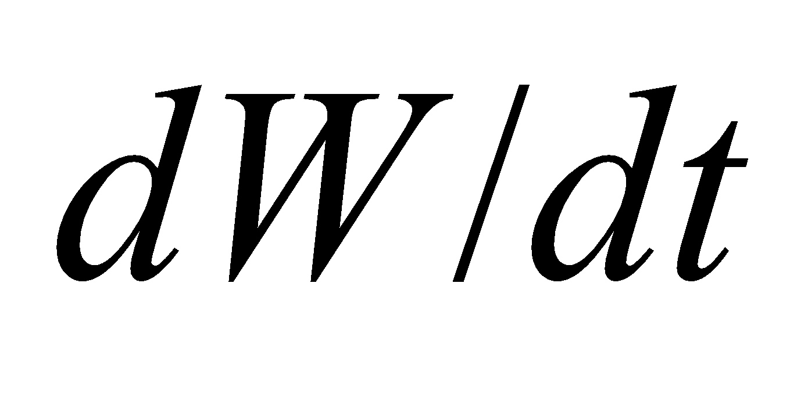 to be proportional to the heat output, 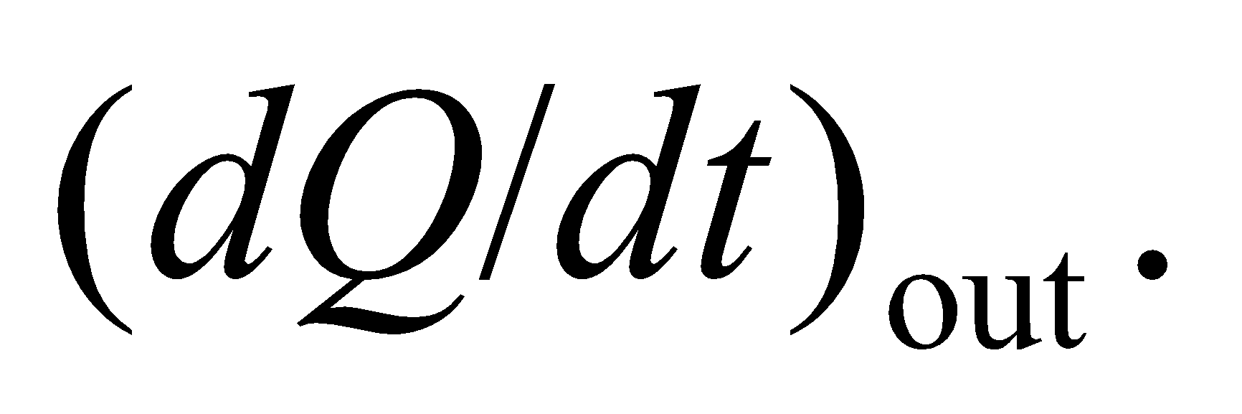 In addition,  also increases with the percentage of the total energy released in burning gasoline that ends up as mechanical work. The mechanical output is negative because the system is doing work on its surroundings.

**Section 18.2 Thermodynamic Processes**

**20.** **Interpret** This problem involves an ideal gas that changes from an initial pressure-volume state to a final pressure-volume state by traversing the given pressure-volume curve. From this, we are to find the work done by the gas during this process.

**Develop** The work done by the gas is given by the negative of Equation 18.3, which is

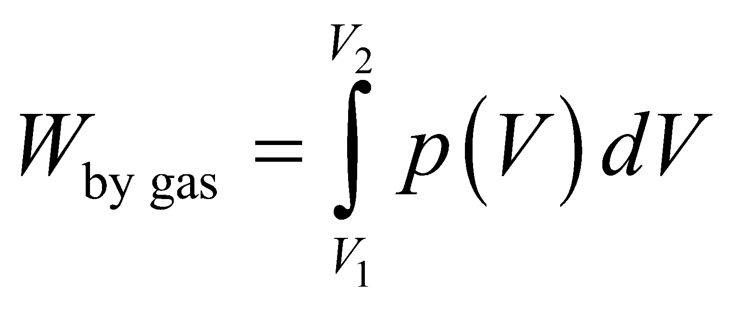

This is the area under the line segment AB in Figure 18.19. We can find this area from simple geometrical arguments, without having to invoke calculus.

**Evaluate** The work done by the gas is the area of the trapezoid under line AB, which is

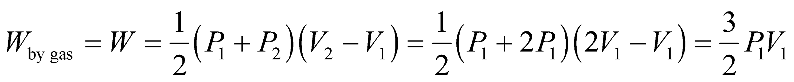

**Assess** The work can also be obtained from Equation 18.3. On the path AB,

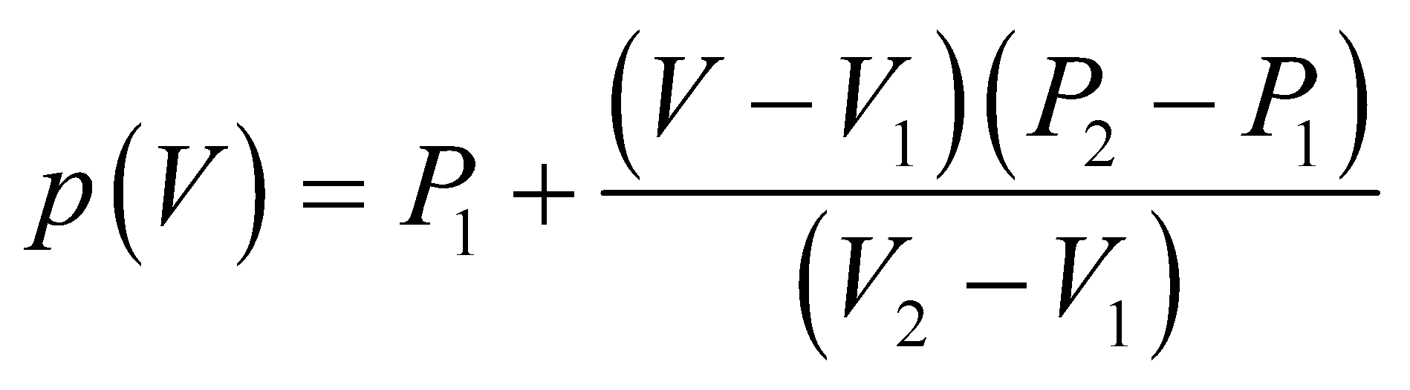

so

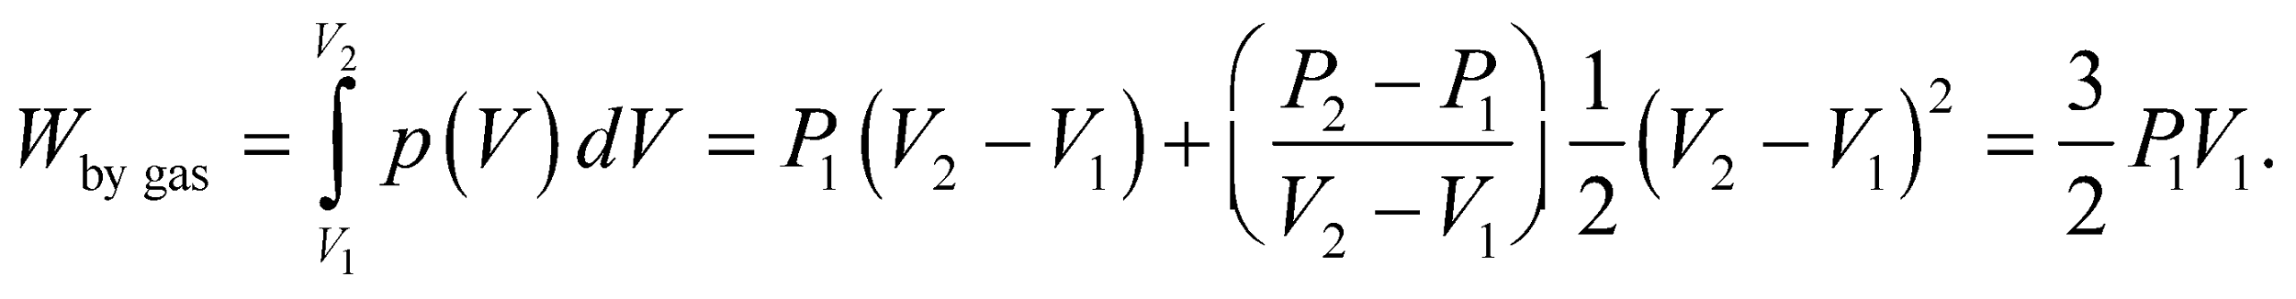

**21. Interpret** The expansion of the ideal gas involves two stages: an isochoric (constant-volume) process and an isobaric (constant-pressure) process. We are asked to find the total work done by the gas.

**Develop** For an isochoric process, *ΔV* = 0 so *W*1 = 0 (see Equation 18.3 and Table 18.1). On the other hand, for an isobaric process, the work done is *W*2 = *pΔV* which is the negative of Equation 18.7 because we are interested in the work done by the gas (Equation 18.7 gives the work done on the gas).

**Evaluate** Summing the two contributions to find the total work gives



**Assess** In the *pV* diagram of Fig. 18.19, the area under *AC* is zero, and that under *CB*, a rectangle, is 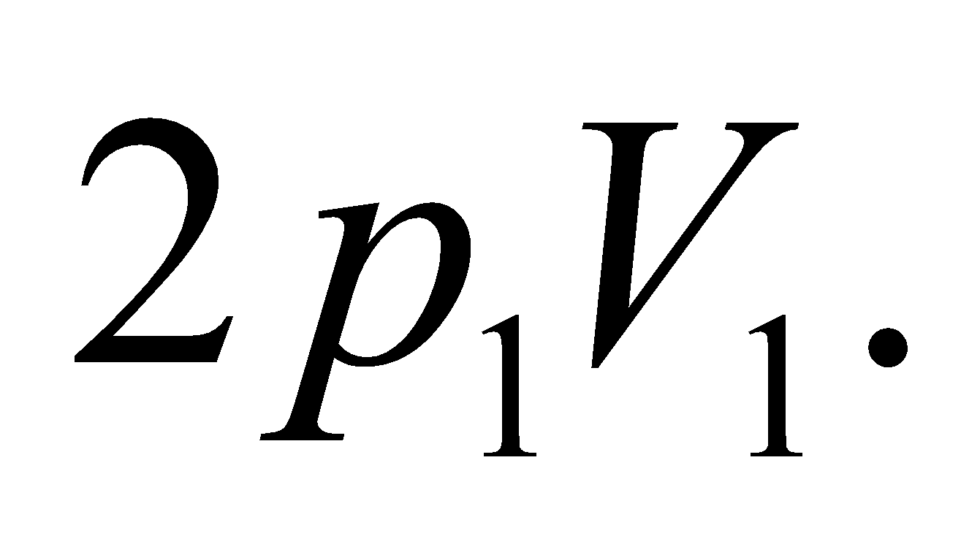 The work done by the gas is the area under the *pV* curve.

**22.** **Interpret** This problem involves the isothermal (i.e., the temperature is constant) expansion of a balloon as it rises. We are asked to find the work done by the helium as the balloon rises.

**Develop** During an isothermal expansion, the work done *by* a given amount of ideal gas is

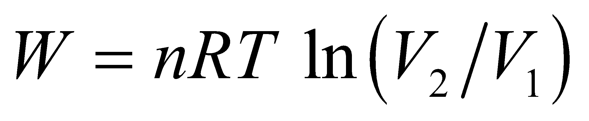

which is the negative of Equation 18.3 because that form expresses the work done *on* the gas.

**Evaluate** Inserting the given quantities yields



**Assess** The result is positive because the work is done by the gas.

**23. Interpret** The constant temperature of 300 K indicates that the process is isothermal. We are to find the increase in volume of the balloon and the work done by the gas, given the pressure difference in experiences.

**Develop** We assume the gas to be ideal and apply the ideal-gas law given in Equation 17.2: *pV* = *nRT*. For an isothermal process, *T* = constant, so we obtain 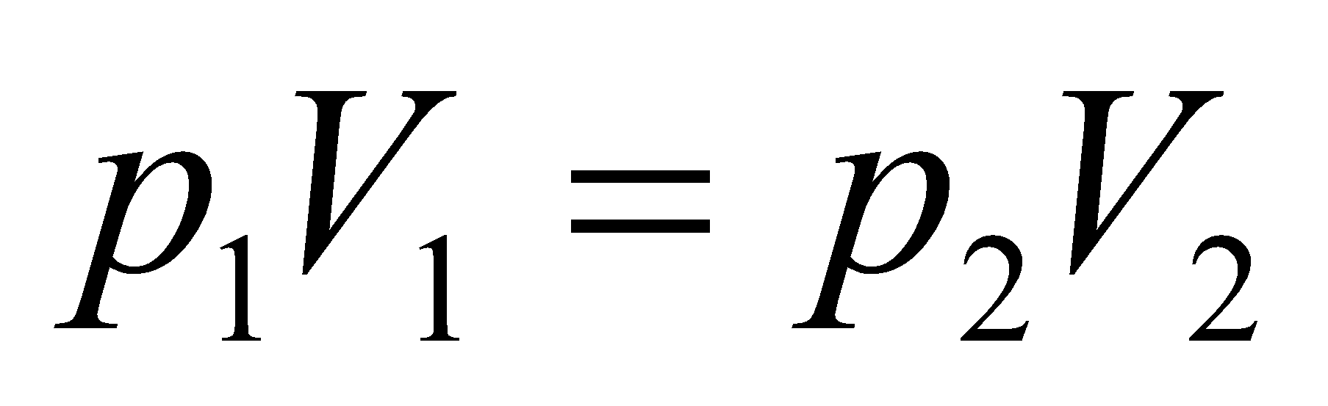, from which we can find the fractional volume increase. The total work done by the gas can be calculated using the negative of Equation 18.4:

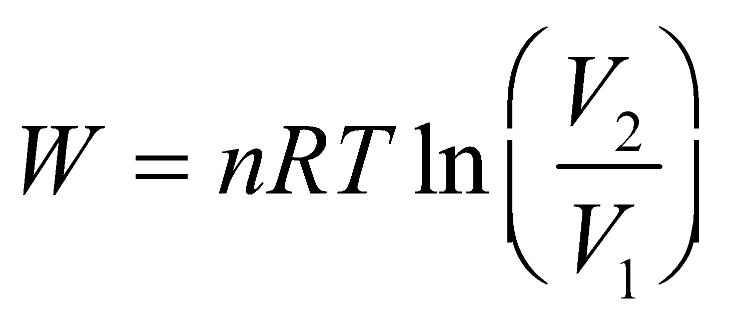

because we are interested in the work done by the gas, not on the gas.

**Evaluate** **(a)** For the isothermal expansion process, the volume increases by a factor of

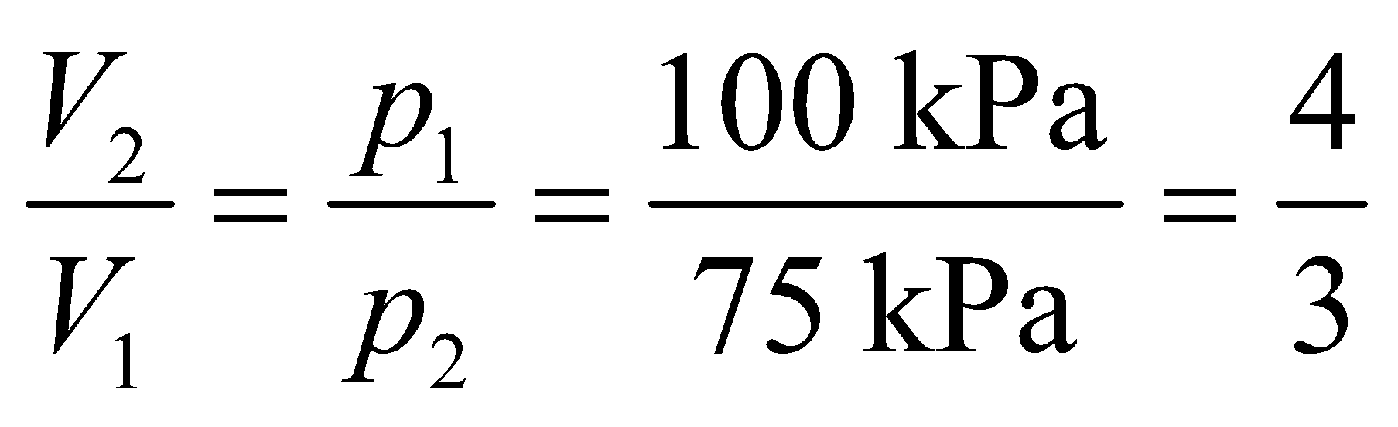

**(b)** Using Equation 18.4, the work done by the gas is

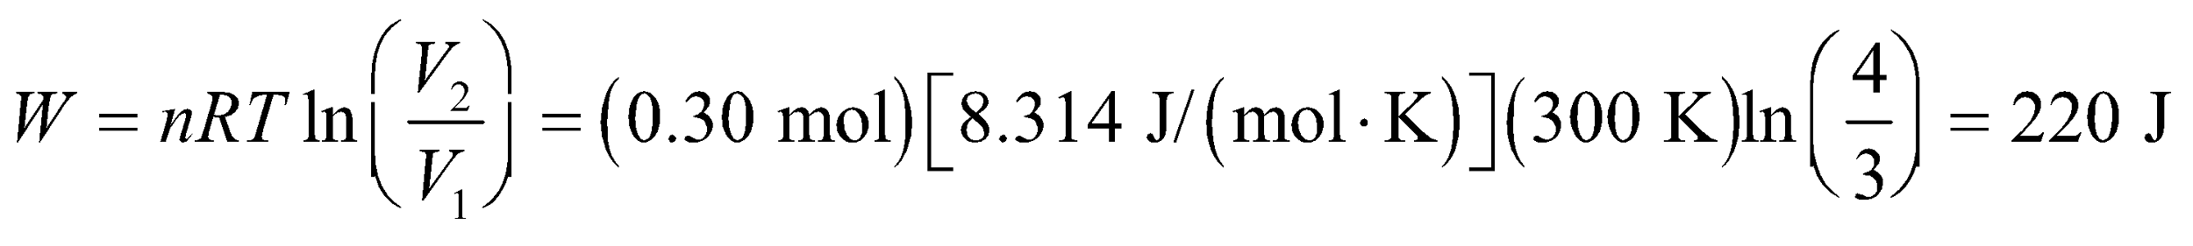

to two significant figures.

**Assess** Because 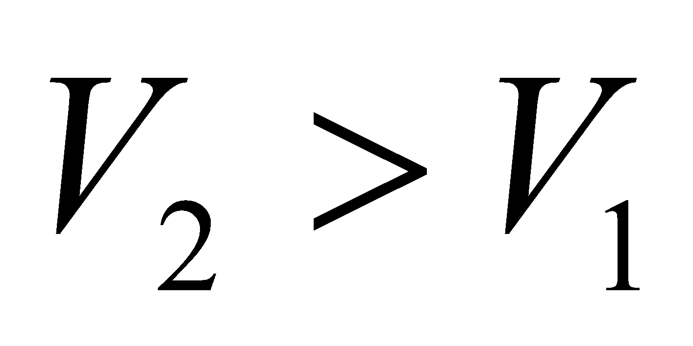, we find the work to be positive, *W* > 0. This makes sense because the gas inside the balloon must do positive work to expand outward.

**24.** **Interpret** This problem involves and ideal gas that we compress in an isothermal process to half its volume. We are to find the work needed to do this.

**Develop** In an isothermal compression of a fixed quantity of ideal gas, work is done on the gas so we use Equation 18.4, *W* = *nRT*ln(*V*1/*V*2), where *V*1 = 2*V*2 and *T* = 300 K for this problem.

**Evaluate** Inserting the given quantities into Equation 18.4 gives



**Assess** The work is negative because it is done on the gas. In other words, the work must be expended by an agent other than the gas to compress the gas.

**25. Interpret** The thermodynamic process here is adiabatic, so no heat flows between the system (the gas) and its environment. We are to find the volume change needed to double the temperature.

**Develop** In an adiabatic process, *Q* = 0, so the first law of thermodynamics (Equation 18.1) becomes 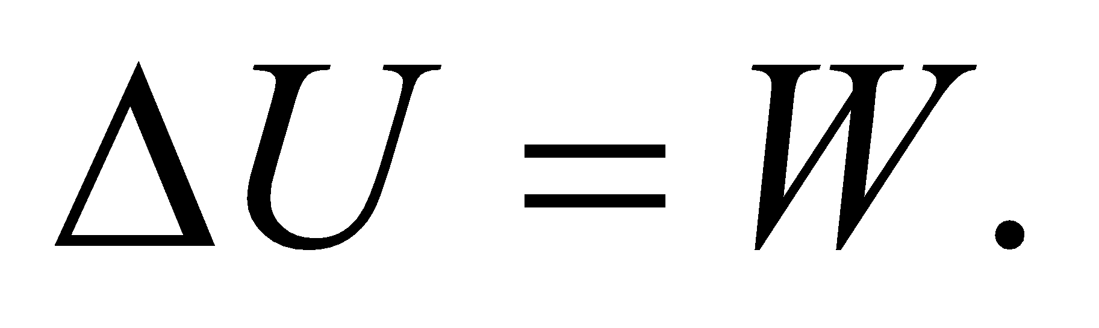 The temperature and volume are related by Equation 18.11b:

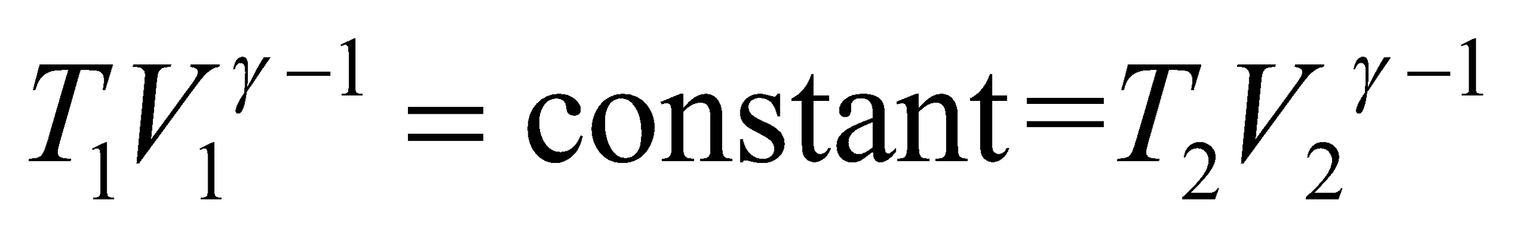

The temperature doubles, so *T*2 = 2*T*1 and *γ* = 1.4, so we can solve for the fractional change in volume.

**Evaluate** From the equation above, we have

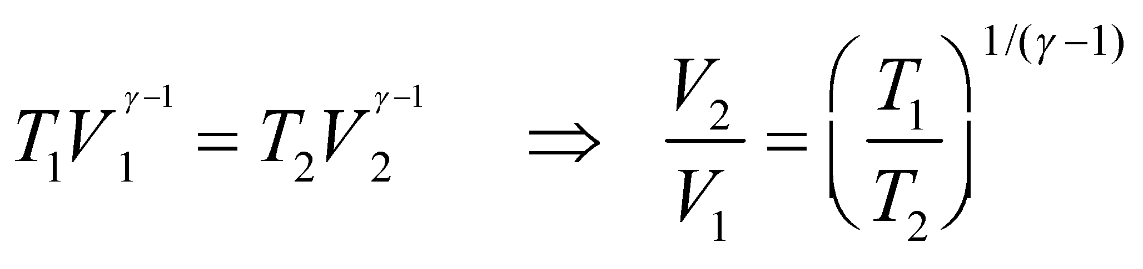

Thus, for the temperature to double, the volume change must be

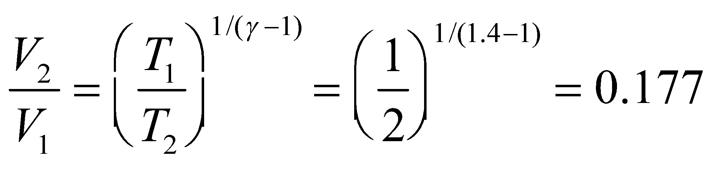

**Assess** We see that increasing the temperature along the adiabat is accompanied by a volume decrease. In addition, since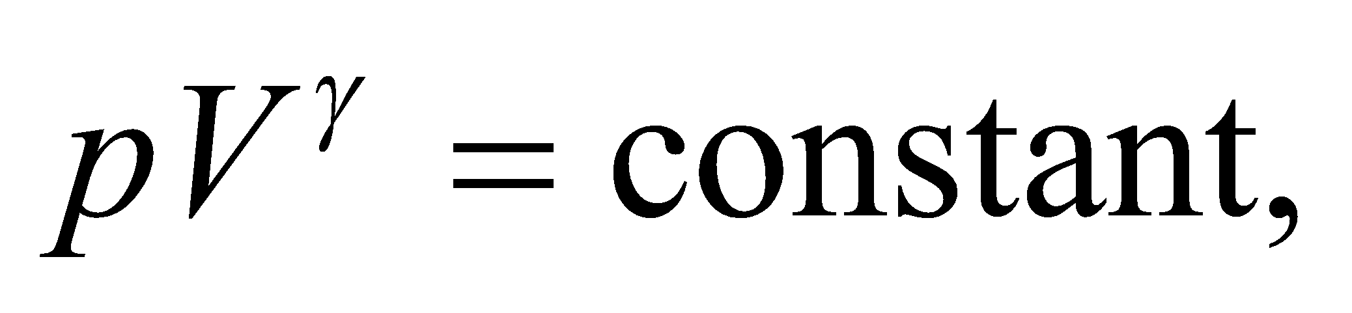the final pressure is also increased:

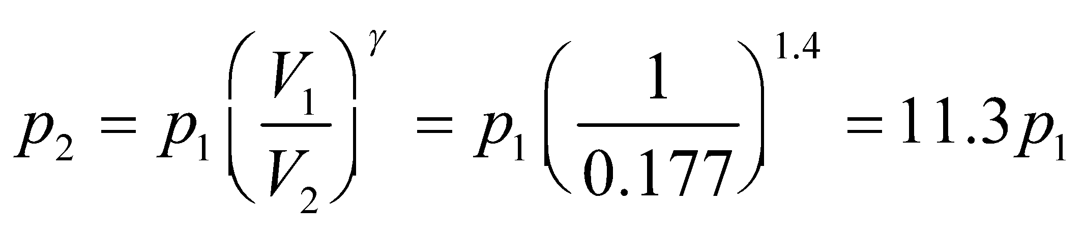

**Section 18.3 Specific Heats of an Ideal Gas**

**26.** **Interpret** This problem involves finding the molar specific heat at constant volume and constant pressure for the given gas mixture, which contains the given quantities of diatomic O2 and monatomic Ar.

**Develop** This problem in similar to Example 18.5, so we will use the same approach as outlined there.

**Evaluate** Because O2 has 5 degrees of freedom, so its average energy per molecule is 5*kT*/2. For Ar, the average energy per molecule is 3*kT*/2 because it is monatomic. The total internal energy is therefore



From Equation 18.6, the molar specific heat at constant volume is

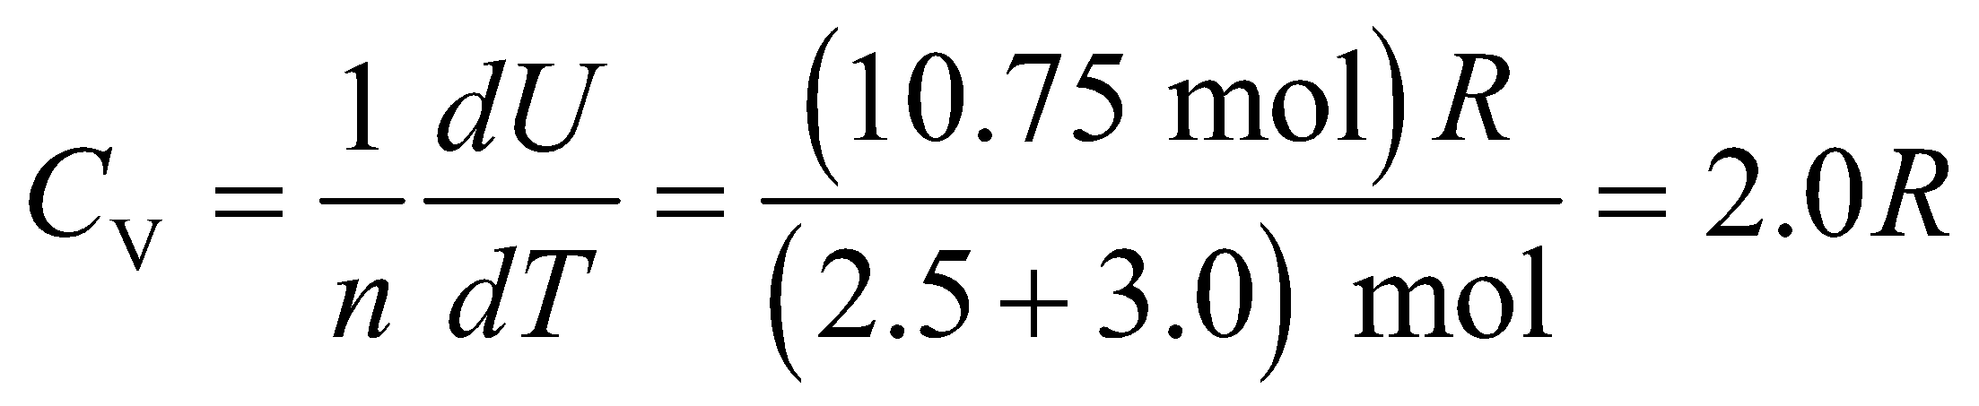

to two significant figures. From Equation 18.9, the molar specific heat at constant pressure is

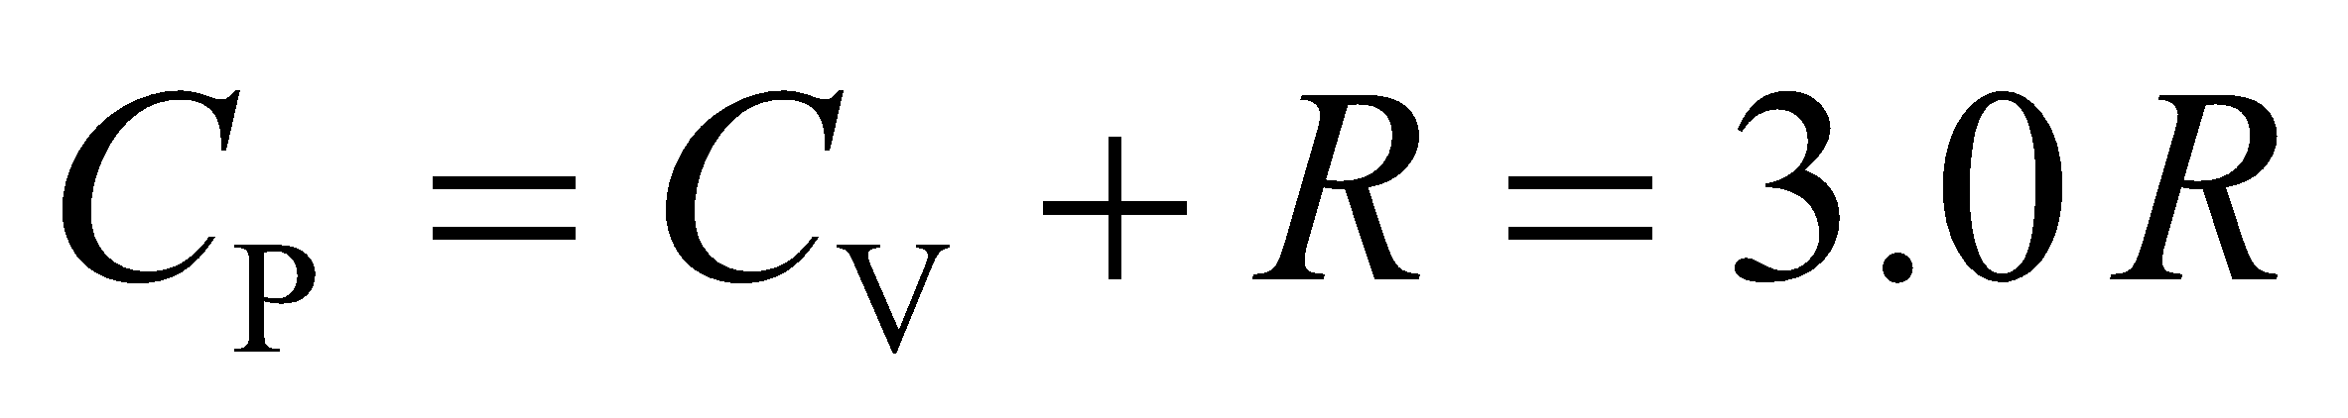

**Assess** We find that the molar specific heat at constant volume is between that of a diatomic molecule (2.5 R) and a monatomic molecule (1.5 R), as expected since we have a mixture of these two types of molecules.

**27. Interpret** The problem is about the specific heat of a mixture of gases. We want to know what fraction of the molecules is monatomic, given the its specific-heat ratio.

**Develop** The internal energy of a mixture of two ideal gases is

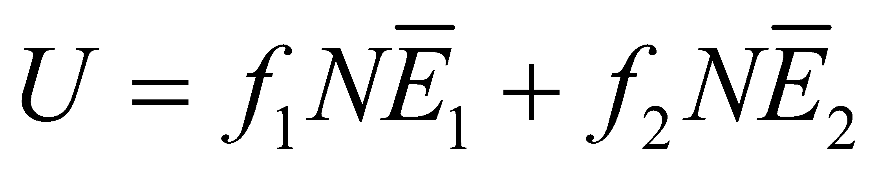

where 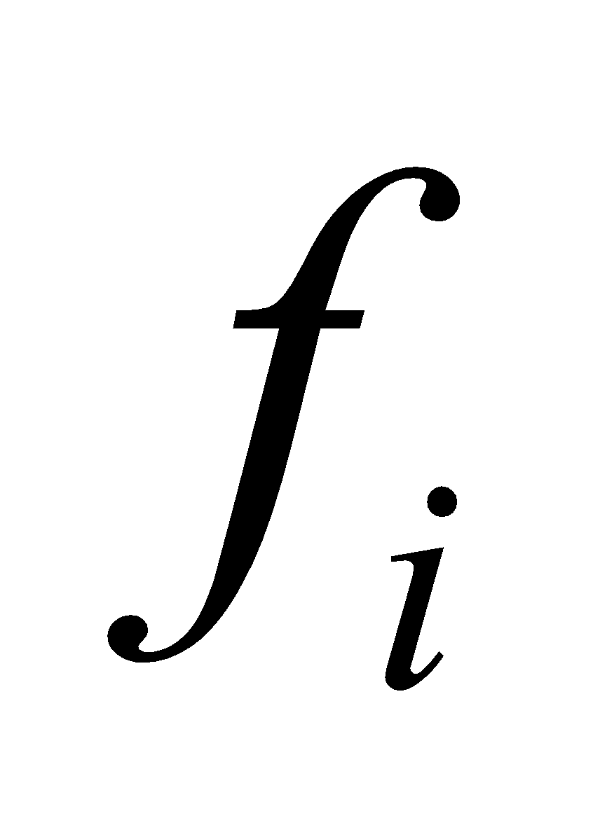 is the fraction of the total number of molecules, *N*, of type *i*, and 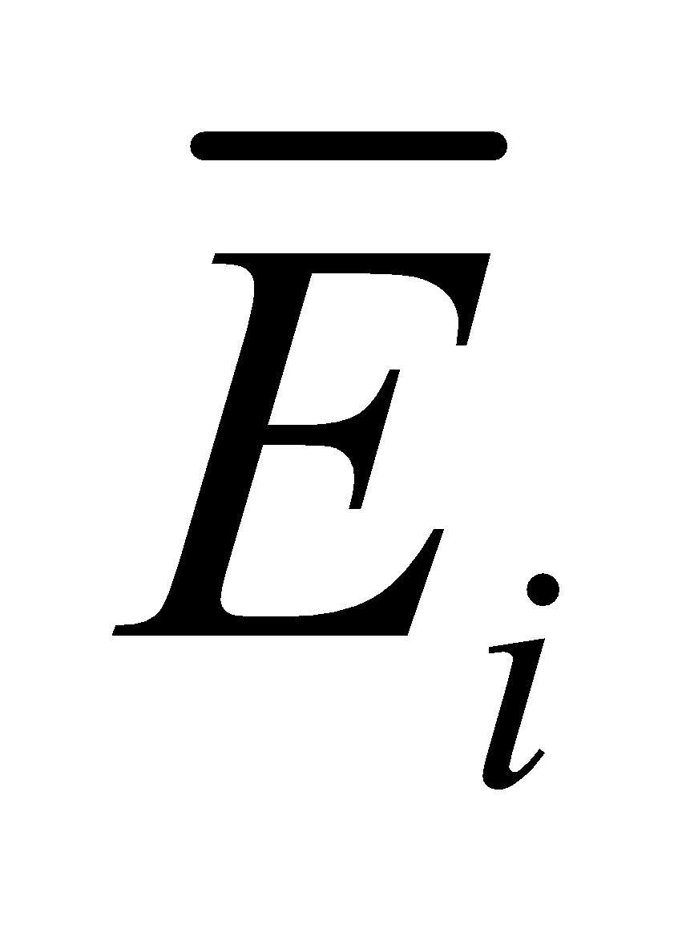 is the average energy of a molecule of type *i*. Classically, 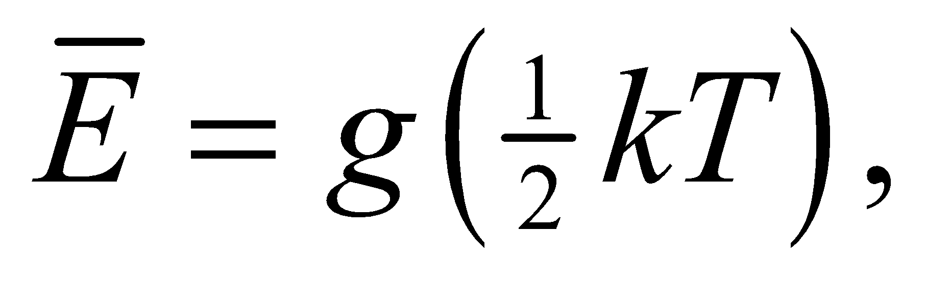 where *g* is the number of degrees of freedom (the equipartition theorem). From Equation 18.6, the molar specific heat at constant volume is

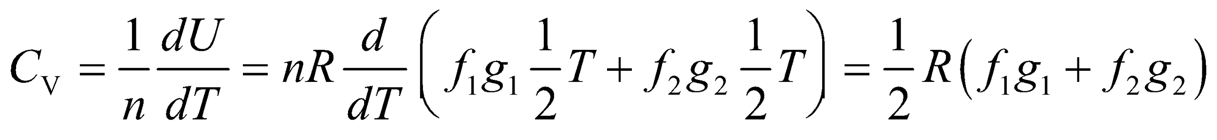

Suppose that the temperature range is such that *g*1 = 3 for the monatomic gas, and *g*2 = 5 for the diatomic gas, as discussed in Section 18.3. Then

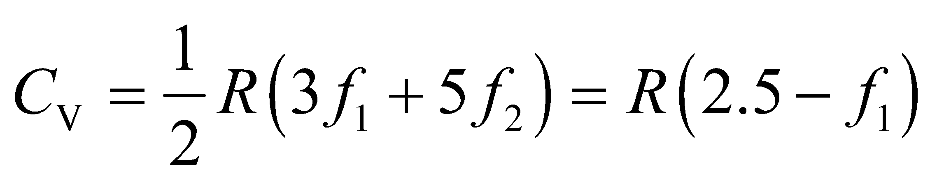

where 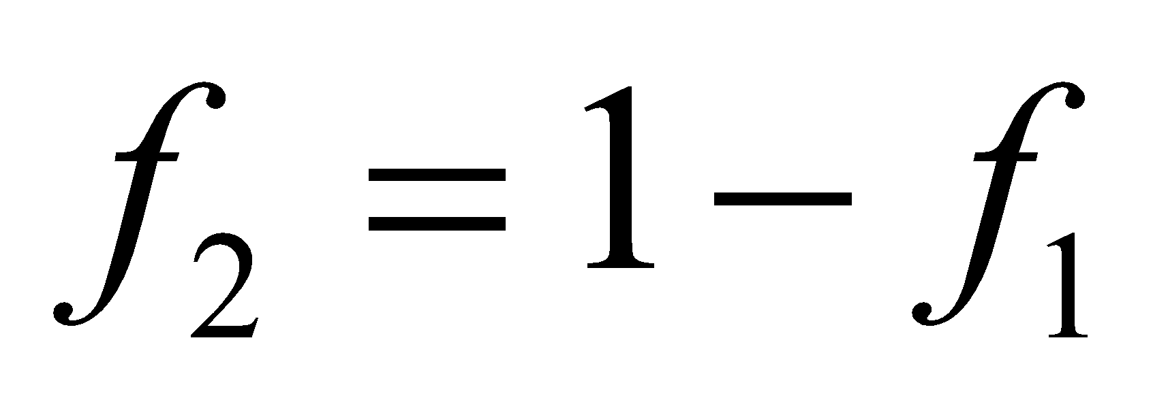 since the sum of the fractions of the mixture is unity. Now, *C*V can also be specified by the ratio

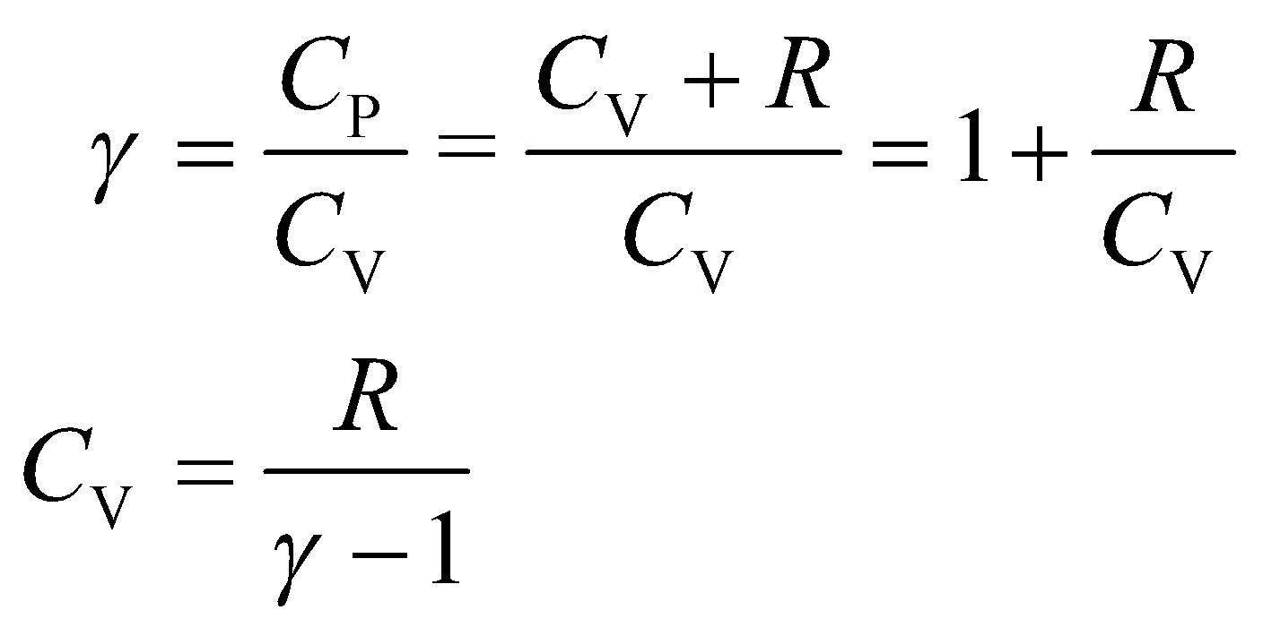

Equating the two expressions allows us to solve for 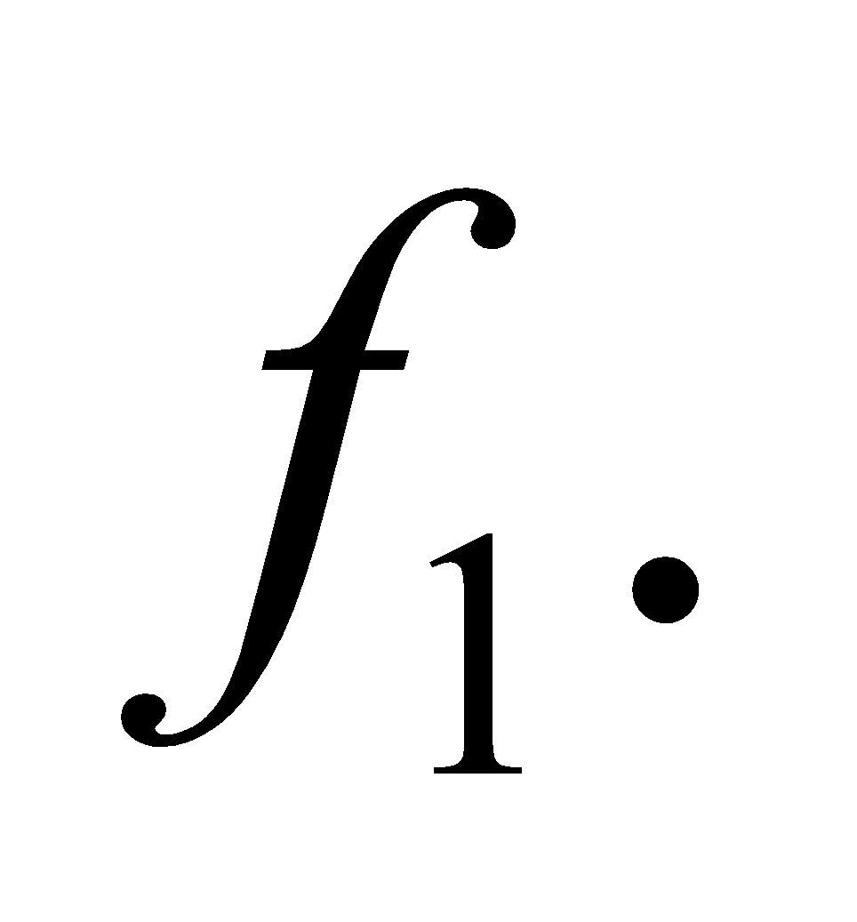

**Evaluate** Solving, we find

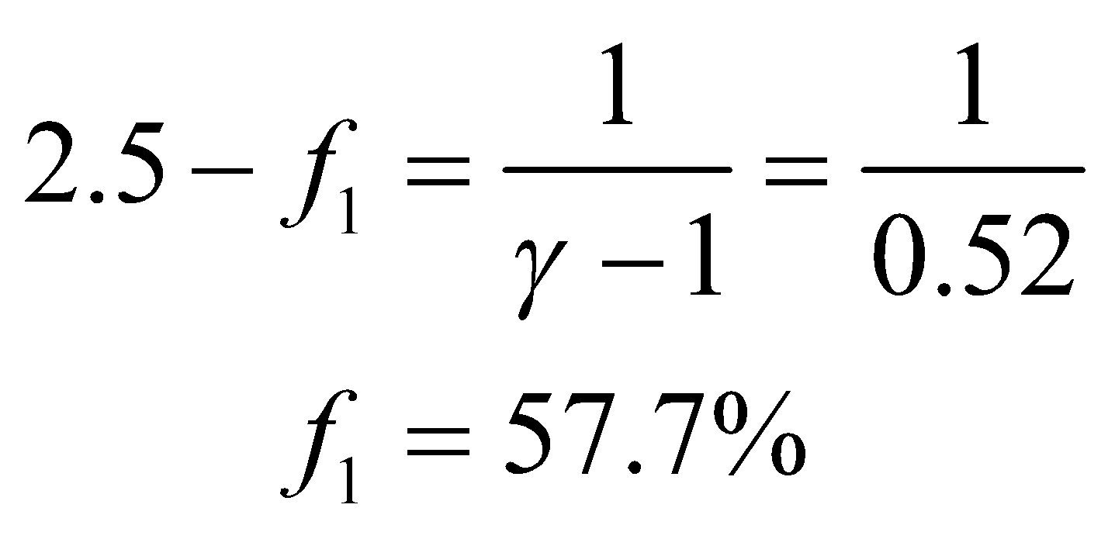or

**Assess** From the equation above, we see that the specific-heat ratio can be written as

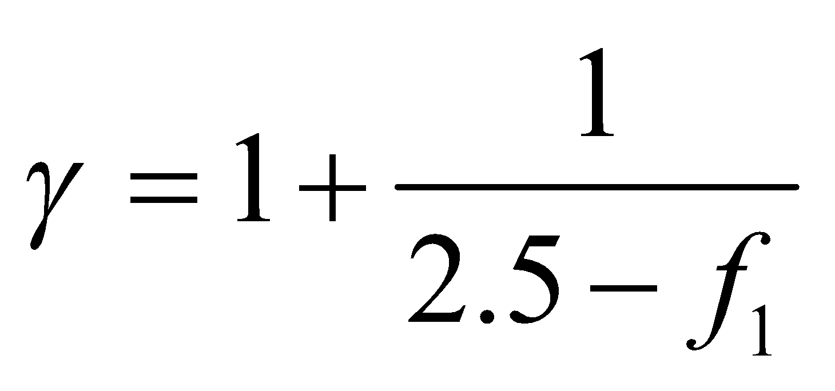

In the limit where all the gas molecules are monatomic, 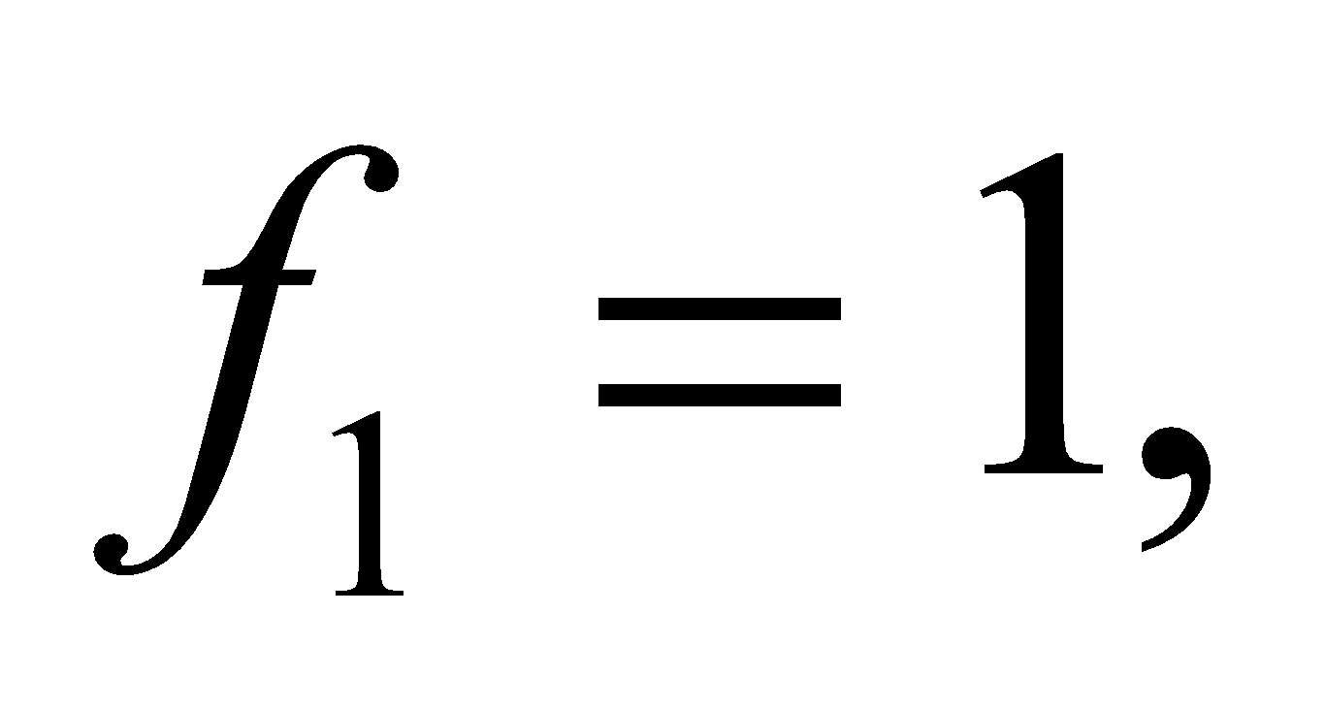 and 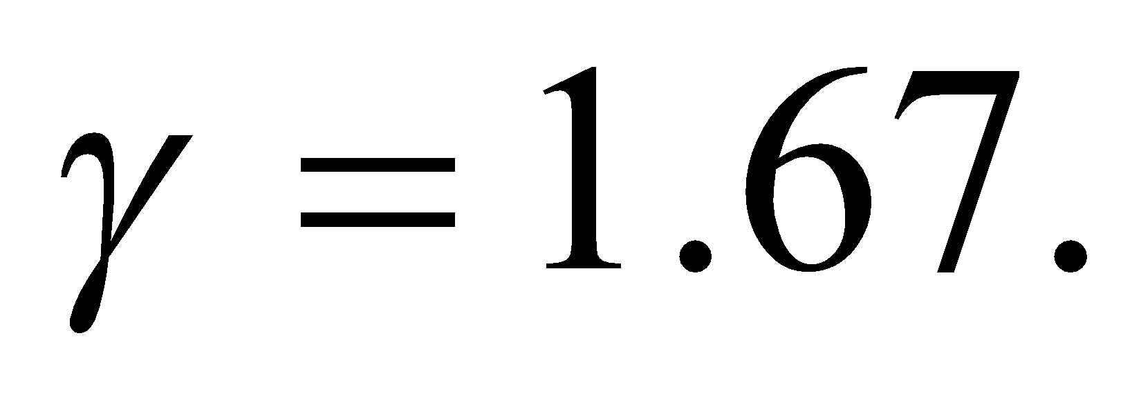 On the other hand, if all the molecules are diatomic, then 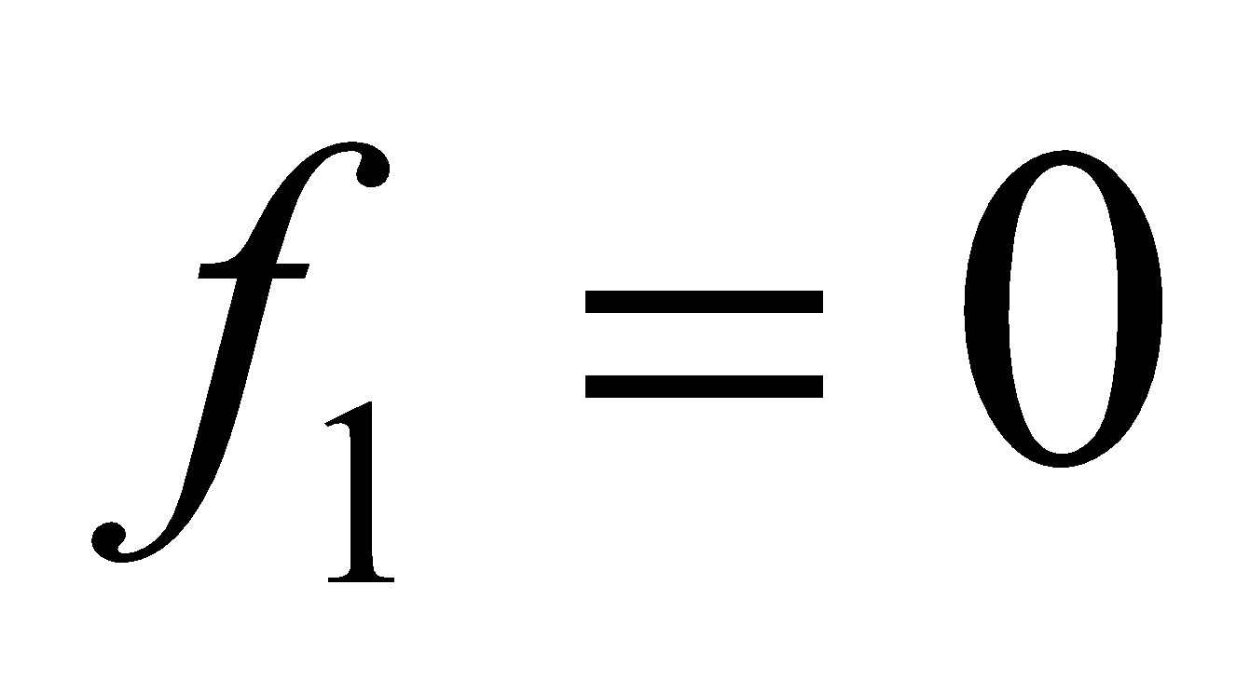 and the specific-heat ratio is 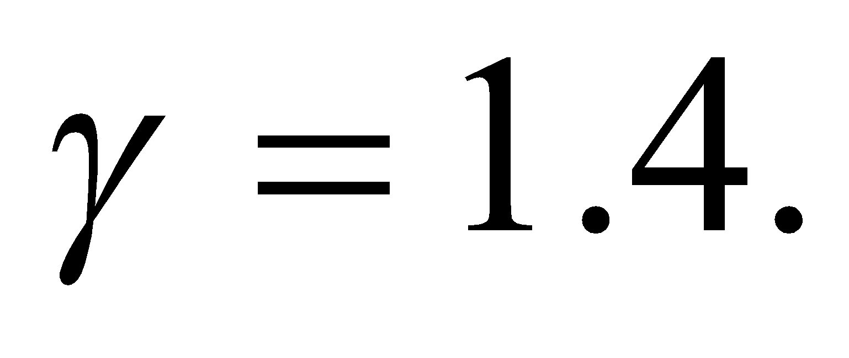 The equation yields the expected results in both limits.

**28.** **Interpret** For this problem, we are to find the specific-heat ratio of a gas consisting of the given ratio of different gas molecules.

**Develop** By generalizing the result of the previous problem, the molar specific heat of a mixture of three gases is

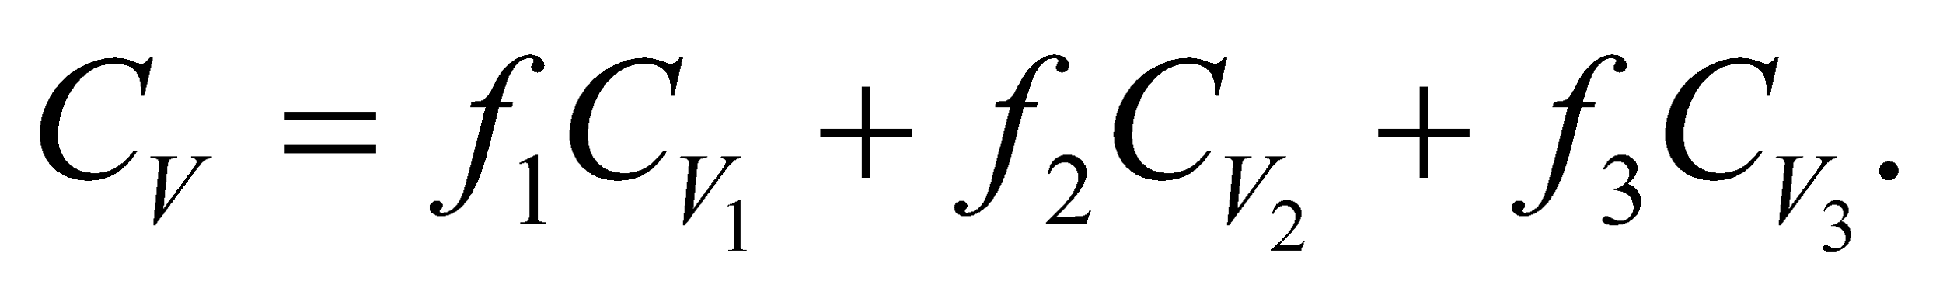

For each gas and the mixture, use 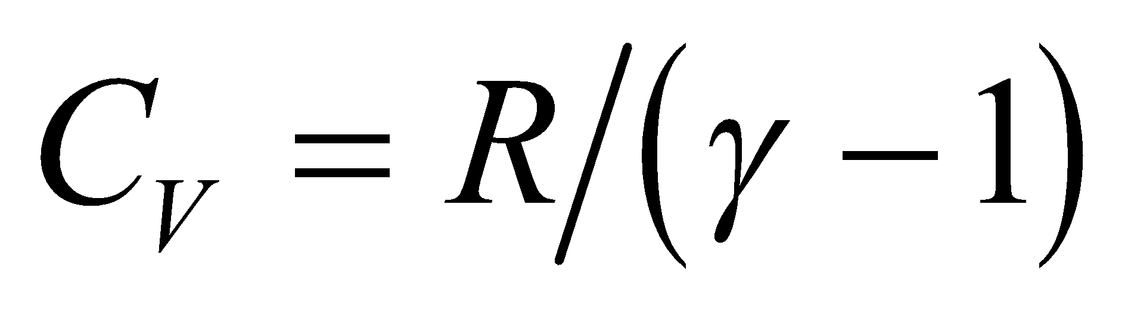 to obtain



which we can evaluate to find *γ*.

**Evaluate**  When the data specified in the problem is inserted, one gets

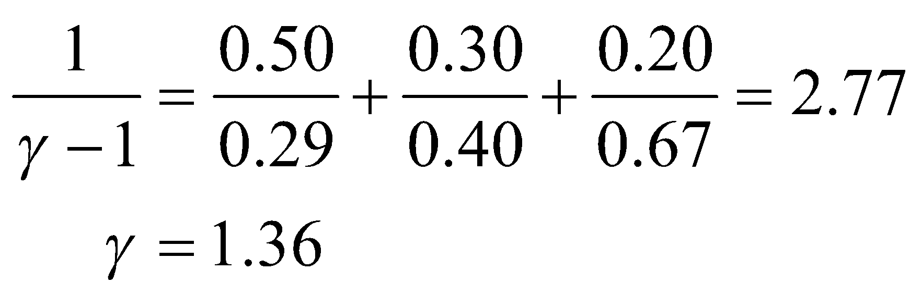

**Assess** Because we have some triatomic molecules, the specific-heat ratio is less than that for a pure diatomic gas (see previous problem).

**29. Interpret** The thermodynamic process is adiabatic, and we want to know the temperature change when work is done on a monatomic gas and a diatomic gas.

**Develop** In an adiabatic process, *Q* = 0, so from the first law of thermodynamics (Equation 18.1)  where *W* is the work done on the gas. From Equation 18.6, 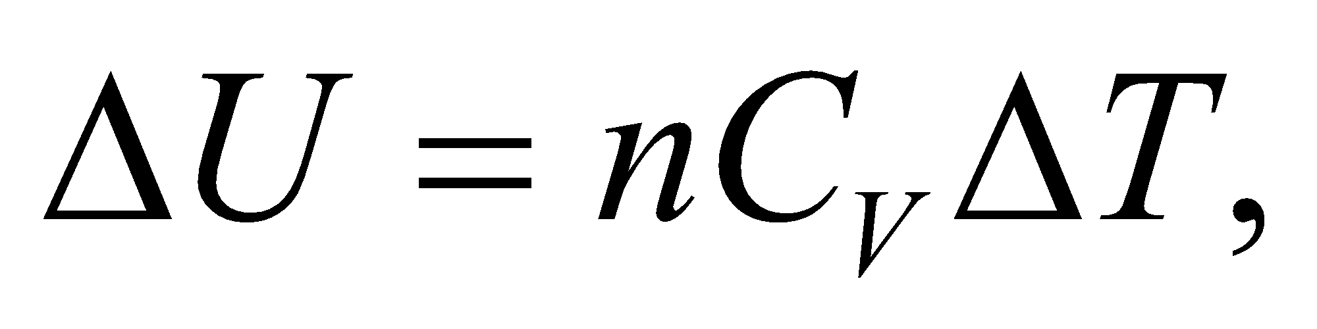 the change in temperature is

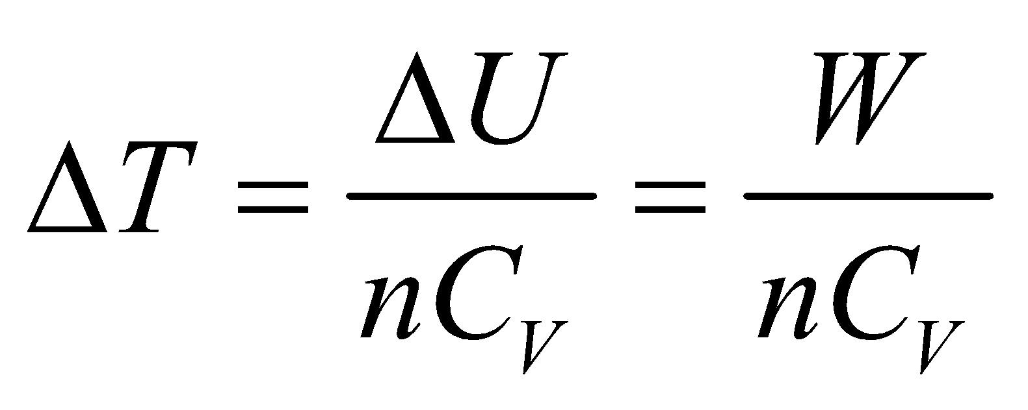

If the work done per mole *on* the gas is 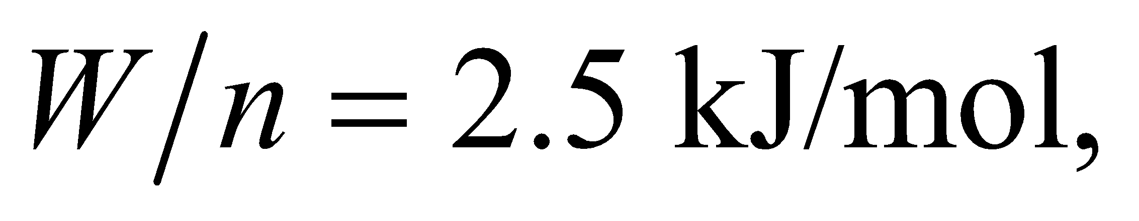 then 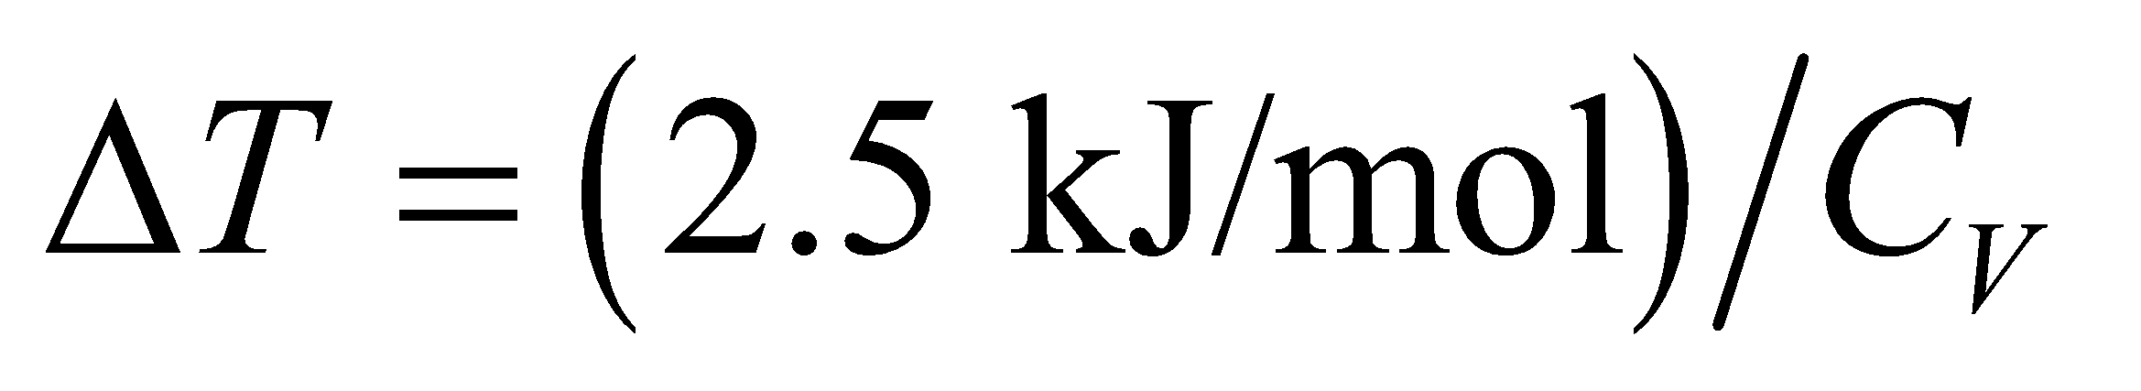

**Evaluate** **(a)** For an ideal monatomic gas, 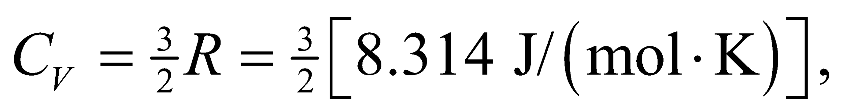 so 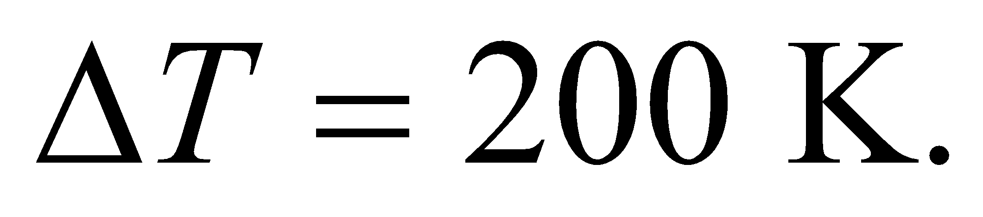

**(b)** For an ideal diatomic gas (with five degrees of freedom), 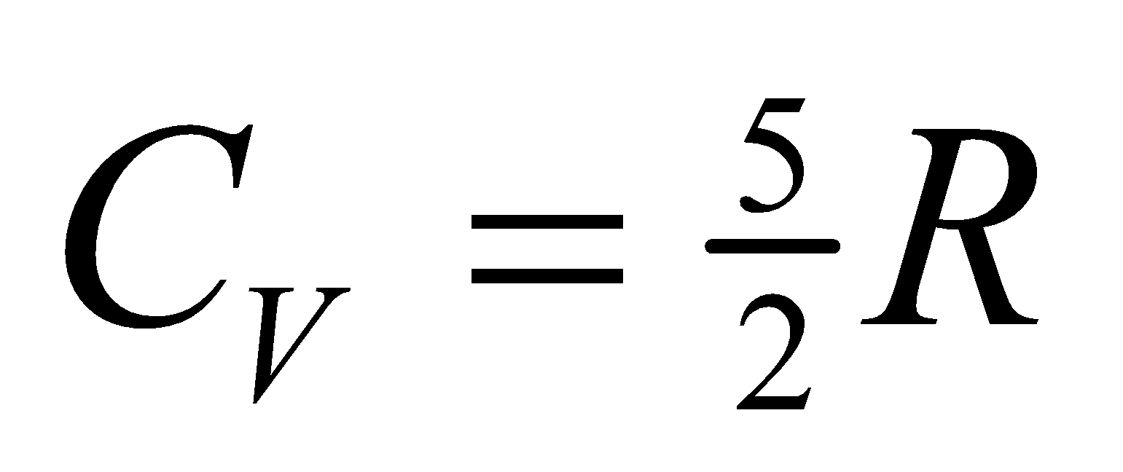 so 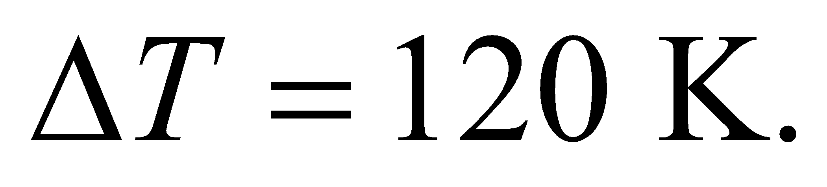

**Assess** Since the diatomic gas has a greater specific heat *CV*, its temperature change is less than that of the monatomic gas.

**Problems**

**30. Interpret** The constant temperature of 440 K indicates that the process is isothermal. We are given the amount of work done by the gas, and are asked to find the heat it absorbs and how many moles of gas there are.

**Develop** Apply the ideal-gas law given in Equation 17.2: 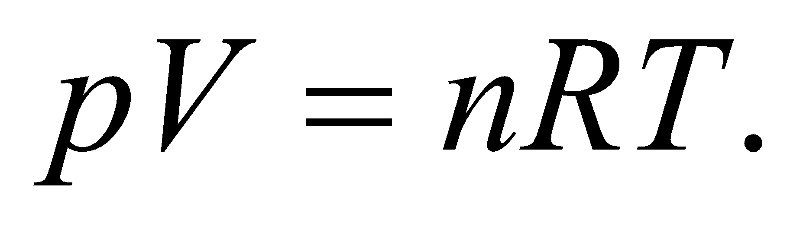 For an isothermal process, *T* = constant, so we obtain 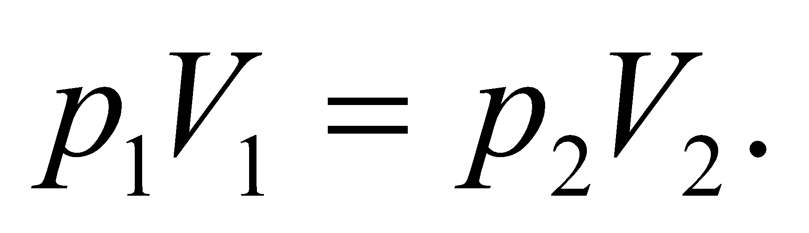 Since 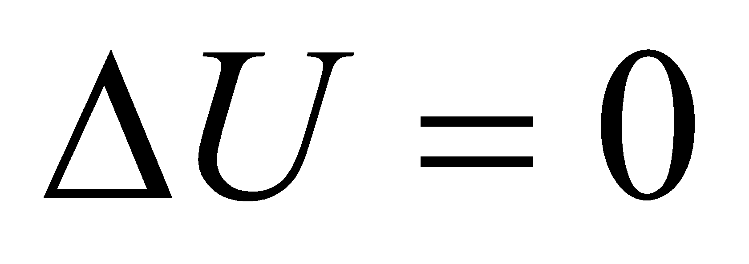 for an isothermal process, the heat absorbed is the negative of the total work done on the gas (Equation 18.4).

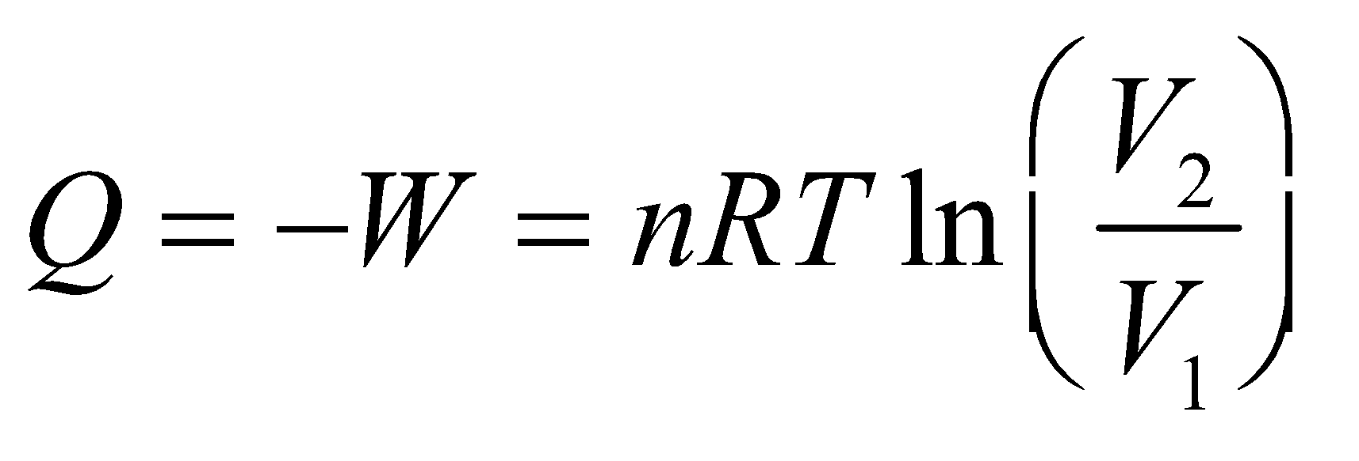

For this problem, the gas does 3.3 kJ of work on its surroundings, so the surroundings do −3.3 kJ of work on the gas, so *W* = −3.3 kJ.

**Evaluate** **(a)** Using the equation above, the heat absorbed is 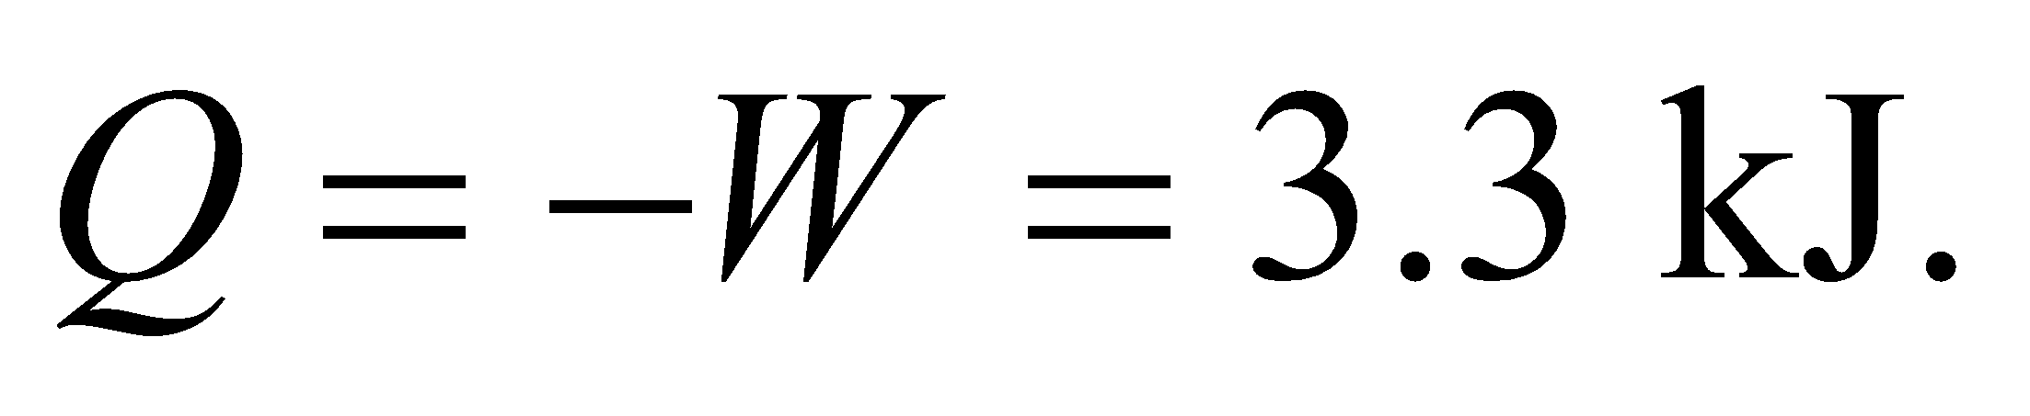

**(b)** Solving the expression above for the number *n* of moles gives

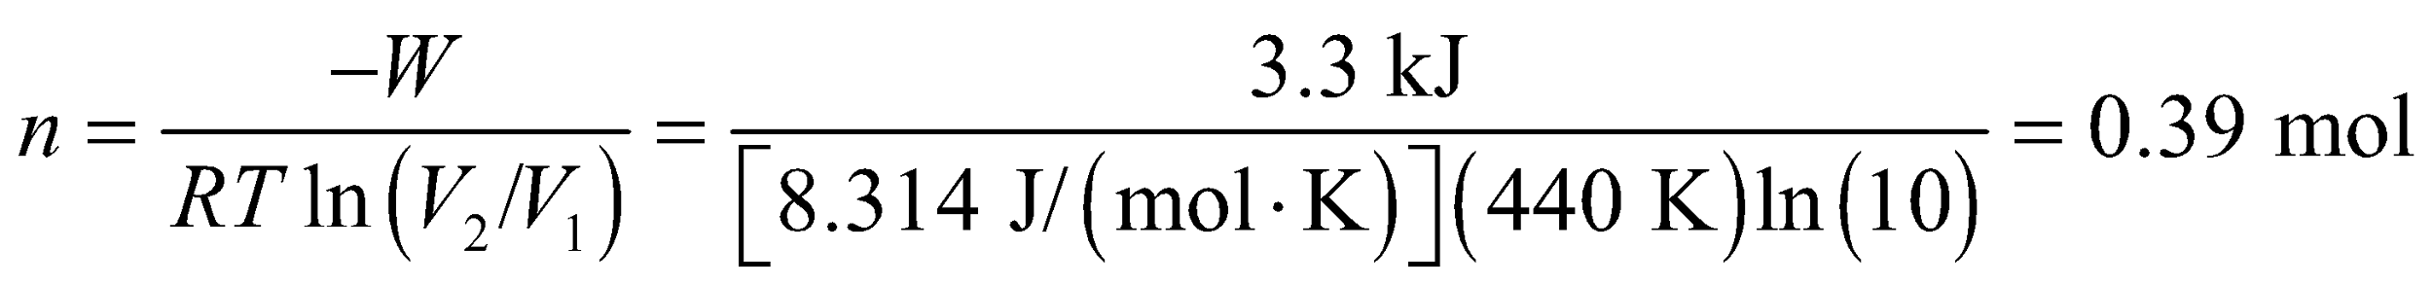

**Assess** The heat absorbed by the gas is equal to the work done by the gas on its surrounding as it expands, and there is no change in temperature.

**31. Interpret** We're asked to find the rate that heat is produced in the body when cycling. This involves the first law of thermodynamics.

**Develop** We're dealing with the rates of work and heat production, so we'll use Equation 18.2: 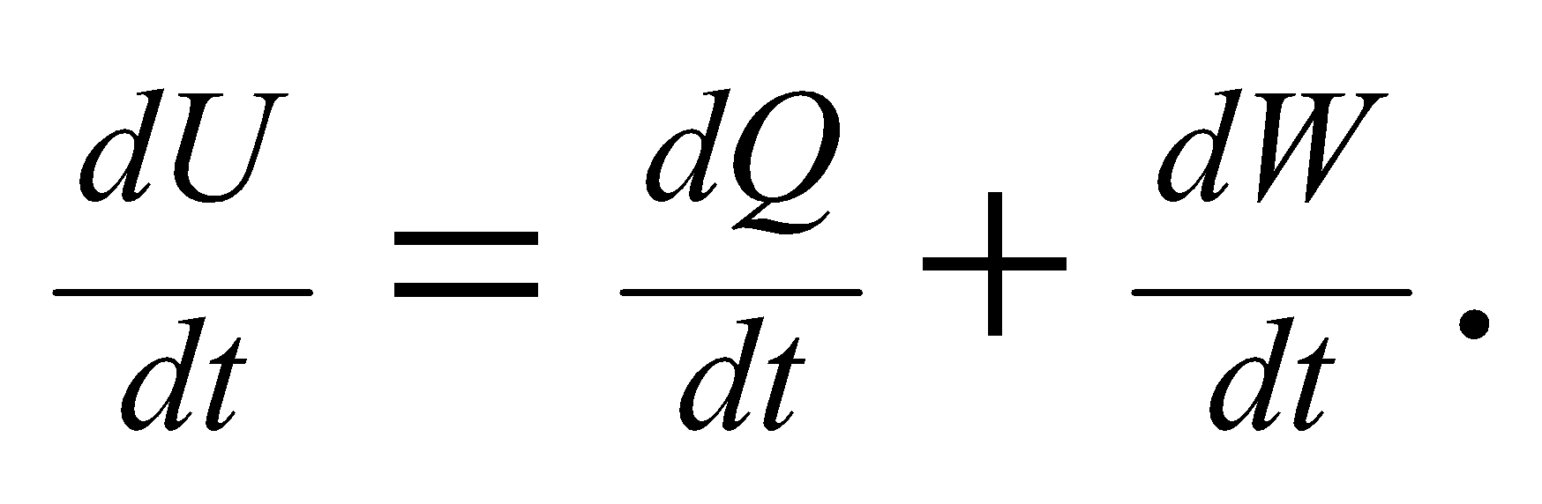 If the body is releasing stored food energy, that corresponds to a *decrease* in the body's internal energy: 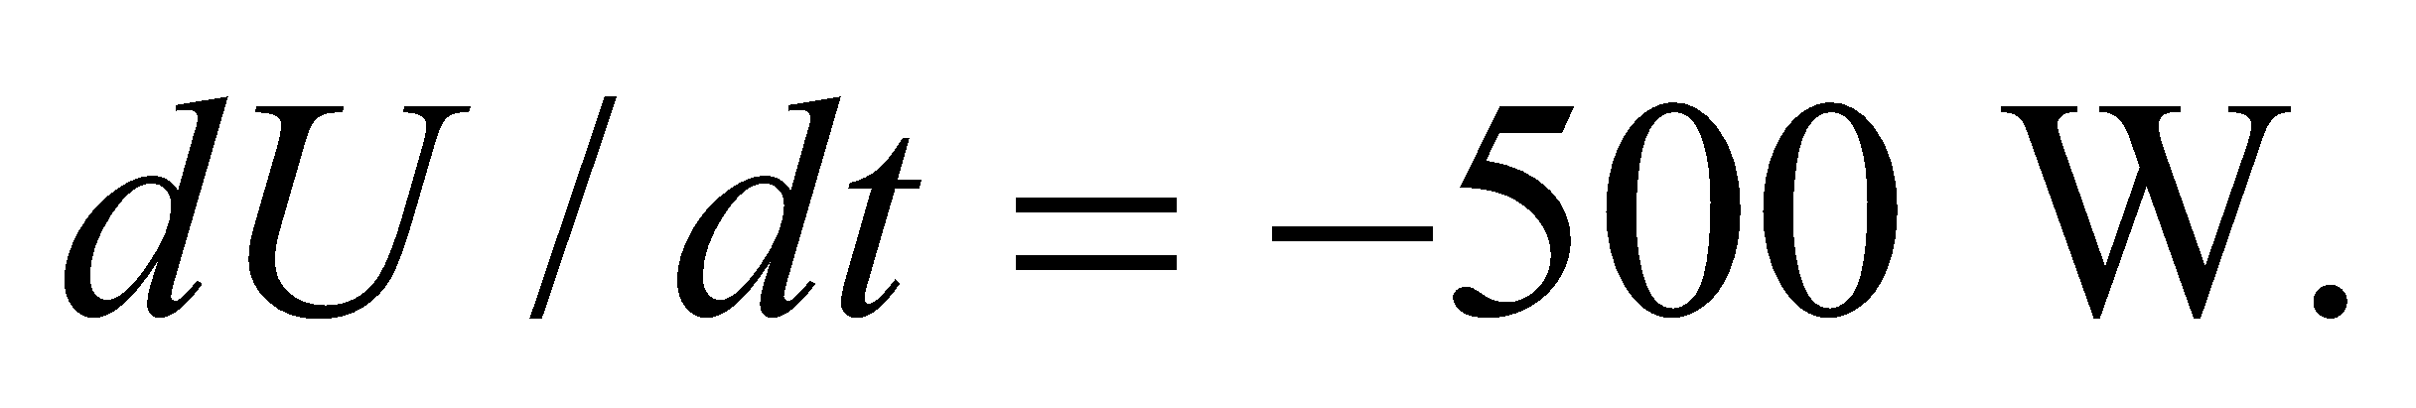 Likewise, the mechanical power quoted is for work done *by* the body, so 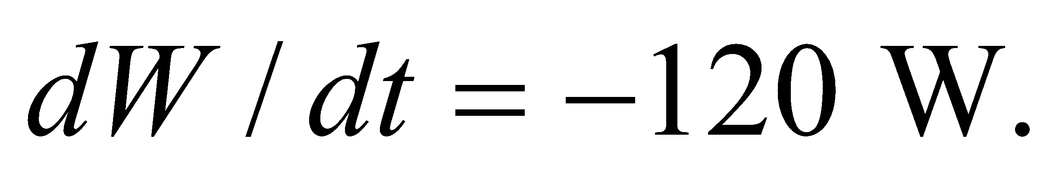We are looking for the rate at which the body produces heat, which is technically heat that it is losing (–*dQ*).

**Evaluate** The rate of heat production is the negative heat absorbed, so

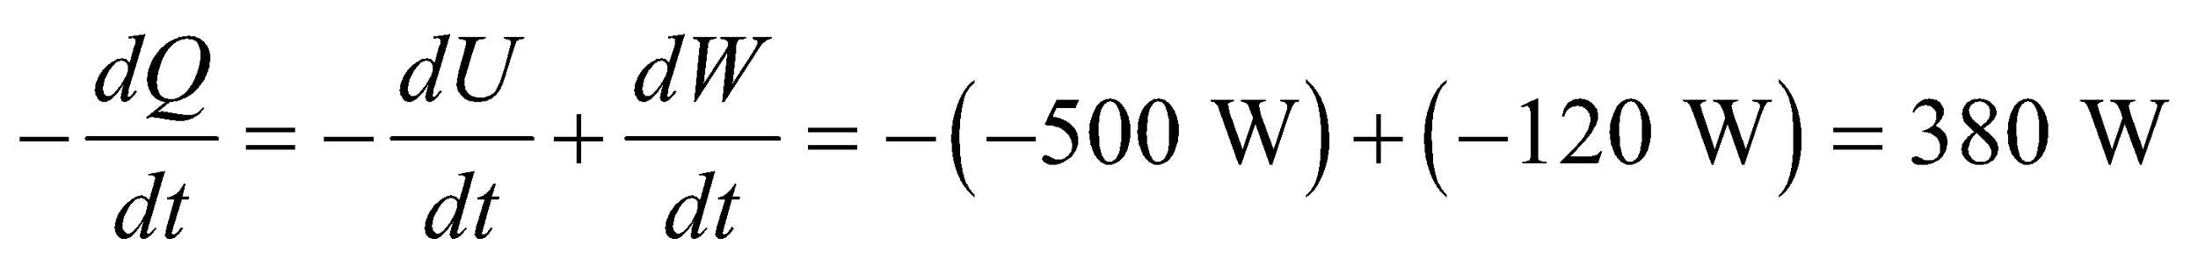

**Assess** All the signs can be confusing, but essentially the body burns stored energy and some of it is used to do work and the rest is released as heat.

**32.** **Interpret** This problem deals with isothermal compression, so the temperature is constant in this process. We are to find the work done to compress the given quantity of ideal gas from 3.5 L to 3.0 L.

**Develop** Apply Equation 18.4,

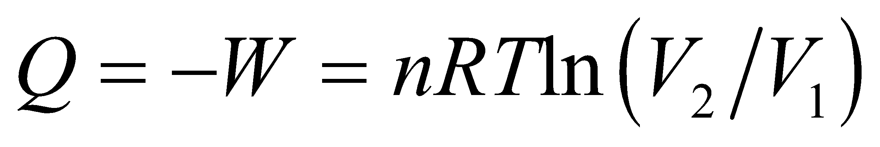

where *W* is the work done by the gas, *V*1 = 3.5 L, and *V*2 = 3.0 L. Since we do 61 J of work on the gas to compress it, *W* = 61 J, so we can solve this expression for the temperature *T*.

**Evaluate** The temperature of the ideal gas is

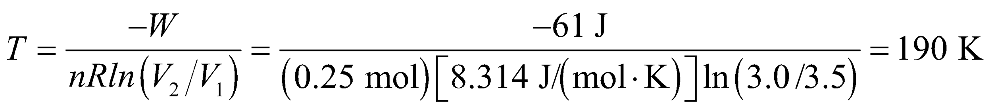

**Assess** This gas is about 100 K below room temperature.

**33. Interpret** Assume the air inside the spherical bubble behaves like an ideal gas at constant temperature, so the process is isothermal. We need to find the diameter of the bubble at maximum pressure and the work done on the gas in compressing it.

**Develop** Apply the ideal-gas law given in Equation 17.2:  For an isothermal process, *T* = constant, which leads to  Since the volume of a spherical bubble of diameter *d* is

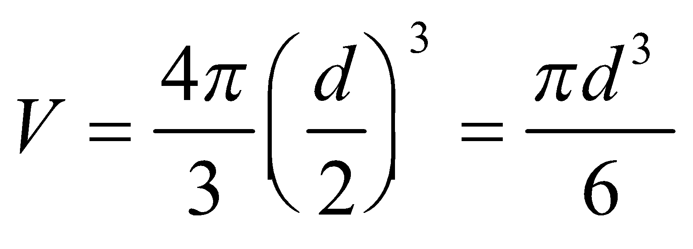

the relationship between the diameter and the pressure is

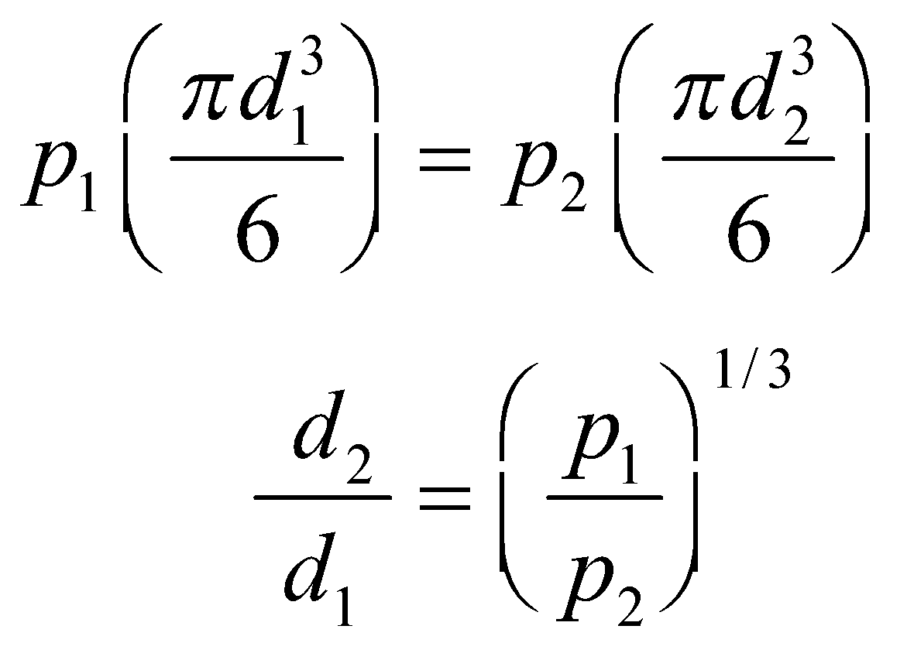

**Evaluate** **(a)** Using the equation above, we find the diameter at the maximum pressure to be

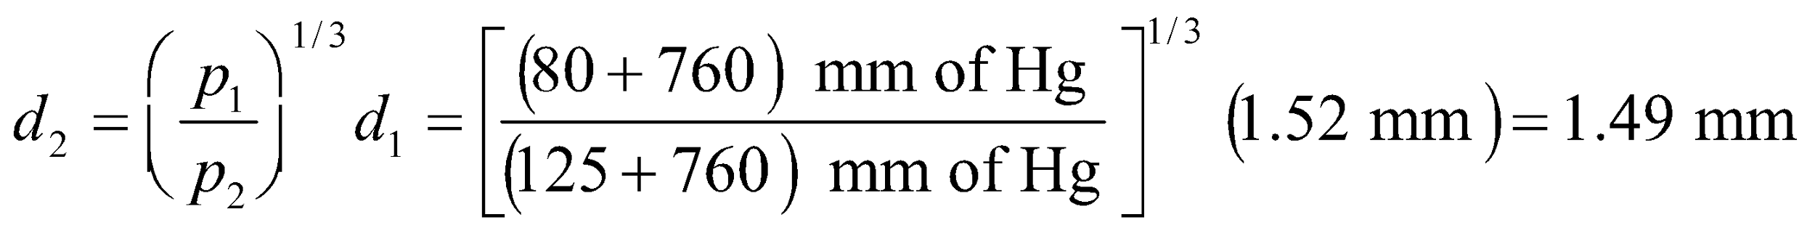

**(b)** The work done *on* the air is given by Equation 18.4, or

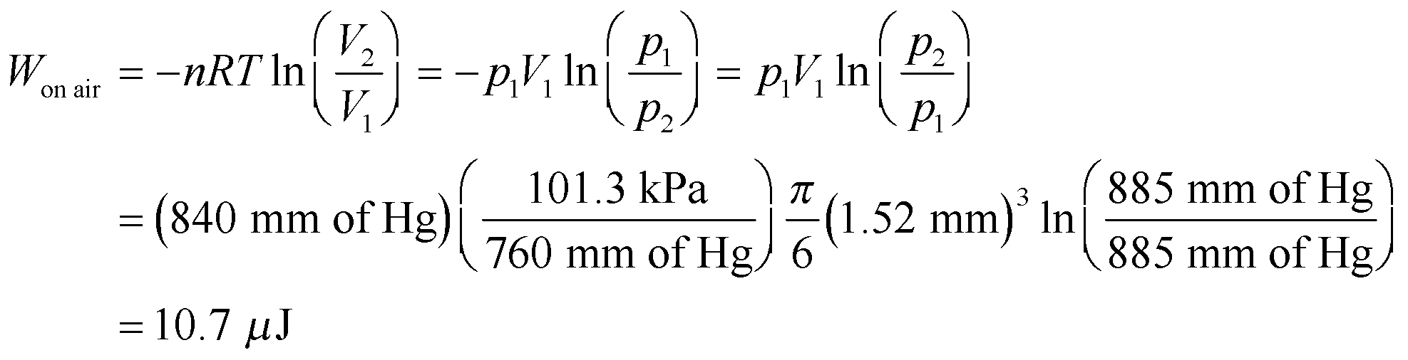

**Assess** Positive work is done by the blood in compressing the air bubble.

**34.** **Interpret** This problem involves compressing a gas in an isothermal process, so the temperature is constant. We are to find how much work it takes to reduce the volume by a factor of 10 given the work it takes to decrease the volume by a factor of 2.

**Develop** Apply Equation 18.4 to both situations. To compress a gas by a factor of two, we have

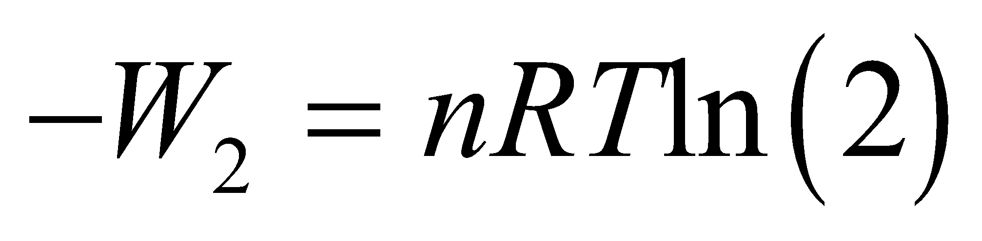

and to compress it by a factor of 10 gives

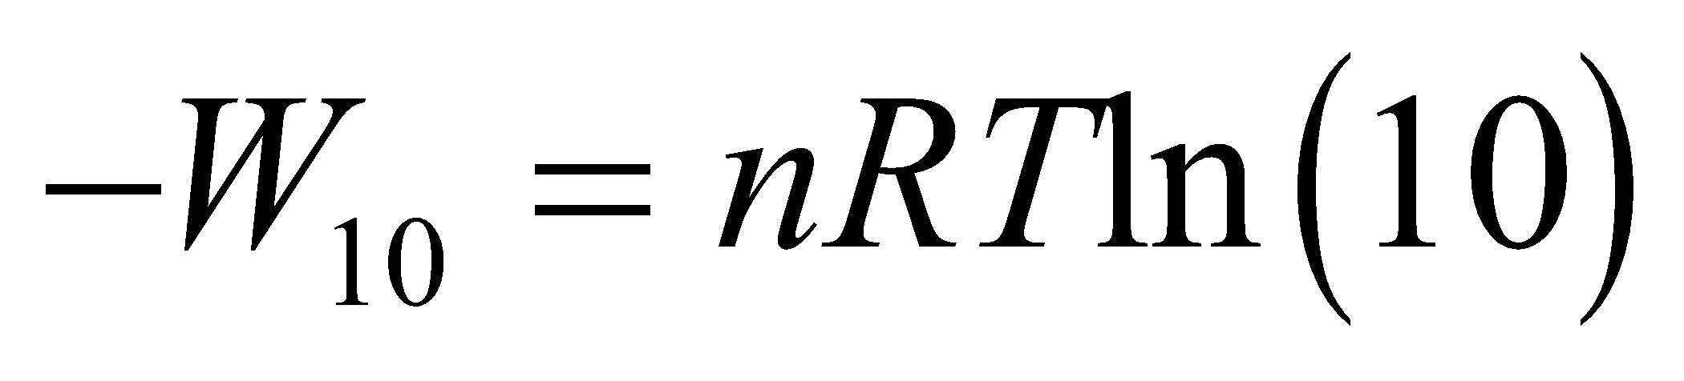

Given that *T* is constant, we can take the ratio of these expressions to find the work *W*10 needed to compress the gas by a factor of 10.

**Evaluate** The work needed to compress the gas by a factor of 10 is

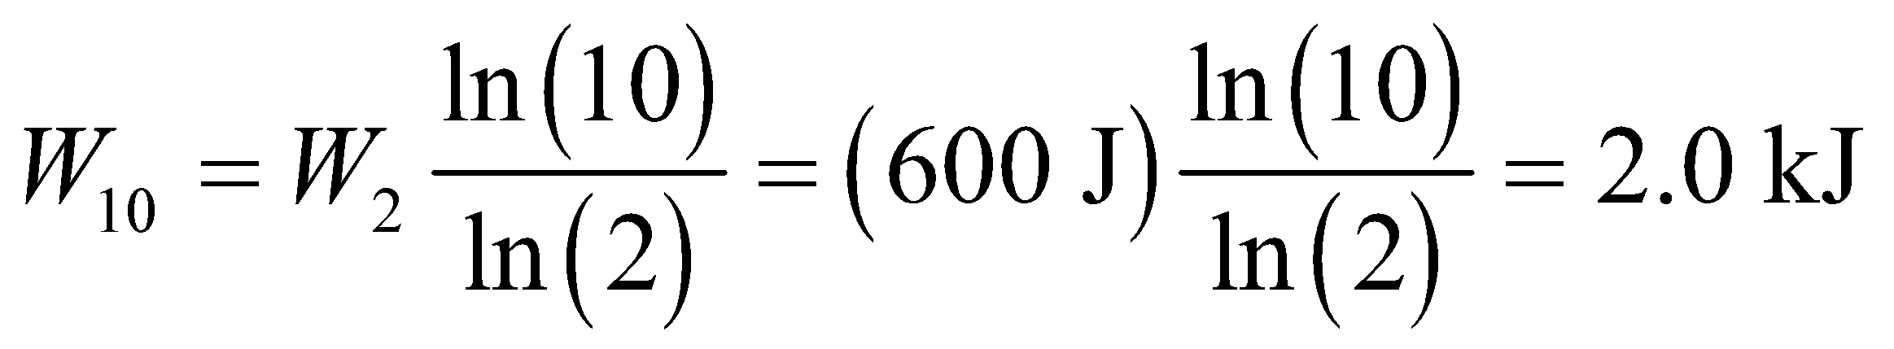

**Assess** Note that the work is sublinear in volume. To reduce the volume five times more requires only 2000/600 = 3.33 times more work.

**35. Interpret** The thermodynamic process here is adiabatic, with no heat flowing between the system (the gas) and its environment. We are to find the specific-heat ratio *γ* given the fraction increase in pressure of the gas.

**Develop** In an adiabatic process, *Q* = 0 and the first law of thermodynamics becomes  The pressure and volume are related by Equation 18.11a: 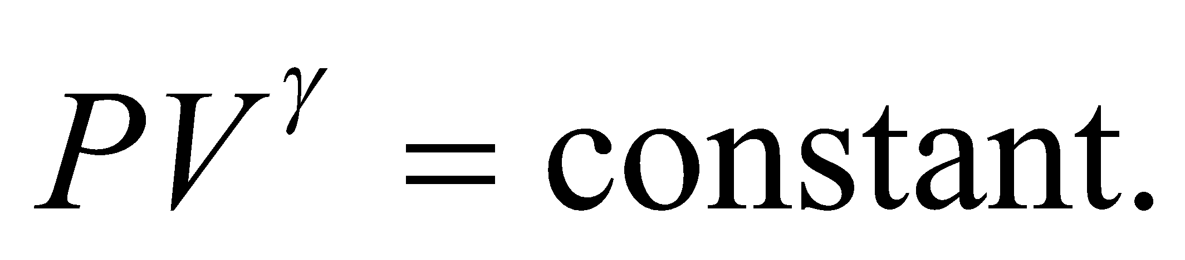 This implies

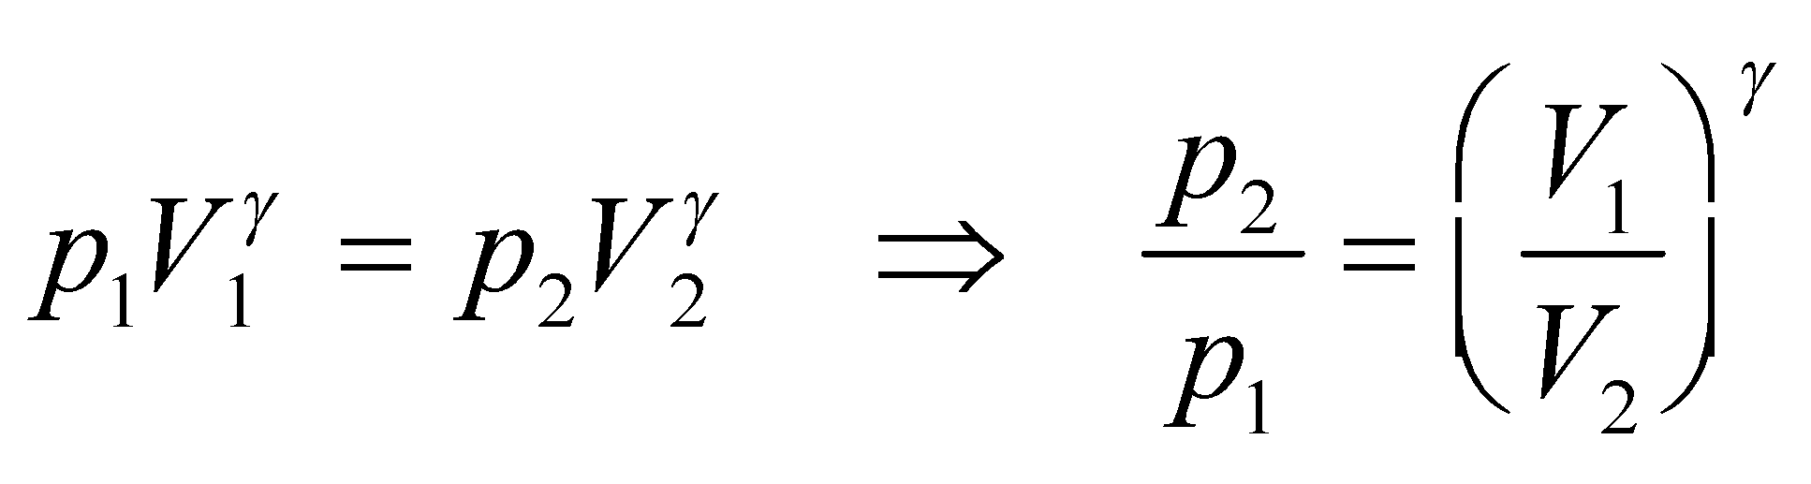

so we can solve for *γ*.

**Evaluate** Taking the natural logarithm on both sides of the above to solve for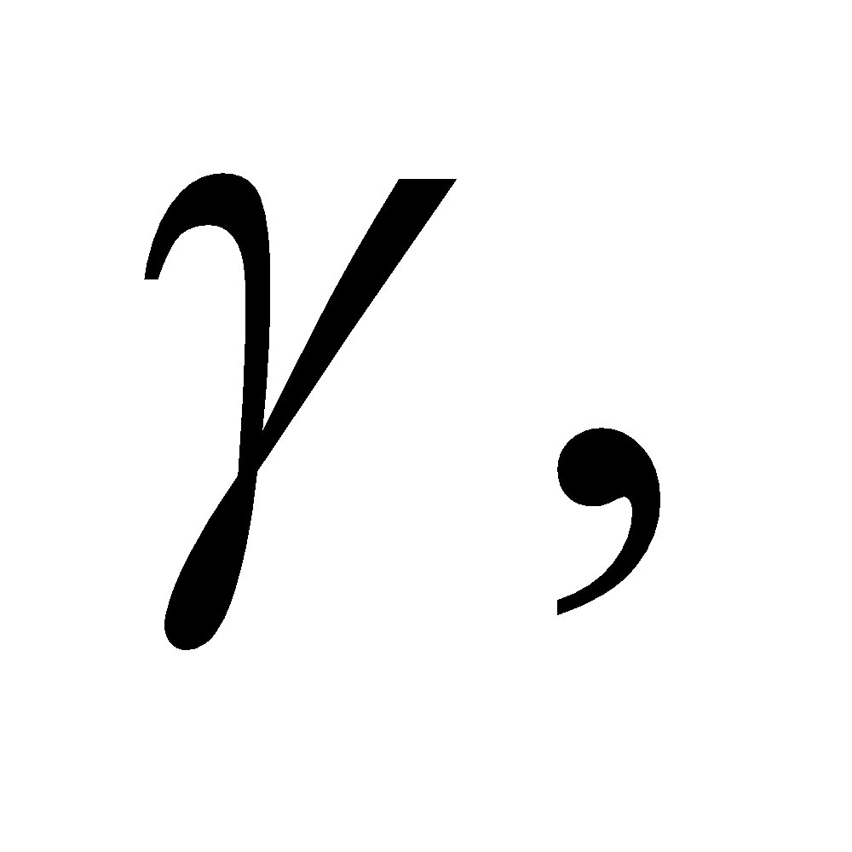we obtain

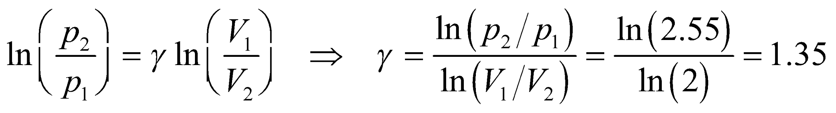

**Assess** The value of *γ* indicates that gas consists of polyatomic molecules (see Problems 27 and 28).

**36. Interpret** The problem involves compressing a gas adiabatically.

**Develop** For an adiabatic process, the initial pressure and volume are related to the final pressure and volume through Equation 18.11a: 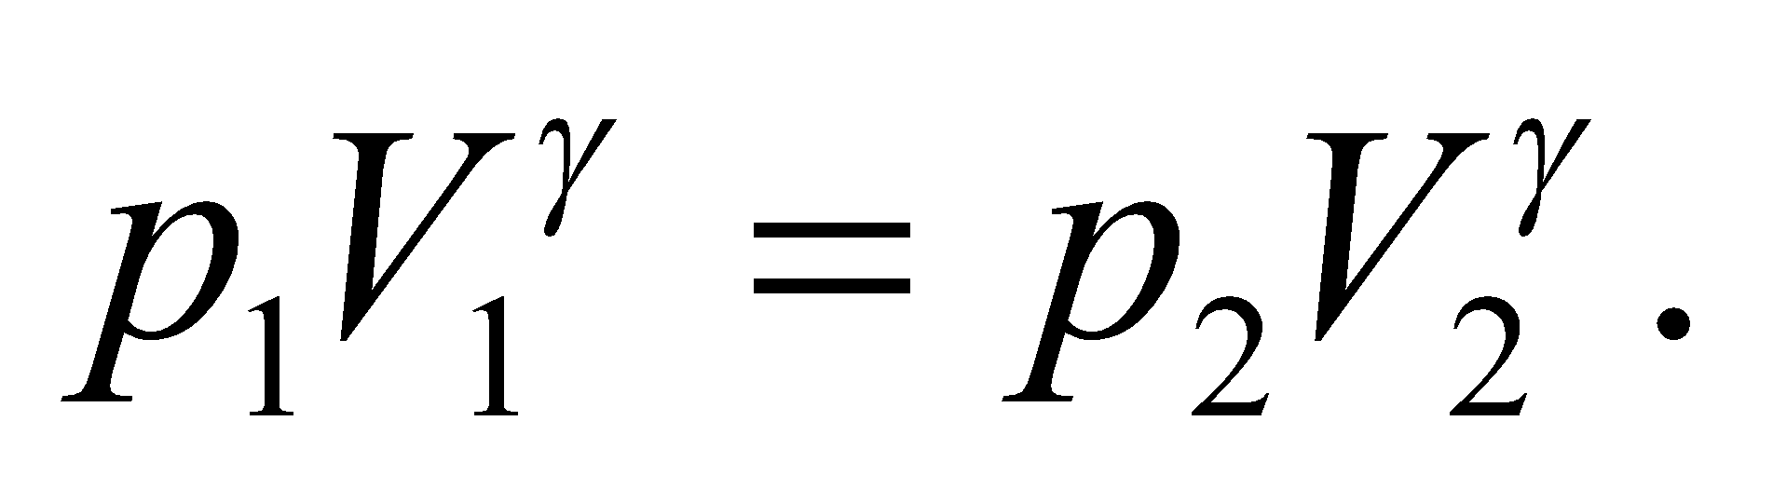We can use this to rewrite Equation 18.12 for the work done on the gas in going from the initial to the final volume:

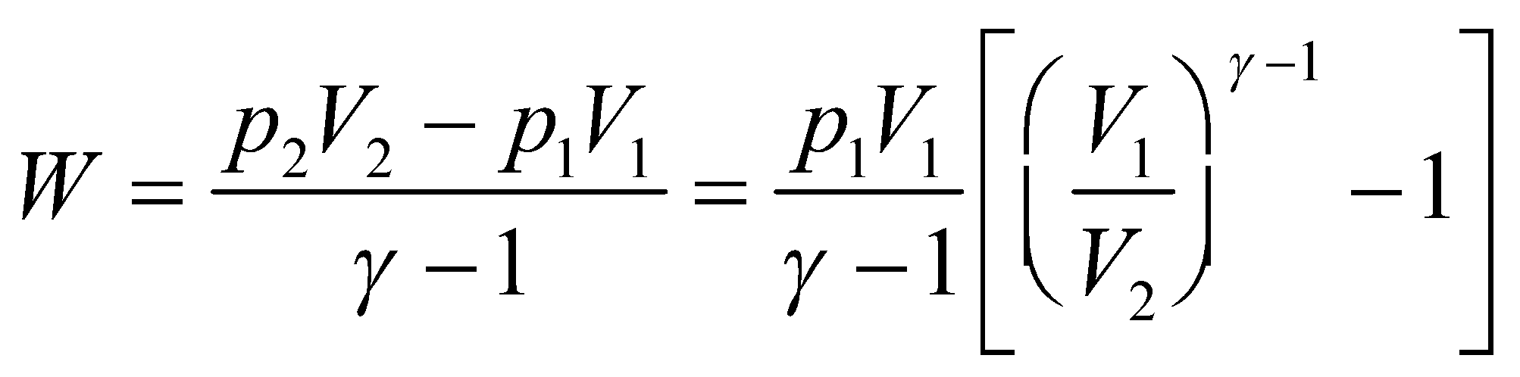

**Evaluate**  (a) The work done on the gas in compressing it to half its volume is

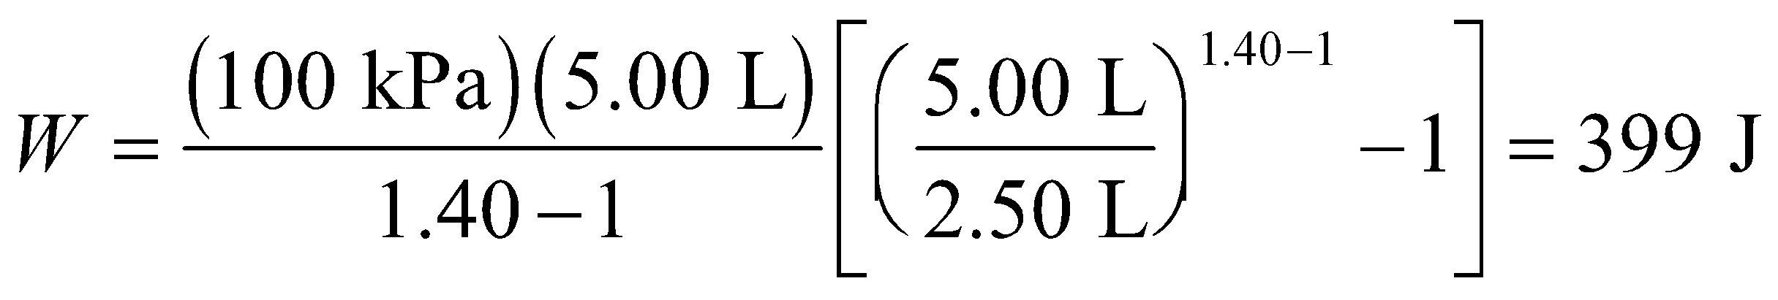

(b) The final pressure in this case is

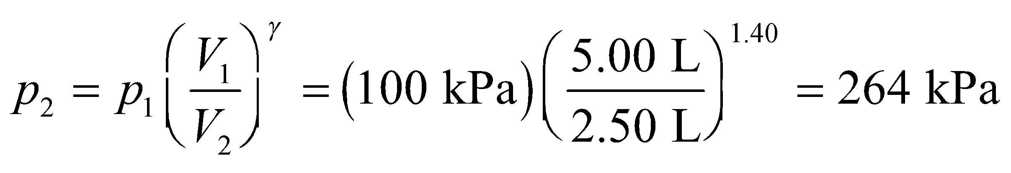

**Assess** Notice that the pressure does not merely double when the volume is reduced by half. The pressure increases due to both the increase in the density (*N*/*V*) and an increase in the internal energy of the gas 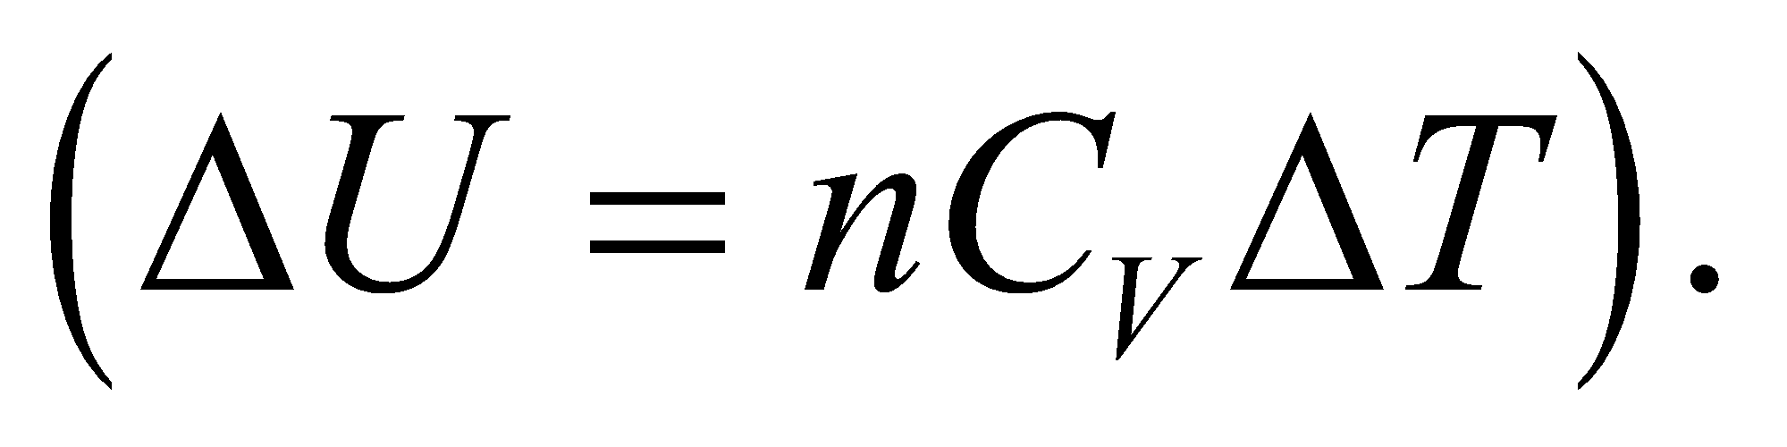

**37. Interpret** This problem involves a cyclic process. The three processes that make up the cycle are: isothermal (*AB*), isochoric (*BC*), and isobaric (*CA*). We are given the pressure at point *A* and are to find the pressure at point *B* and the net work done on the gas.

**Develop** Along the isotherm *AB* *T* = constant, so the ideal-gas law (Equation 17.2, *pV* = *nRT*) gives 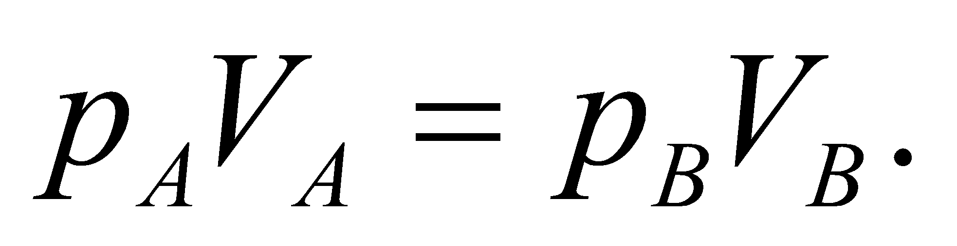 For an isothermal process, the work *W* done on the gas is (Equation 18.4):

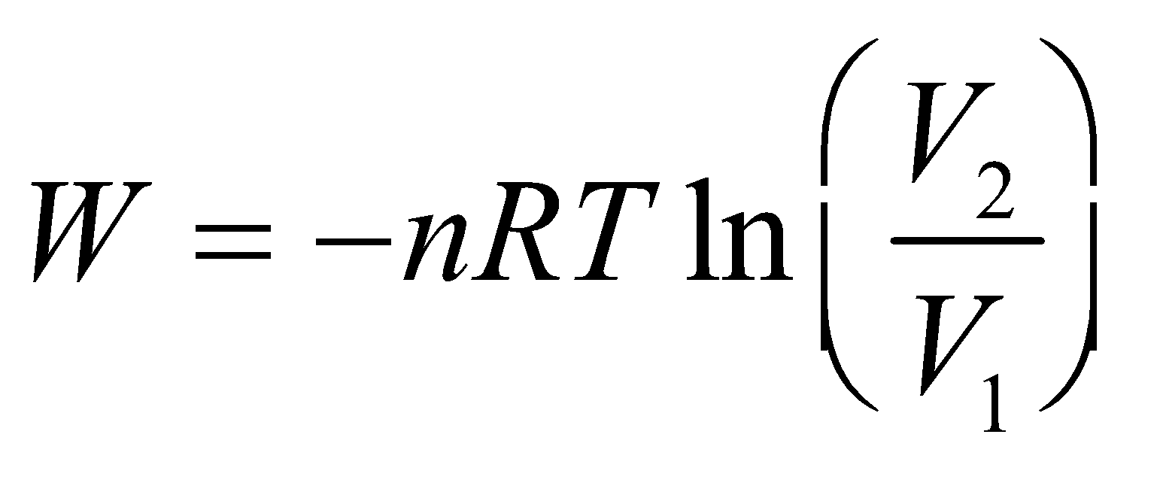

**Evaluate** **(a)** If *AB* is an isotherm, with 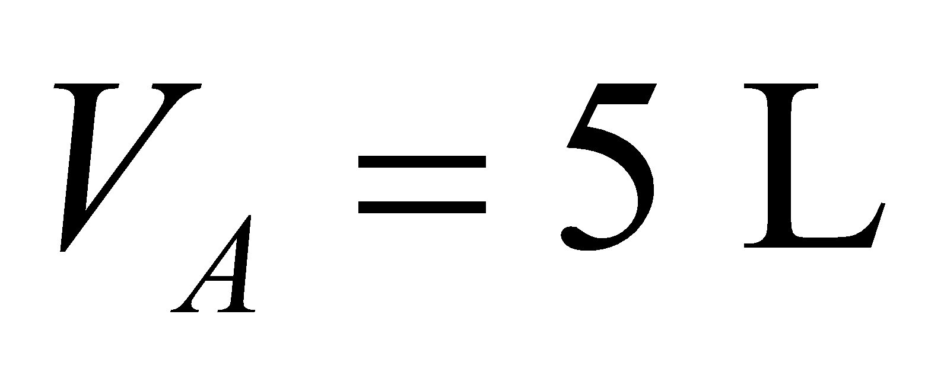 and 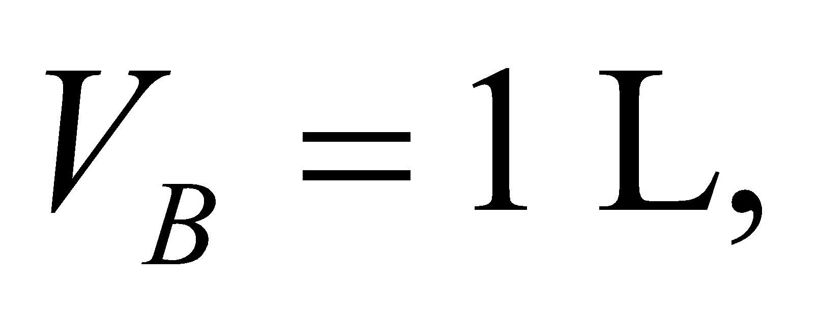 then the ideal-gas law gives

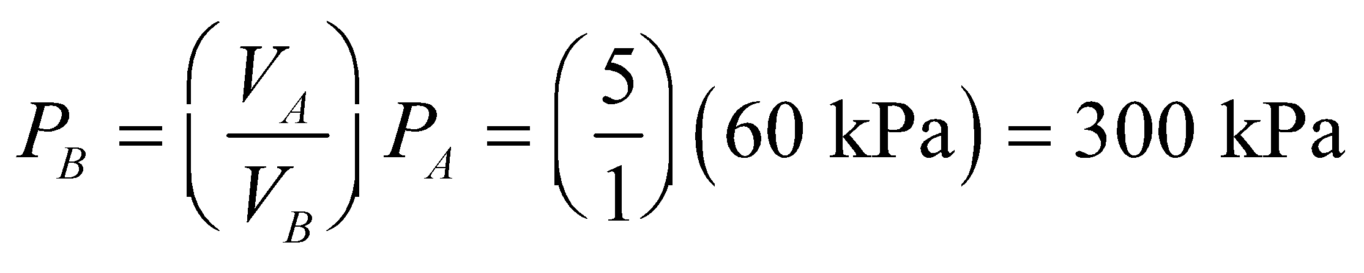

**(b)** The work *W* done *on* the gas in the isothermal process *AB* is

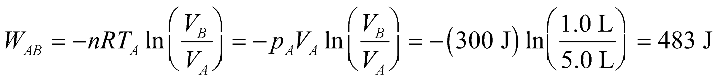

The process *BC* is isochoric (constant volume) so 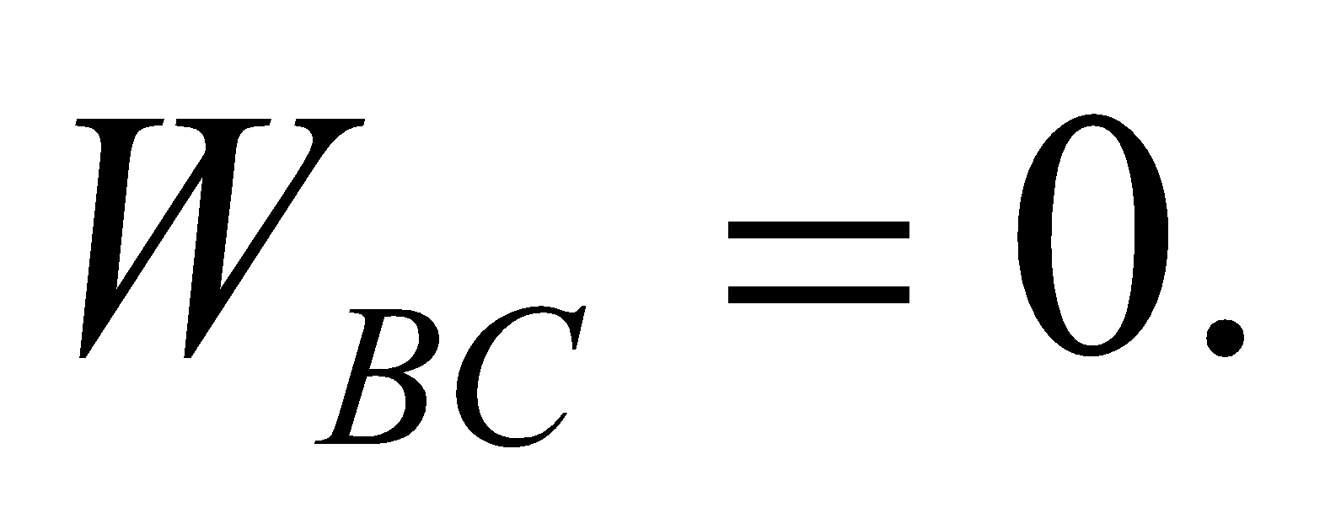 The process *CA* is isobaric (constant pressure) so the work done by the gas is (see Table 18.1)



or the work done *on* the gas is *W*CA = −240 J. The total work done by the gas is the sum of these three contributions, or



to two significant figures.

**Assess** Since the process is cyclic, the system returns to its original state, there’s no net change in internal energy, so 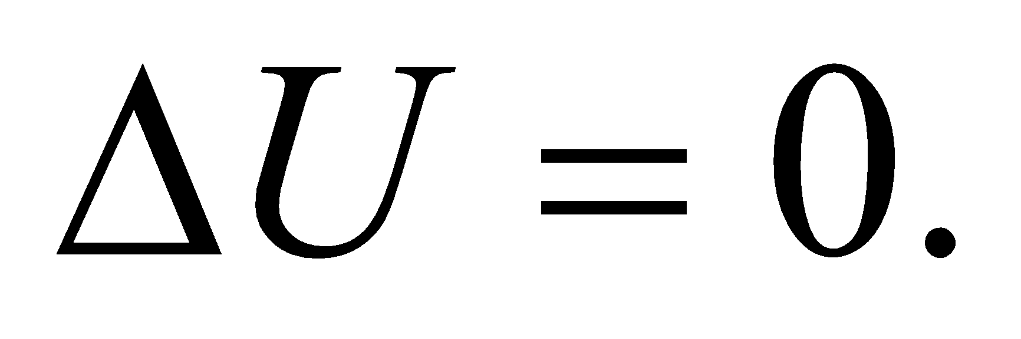 This implies that 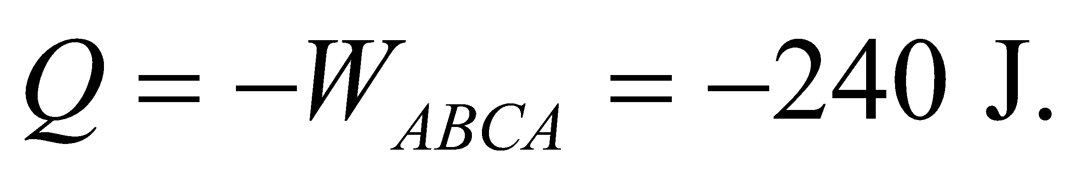 That is, 240 J of heat must come *out* of the system.

**38.** **Interpret** This problem is similar to the previous one, except that the isotherm curve AB is now to be considered as an adiabat. We are given the specific-heat ratio and are to find the pressure change in going from point A to point B, and the net work done by the cycle.

**Develop** For an adiabat, Equation 18.11a is valid. Applying this to points *A* and *B*, and taking the ratio, gives

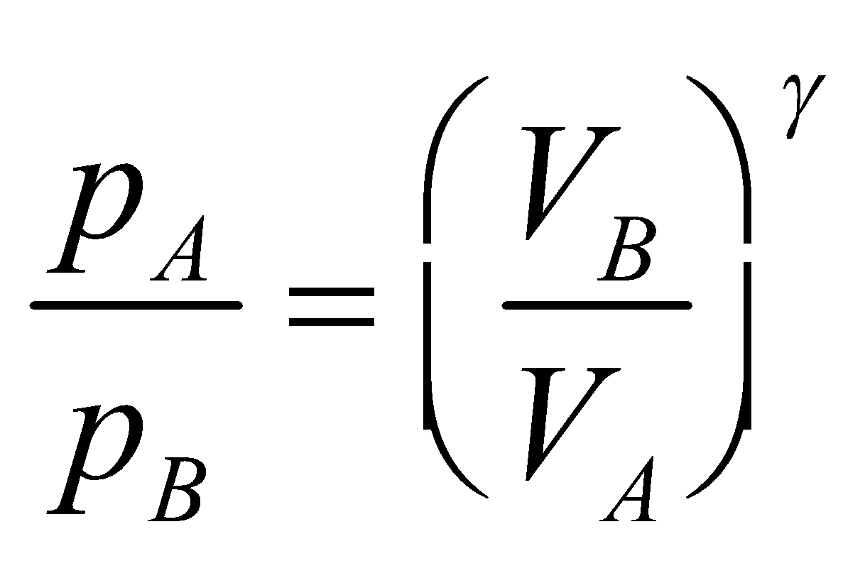

which allows us to find the pressure at point *B*. The calculation for part (b) then proceeds as for Problem 18.37, with the help of Equation 18.12, which gives the work done on the gas in an adiabatic process.

**Evaluate** (a) The pressure at point B is

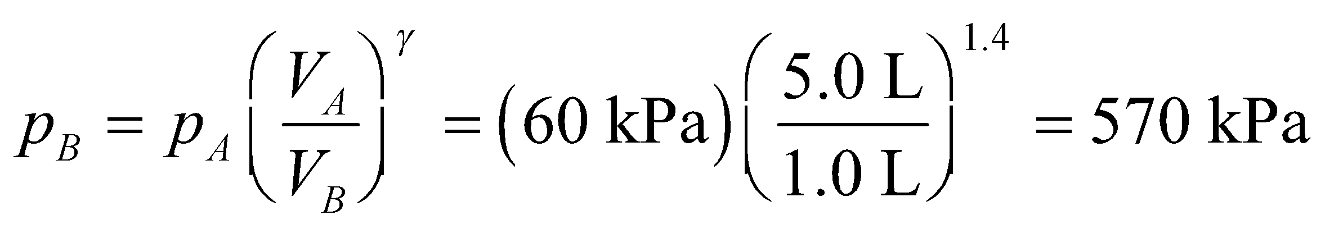

to two significant figures.

(b) The work done *on* the gas between points *A* and *B* is

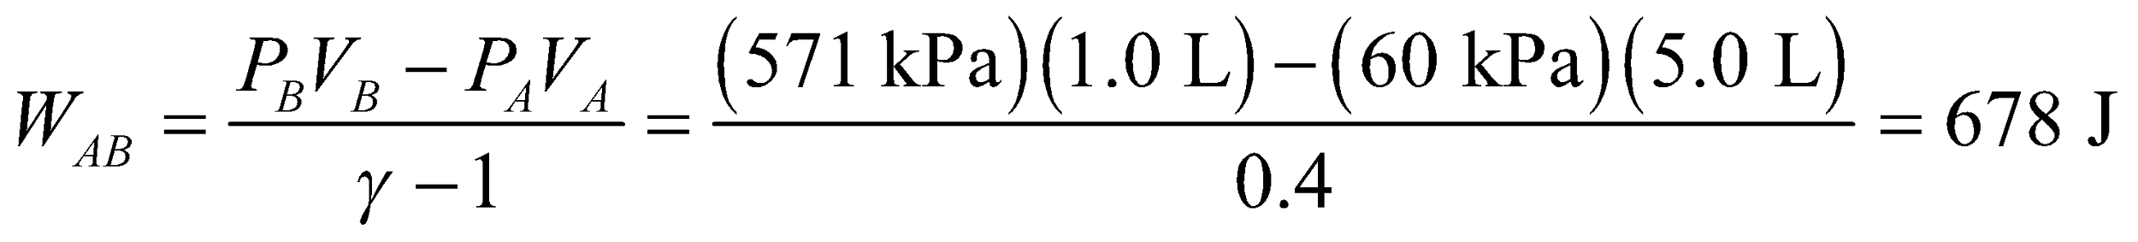

The process BC is isochoric (constant volume), so *W*BC = 0. The process CA is the same as for Problem 18.37, so WCA = −240 J. Summing all three contributions gives a net work done on the gas of



to two significant figures.

**Assess** Because the net work done on the gas is negative, the gas does work on its environment.

**39. Interpret** We identify the thermodynamic process here as adiabatic compression.

**Develop** In an adiabatic process, *Q* = 0, and the first law of thermodynamics becomes  The temperature and volume are related by Equation 18.11b:

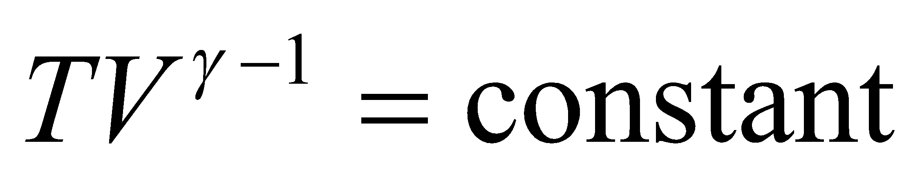

From the equation above, we obtain

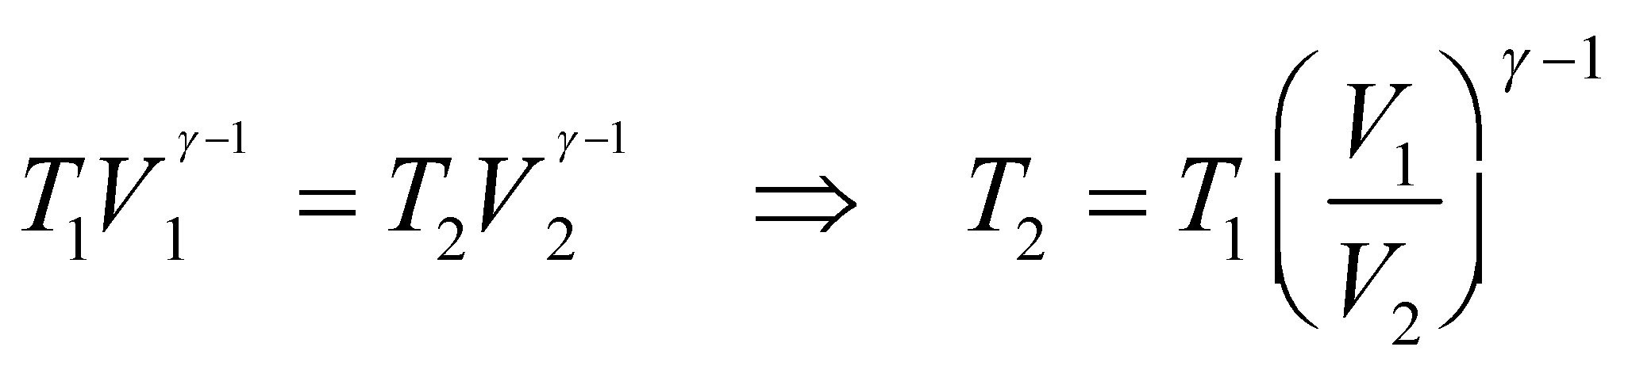

where 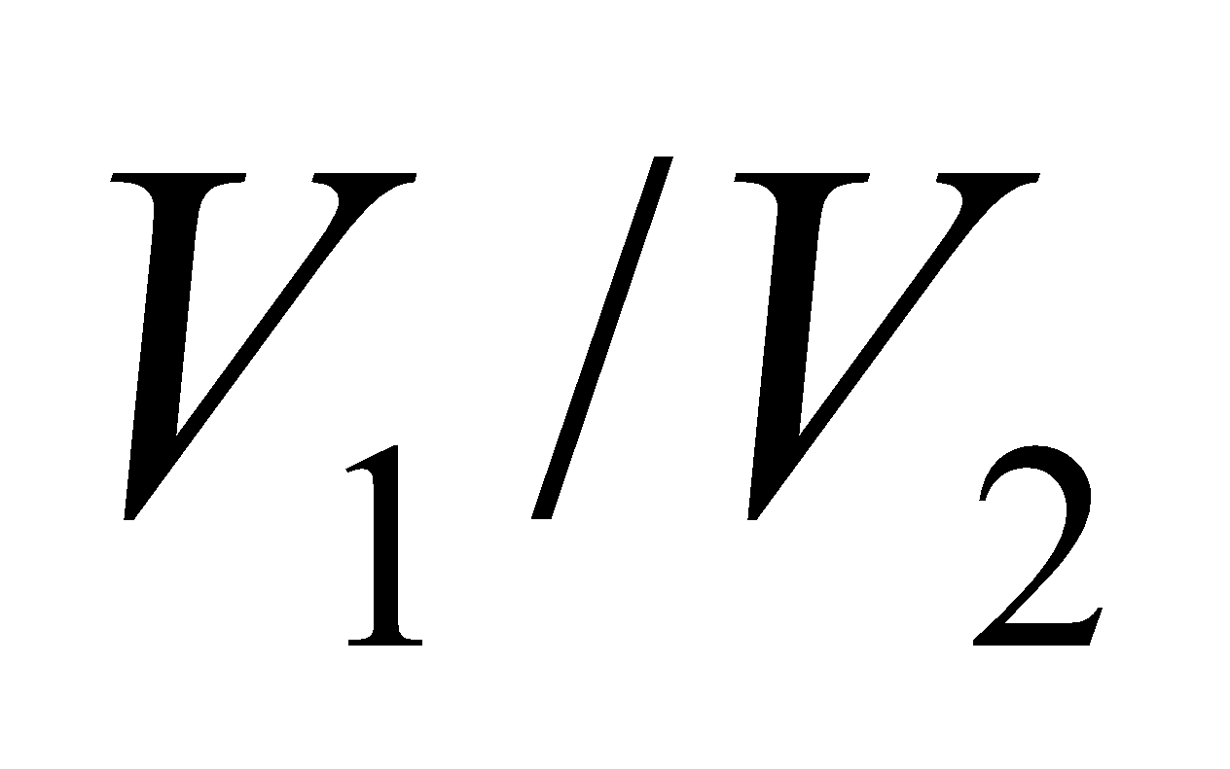 is the compression ratio (for *T* and *V* at maximum compression).

**Evaluate** Inserting the values given gives

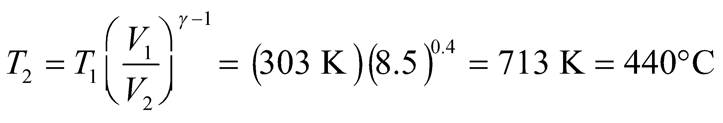

**Assess** Note that the temperature *T* appearing in the gas laws is the absolute temperature. The higher the compression ratio 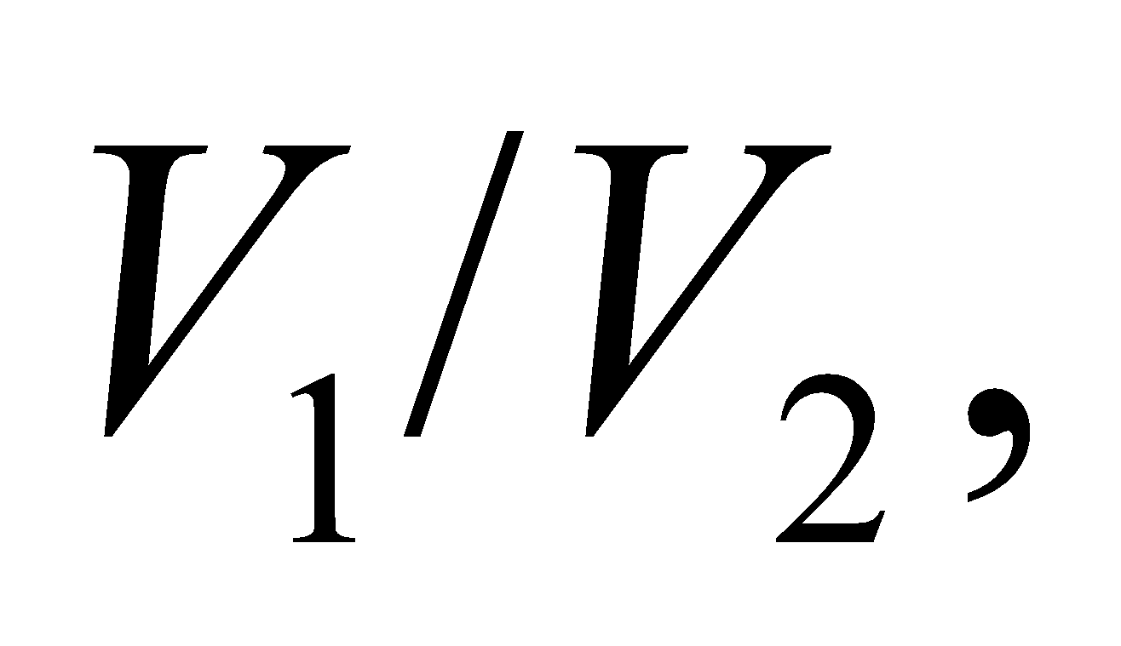 the greater the temperature at the maximum compression, and hence a higher thermal efficiency.

**40.** **Interpret** This problem involves an adiabatic process which results in a change of pressure and volume. We are to find the fractional change in volume given that the pressure increases by a factor of 2.

**Develop** Apply Equation 18.11a, *pVγ* = constant. Using subscripts 1 and 2 to indicate before and after the process, respectively, this gives

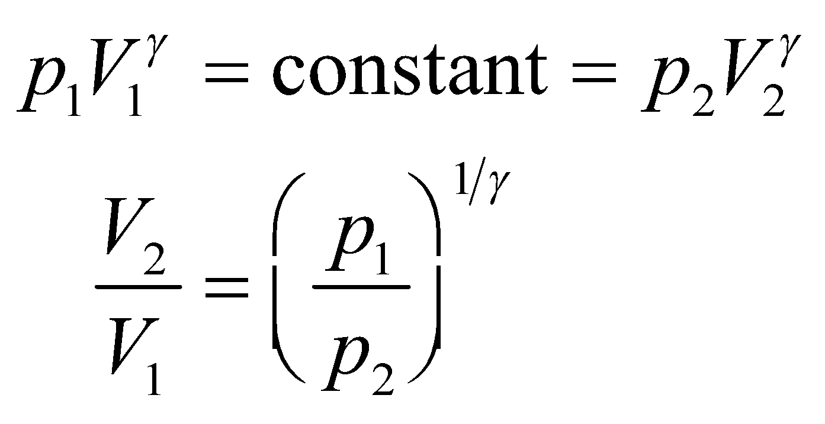

which we can solve for the fractional change in volume, using *γ* = 1.4 and *p*2 = 2*p*1.

**Evaluate** Inserting the given quantities into the expression above gives

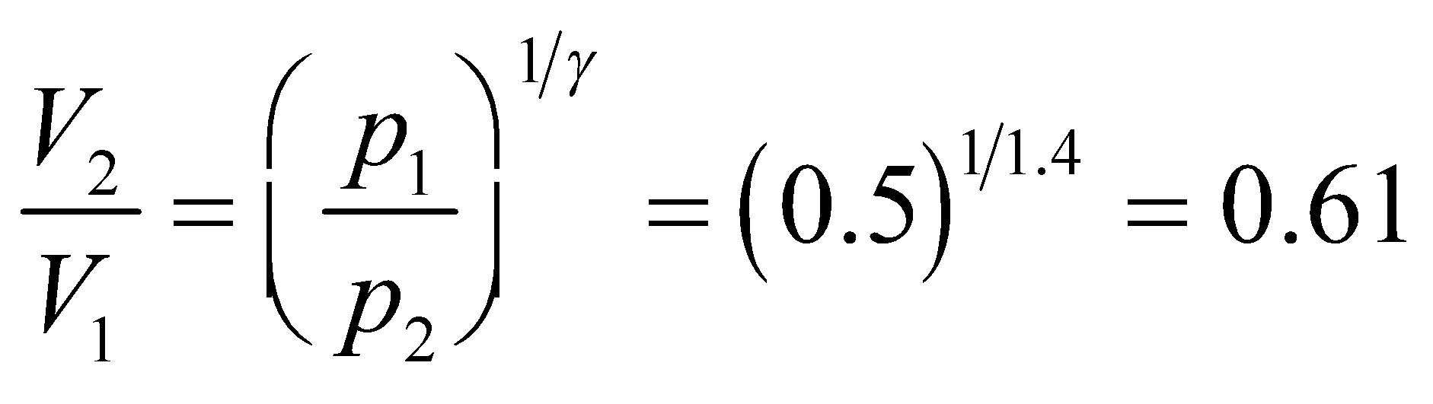

**Assess** Thus, the new volume is almost 50% of the original volume, which seems reasonable given that the pressure has doubled.

**41. Interpret** We identify the thermodynamic process here as adiabatic compression. We are to find the temperature and pressure in the cylinder when it is at maximum compression.

**Develop** In an adiabatic process, *Q* = 0, and the first law of thermodynamics becomes  Because we are dealing with an adiabatic process, the temperature and volume are related by Equation 18.11b:



Applying this expression before (subscript 1) and after (subscript 2) compression gives

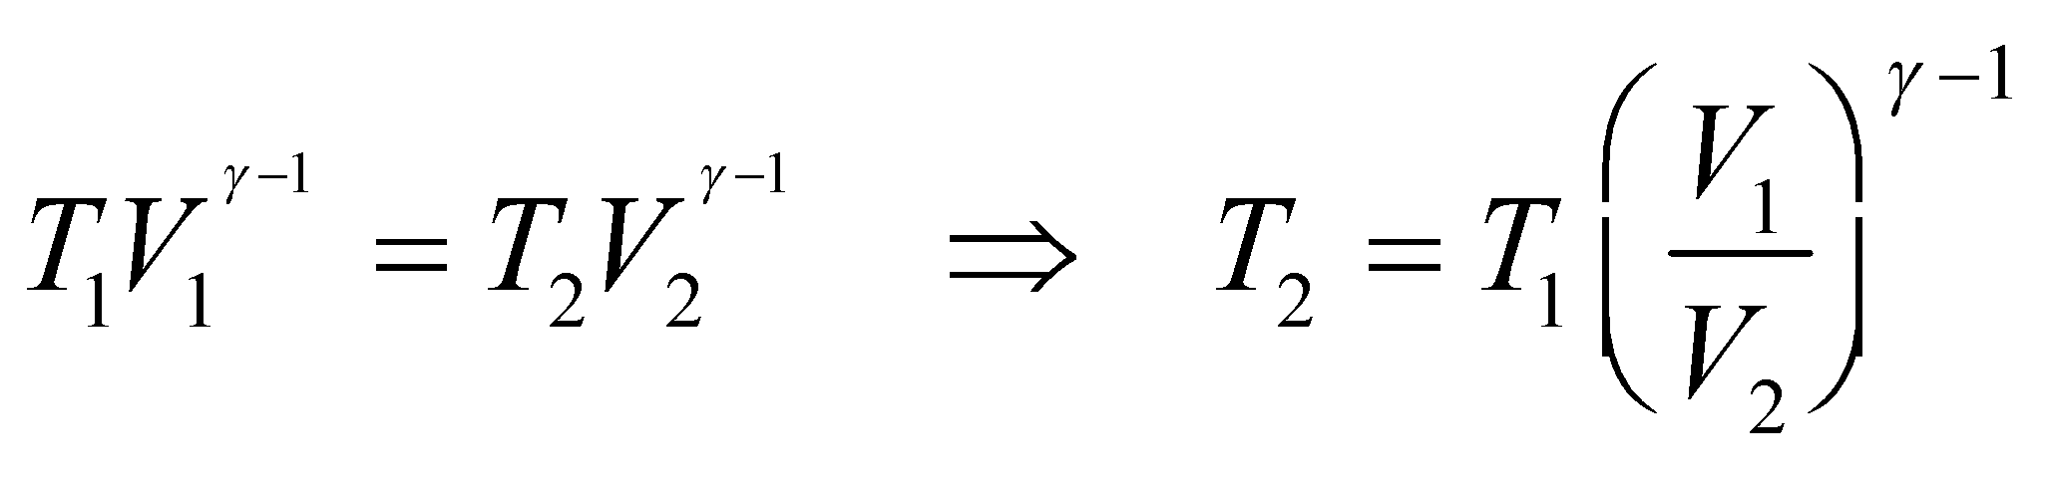

where 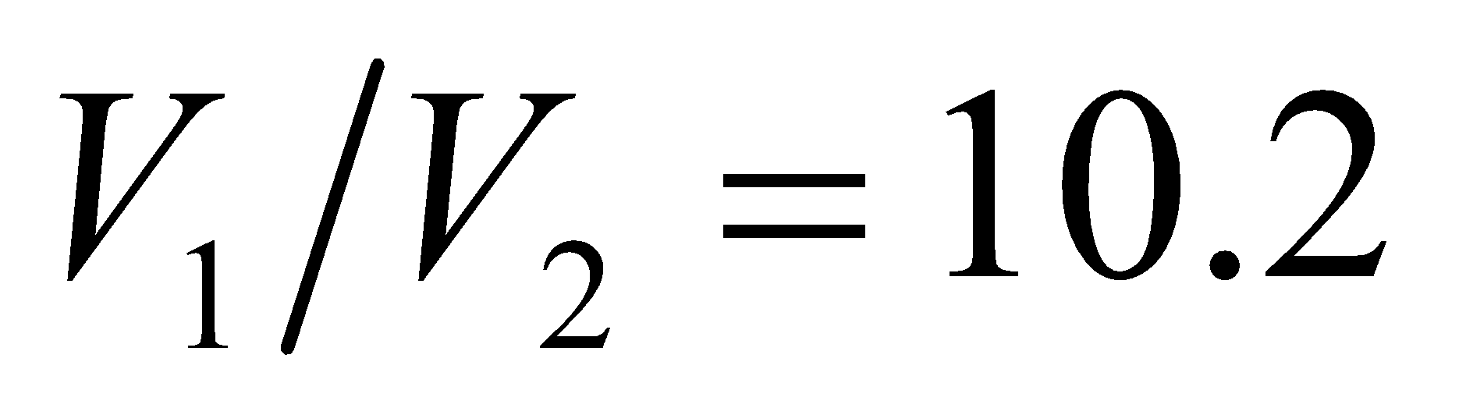 is the compression ratio (for *T* and *V* at maximum compression) and *γ* = 1.4. In addition, since 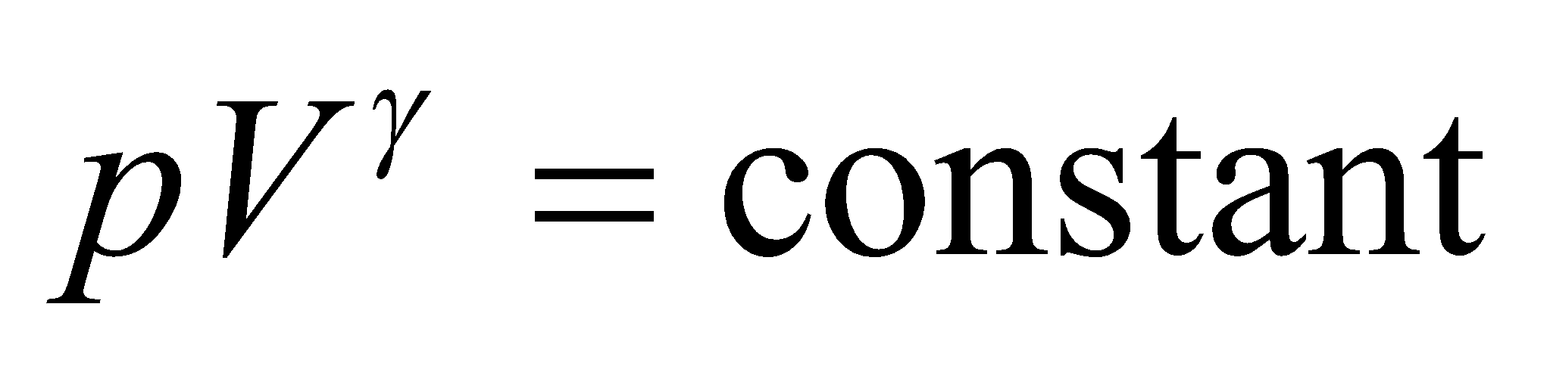 (Equation 18.11a), the final pressure is 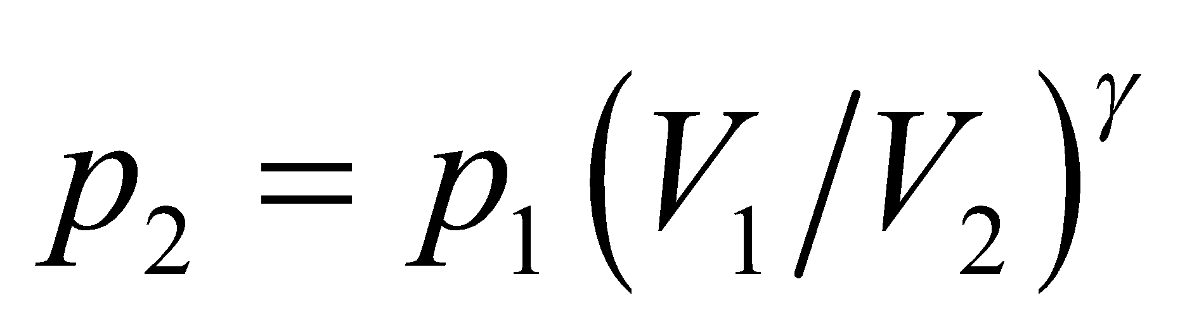.

**Evaluate** **(a)** Substituting the values given in the problem statement, we find the air temperature at the maximum compression to be

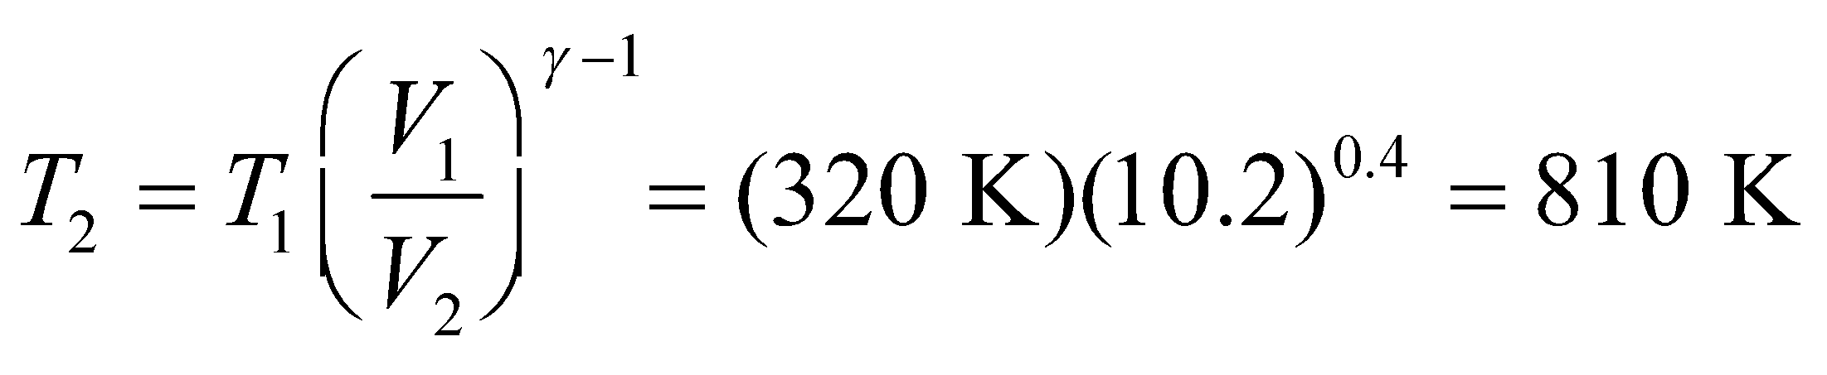

**(b)** The corresponding pressure is



**Assess** The higher the compression ratio 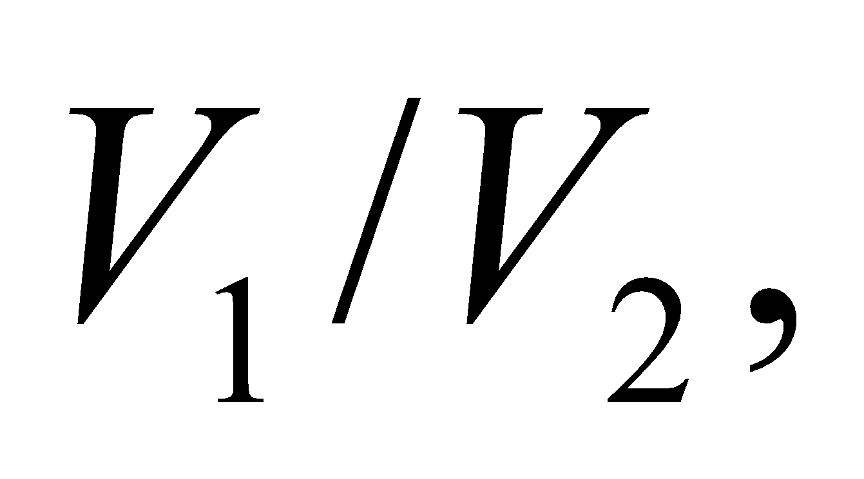 the greater the temperature and pressure at the maximum compression, and hence, a higher thermal (fuel) efficiency.

**42.** **Interpret** This problem involves first an isothermal expansion, then an isobaric compression, then finally an isochoric process to return to the original state. We are to draw a *pV* diagram of this process, then calculate the work done over the entire cycle, then finally, find the heat transfer between the given stages.

**Develop** The isothermal expansion is along the curve AB in the figure below, which is given by *PV* = constant. Because the gas expands, it starts at the lower volume *V*A at point A, and expands to occupy the greater volume *V*B at point B. For the isobaric compression, the gas follows the horizontal line BC, with the pressure remaining constant at *P*B = *P*C. Finally, for the isochoric process, the gas follows the vertical line CA, with the volume remaining constant at *V*C = *V*A. To find the total work done on or by the gas during this cycle, sum the work done over each interval,



where we consider work done on the system to be positive. For the isotherm (process AB), *ΔU* = 0 and the heat transferred to the system is *Q*AB = 35 J. From the first law of thermodynamics (Equation 18.1), this gives *W*AB = −*Q*AB = −35 J. For process BC, the work done on the gas is *W*BC = 22 J, and *W*CA = 0 because the volume of the gas does not change (see Equation 18.7). To find the heat that enters or leaves the system during the stages BCA, recall that the change in internal energy is zero for the whole cycle, so

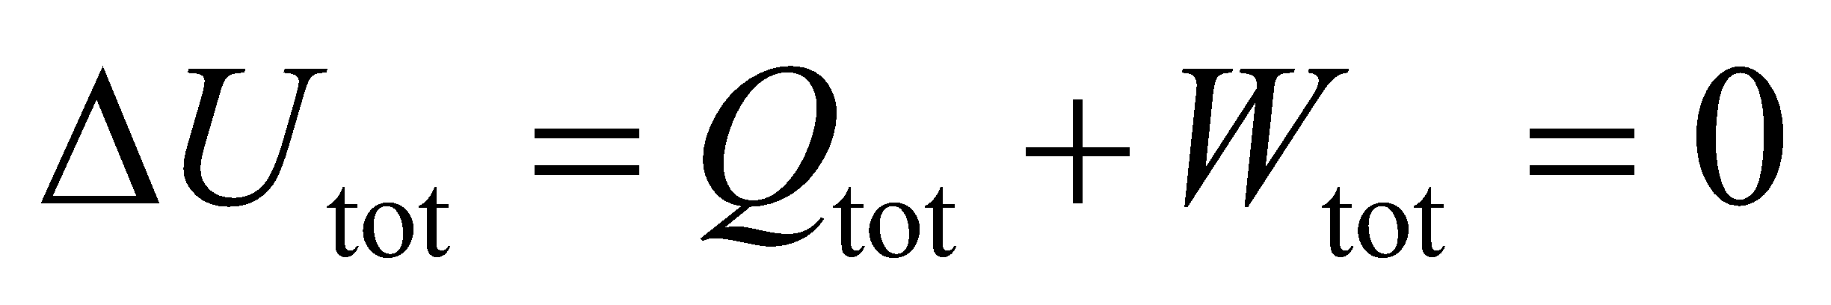

and that the total heat is composed of two parts:



so we can solve for *Q*BCA.



**Evaluate** (a) See figure above.

(b) Summing the various contributions to the work gives



so the gas does 13 J of work on its environment.

(c) The heat transferred to the system is

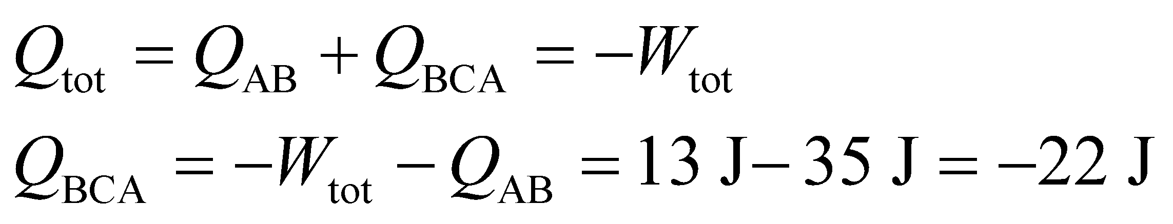

so 22 J of heat is transferred out of the gas during the process BCA.

**Assess** The total heat transferred *to* the system over the cycle is *Q*tot = 35 J − 22 J = 13 J, which provides the energy for the 13 J of work done *by* the system over this same cycle.

**43. Interpret** This problem explores how different ways of adding heat (isothermal, isochoric, or isobaric) affects the final temperature of the system. Starting with the given quantity of gas at the given temperature, we are to find the work done by the gas upon adding heat to the gas via these different processes.

**Develop** In an isothermal process, the temperature *T* is kept constant, so . The first law of thermodynamics (Equation 18.1) therefore gives *Q* = −*W*. In an isochoric process, *ΔV* = 0 and *W* = 0 (see Equation 18.7), so the first law of thermodynamics gives 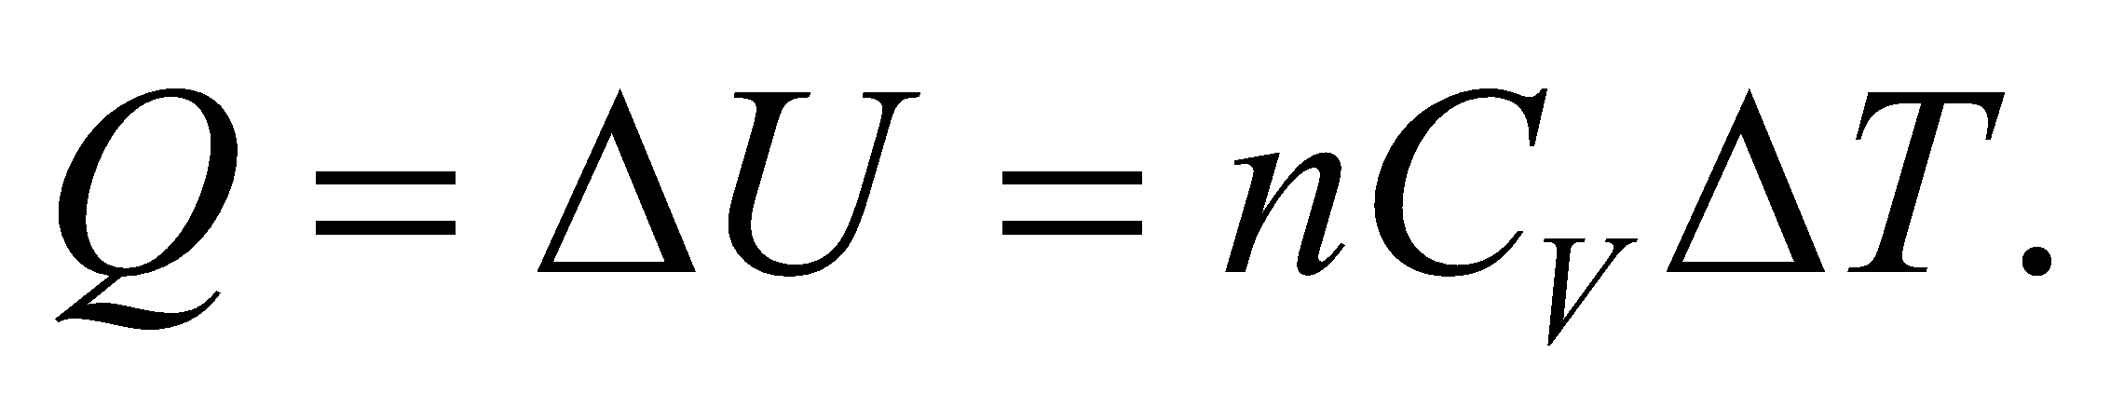 Finally, in an isobaric process, *Δp* = 0 and

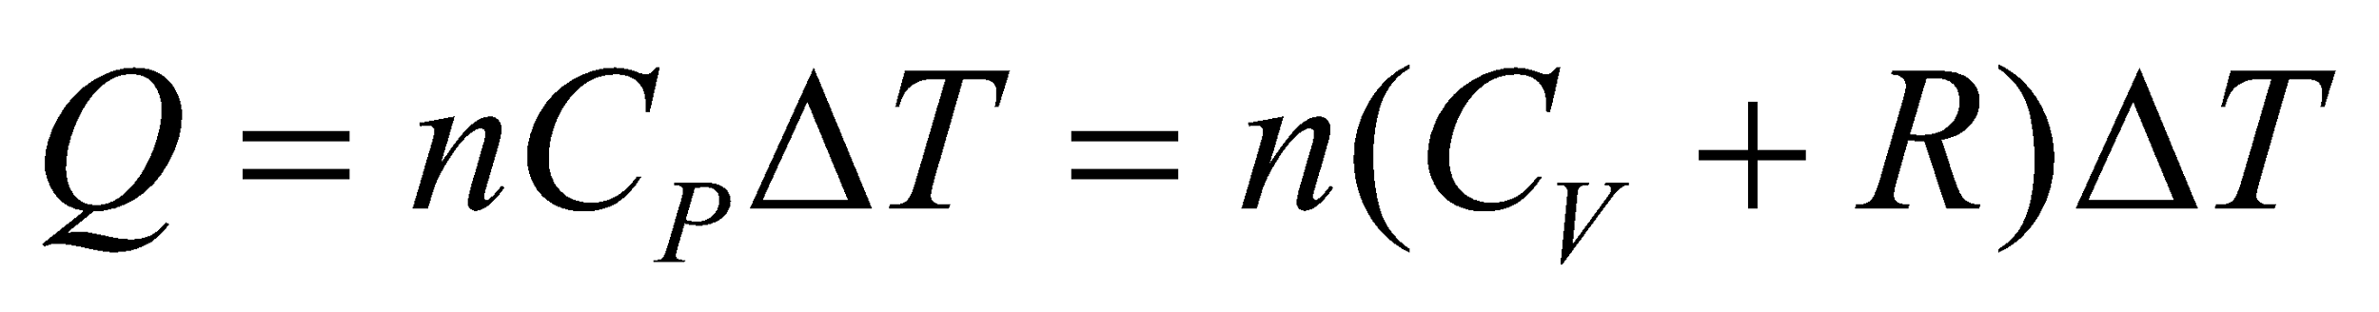

Use these expressions to solve for *ΔT* and *W* for each case.

**Evaluate** **(a)** With *ΔU* = 0, *W* = −*Q* = −1.5 kJ. For an isothermal process, the temperature is constant so *T*2 = 300 K.

**(b)** Solving the expression above for *ΔT*, we find for an isochoric process

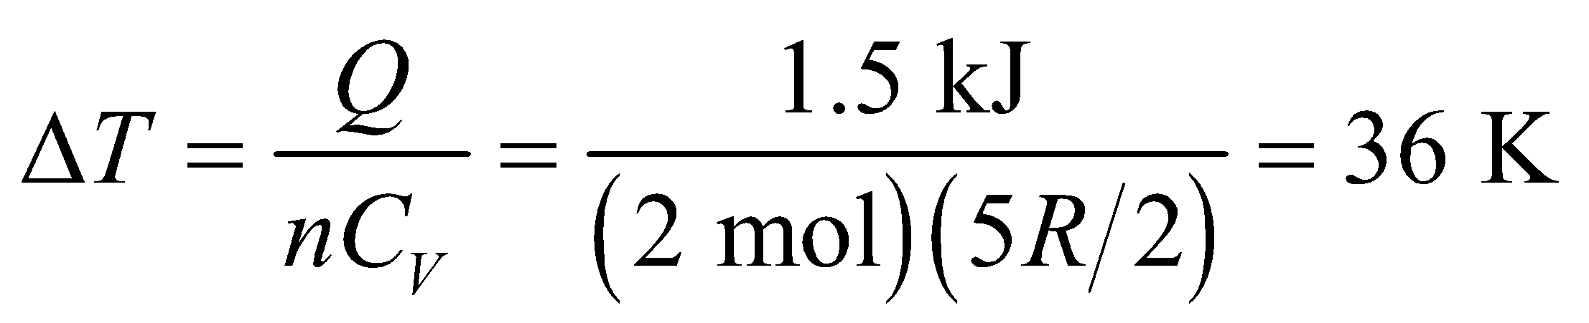

Therefore,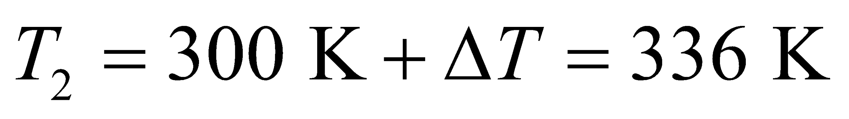. Because the volume does not change, *W* = 0.

**(c)** In an isobaric process,

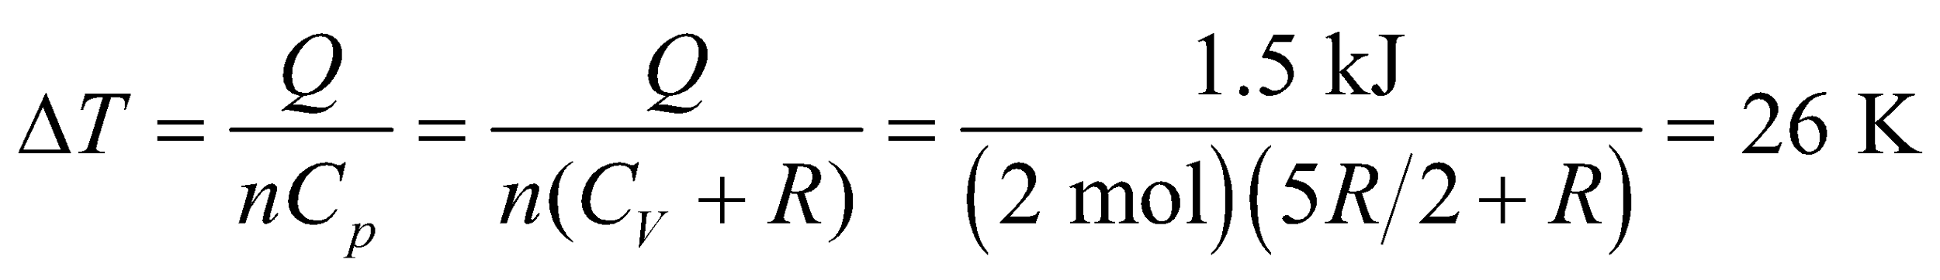

and *T*2 = 326 K. The work done is

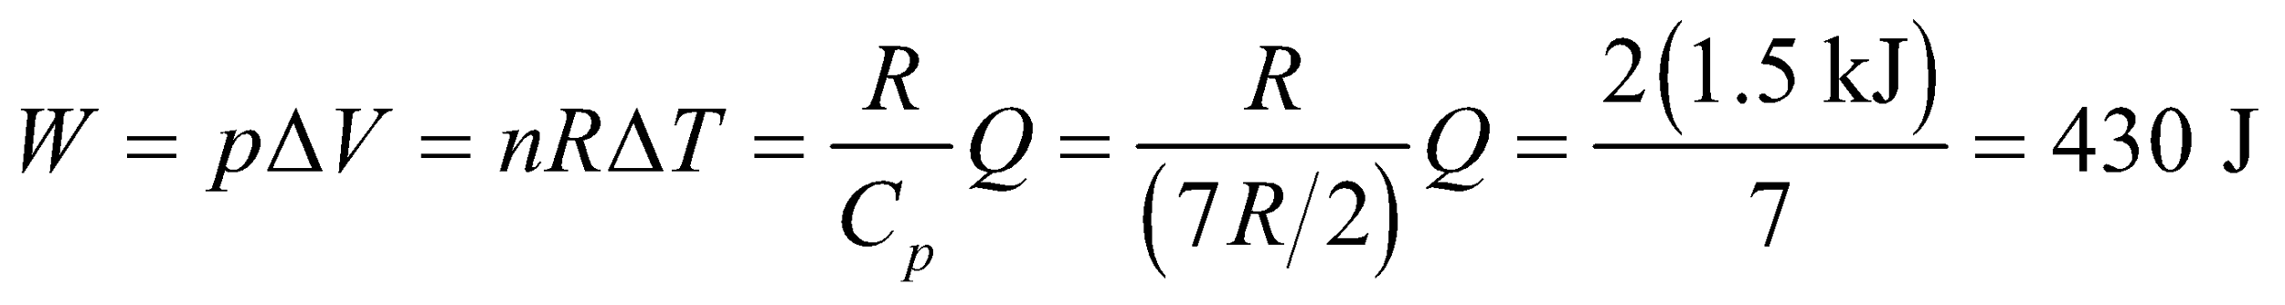

**Assess** Comparing all three cases, we find

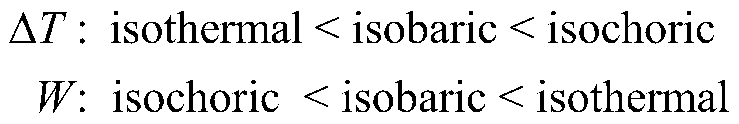

The results agree with that illustrated in Table 18.1.

**44.** **Interpret** This problem is an exercise to show the functional relationship in terms of pressure and volume between an adiabatic process and an isothermal process.

**Develop** The equations of an adiabat and an isotherm, passing through the point 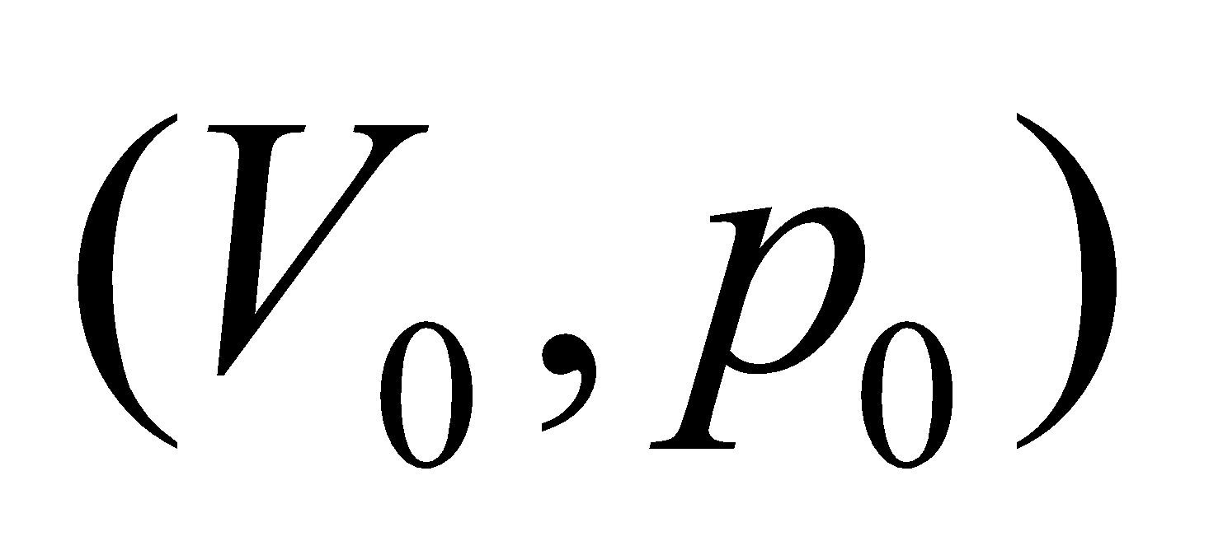 in the *pV* diagram are 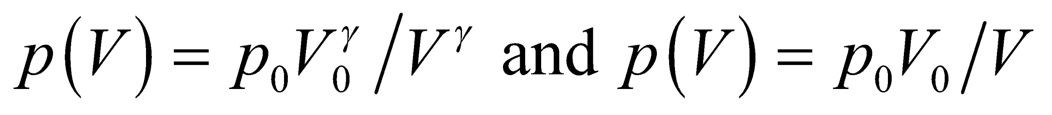

respectively. Differentiate these expressions and evaluate the results at (*V*0, *p*0) to find the desired relationship.

**Evaluate** Differentiating the above expression for an adiabat and evaluating the result at *V* = *V*0 and *p* = *p*0 gives

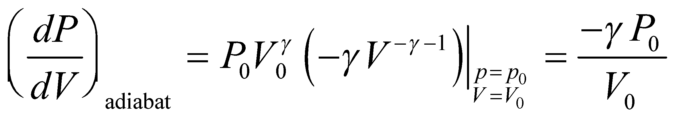

Differentiating the expression above for an isotherm and evaluating the result at *V* = *V*0 gives

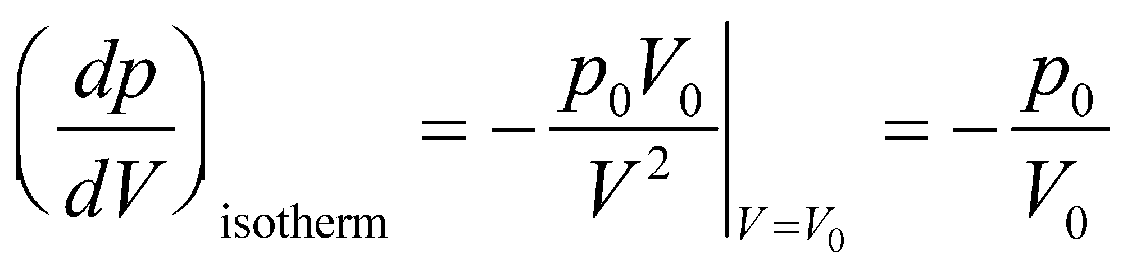

Comparing the two results gives

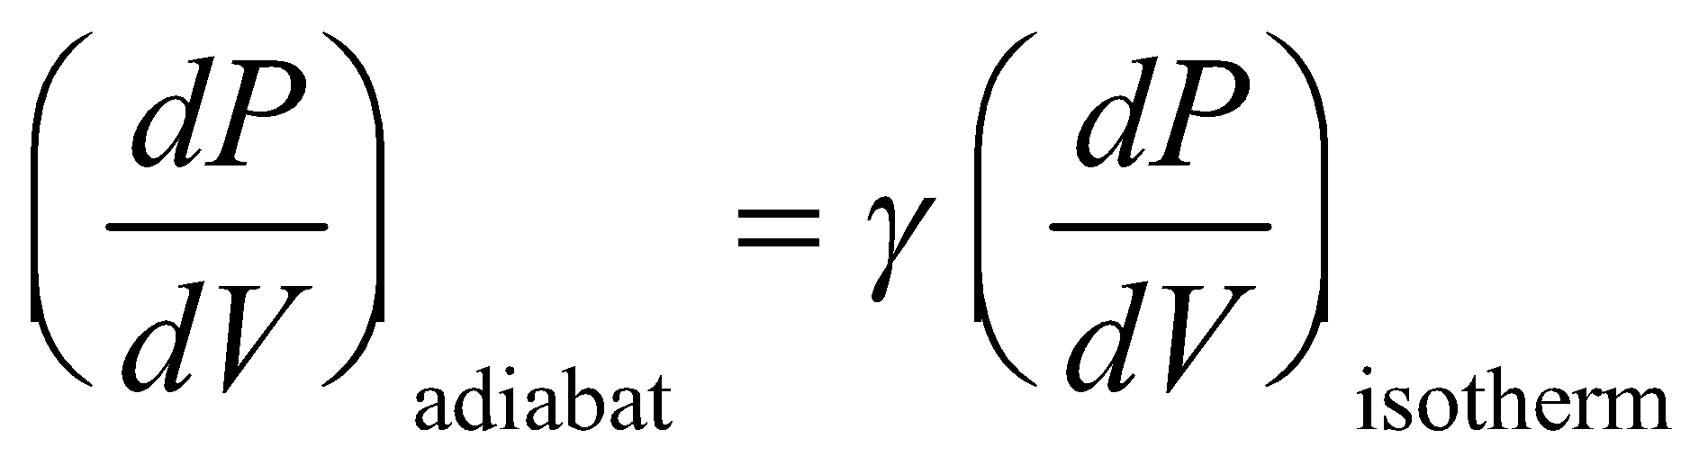

**Assess** We have found the expression given in the problem statement. Because *γ* > 0, we see that the slope of the *pV* curve for an adiabat is greater than that for an isotherm, so the pressure of an adiabatic process changes more rapidly with volume compared with an isothermal process, as shown in Fig. 18.11.

**45. Interpret** The problem involves a cyclic process with three separate stages: adiabatic, isochoric, and isothermal. We are given the initial volume and pressure of the gas, and its adiabatic exponent *γ*, and are to find the pressure at points B and C and the net work done on the gas.

**Develop** For the adiabatic process AB, *Q* = 0 and the first law of thermodynamics becomes  The pressure and volume are related by Equation 18.11a: , which gives

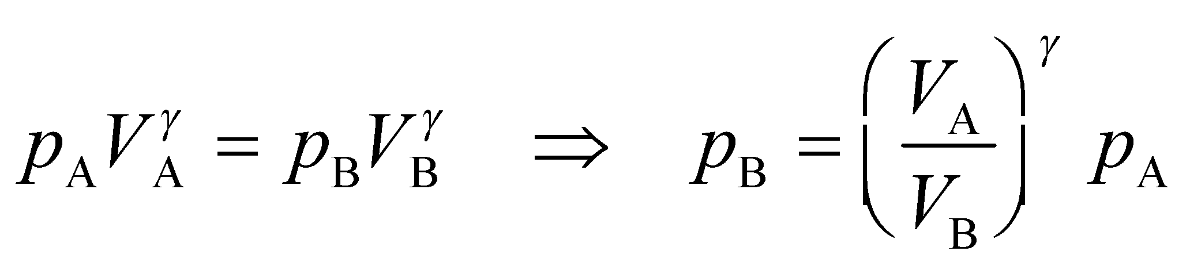

Point C lies on an isotherm (constant temperature) with A, so the ideal-gas law (Equation 17.2) yields

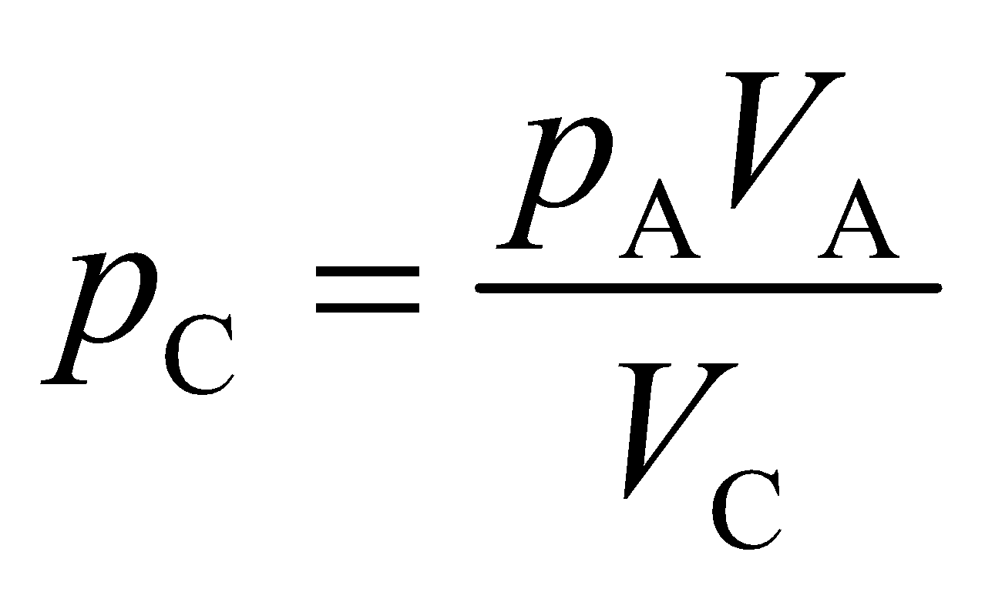

To find the net work done on the gas, sum the contributions from each stage of the cycle. The contribution *W*AB may be found from Equation 18.12 for an adiabatic process:

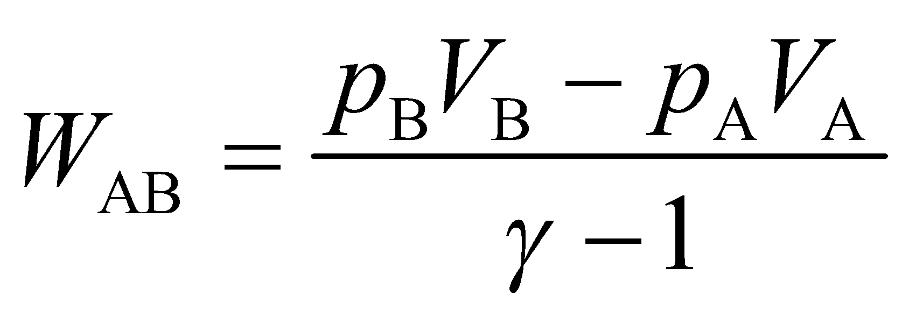

For an isochoric (constant volume) process *W*BC = 0 (see Equation 18.7), and for the isothermal process

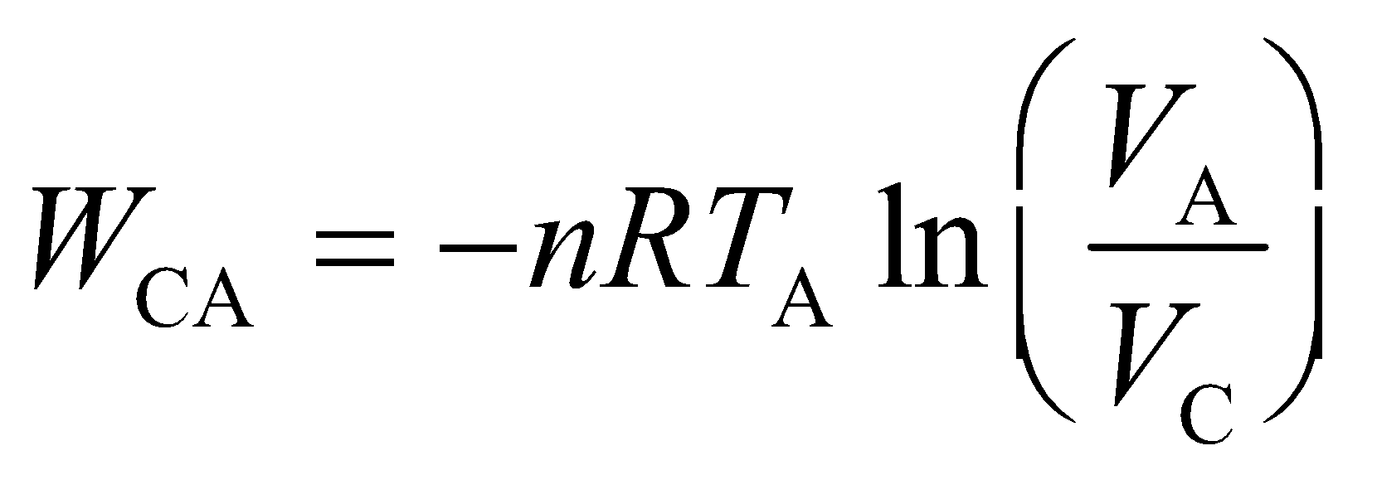

**Evaluate** **(a)** From the equation above, the pressure at point B is

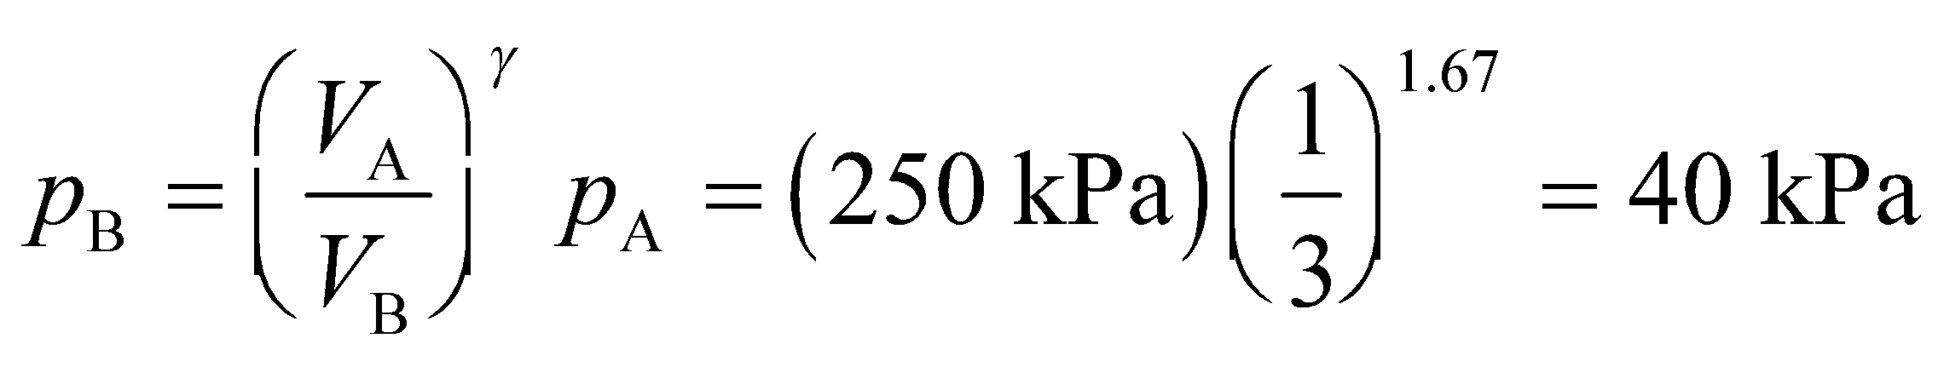

**(b)** The pressure at point C is

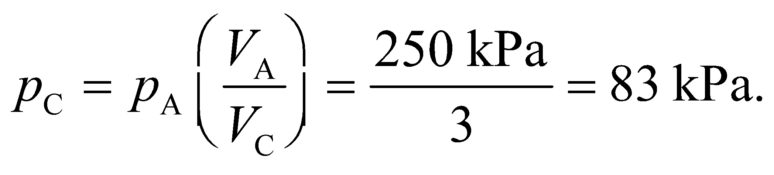

**(c)** The net work done *by* the gas is 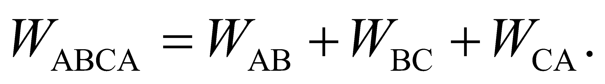 The work  for the adiabatic segment is

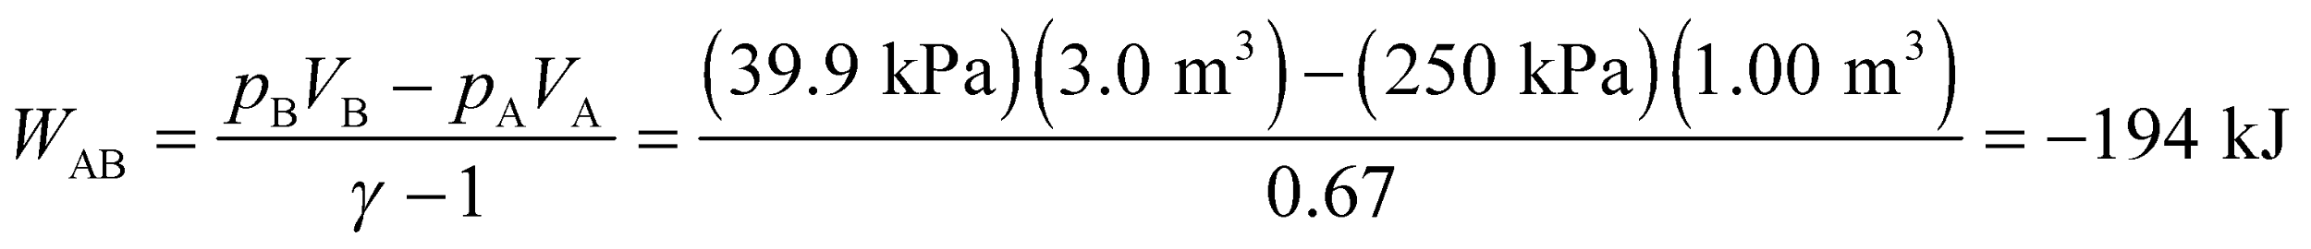

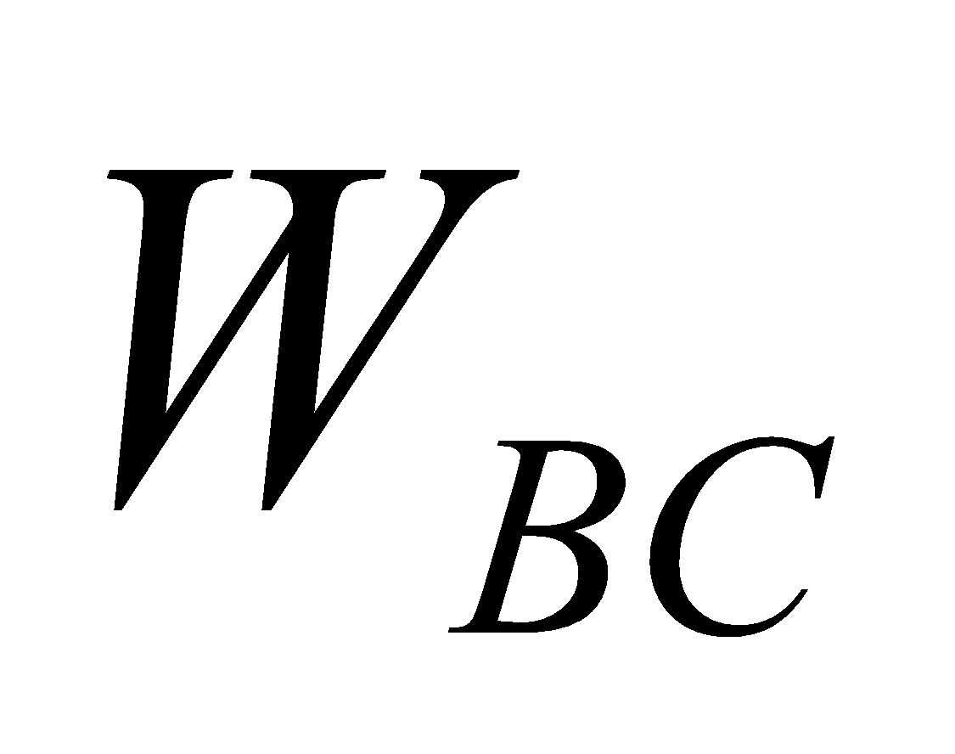is for an isochoric process and equals zero. Finally,is for an isothermal process and is

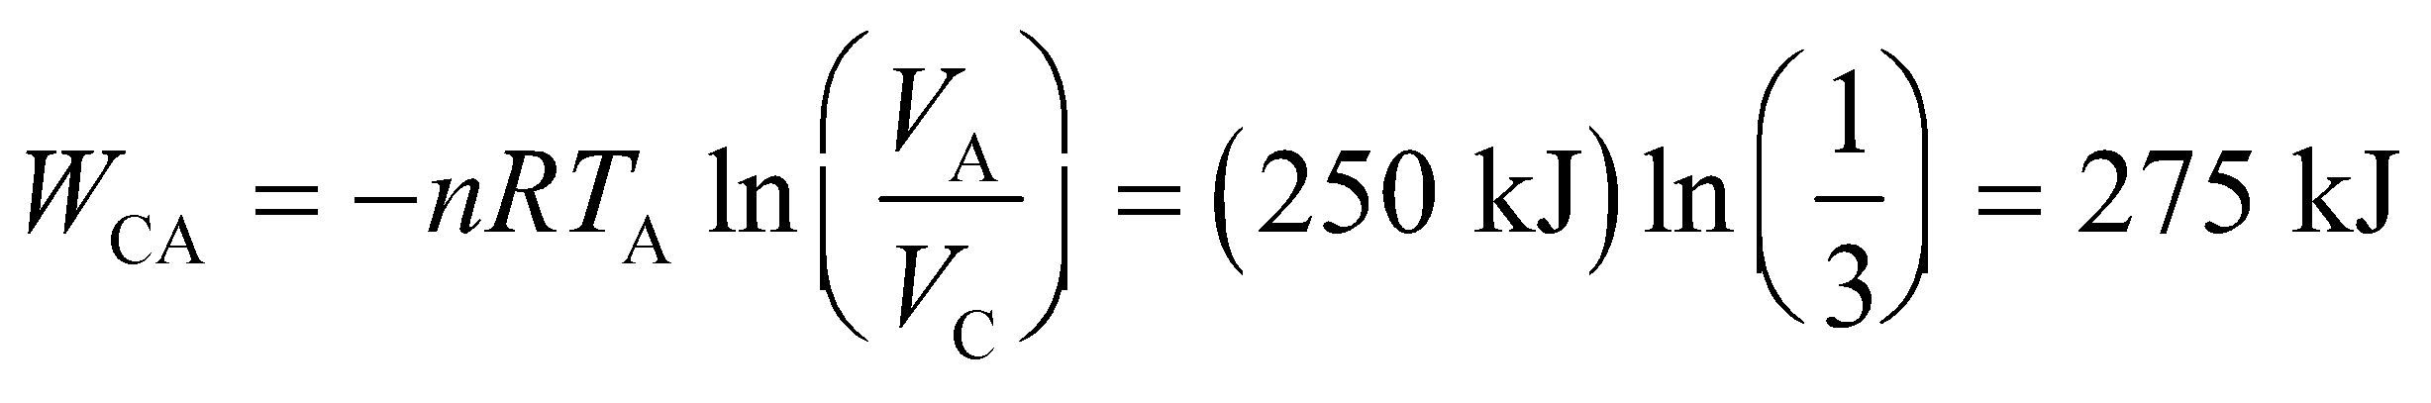

Summing these contributions gives



so the work done *on* the gas 80 kJ.

**Assess** Since the process is cyclic, the system returns to its original state, there’s no net change in internal energy, so *ΔU* = 0. This implies that 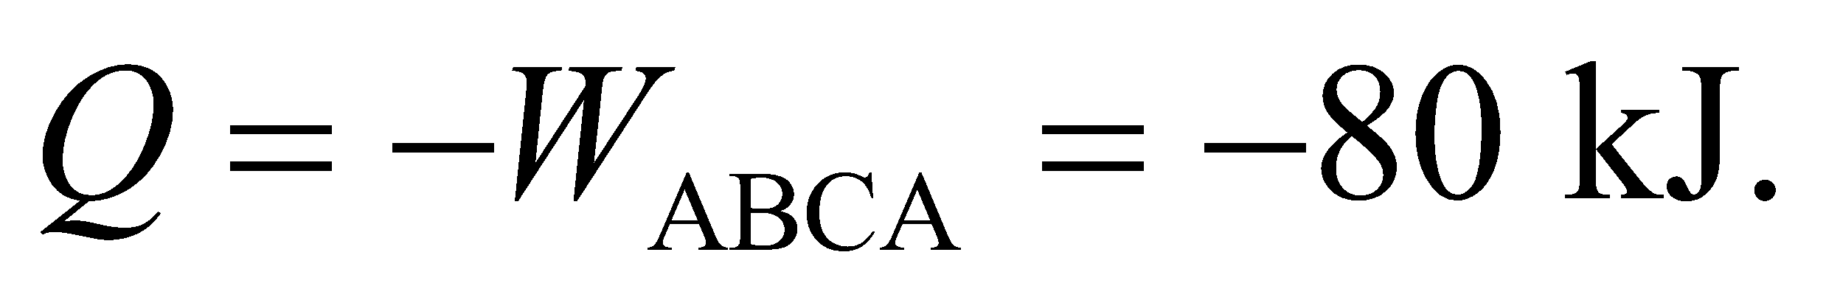 That is, 80 kJ of heat must come *out* of the system.

**46.** **Interpret** This problem involves a cyclic process with an adiabatic compression, an isobaric compression, and an isothermal expansion. We are to find the net work done on the gas and its minimum volume.

**Develop** The *pV* diagram for this problem is different than that of Figure 18.14; only point A is the same (see figure below). Note that *p*A*V*A = 400 J and *V*A = 2*V*B. To find the net work done on the gas, sum up the contributions from each stage. For the adiabatic stage AB, the work done on the gas is given by Equation 18.12:



For the isobaric process BC, the work done on the gas is given by Equation 18.7:

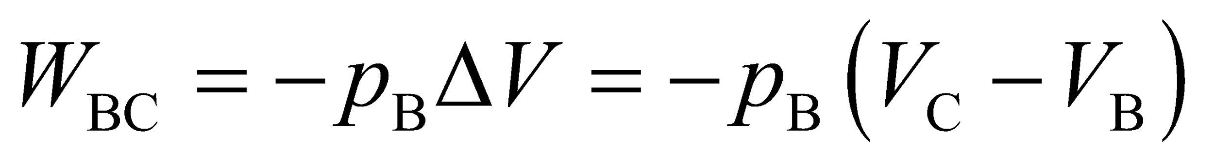

Via the adiabatic process, we can find the product *p*B*V*B (using Equation 18.11), which gives

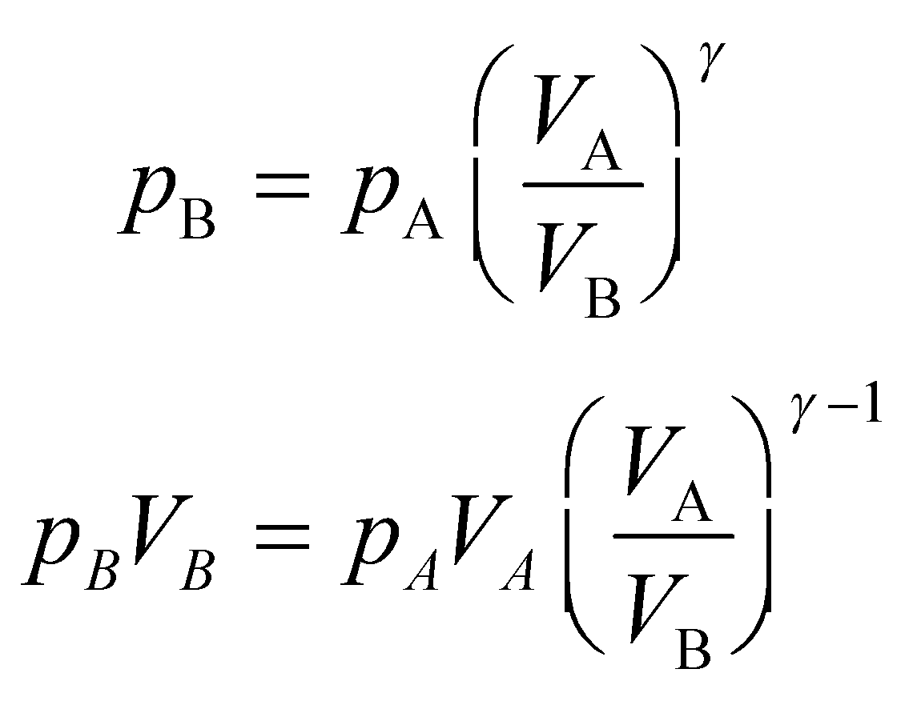

Via the isothermal process CA, we know that C is at the same temperature as A. We also know that *p*C = *p*B because BC is isobaric. Thus, from the ideal-gas law (Equation 17.2), we have

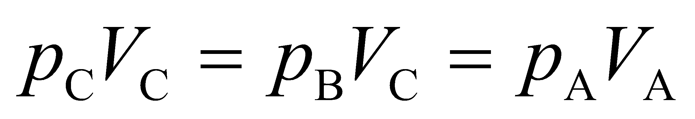

Therefore, the work *W*BC is

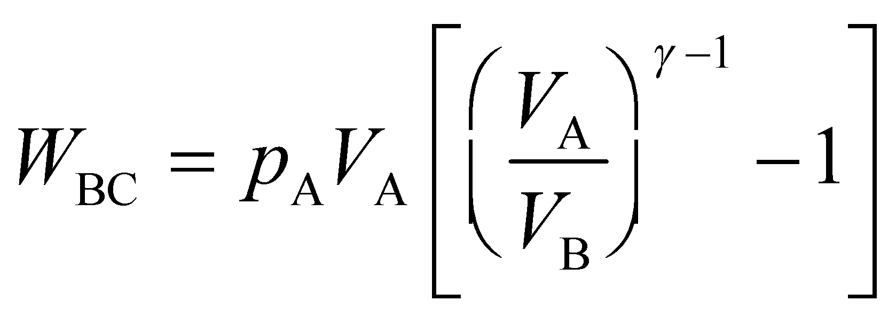

The work done on the gas for the isothermal process CA is given by Equation 18.4, which gives (using the ideal-gas law *pV* = *nRT*)

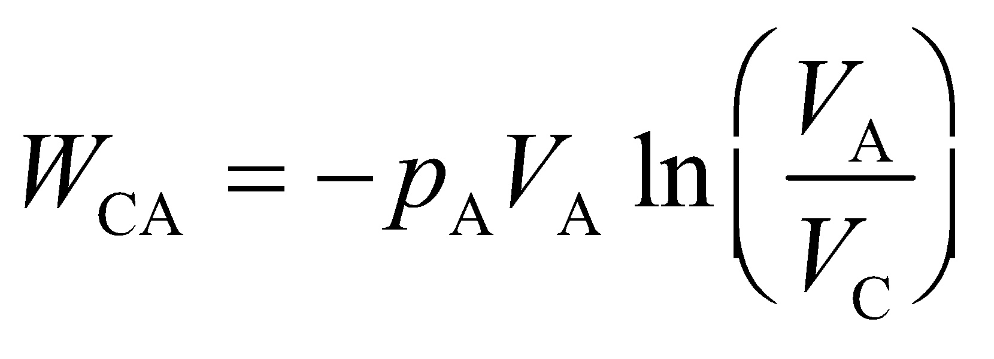

The minimum volume of the gas occurs at point C, and is given by

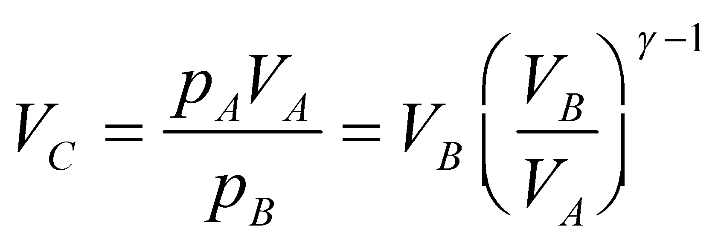



**Evaluate** (a) Summing the work done on the gas for each process gives

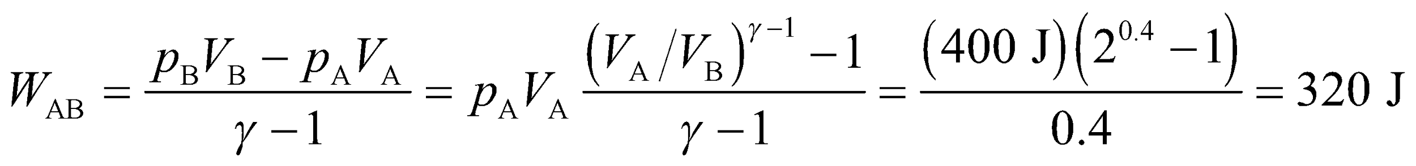

where we have used the expression above relating *p*B*V*B to *p*A*V*A from the adiabatic process. Continuing, we have for process BC

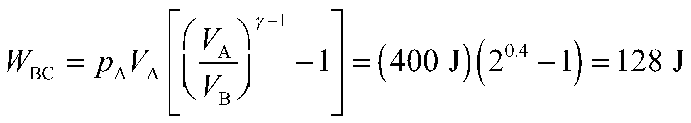

and for process CA we have

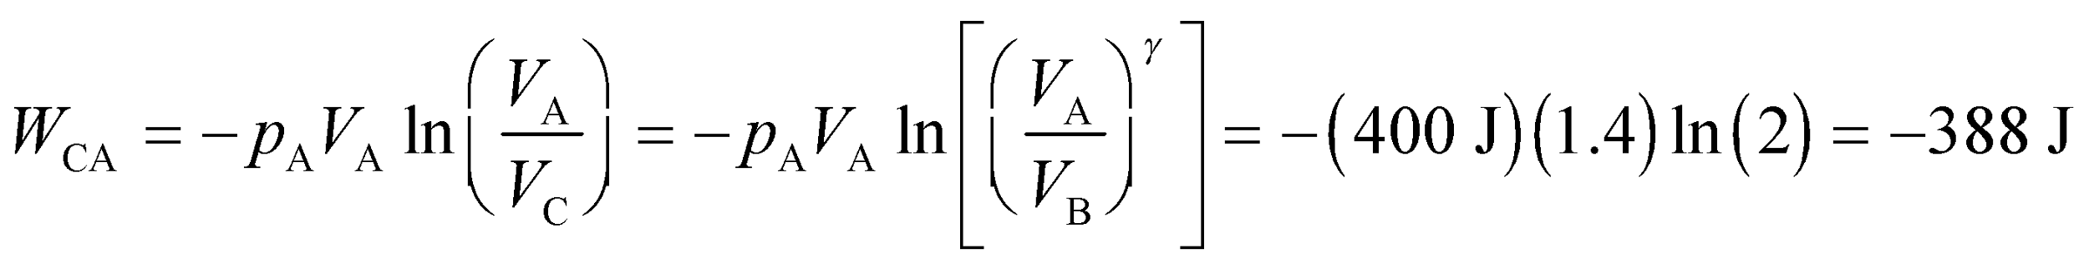

Summing these, the total work done on the gas is 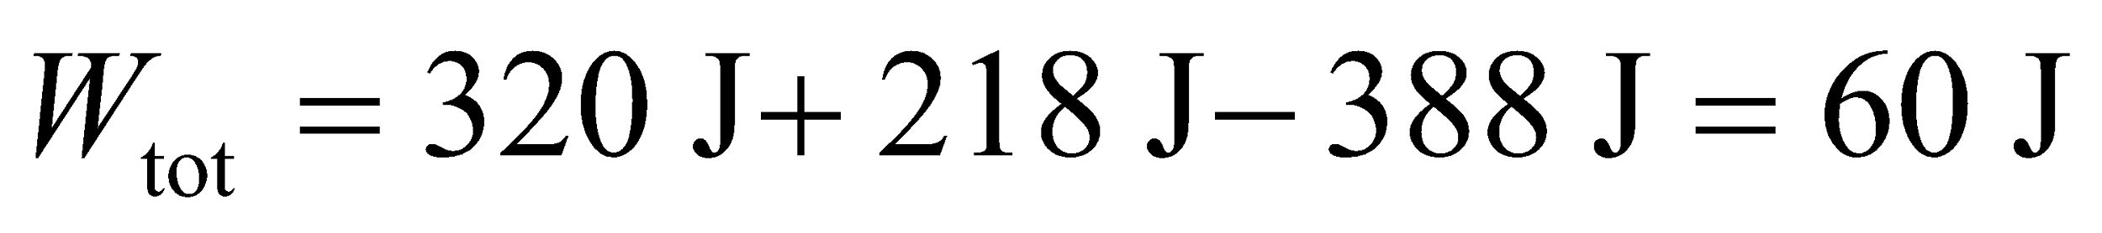.

(b) The minimum volume is

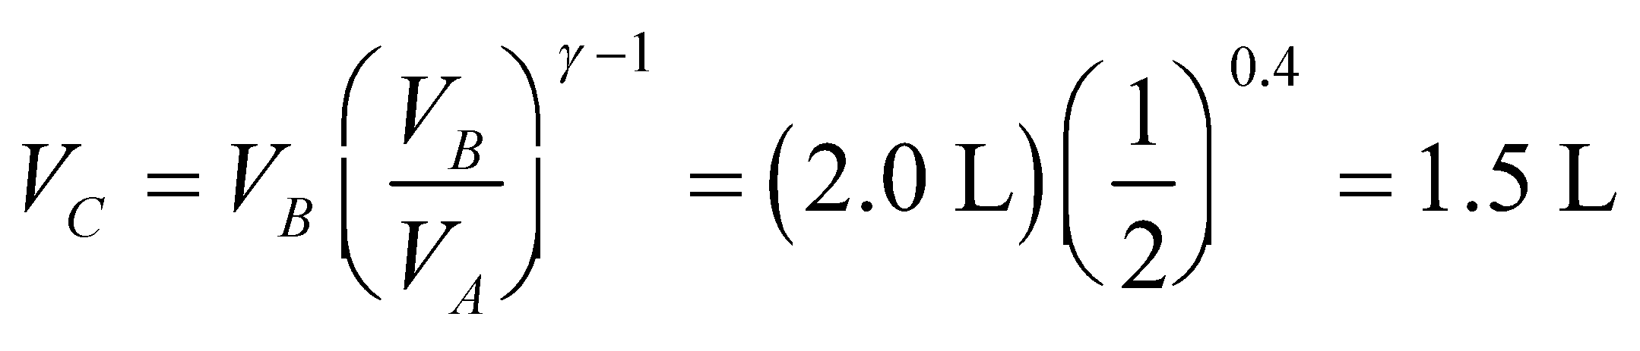

**Assess** The total work is positive, so work is done on the gas in this cycle.

**47. Interpret** We are to find the work done in the given heat cycle, which consists of an isochoric doubling in pressure, and adiabatic compression, an isochoric cooling to 300 K, and an isothermal expansion.

**Develop** The net (or total) work done on the gas is the sum of the work done for each process in the cycle (see figure below), which we give here:

**(AB)** It is heated at constant volume until the pressure is doubled. Because *ΔV* = 0, *W*AB = 0 (see Equation 18.7).

**(BC)** It is compressed adiabatically until its volume is 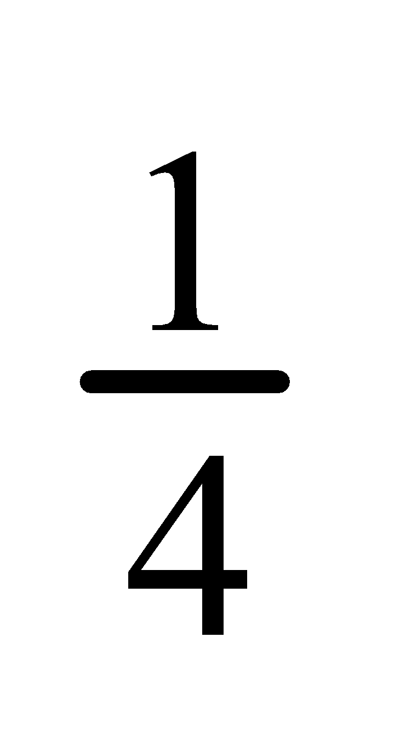 the initial value. This is analogous to the process AB of Problem 18.46, so the result is

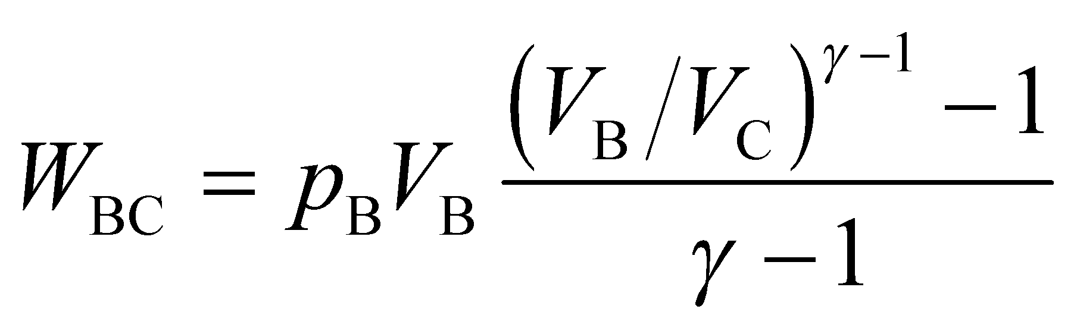

where *V*B/*V*C = 1/4 and *p*B*V*B = 800 J (see figure below).

**(CD)** It is cooled at constant volume to a temperature of 300 K. No work is done because *ΔV* = 0, so *W*CD = 0.

**(DA)** It is expanded isothermally until it returns to the original state. This is analogous to the process CA of Problem 18.46, so we use that result:

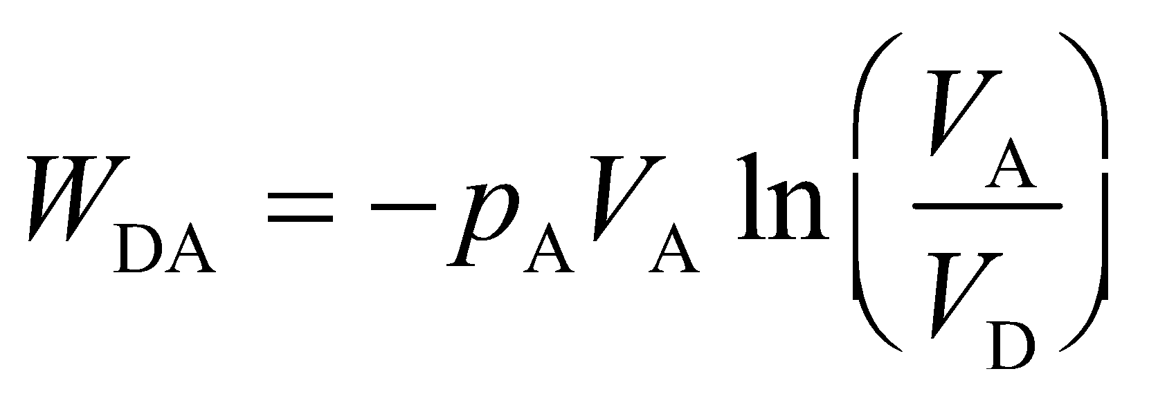

where *V*A/*V*D = 4 and *p*A*V*A = 400 J (see figure).



**Evaluate**Summing the nonzero contributions to the work gives

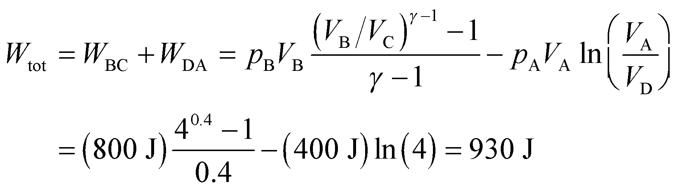

**Assess**Work is done on the gas. From the figure above, we see that the area under the entire curve is negative, because the gas goes around the cycle counterclockwise. As per Figure 18.6, the work done by the gas is the negative of the area under the *pV* curve.

**48.** **Interpret** This problem is similar to the preceding two problems. It involves again a thermodynamic cycle, this time involving an isothermal compression, followed by an isochoric increase in pressure, then an adiabatic expansion. We are to find the total work done on or by the gas over this cycle.

**Develop** We begin by drawing the *pV* curve for this cycle (see figure below). Sum the contributions to the work from each process in the cycle. For the isothermal process AB, apply Equation 18.4 and the ideal-gas law (Equation 17.2, *pV* = *nRT*). The work done on the gas is

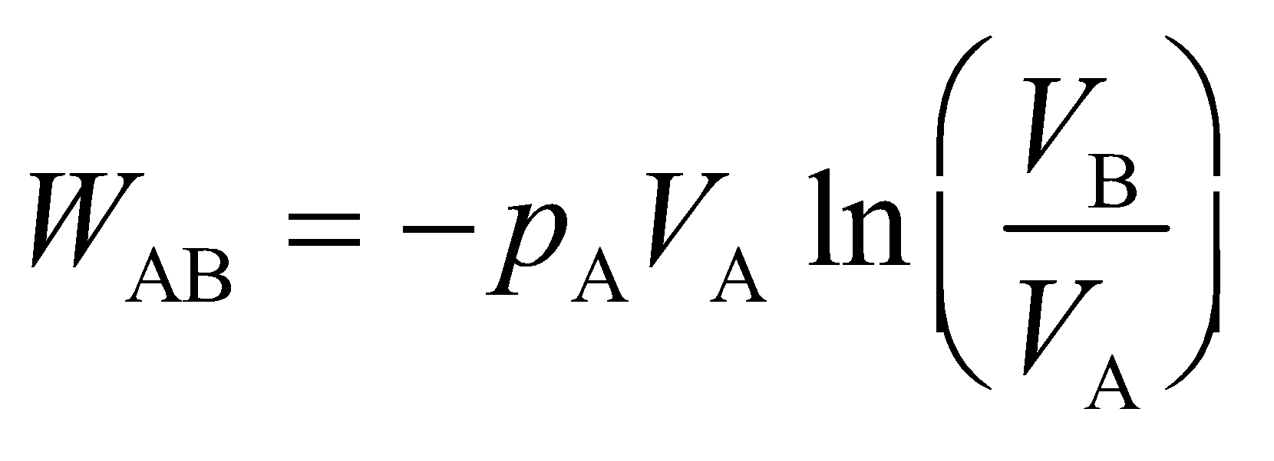

where *p*A*V*A = 1.25 kJ and *V*B/*V*A = 1/3 (see figure below). For the isochoric process BC, no work is done because *ΔV* = 0 (see Equation 18.7). For the adiabatic process CA, the work done is

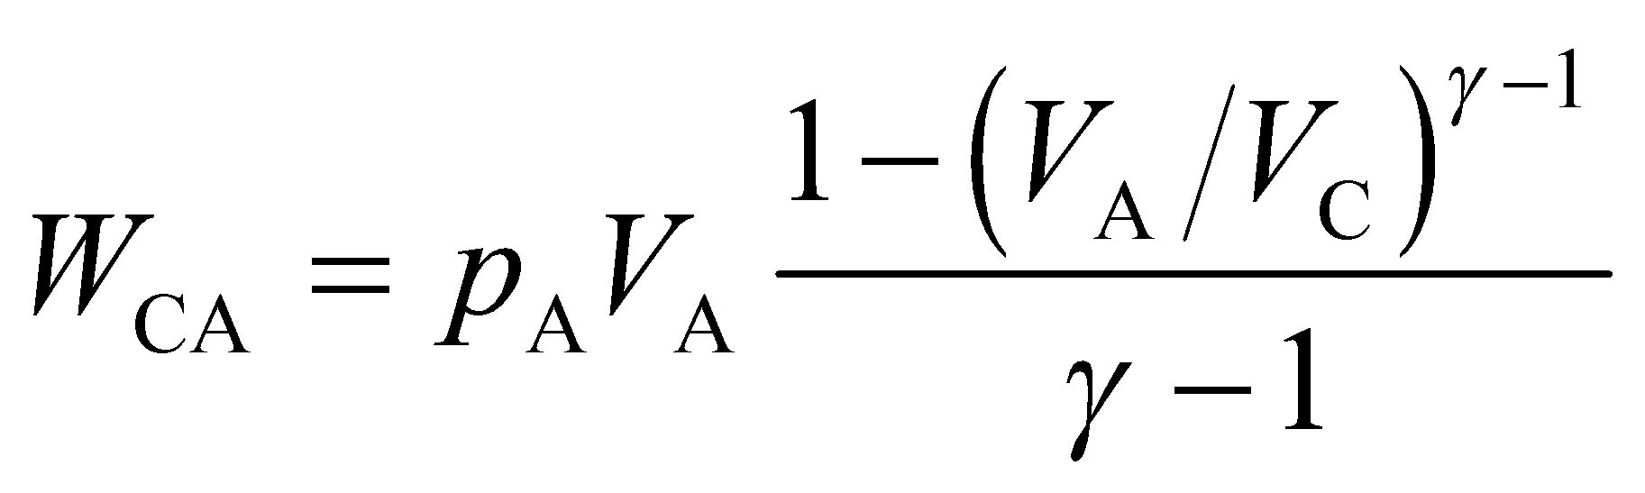

where *p*A*V*A = 1.25 kJ and *V*A/*V*C = 1/3.



**Evaluate** Summing the nonzero contributions to the work gives

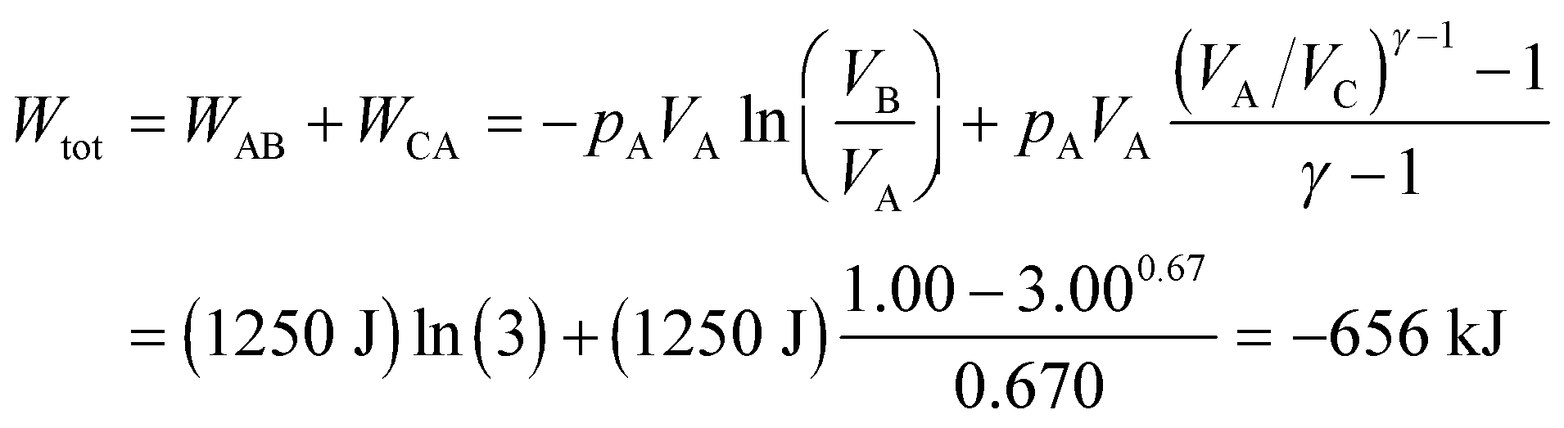

**Assess** The work is negative, which means that the gas does work on the environment, which is consistent with the clockwise direction of the cycle about the *pV* curve.

**49. Interpret** We're asked to derive the relation between pressure and temperature in an adiabatic process.

**Develop** We just need to combine Equations 18.11a and 18.11b: and 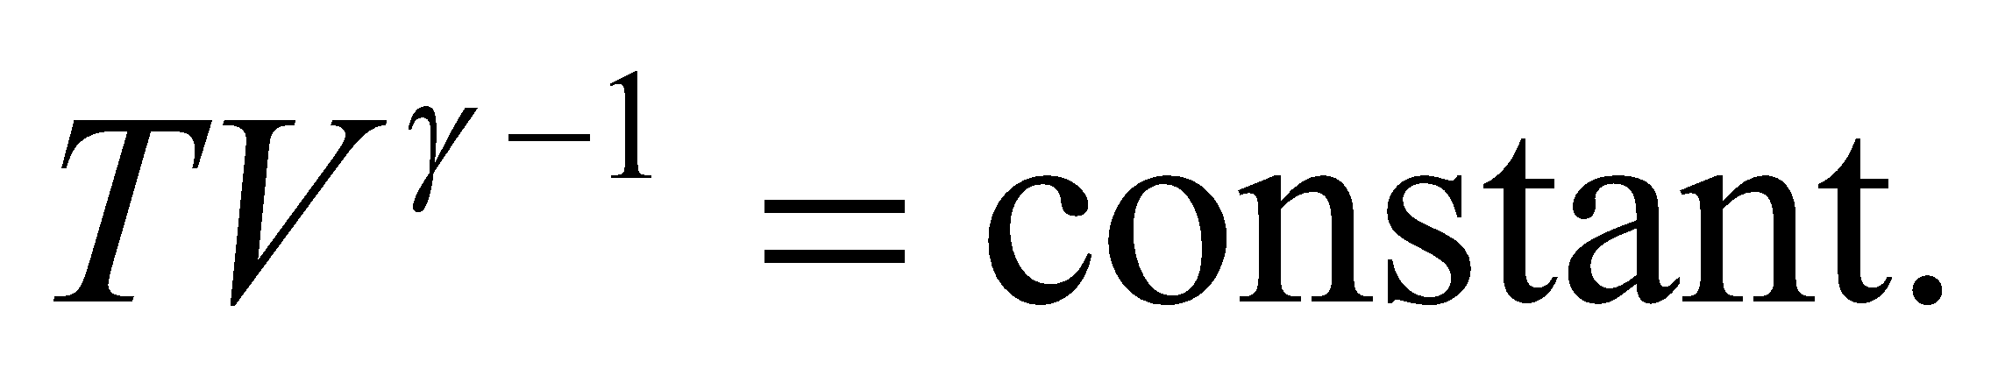

**Evaluate** Isolating the volume in both equations and matching the exponents gives

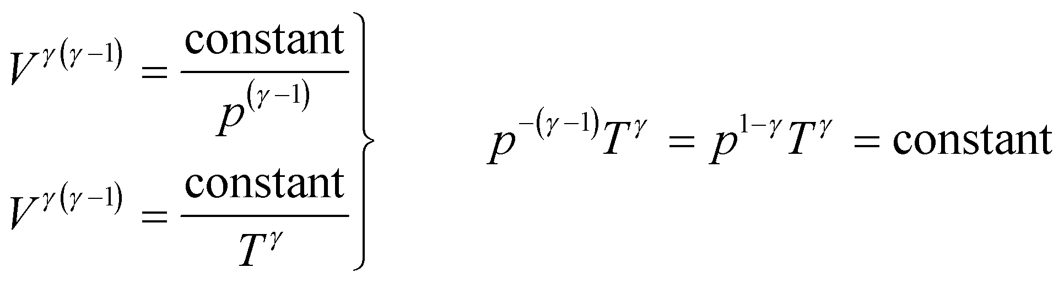

The "constant" term is just a place-holder. You can raise the constant to a power and it's still just a constant. Or you can multiply the constant by another constant, and the result is still just a constant.

**Assess** For 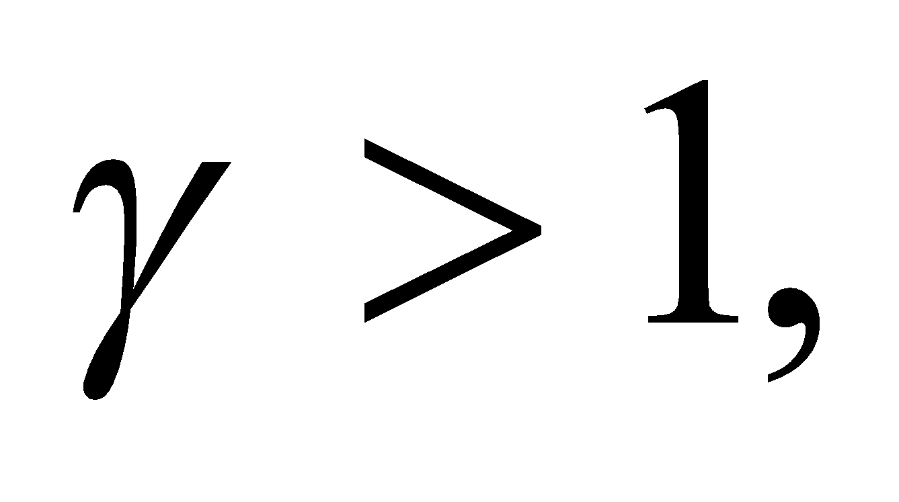the result says the pressure and temperature will increase or decrease together during an adiabatic process.

**50. Interpret** The problem involves a cyclic process with three separate stages, which are (in order) adiabatic, isochoric, and isothermal. We are to find the total work done in the process. As seen in Problems 18.46–18.48, there will be net work on the gas by the environment because the system proceeds in a counterclockwise manner around the cycle.

**Develop** We begin by sketching the *pV* curve for this cycle (see figure below). The total, or net, work done is the sum of the work done in the individual processes of the cycle. For the adiabatic process AB, *Q* =0, and the first law of thermodynamics (Equation 18.1) becomes 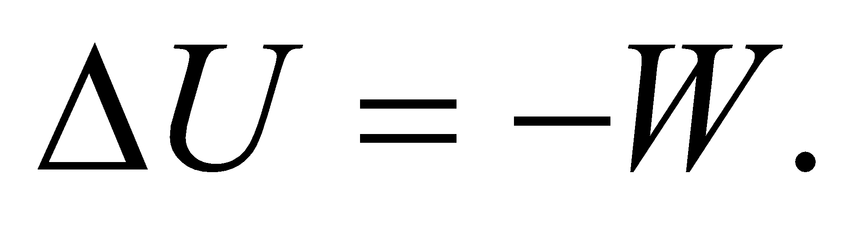 The pressure and volume are related by Equation 18.11a:  and the work done by the gas is given by Equation 18.12:



Since 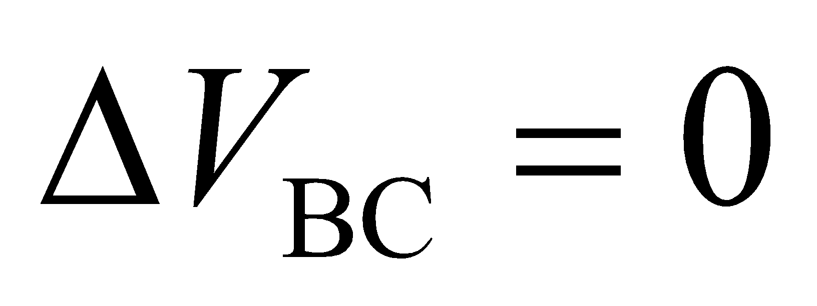 for the isochoric process, 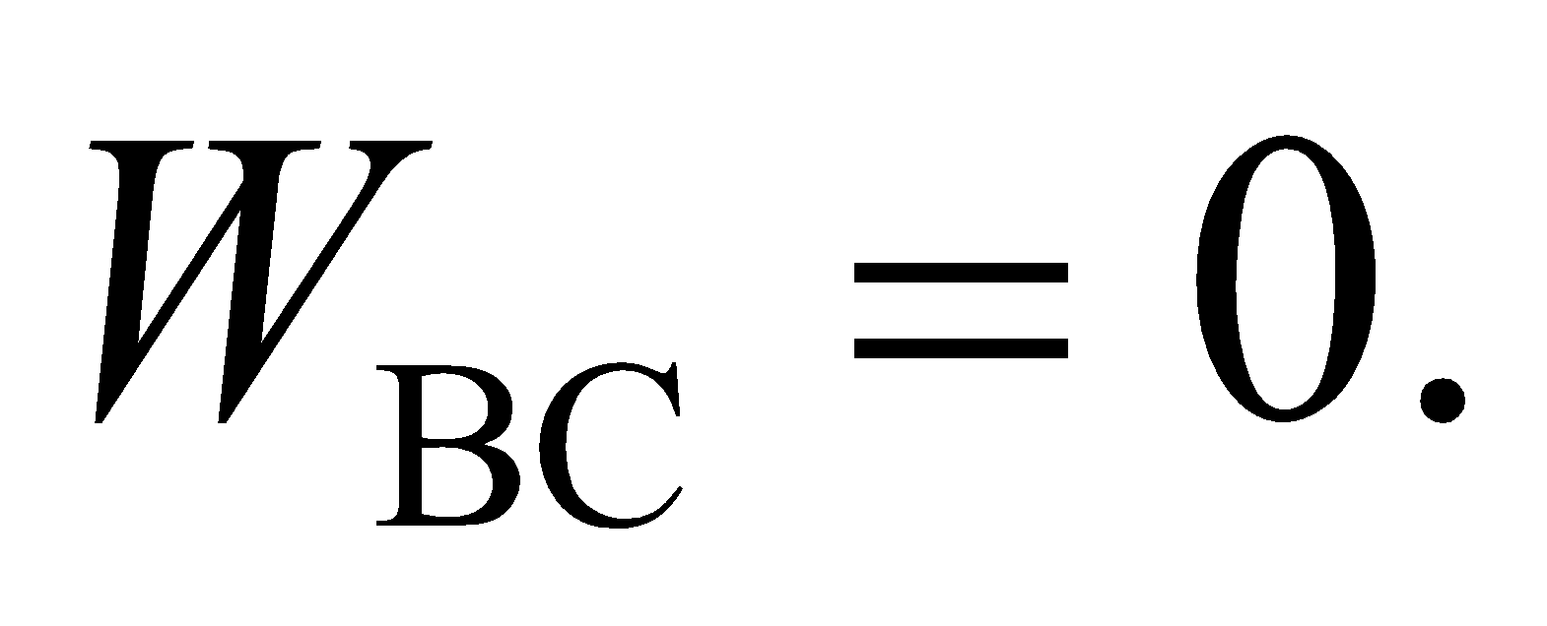 Similarly, for an isothermal process, the work done is (Equation 18.4)

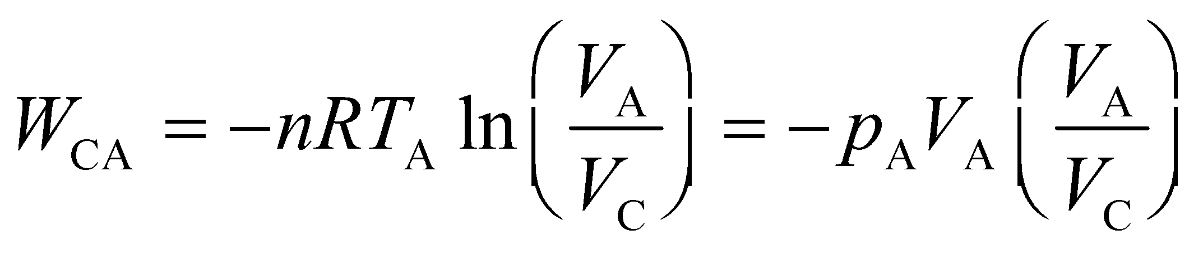

where we have used the ideal-gas law (Equation 17.2) *pV* = *nRT*. The minimum volume attained is *V*B = *V*C, which is related to *V*A by the adiabatic compression, because *pVγ* = constant for an adiabatic process (Equation 18.11a), we have

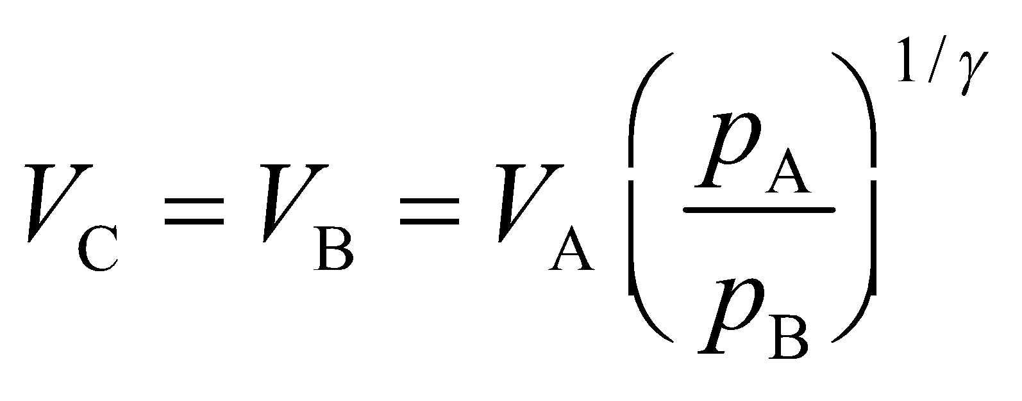

where *p*A/*p*B = 1/3 (see figure below) and *V*A = 25 L.



**Evaluate** The solutions below are presented in the reverse order.

**(a)** The work done *on* the gas is the sum of the work done on the gas during each process:

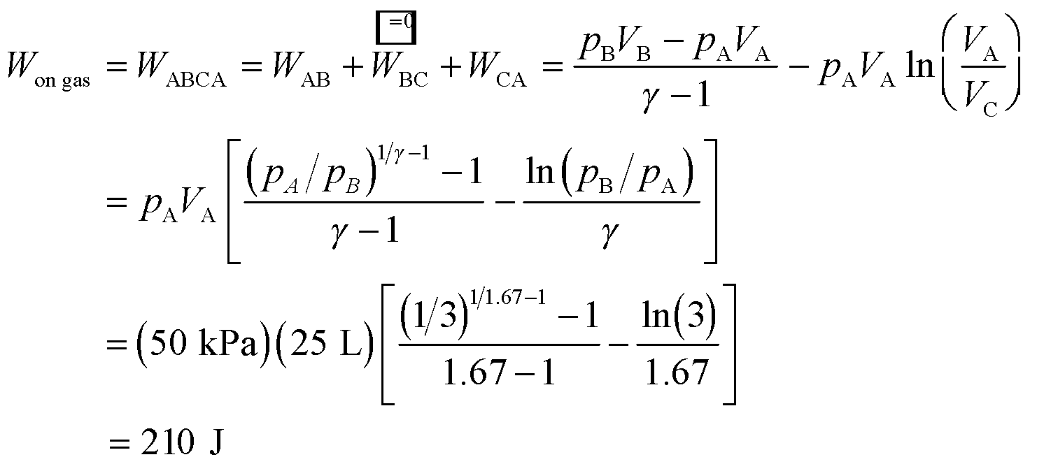

to two significant figures, and where we have used the relationship between *V*A, *V*B, and *V*C derived for part (b) to find the minimum volume.

**(b)** Inserting the volume and pressure in to the expression for the minimum volume gives

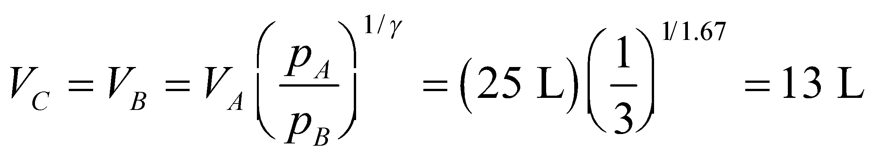

**(c)** See the figure above for the *pV* cycle.

**Assess** Since the process is cyclic, the system returns to its original state and there is no net change in internal energy, so  This implies that 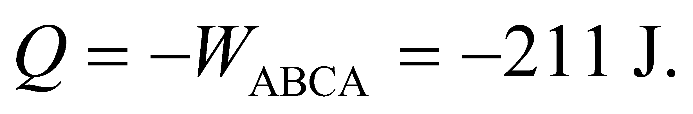 That is, 211 J of heat must come *out* of the system.

**51. Interpret** The pump handle is pressed rapidly, so you can assume that there's no time for heat to flow into or out of the gas in the pump. This means that process is adiabatic.

**Develop** You want to check that the temperature rise in the pump is less than 50°C. Equation 18.11b tells you how to relate the final temperate and volume to the initial temperature and volume: 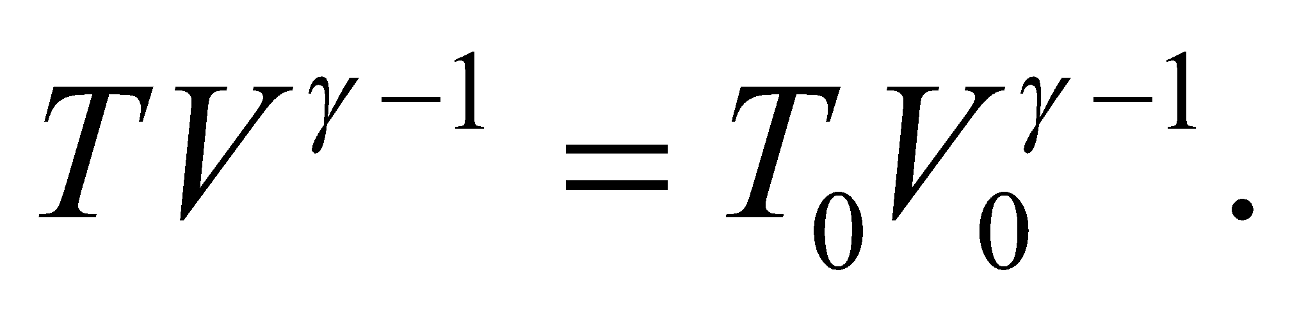Therefore, the temperature rise is

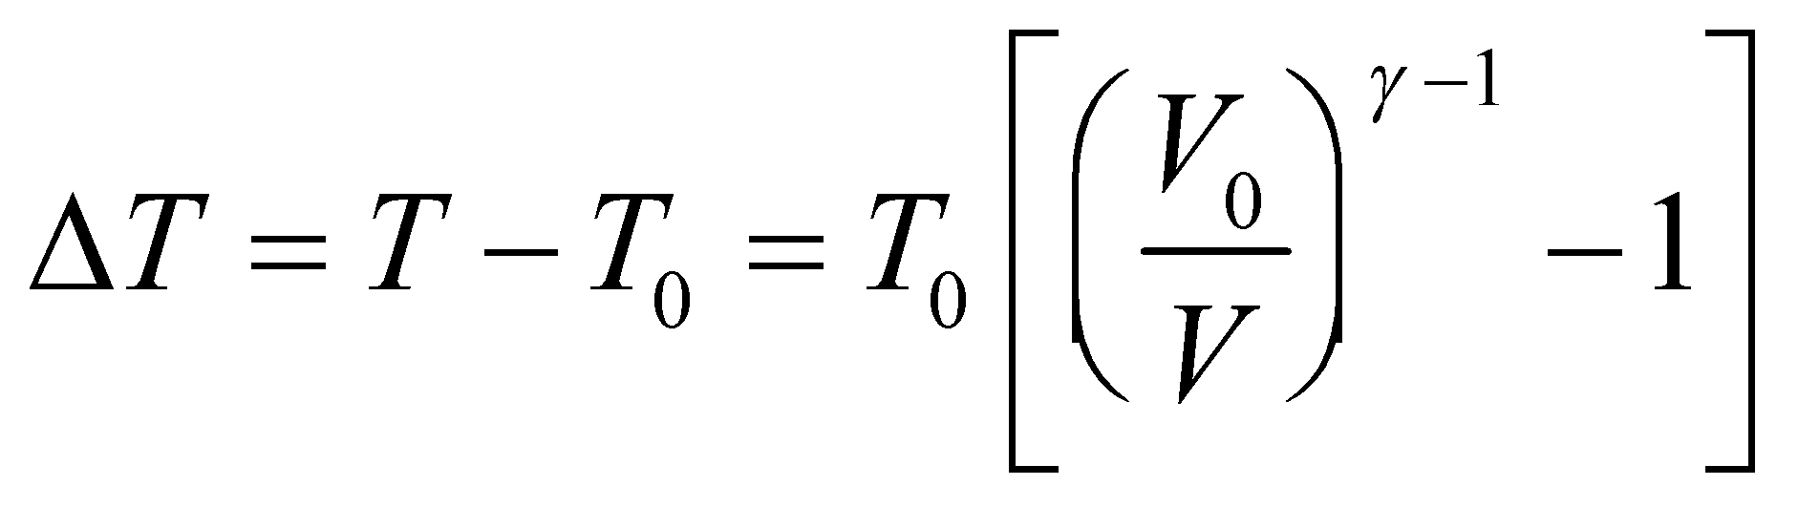

The gas in the cylinder is air 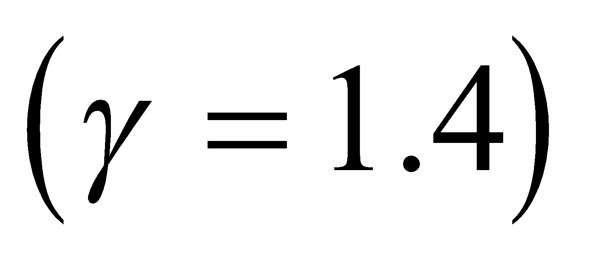initially at 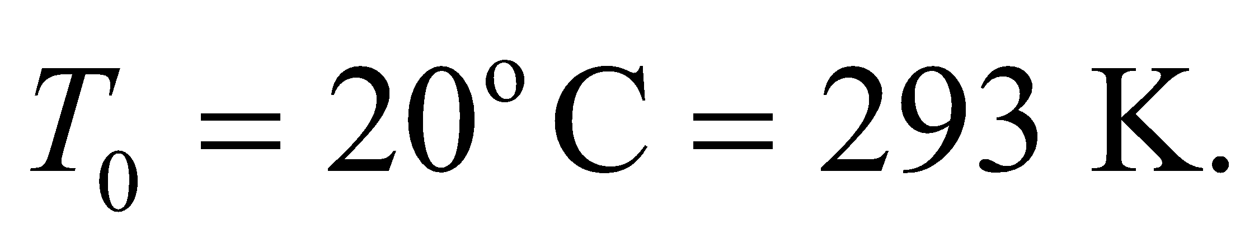

**Evaluate** Since the cross-sectional area of the cylinder remains unchanged during the compression, the volume ratio is just equal to the ratio in the cylinder's height:

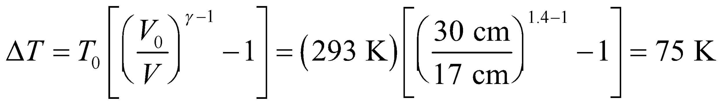

This does not meet your 50°C criteria.

**Assess** There's no obvious way to avoid this temperature rise. The cylinder can be made of a material with a high thermal conductivity, such as aluminum, so that heat can flow out as fast as possible.

**52. Interpret** We're given experimental data and are asked to estimate the work involved in inflating a human lung.

**Develop** We want calculate the work done *by* the gas in expanding the lungs: 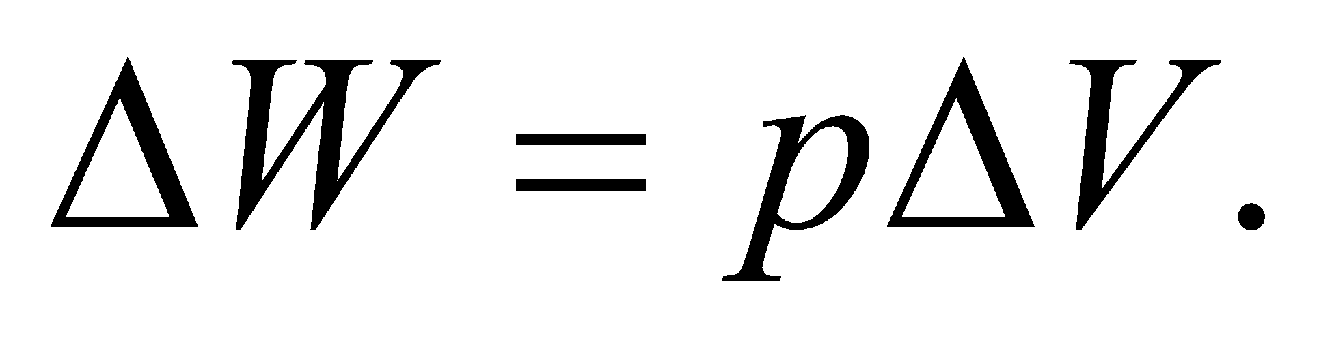In the given graph, we can take the volume change between successive points as 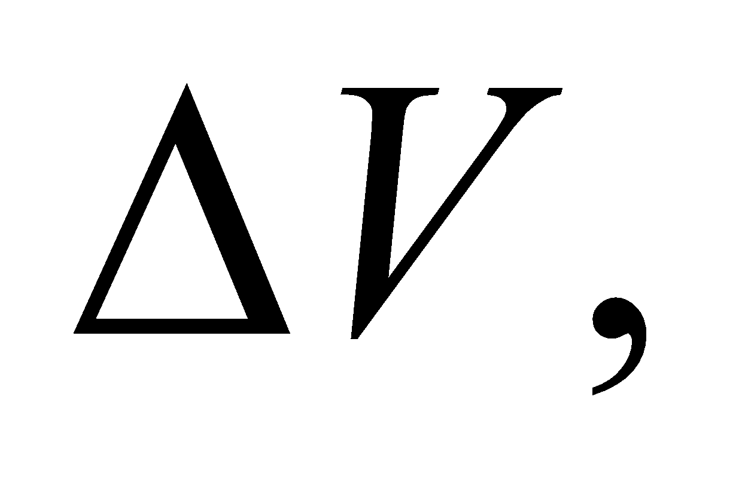and the pressure at the midpoint between successive points as the average pressure 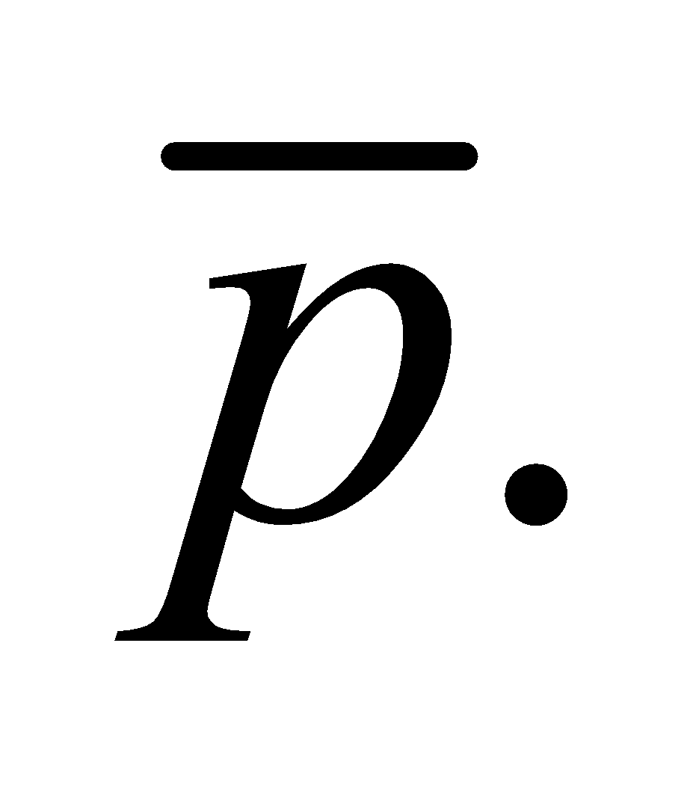 To find the total work done, we sum over these small individual expansions.

**Evaluate** There are seven main volume expansions that correspond to pressure increases of 5 kPa. We add the work involved in each expansion to get the total work. (Note: to save space, we leave off the units until the end of the sum):

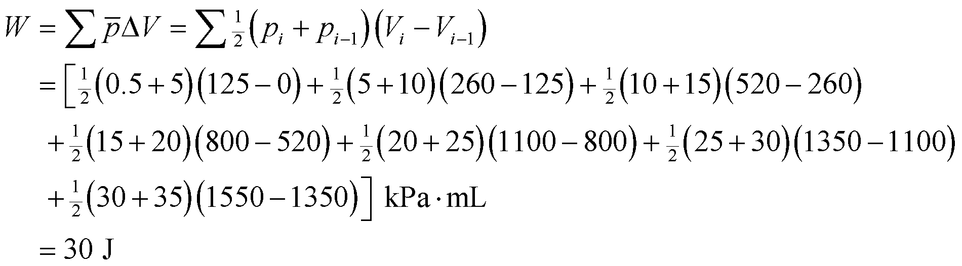

**Assess** It may seem counterintuitive that the pressure increases as the volume increases, but in this case air is rushing into the lungs from the outside. When a person breathes, their diaphragm contracts to open up the lung cavity. This lowers the pressure on the lungs, so they inflate like two balloons. The air rushing into the lungs does the work to expand the lung volume; the diaphragm is only indirectly responsible. Afterwards, the diaphragm expands to squeeze on the lungs, which increases the pressure and thus forces air out.

**53.** **Interpret** For this problem, we are given the heat transferred from a monatomic gas to the surroundings and the change in internal energy of the gas, and we are to find the work done in the process.

**Develop** Apply the first law of thermodynamics, Equation 18.1, *ΔU* = *Q* + *W*, where *Q* = −15 kJ. The internal energy change can be calculated using the constant-volume specific heat for a monatomic gas, which is *CV* = 3R/2 (see Equation 18.13). Thus,

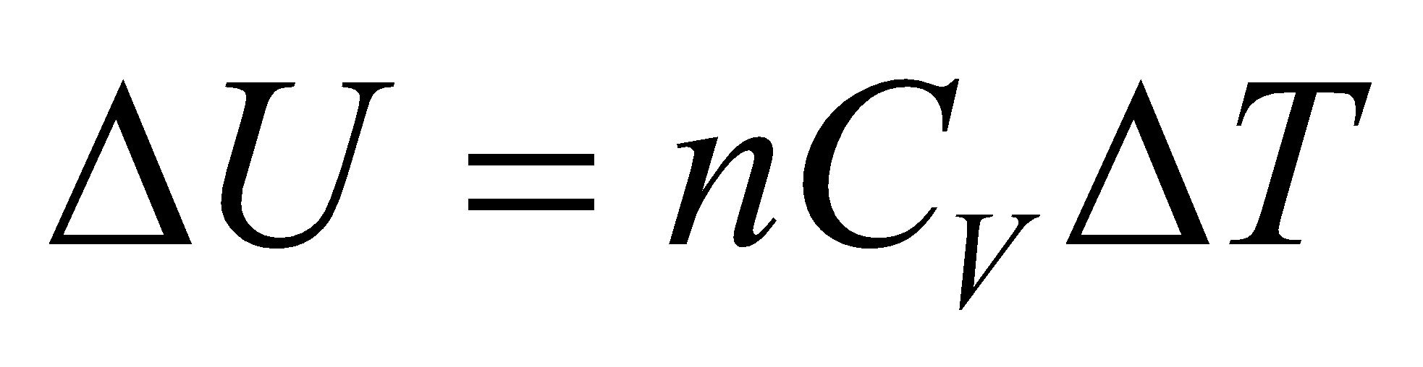

where *n* = 21 mol and *ΔT* = 160 K.

**Evaluate** Combining the above expressions and inserting the given quantities gives



**Assess** The work is positive so the work is done on the gas.

**54. Interpret** The thermodynamic process here involves two stages: isothermal compression followed by an adiabatic compression. We are to find the final temperature of the gas.

**Develop** During the first stage, the gas is compressed isothermally so *ΔT* = 0 and there is no change in the temperature of the system (i.e., *T*0 = *T*1), but the volume is reduced from *V*0 to *V*1 = *V*0/3. During the next stage of adiabatic compression, the temperature and volume are related by Equation 18.11b:



which we apply to the points 1 and 2 (i.e., before and after the adiabatic compression, respectively) to find



where the final temperature is *T*2.

**Evaluate** Substituting the values given, we find *T*2 to be

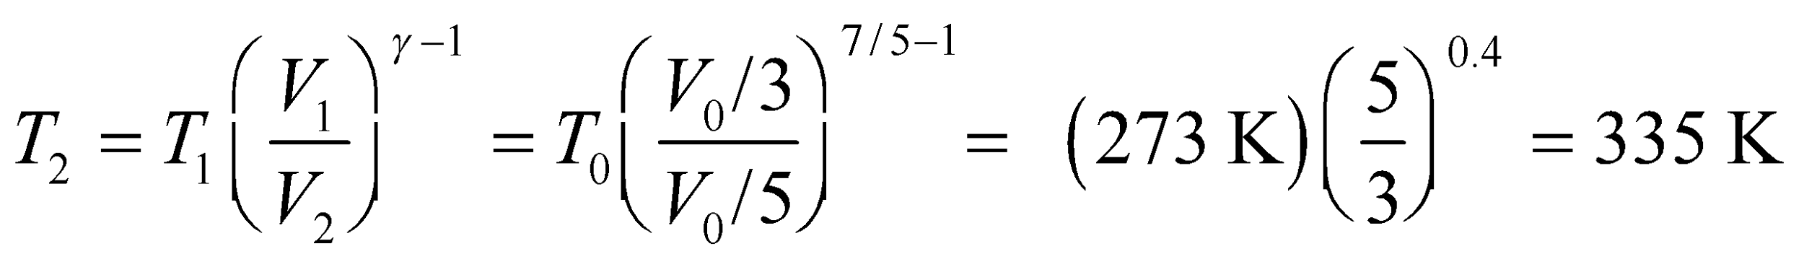

**Assess** Since  for an adiabatic process, the compression results in an increase of the final temperature.

**55.** **Interpret** This problem involves an adiabatic compression of a gas, for which we know the initial temperature and pressure and the final pressure. We are to find the final temperature of the gas.

**Develop** For an adiabatic process, the temperature and pressure are related by Equation 18.11a:

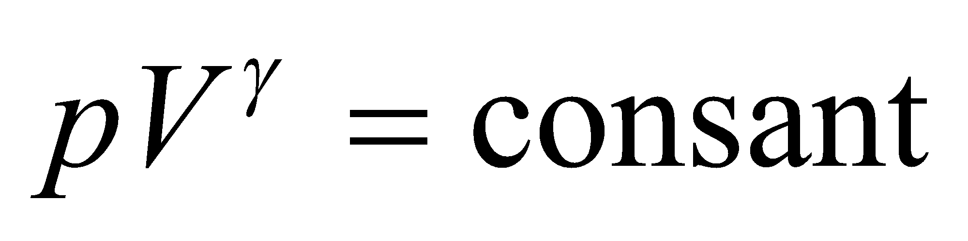

Rearranging this equation and using the ideal-gas law (Equation 17.2, *pV* = *nRT*) gives

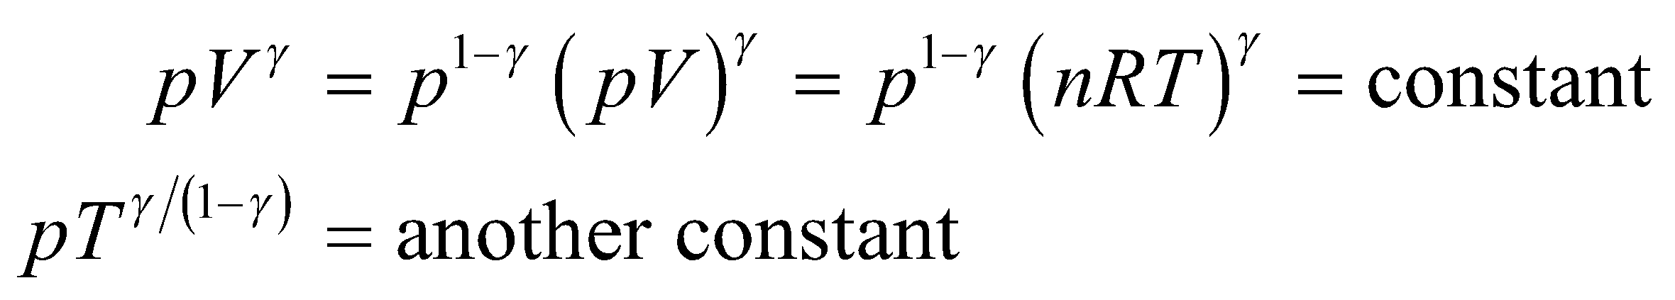

Applying this to the gas both before and after the compression gives 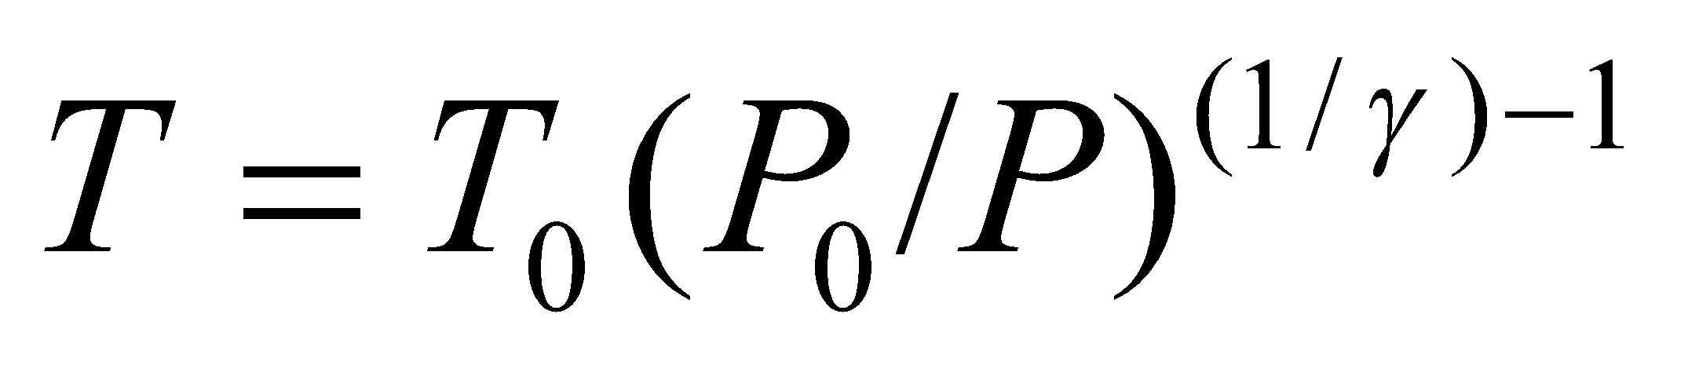

**Evaluate** Inserting the given quantities into the expression above for temperature gives

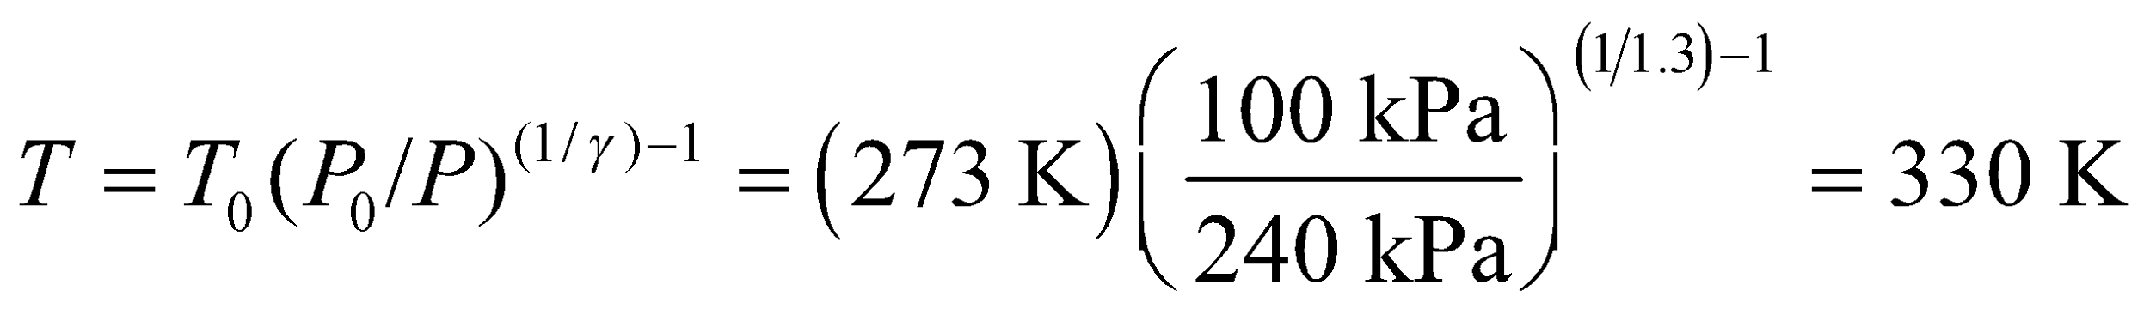

to two signficant figures.

**Assess** Because the gas is compressed adiabatically, its temperature rises.

**56. Interpret** The problem involves a cyclic process with three separate stages of the cycle: isochoric (*AB*), isobaric (*BC*), and isothermal (*CA*). We are to calculate the net work done on the gas over the entire cycle, and the heat transfer over segment *AB*.

**Develop** The work done *on* the gas in each segment of the cycle is summarized in Table 18.1. For the isochoric process (path *AB*), *ΔV* = 0 so *W* = 0. For the isobaric process (path *BC*), the work done is

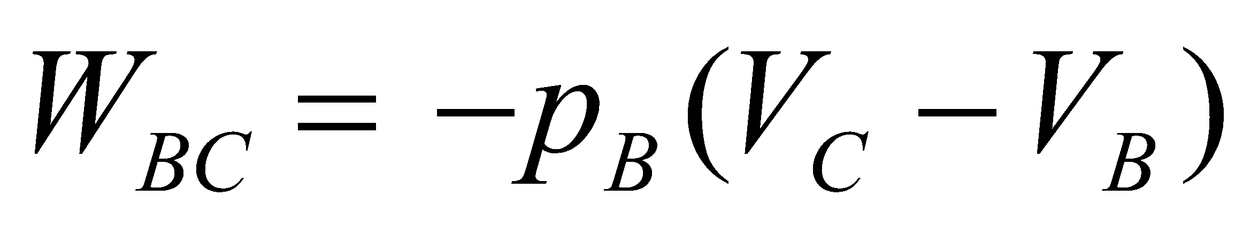

Finally, for the isothermal process (*CA*), the work done on the gas is given by Equation 18.4:

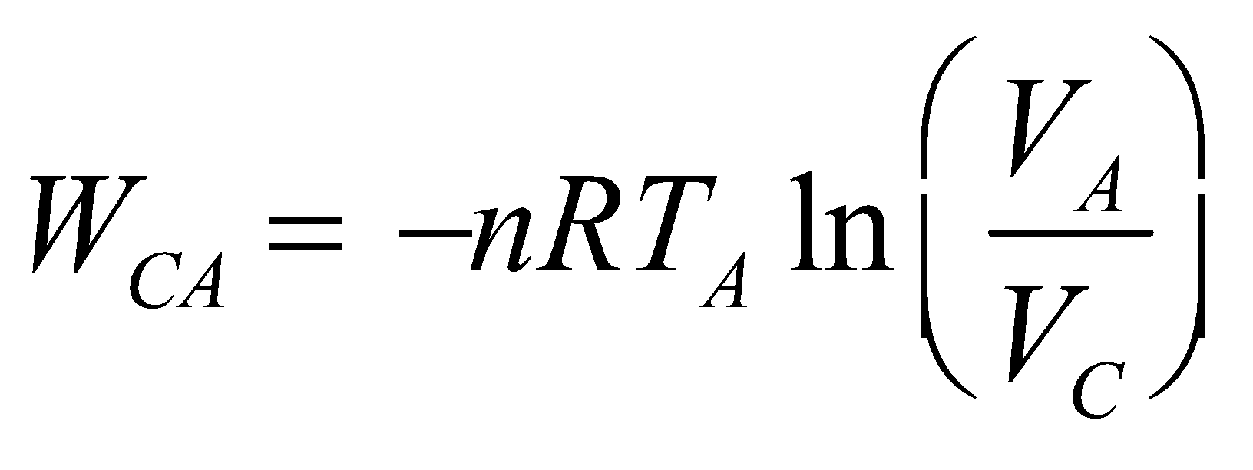

Segment *AB* is isochoric, so *QAB* = *nC*V*ΔT* (see Table 18.1). To eliminate CV, note that

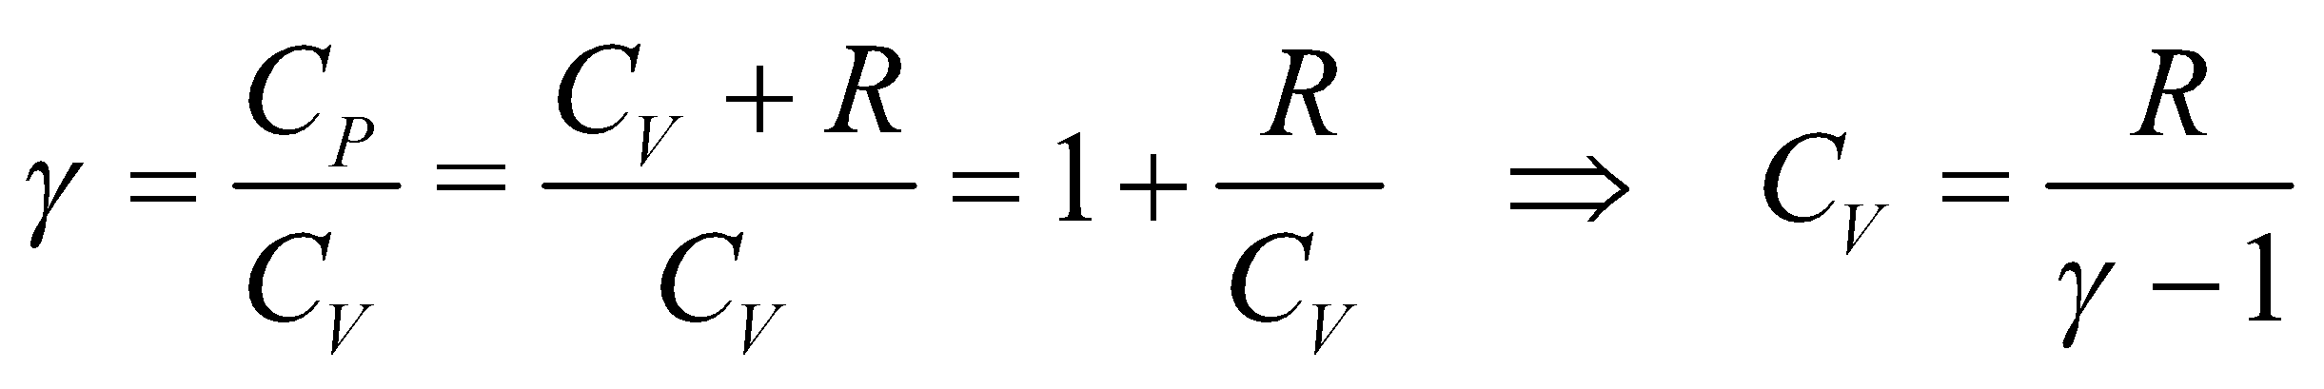

which follows from the definition of the adiabatic ratio *γ* (see discussion for Equation 18.11a). Inserting this into the expression for the heat transfer gives

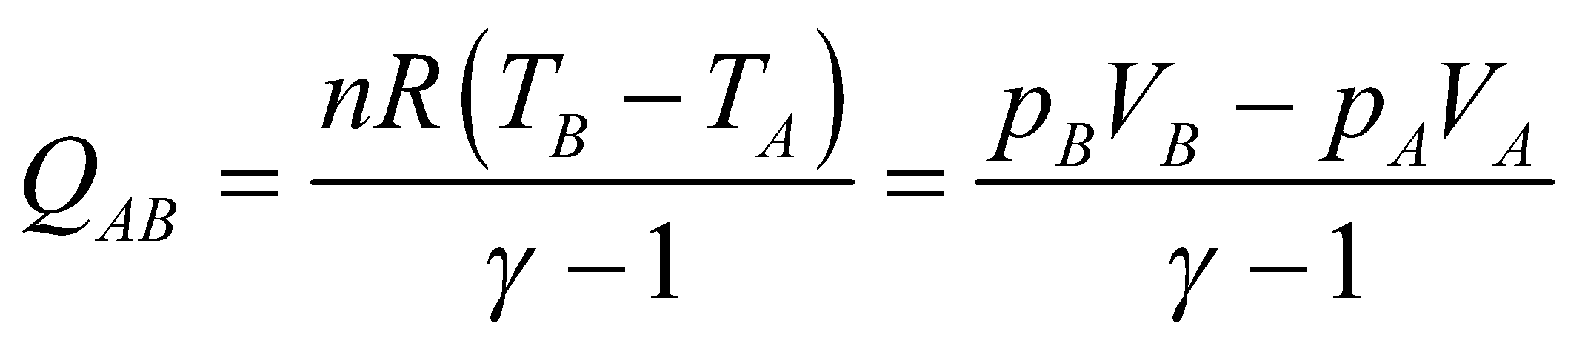

where the second equality follows from the ideal-gas law (Equation 17.2), *pV* = *nRT*.

**Evaluate** **(a)** Using the equations above, we obtain

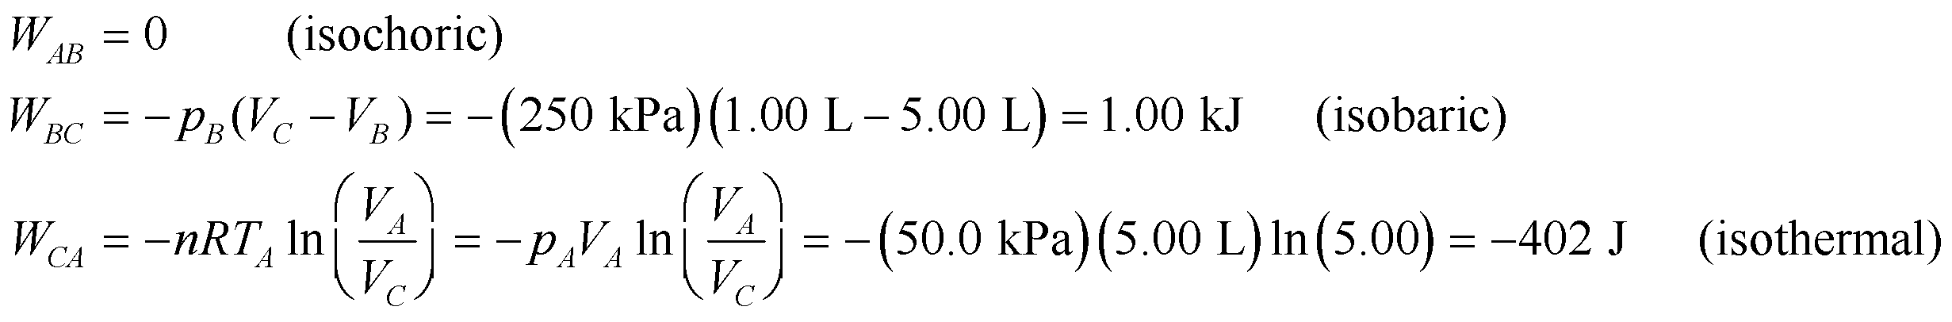

Adding up all the contributions, the net work done *on* the gas is



**(b)** The heat transferred is

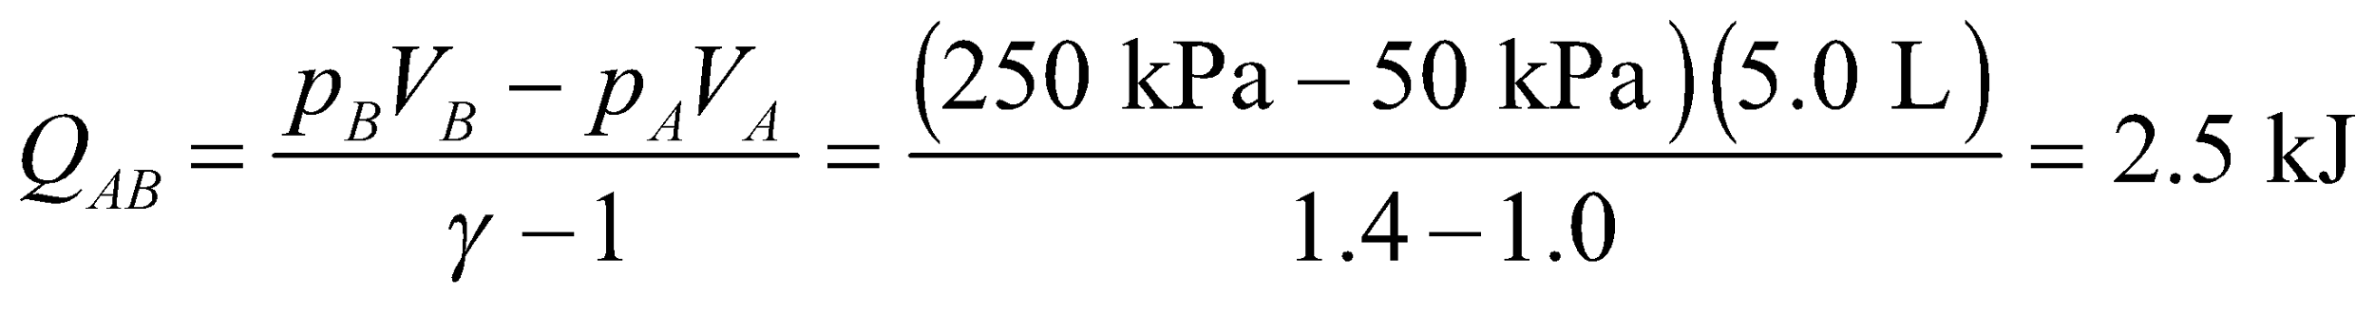

Since 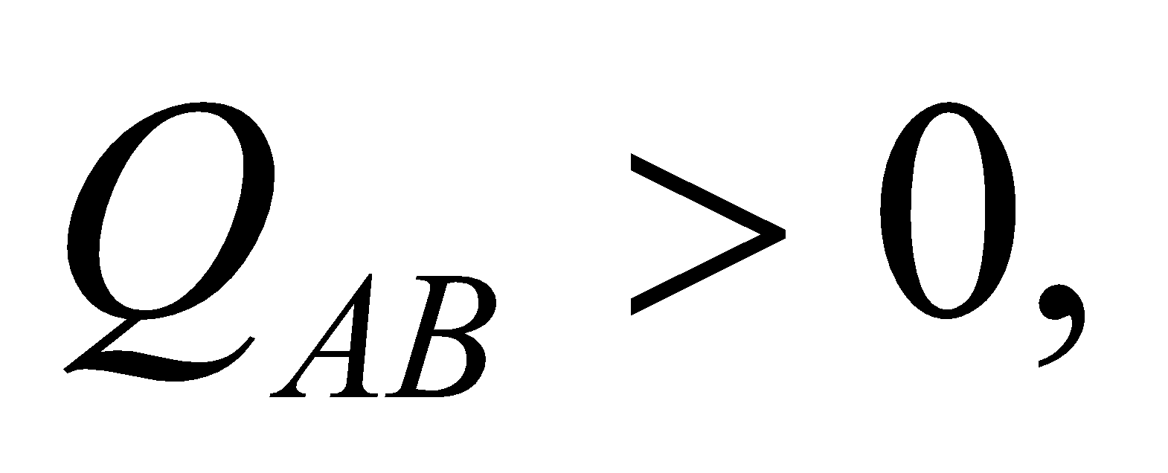 heat is transferred into the gas.

**Assess** At constant volume, the gas must be heated in order to raise its pressure.

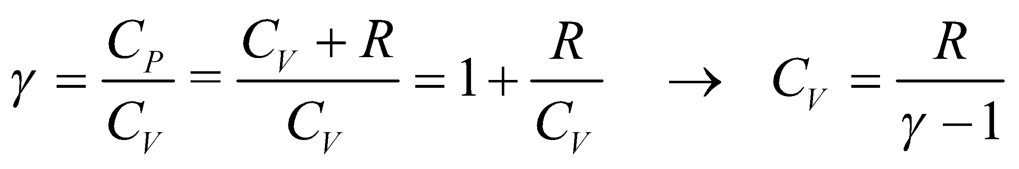

**57.** **Interpret** This problem is similar to the preceding one, except that the order of segments in the cycle are changed. The cycle proceeds along the 350-K isotherm from 50 kPa to 250 kPa (*AC*), then decreases its pressure to 50 kPa via an isochoric process (*CD*), then returns to the starting point via a 50-kPa isobar (*DA*). We are to find the total work done on the gas for the complete cycle and the heat transferred in segment *CD*.

**Develop** The formulas are the same as for the previous problem, but the initial and final point for each segment are different. The work done on the gas over segment AC will be the opposite of the result we found for the segment CA in Problem 18.56, so *WAC* = 402 J. The work done over segment *CD* is zero because the volume is constant (see Equation 18.7). The work done over segment DA is

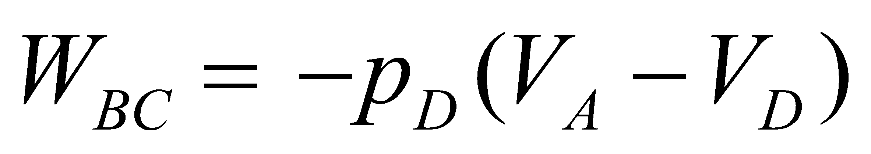

The heat transfer can be calculated as per Problem 18.56, which gives

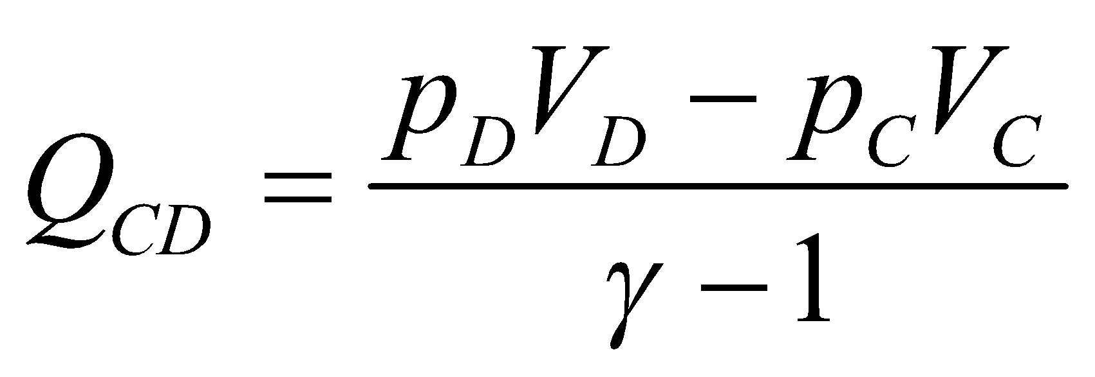

**Evaluate** (a) The total work is



(b) The heat transfer over segment *CD* is

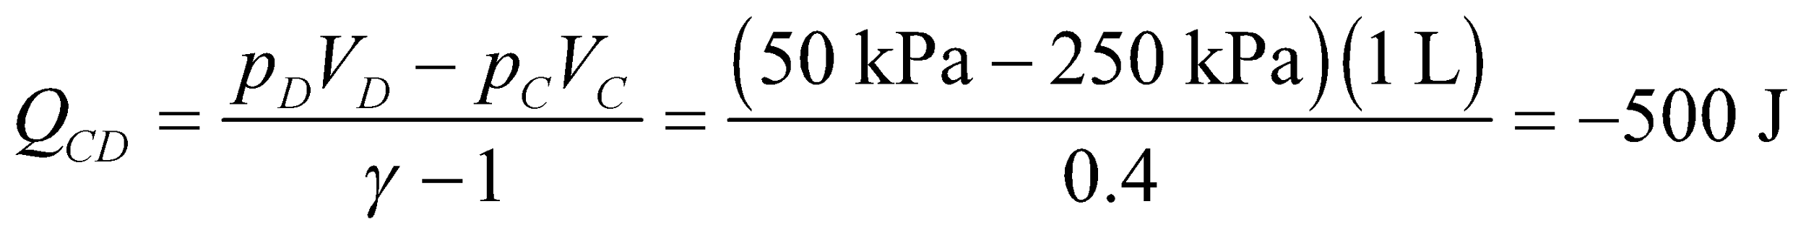

Because *QCD* < 0, we interpret the result as 500 J of heat transferred out of the gas.

**Assess** At constant volume, the gas must be cooled to lower its pressure.

**58. Interpret** This problem deals with an adiabatic expansion of a gas mixture. The gas contains monatomic and diatomic molecules, and we are given the volume doubles and the pressure decreases by one third because of the adiabatic expansion, and we are to find the fraction of each molecule type.

**Develop** In an adiabatic process (*AB*), *Q* = 0 and the pressure and volume are related by Equation 18.11a: 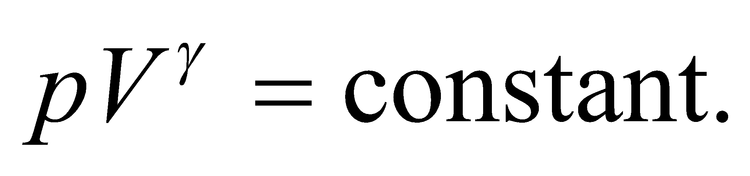 Applying this to the gas before and after the expansion gives



Taking the natural logarithm of both sides of the above and solving for *γ*, we obtain

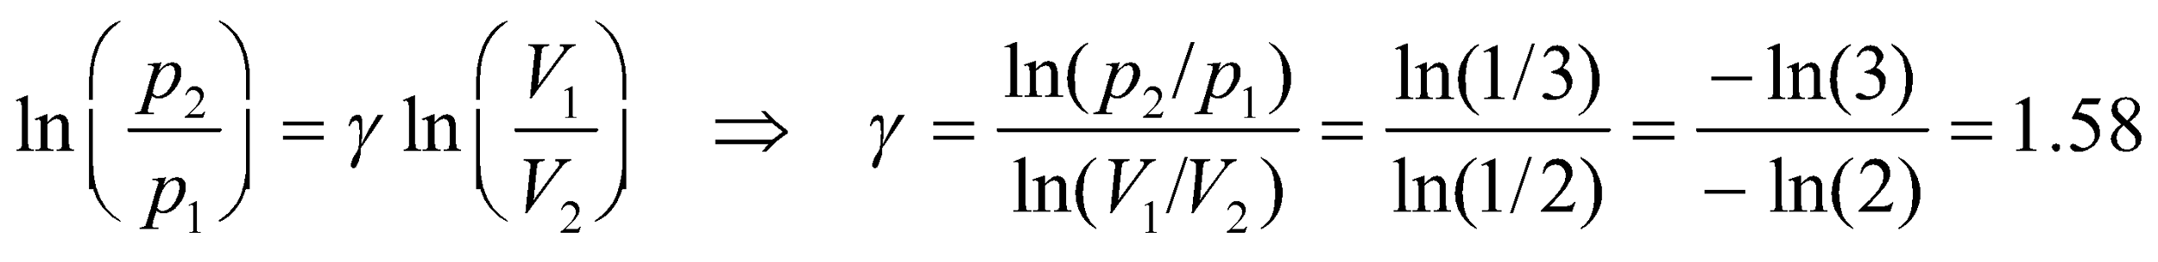

To find the fraction of the molecules that are argon, we use the result from Exercise 27:

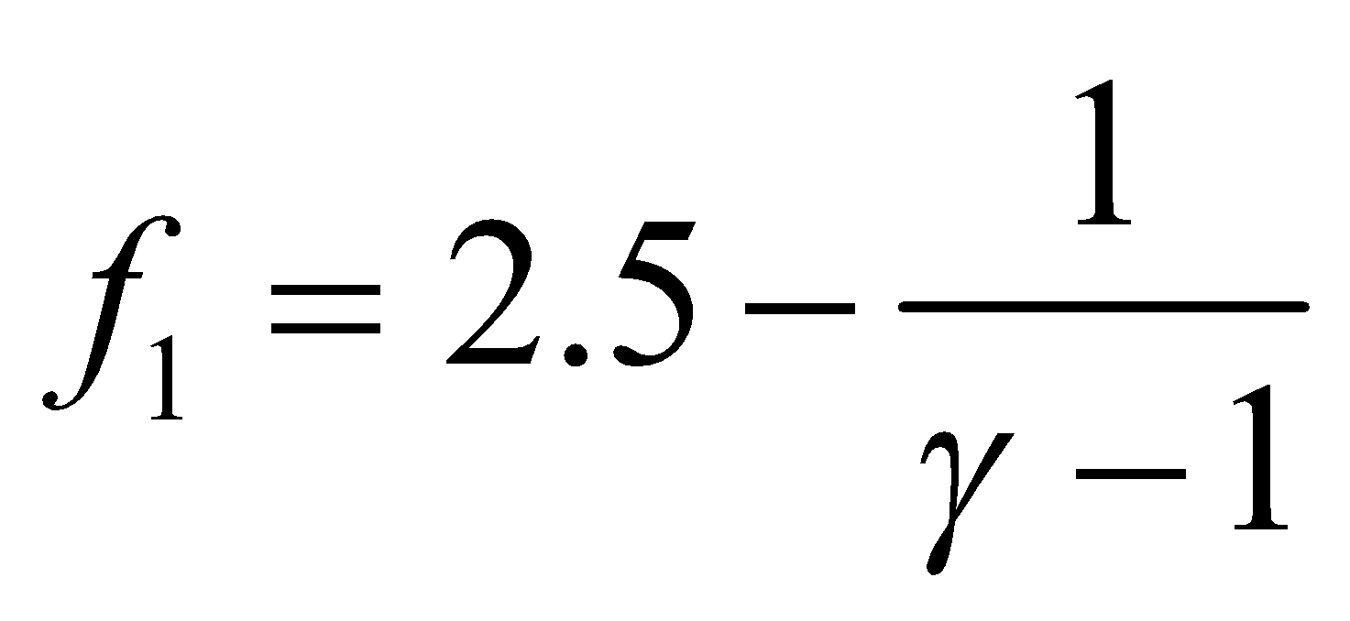

**Evaluate** Substituting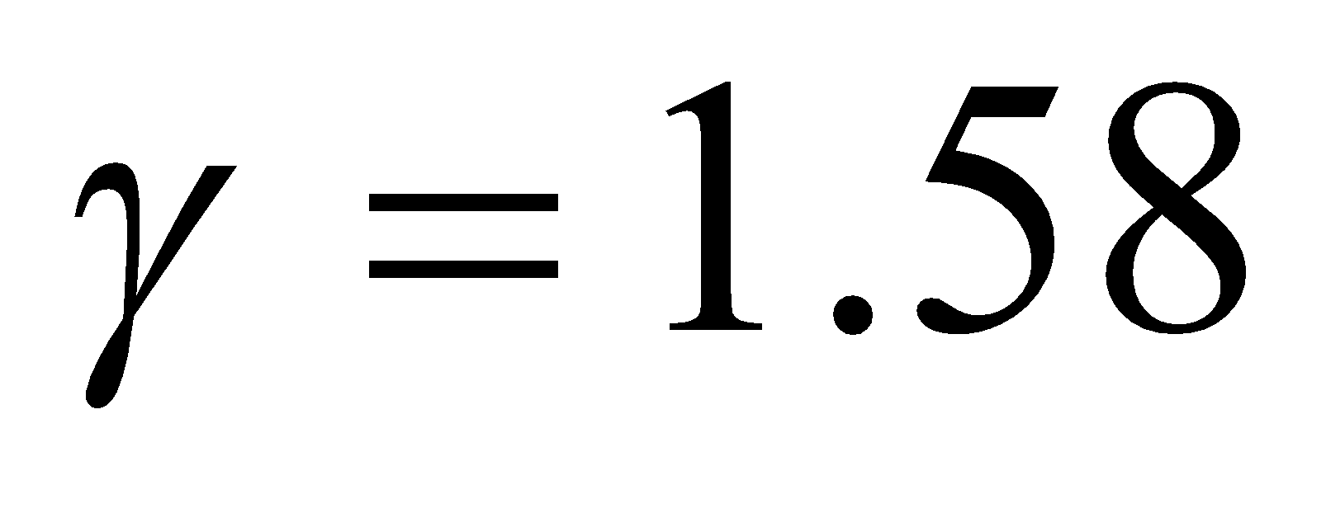into the equation above gives

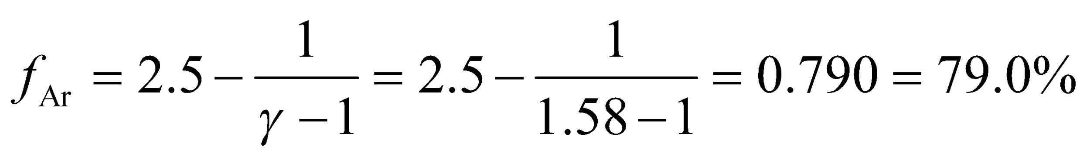

**Assess** In the limit where all the gas molecules are monatomic,  and 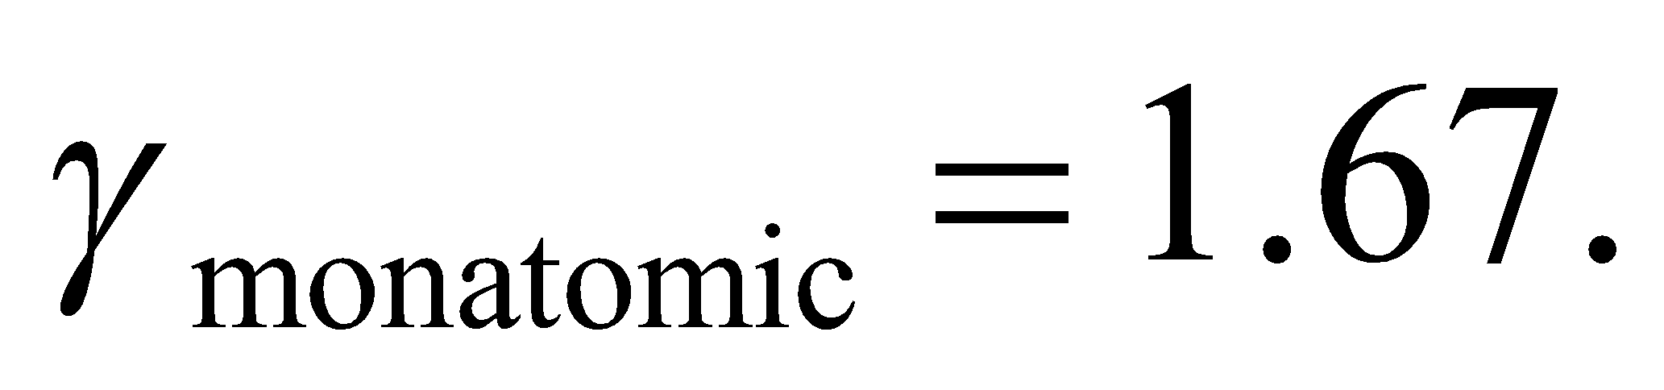 On the other hand, if all the molecules are diatomic, then  and the specific-heat ratio is 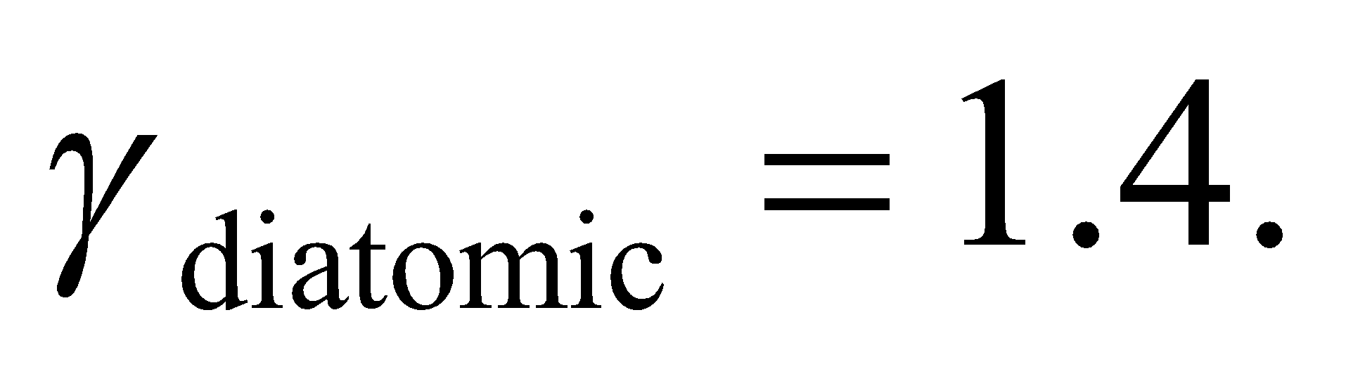 Our ratio of *γ* = 1.58 is closer to 1.67. This implies that the gas mixture is predominantly monatomic.

**59.** **Interpret** For this problem, we are to find the ratio of triatomic molecules to monatomic molecules that will result in a gas that has the specific heat at constant volume of a diatomic gas.

**Develop** The specific heat of a mixture of two gases is 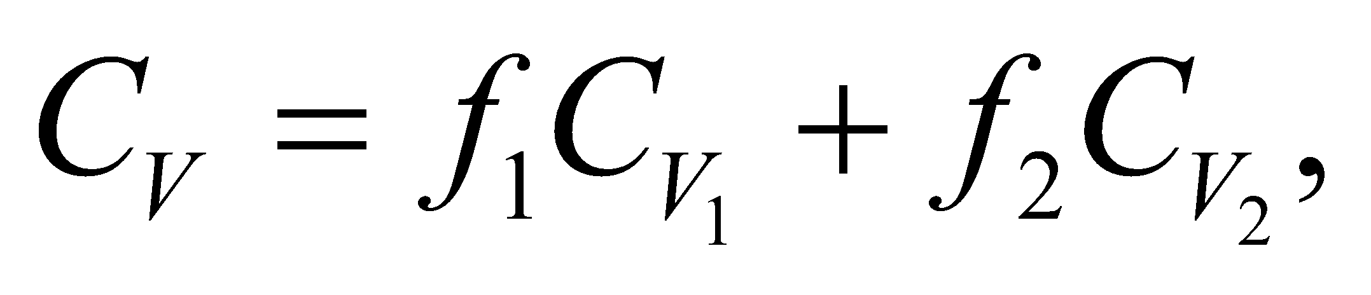 where the *fi* are the number fractions of the gases. Gas 1 is monatomic 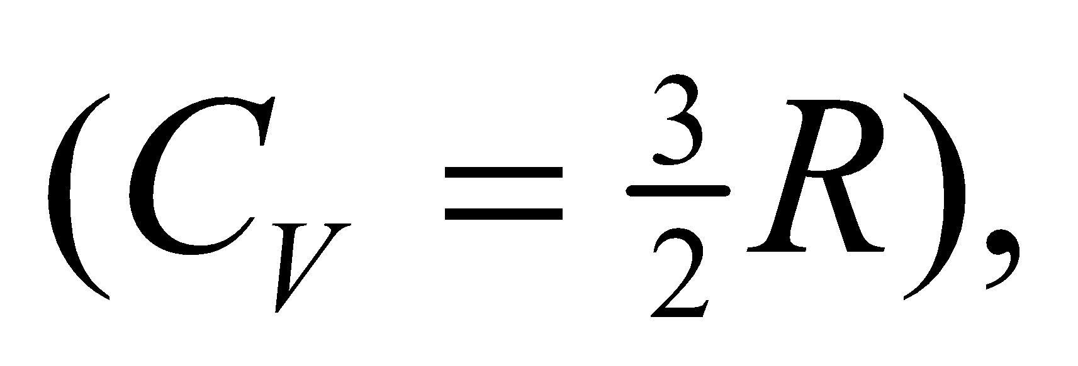 gas 2 is triatomic (with 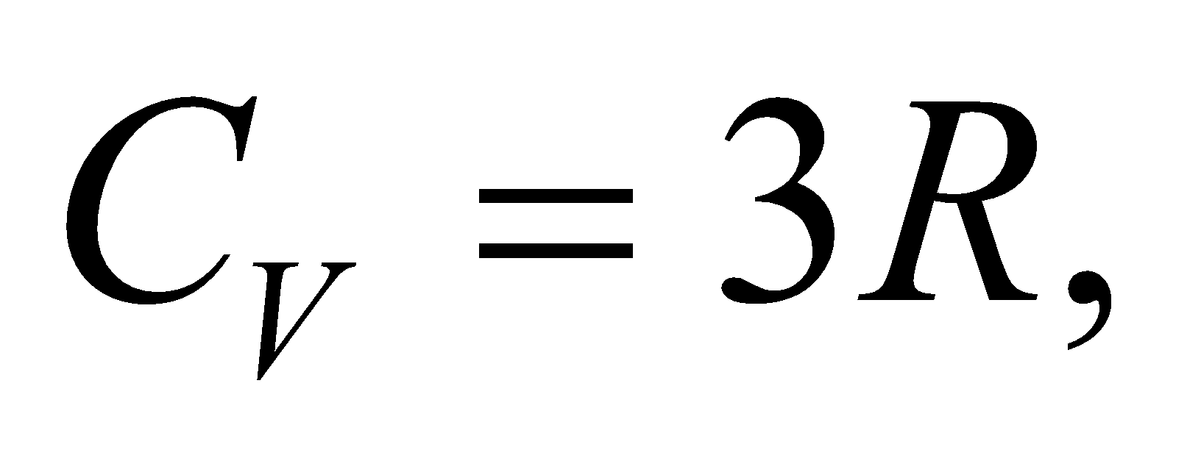 as given in the problem statement), and we wish to have mixture with , as for a diatomic gas. In this case, then

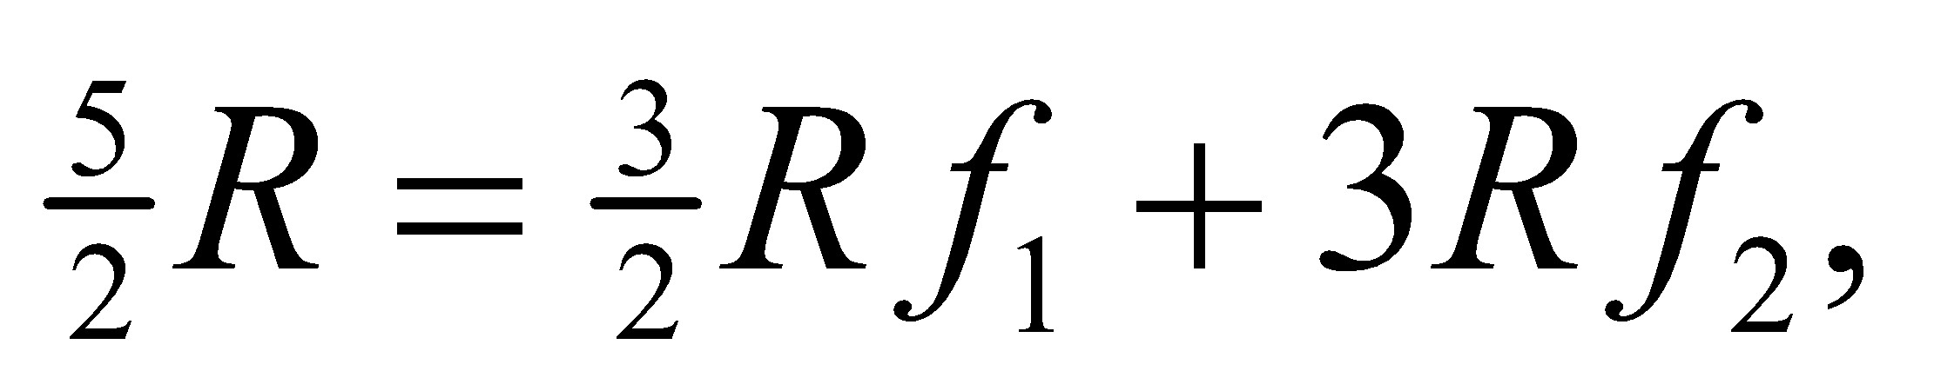 or 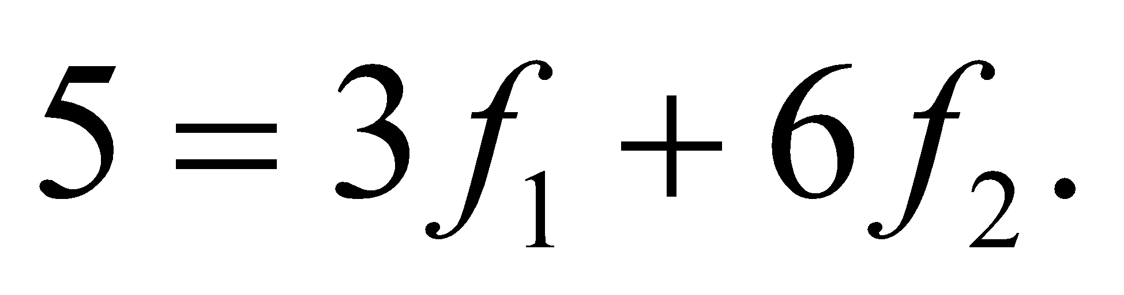

Given that *f*1 + *f*2 = 1 and *f*1 = 10 mol, we can solve for *f*2.

**Evaluate** From the equations above, we find 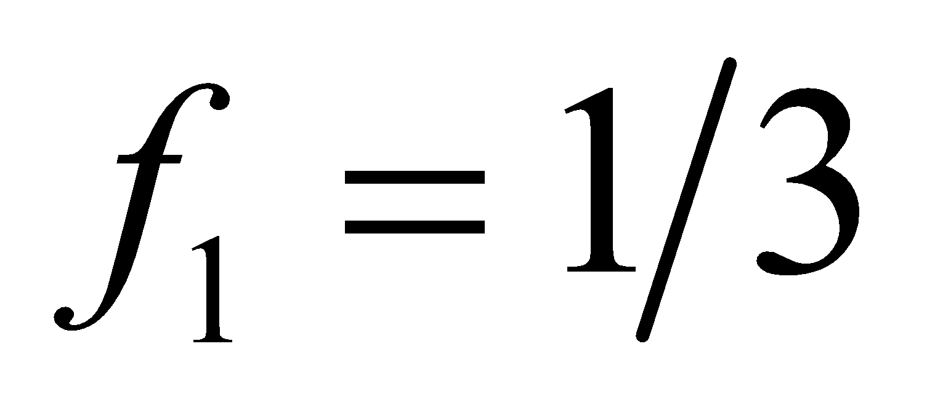 and 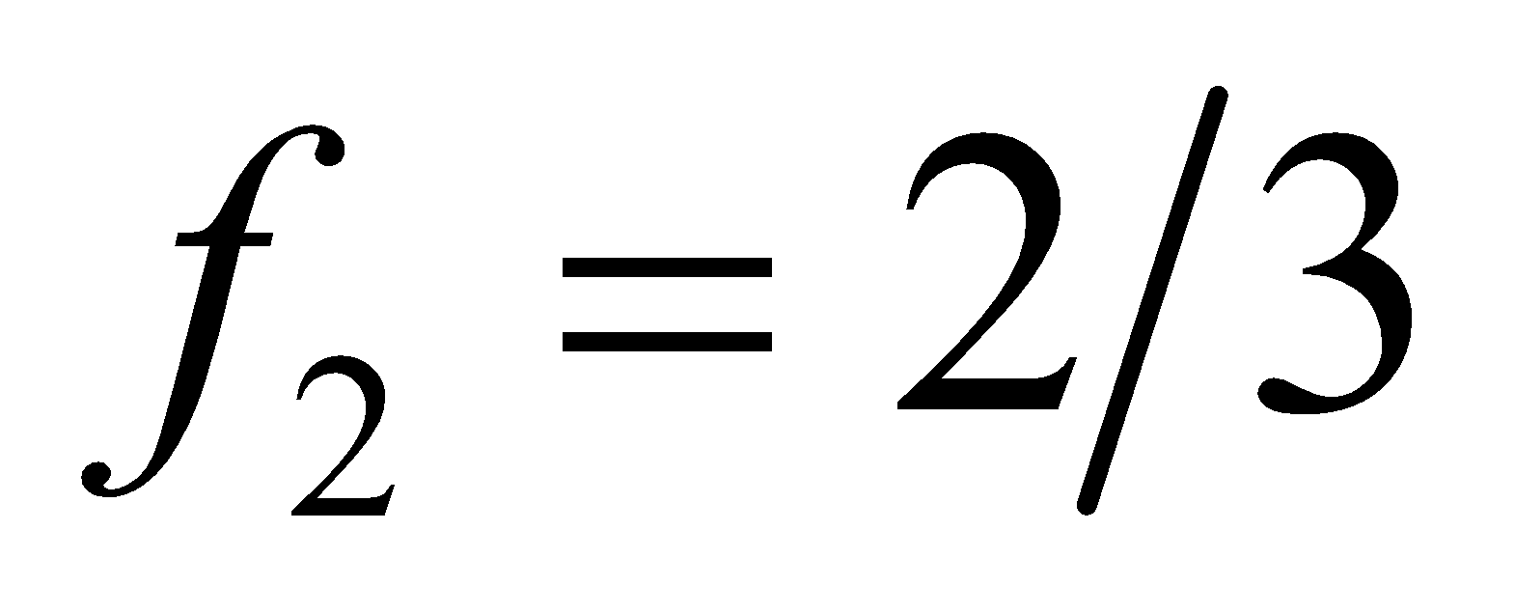. With 10 mol of monatomic gas, one needs 20 mol of triatomic gas.

**Assess** There is twice the number of triatomic molecules as there are monatomic molecules.

**60. Interpret** This problem is about melting, and it involves heat of fusion. The source of energy is the gravitational potential energy of the rock that is dropped into the water.

**Develop** The gravitational potential energy of the rock melts the ice and no heat energy is transferred (Q = 0) to the environment. The first law of thermodynamics (Equation 18.1) then takes the form *ΔU* = *W*. The work is *W* = *m*rock*gh* and the internal energy of the ice is raised *m*ice*L*f (see Equation 17.5), where *L*f = 334 kJ/kg (from Table 17.1). Therefore, we have

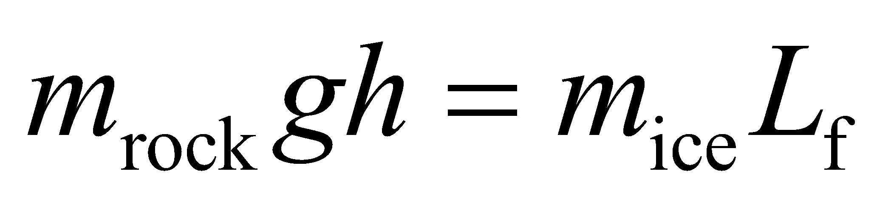

**Evaluate** Thus, we find the height from which the rock must be dropped is

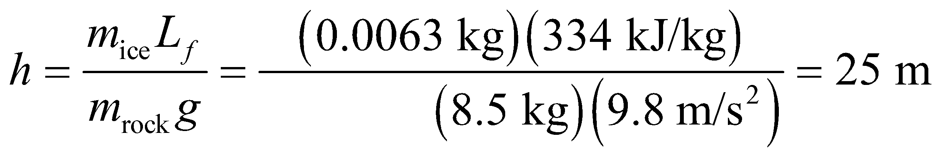

**Assess** In this problem, the rock did positive work on the ice-water system. Therefore, the work done *on* the system is positive, so *W* > 0.

**61.** **Interpret** This problem deals with an isothermal expansion of a gas from an unknown pressure to the ambient pressure of 1 atm. The expansion extracts heat from the surrounding ice-water bath so that 10 g of ice are created in the process. We are to find the original pressure of the gas.

**Develop** For an isothermal expansion of an ideal gas, Equation 18.4 and the ideal-gas law (PV = nRT = constant for an isothermal expansion) give

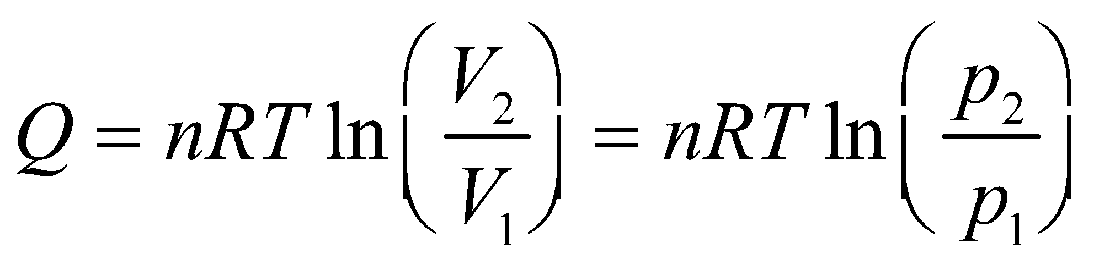

From this,

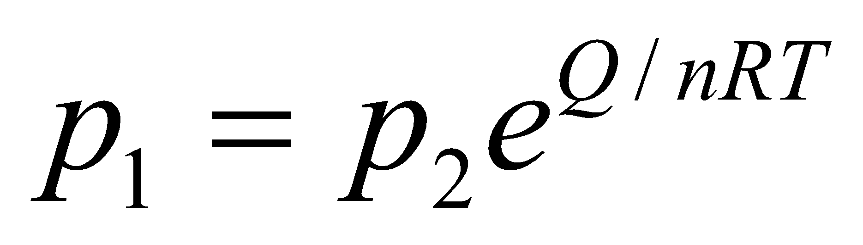

where *p*1 is the original gas pressure, *p*2 = 1 atm, and n = 0.30 mol. The heat Q is provided by the freezing of 10 g of ice that is already at 0°C, which is (see Equation 17.5)



**Evaluate** Inserting the known quantities into the expression for p1 gives

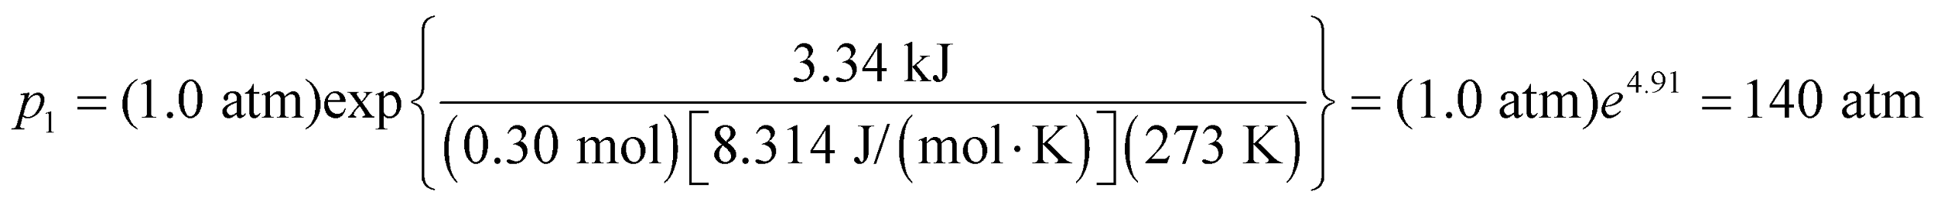

to two significant figures.

**Assess** Notice that the original quantity of ice is not involved, provided we know the ice-water bath is at 0°C and the quantity of the ice that is produced by the energy requirements of the isothermal expansion.

**62. Interpret** The problem concerns the work done in expanding a frog's lung.

**Develop** Equation 18.3, 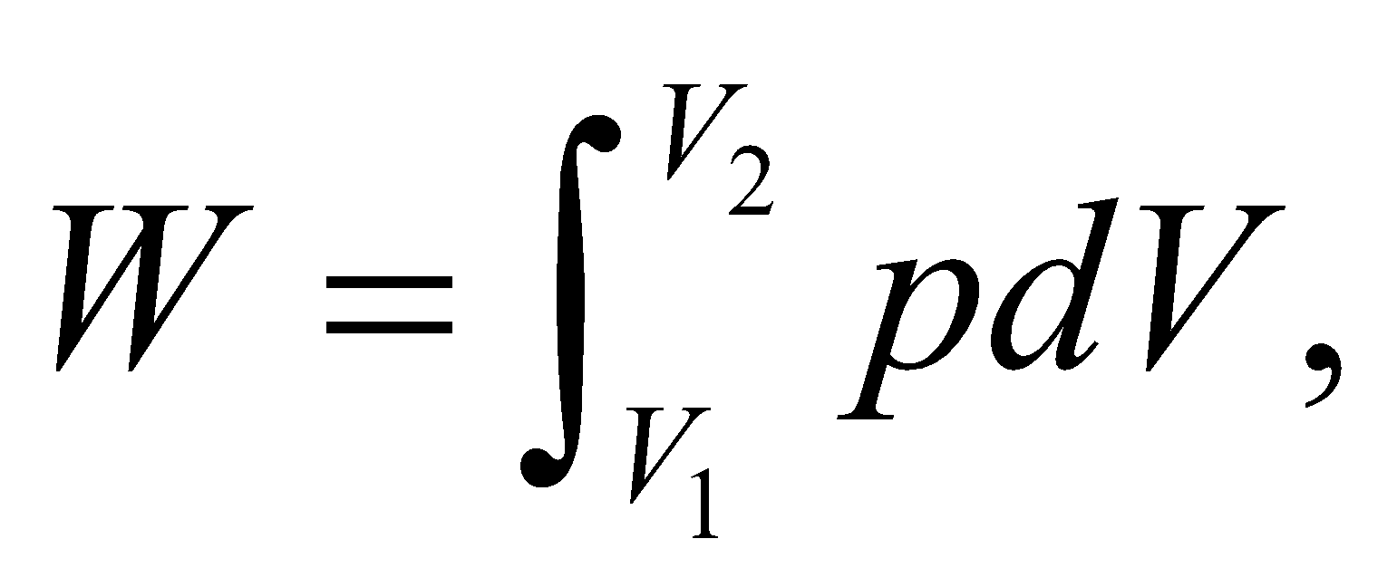 gives the work done by a gas as its volume goes from 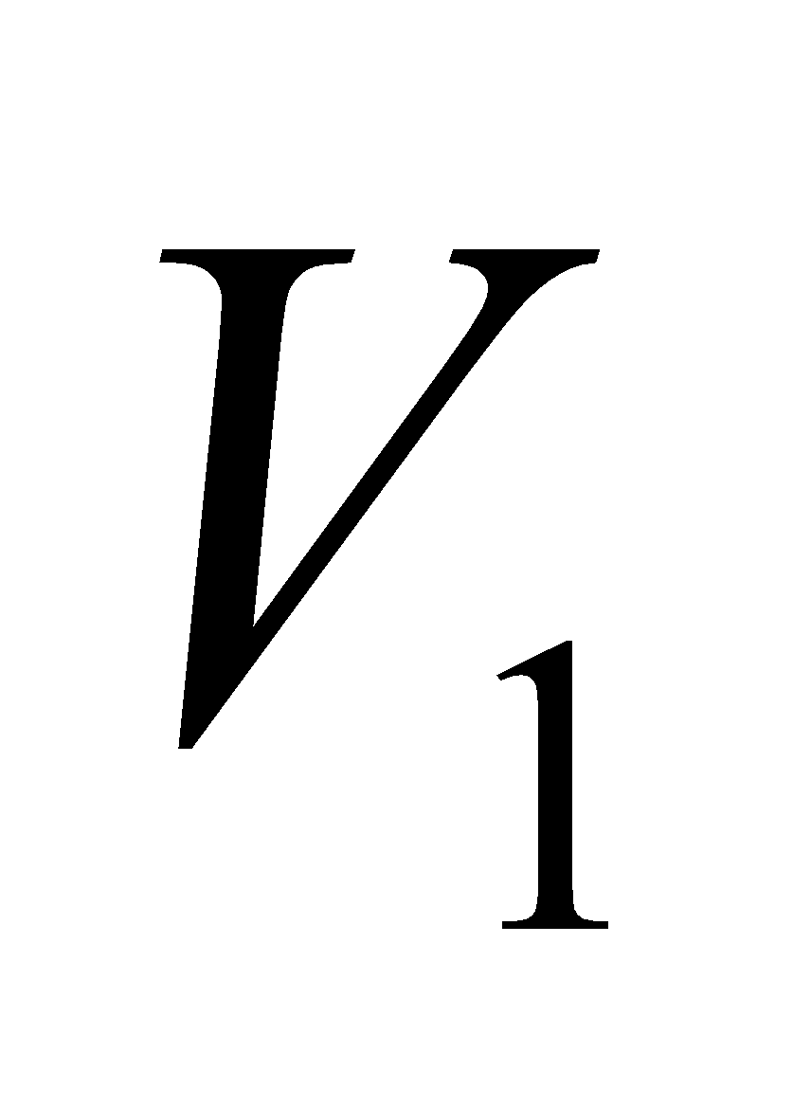 to 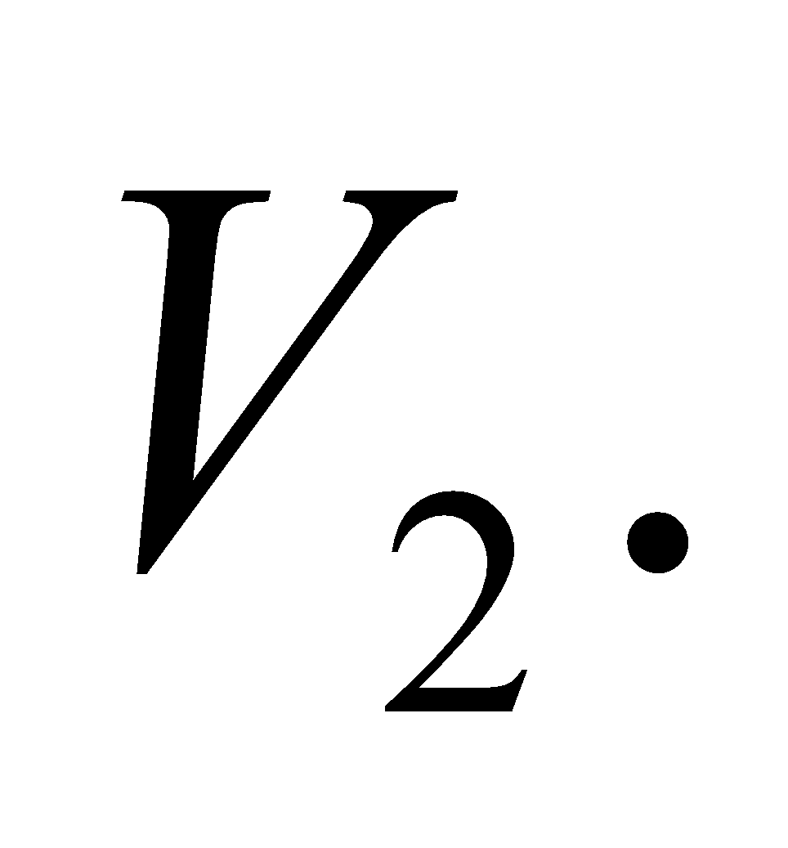 We'll plug the formula for the pressure in the frog's lung, 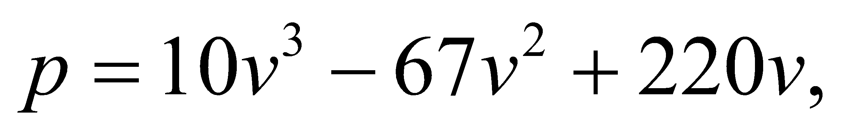 where *p* is in Pa and 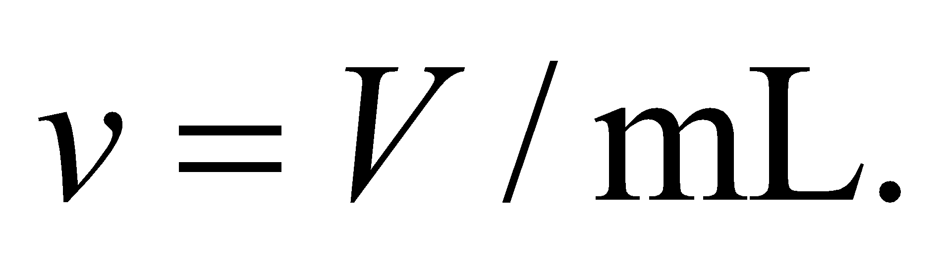

**Evaluate** If the frog's lung inflates from 0 to 4.5 mL, the work done by the gas is

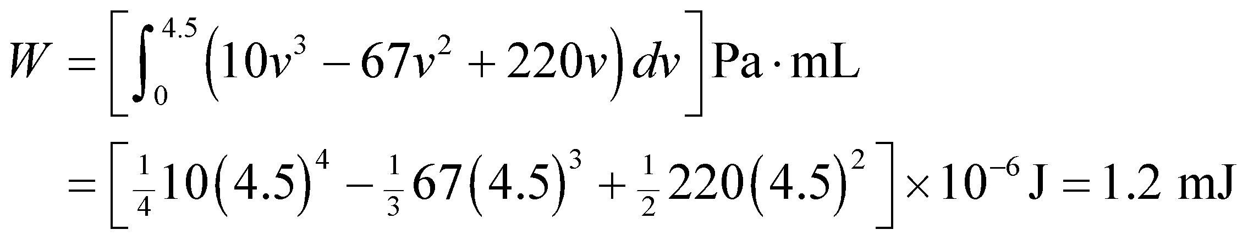

**Assess** This is much smaller than our result in Problem 18.52, but there we were considering a human lung inflating to over 1500 mL.

**63.** **Interpret** For this problem, we are to derive the work done by an adiabatic process by applying Equation 18.3, which describes the work done by changes in a volume of gas.

**Develop** For an adiabatic process, pressure and volume are related by Equation 18.11a, *pVγ* = constant. Applying this to a gas before and after an arbitrary adiabatic process

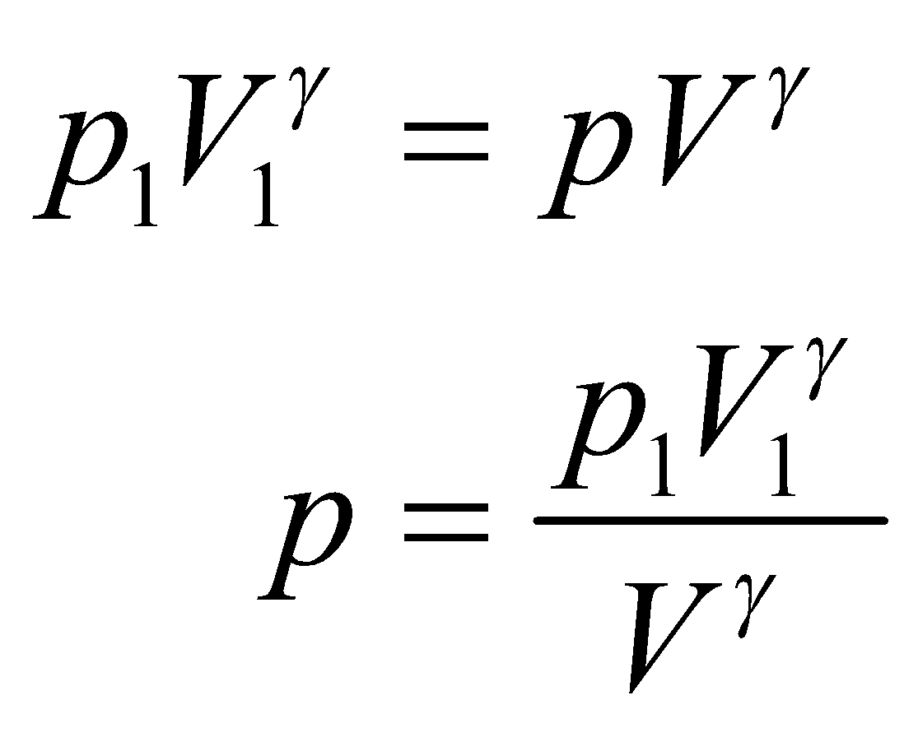

Insert this expression into Equation 18.3 to find the work done by an adiabatic process.

**Evaluate** The work in going from a pressure *p*1 to a pressure *p*2 via an adiabatic process is

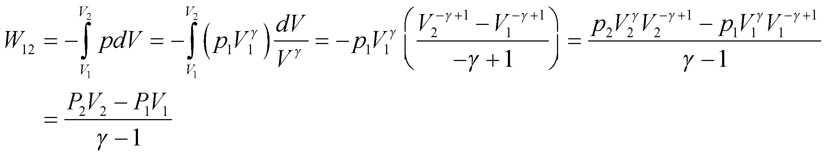

which is Equation 18.12 (note that we have used 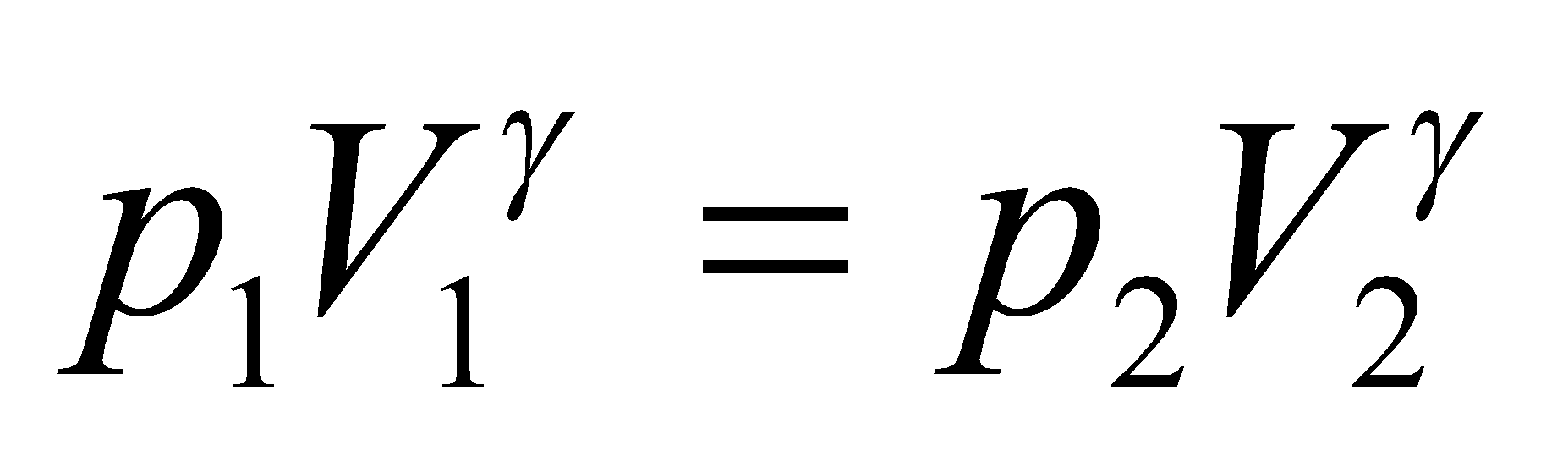 to obtain the last equality of the first line).

**Assess** From the general expression for work done by a change in volume of a gas, we have derived the expression for the work done by an adiabatic change in volume of a gas.

**64. Interpret** The system of interest is the horizontal piston-cylinder system that contains an ideal gas. We want to demonstrate that the piston undergoes simple harmonic motion when slightly displaced.

**Develop** Since the piston-cylinder system is horizontal (see figure below), we do not need to consider the force of gravity on the piston. At equilibrium, the pressure forces from inside and outside the piston are equal, so the gas pressure at the equilibrium position of the piston is *p*0. We also assume that the gas temperature at equilibrium is *T*0, so 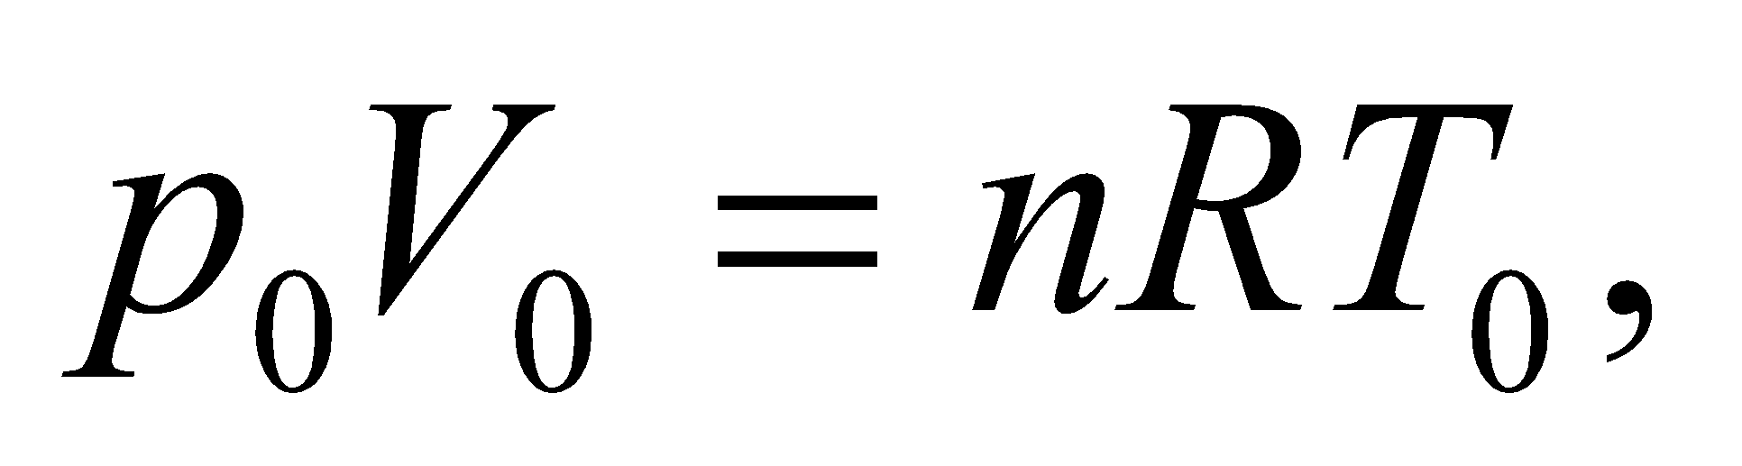 where 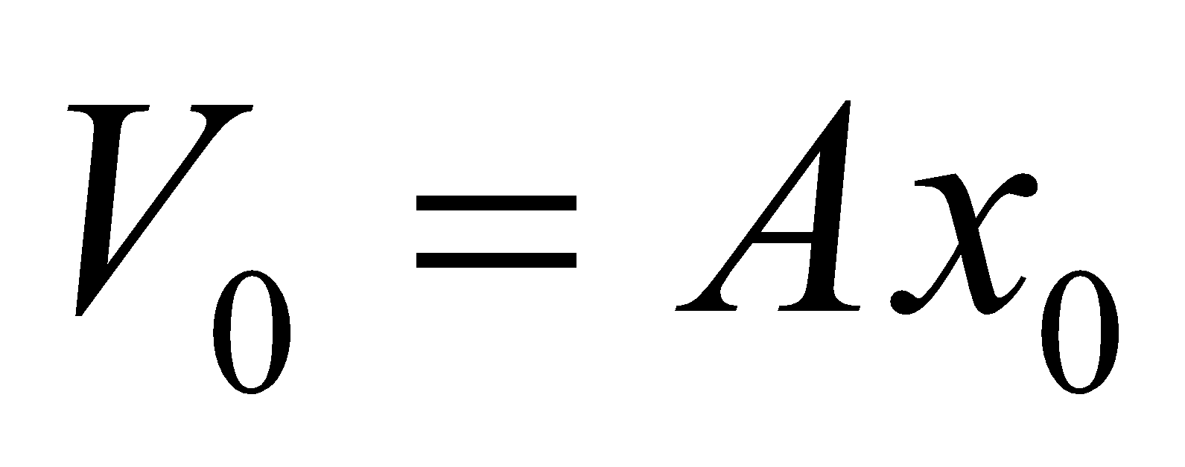 is the piston volume at equilibrium. When the piston is displaced from its equilibrium position by an amount *Δx* (positive to the right), the horizontal force on it is 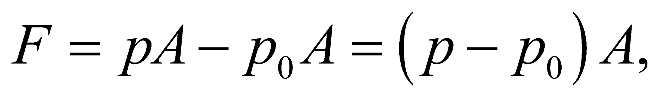 and Newton’s second law gives an acceleration of

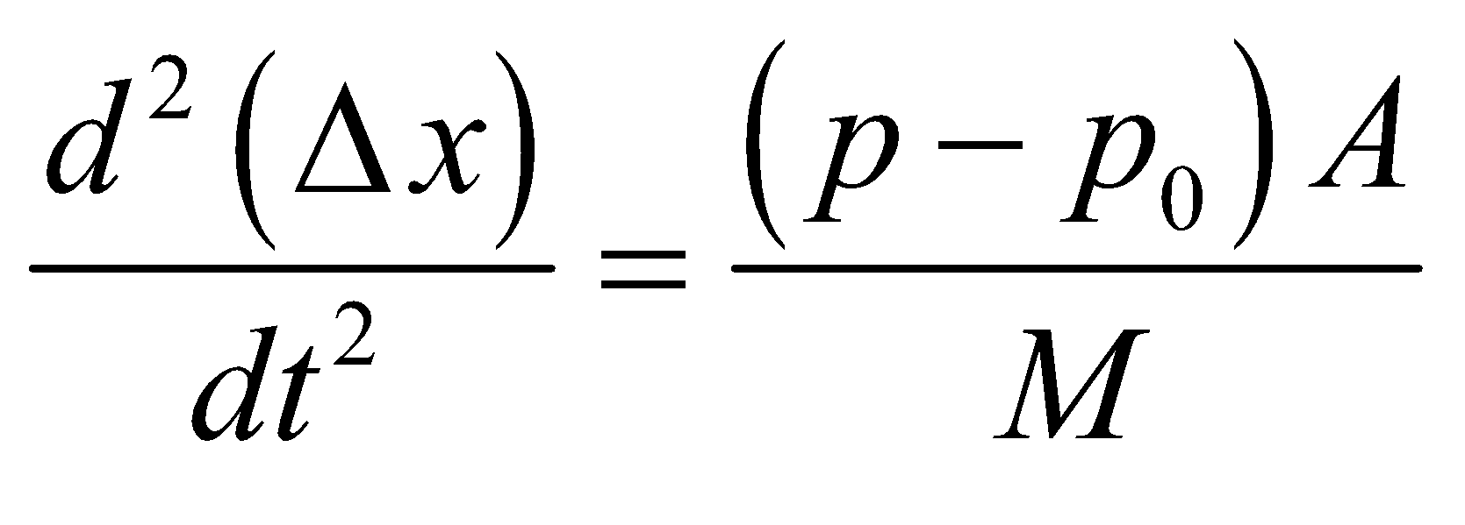

For isothermal expansions and compressions of the gas,

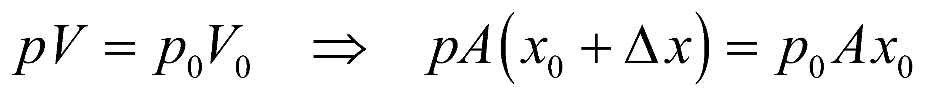

For small displacements 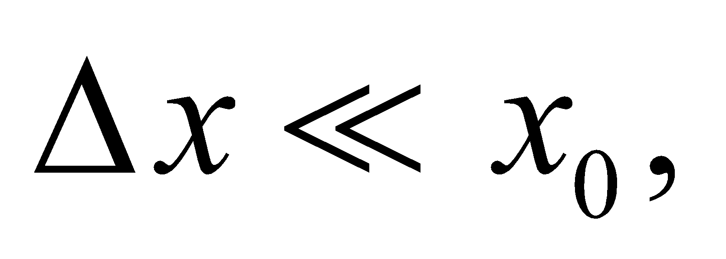 the pressure is

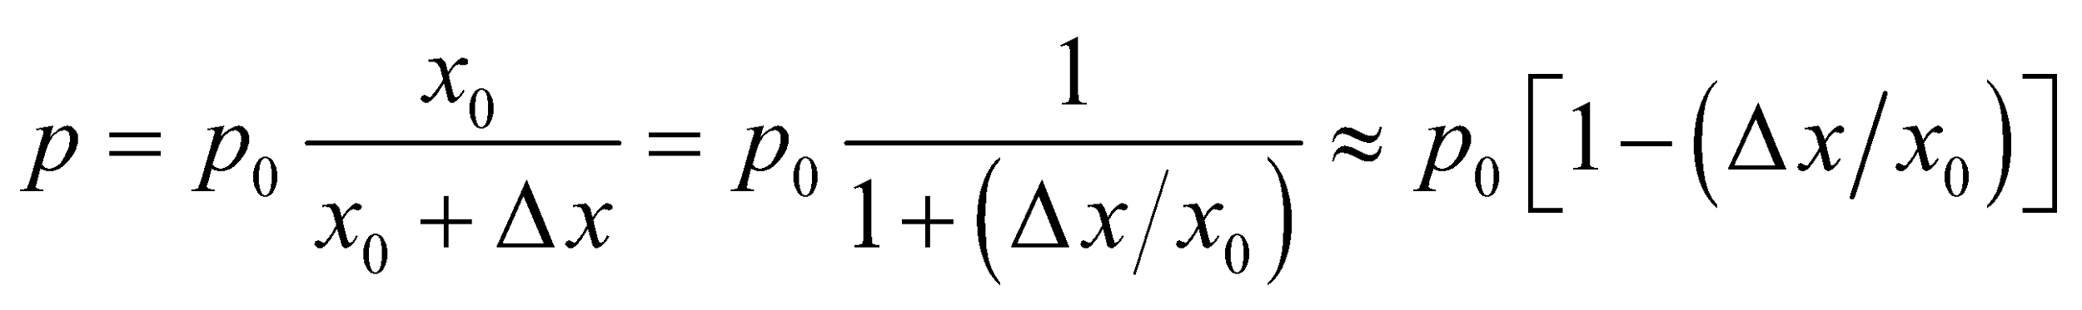

(see the binomial approximation in Appendix A). Substituting the expression for *p* into Newton’s second law equation allows us to show that the piston executes simple harmonic motion.



**Evaluate** Combining the two equations above yields

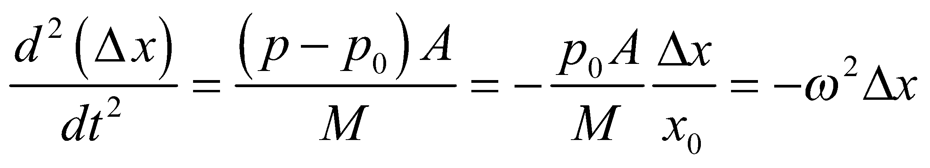

where 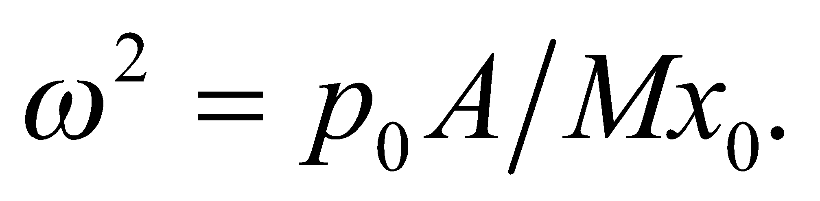 This is the equation for simple harmonic motion of the piston, about its equilibrium position 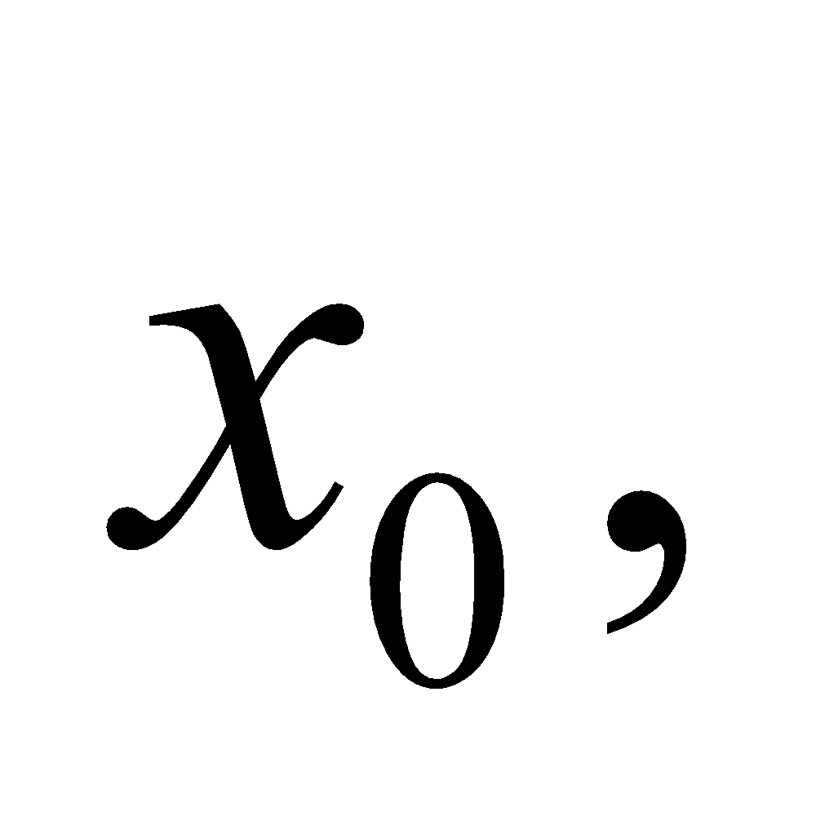with angular frequency 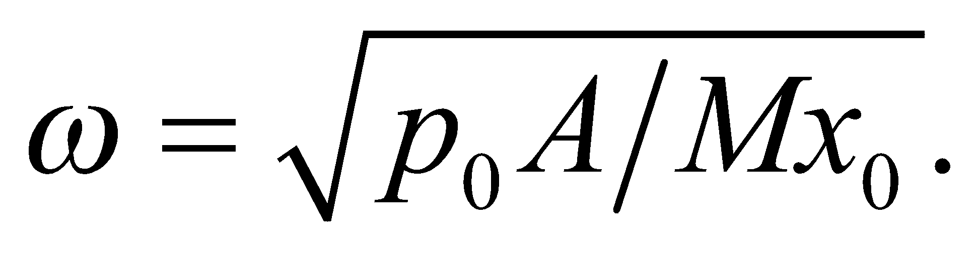 Since 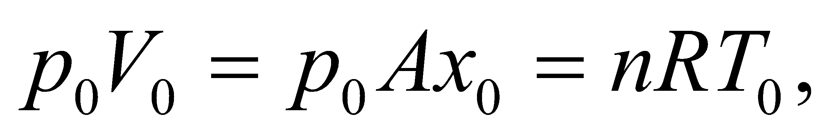 we may eliminate *x*0 to obtain

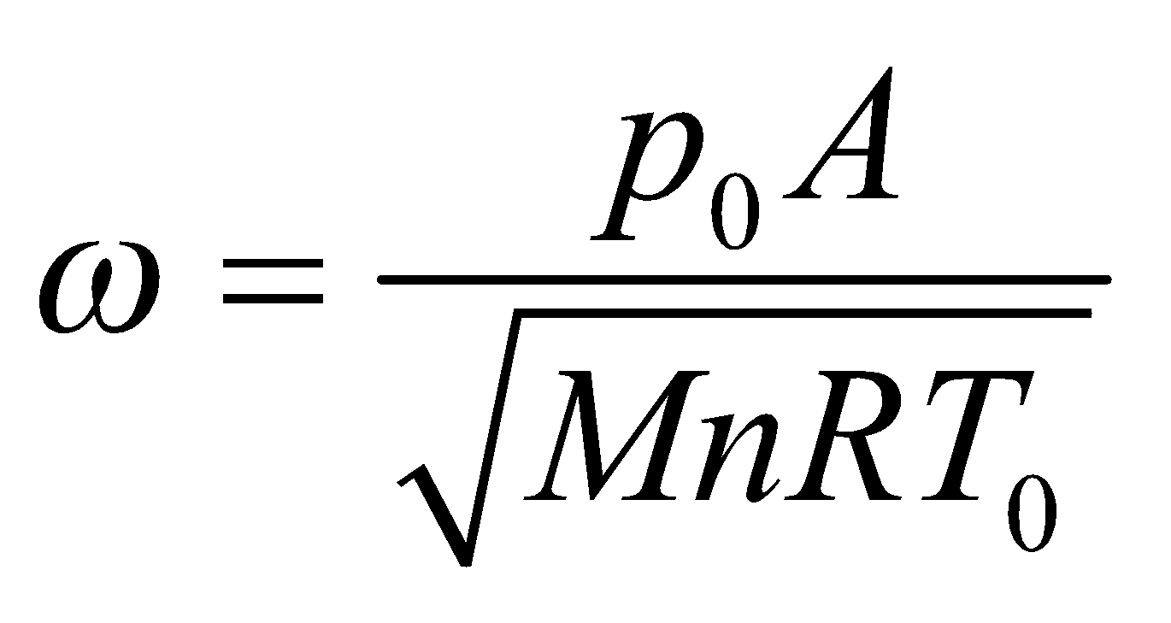

**Assess** In order for the gas temperature to remain constant, as assumed above, heat must flow into and out of the gas. This requires time, so the motion of the piston must be very slow. If the motion is rapid (or if the cylinder is thermally insulated), there is no time for heat transfer in the gas and the expansions and compressions are adiabatic. In this case,



or 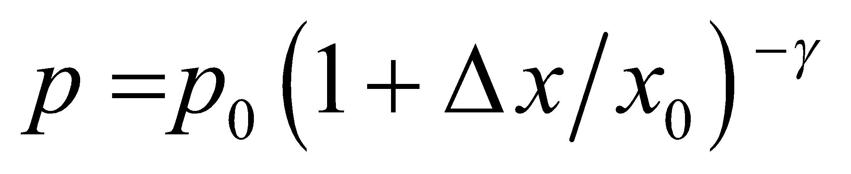 For small displacements 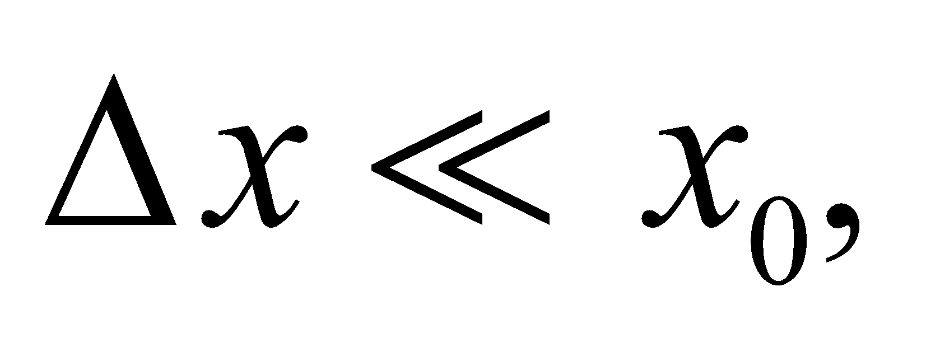 we have 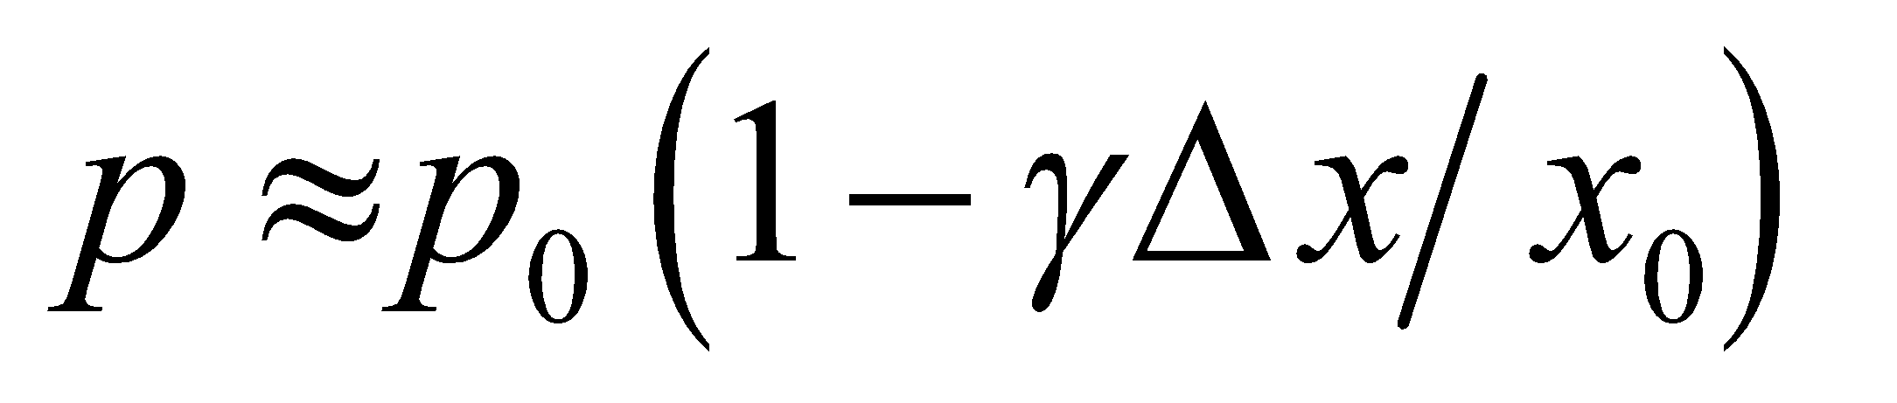 and

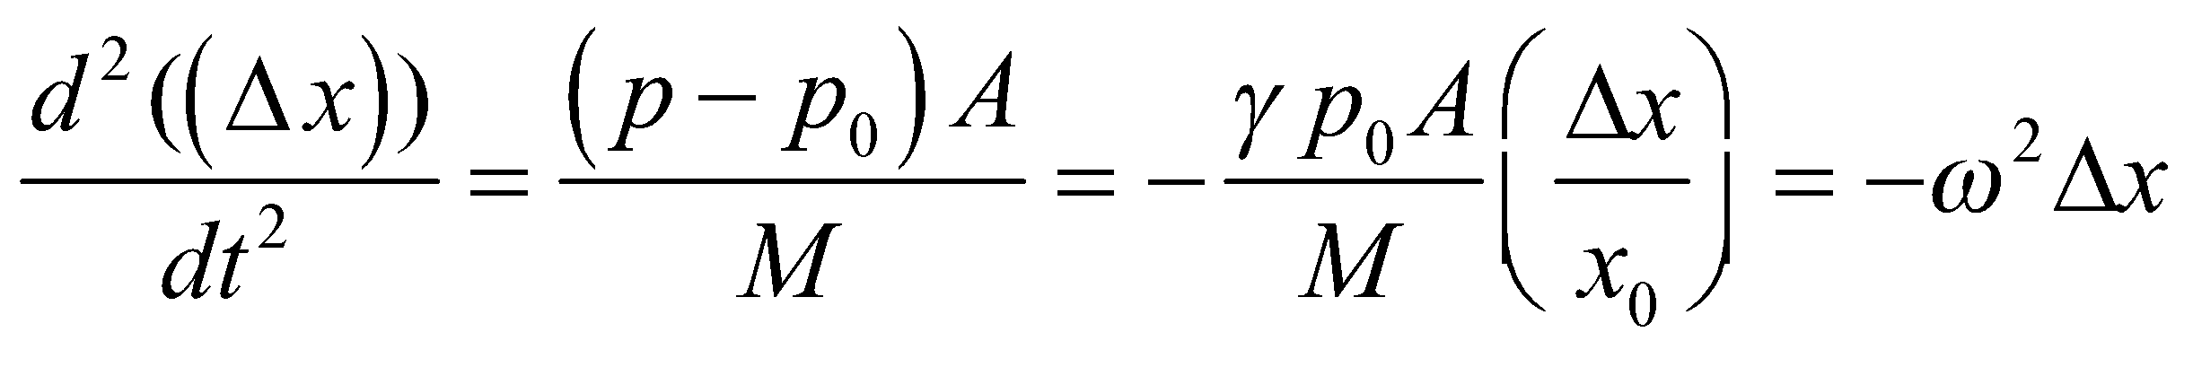

where 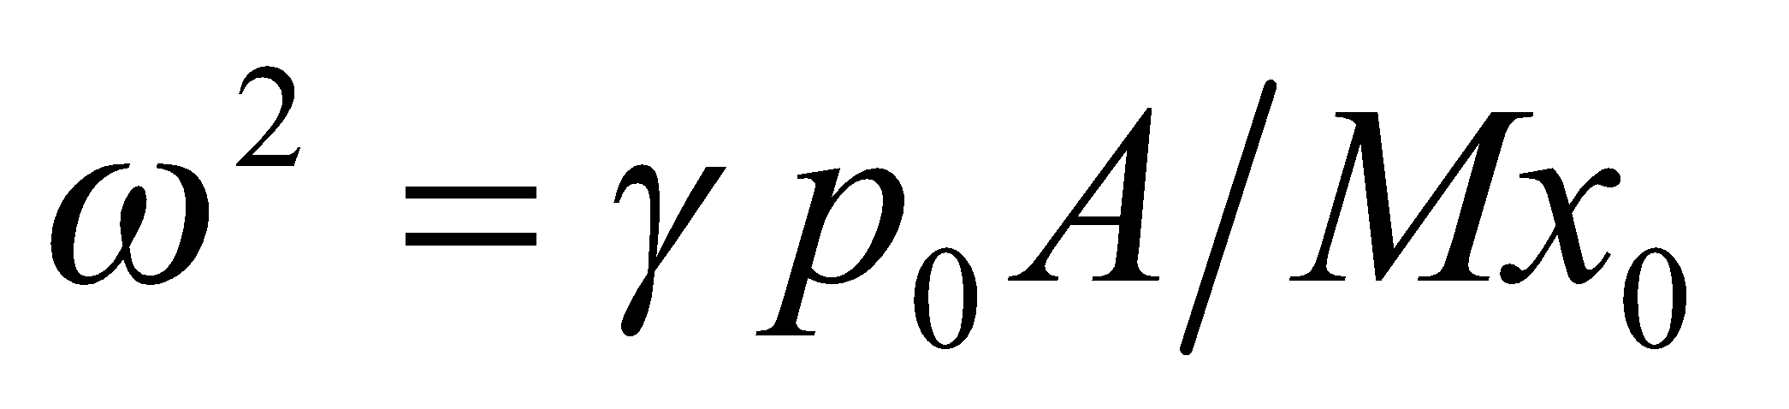 This represents simple harmonic motion with

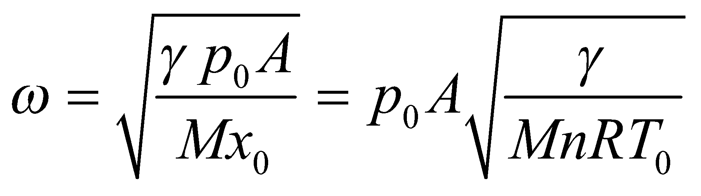

**65. Interpret** We are to derive the relationship between temperature and volume for adiabatic processes.

**Develop** For an adiabatic, the relationship between pressure and volume is  Use this and the ideal-gas law (Equation 17.2) 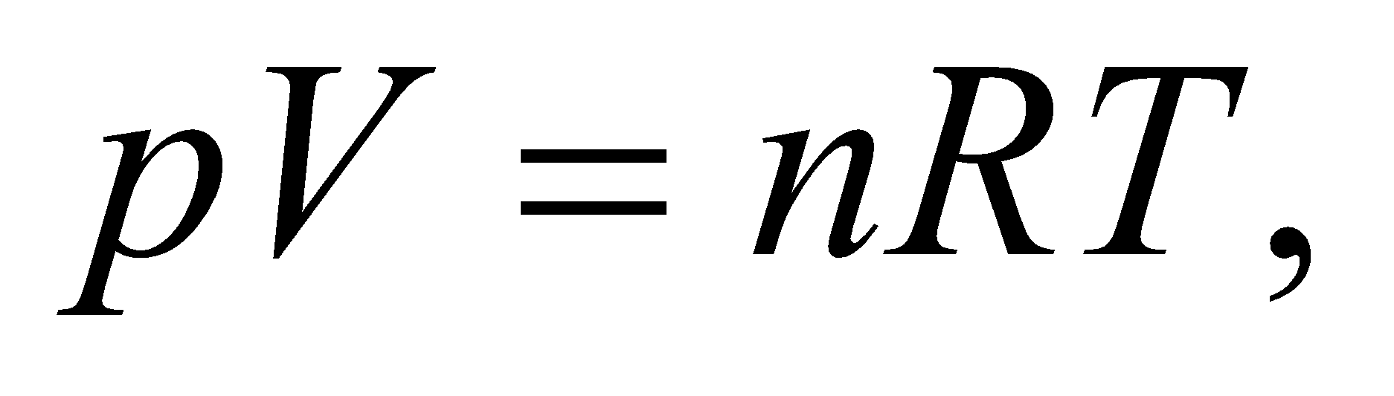 to derive equation 18.11b, 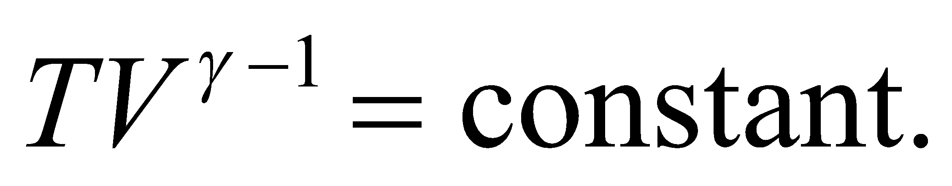

**Evaluate** From the ideal-gas law,

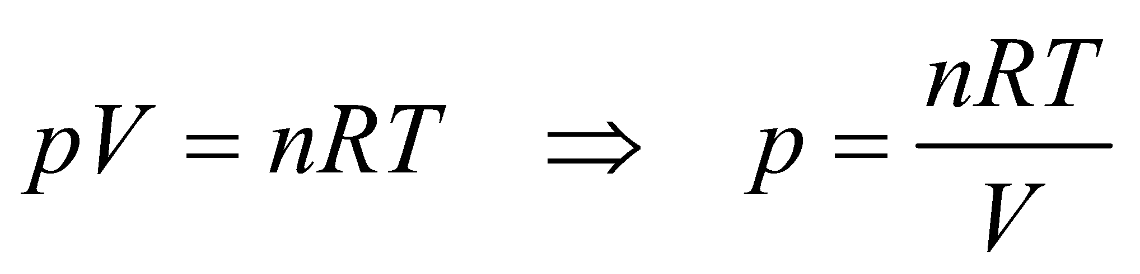

Substitute this into 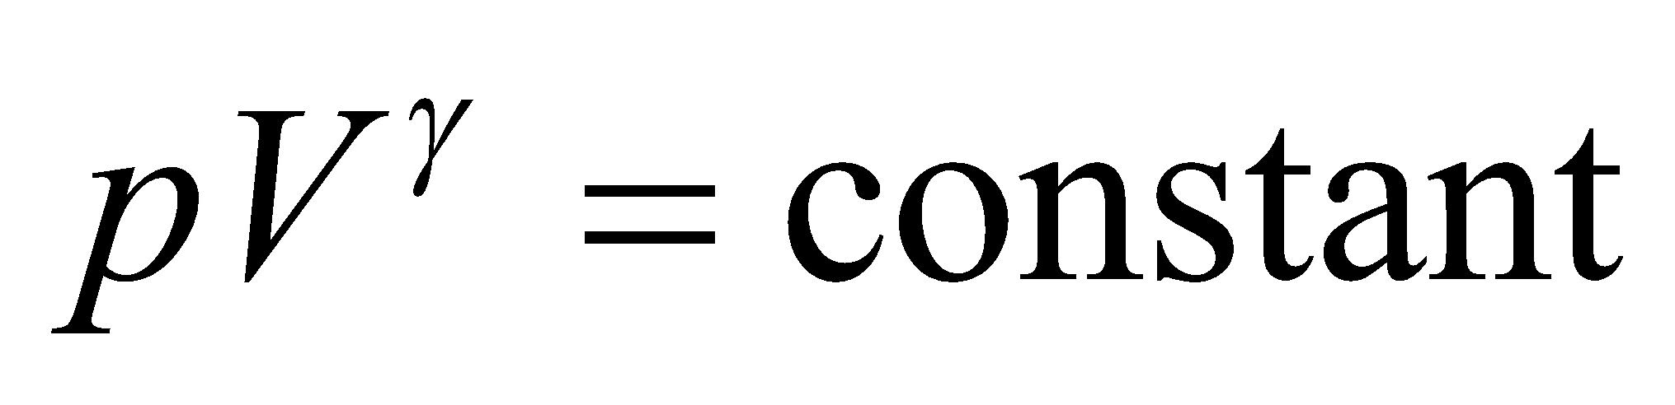 to obtain

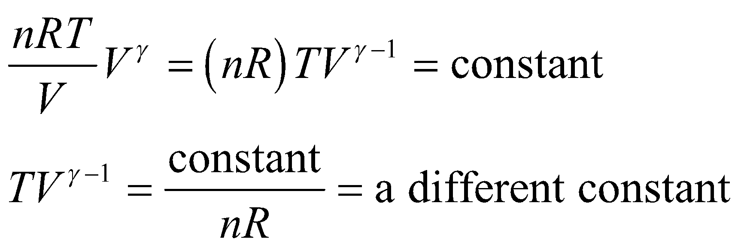

**Assess**We have shown what was required. Note that the constants involved in Equations 18.11a and 18.11b are different constants.

**66. Interpret** The problem involves a cyclic process, and we identify four separate stages of the cycle: adiabatic compression, isobaric expansion, adiabatic expansion, and constant-volume cooling.

**Develop** From Table 18.1, the work done and heat absorbed during each of the four processes comprising the diesel cycle is:

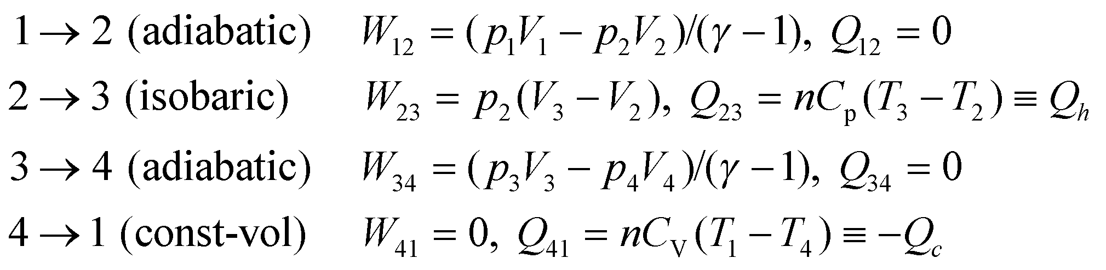

For the whole cycle, the work done is



where we have used the fact that 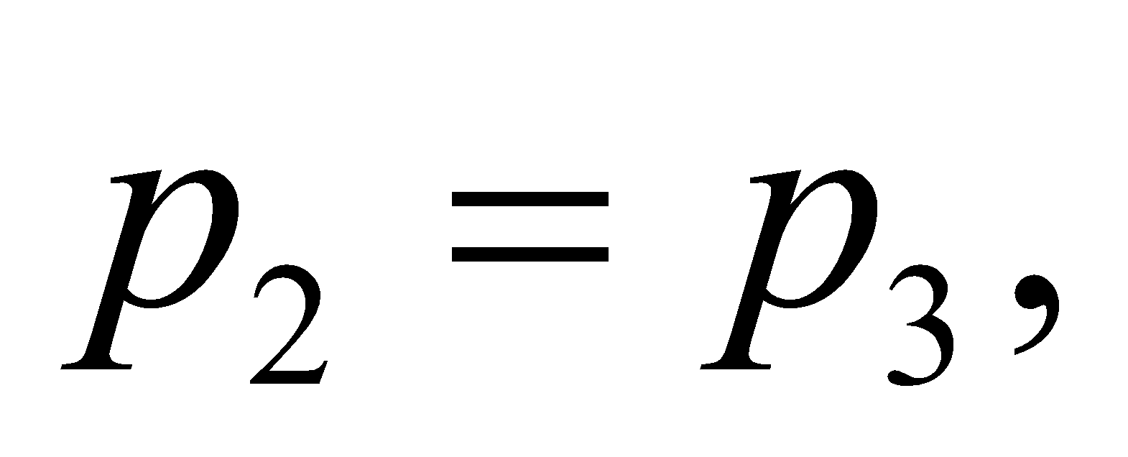and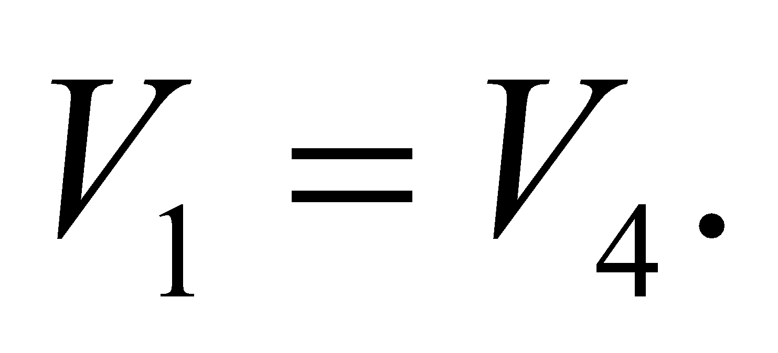The heat added in the isobaric process can be written as

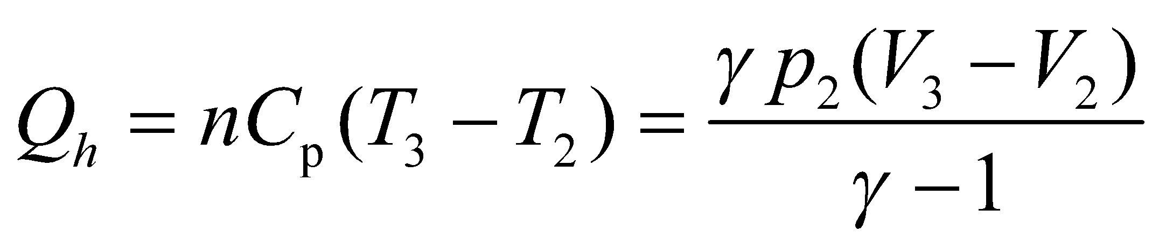

where we used the ideal-gas law,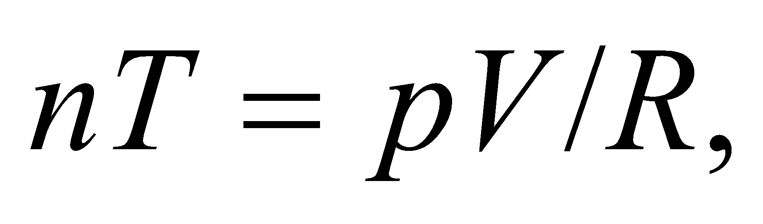and have rewritten the specific heat as

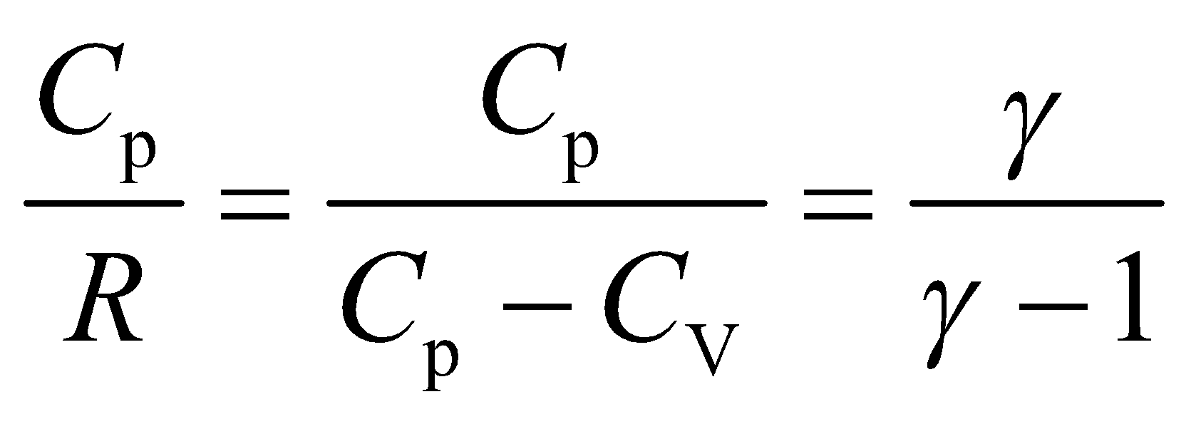

Therefore, the work done by the system can be rewritten as

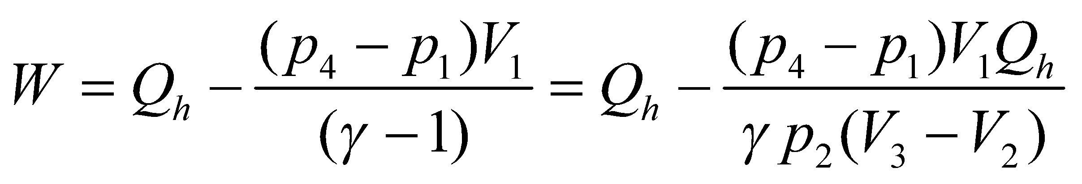

**Evaluate** The efficiency is the work divided by the heat input:

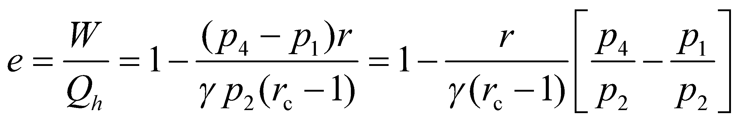

Where we have used 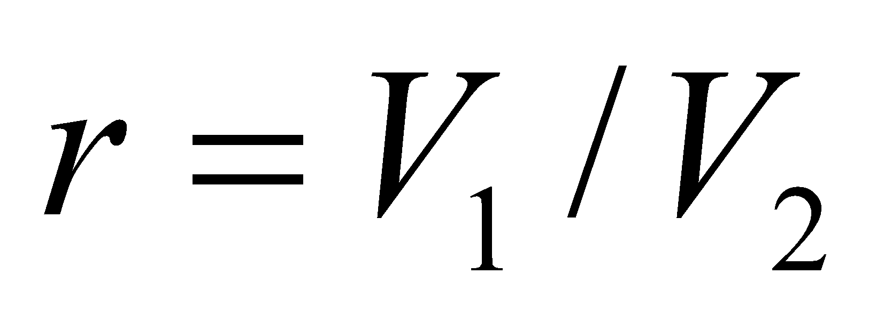 and 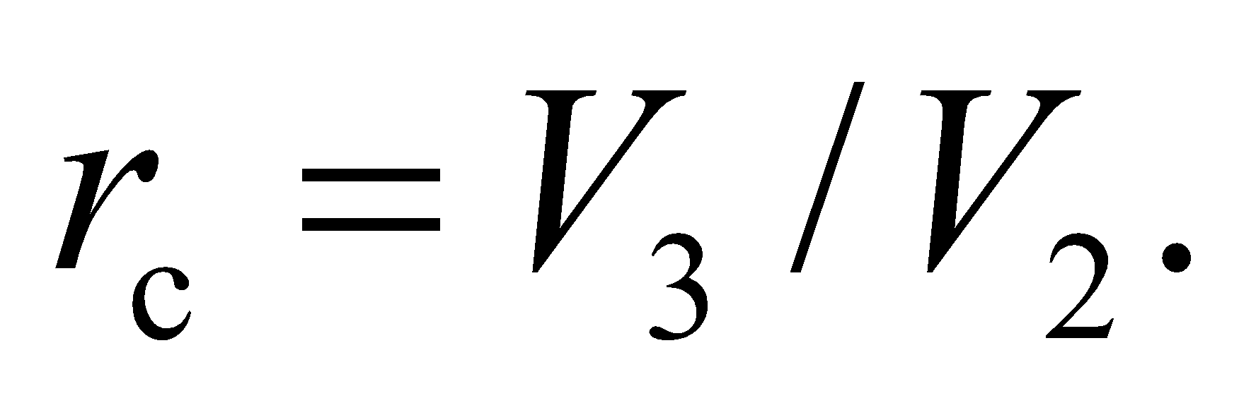For the adiabatic expansion, 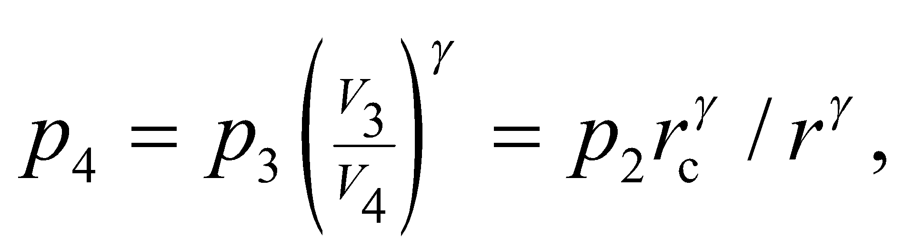 while for the adiabatic compression, 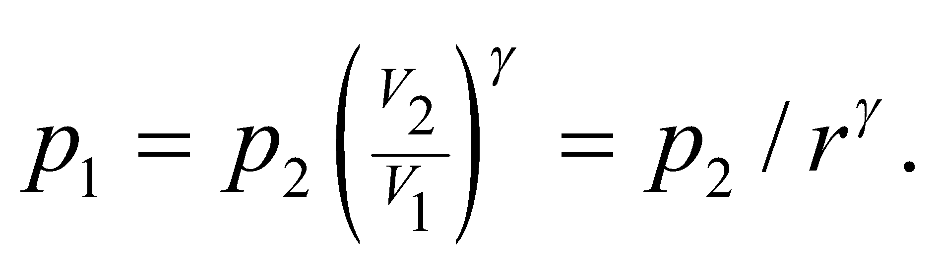 The efficiency can be finally written as

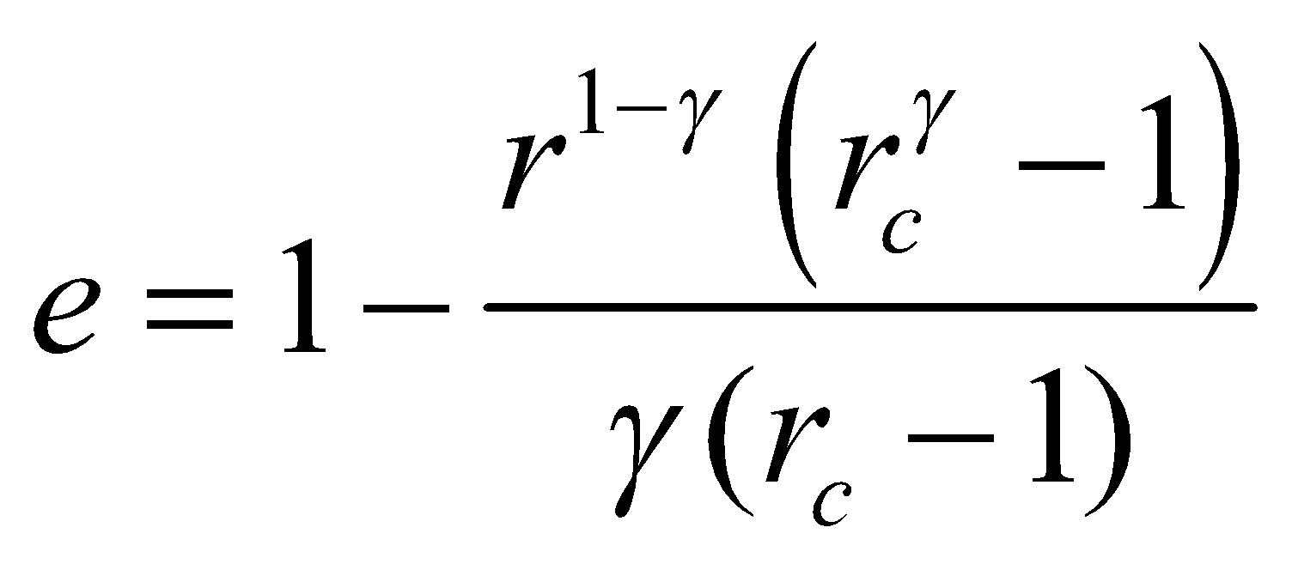

**Assess** A gasoline engine has a similar efficiency: 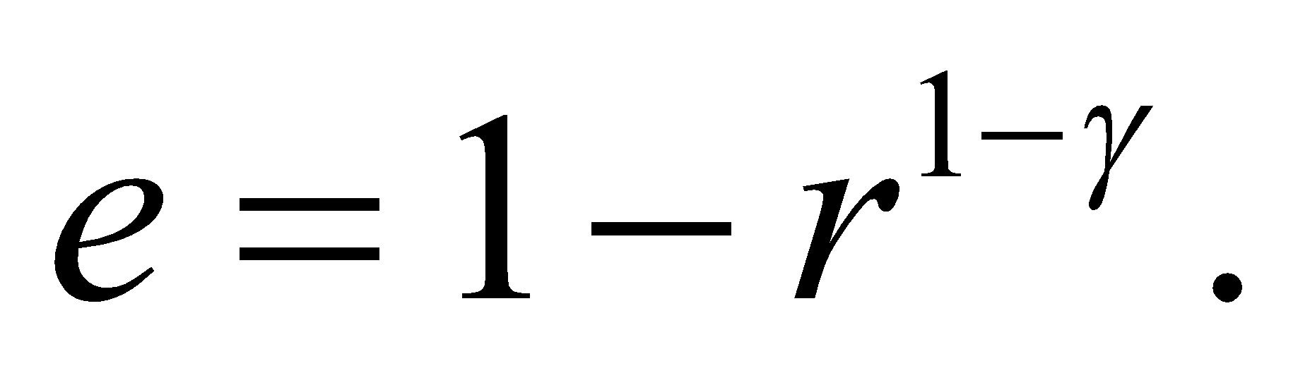For the same compression ratio, the gasoline engine would be more efficient. However, in general, diesel engines have much higher compression ratios that make them around 30% more efficient than gasoline engines.

**67. Interpret** We are given the relationship between pressure and volume for compressing a given volume of air, and we are to find the work done during this reversible process.

**Develop** The most general equation for work done by a gas is Equation 18.3: 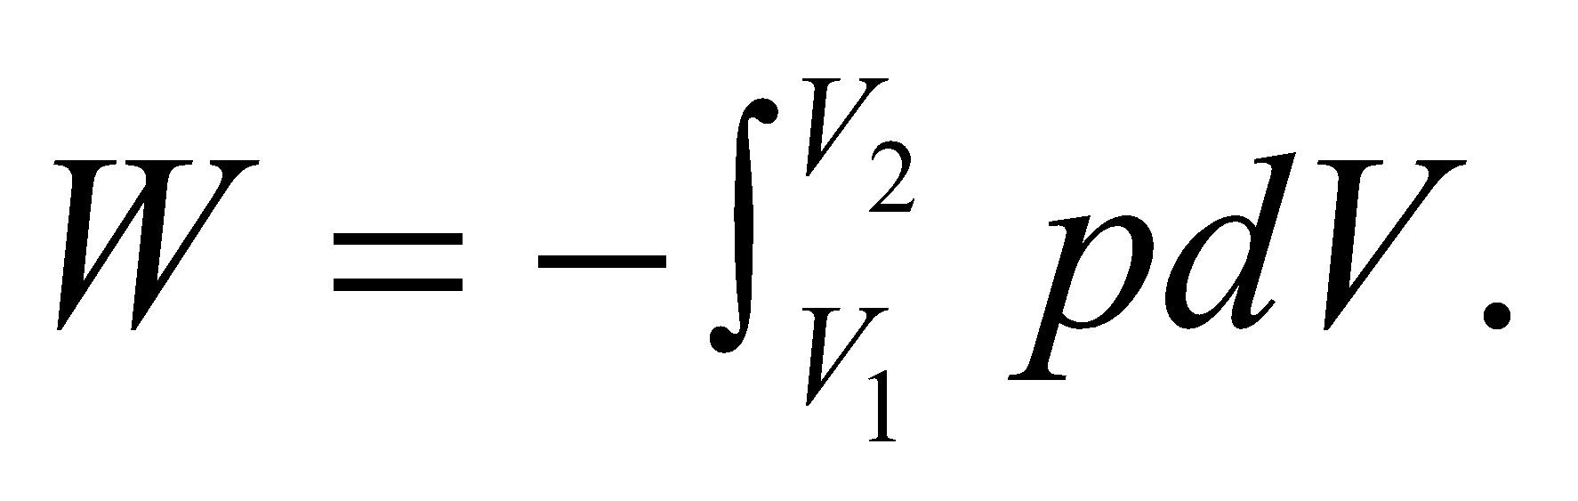 We are given the initial pressure *p*0 = 1.0 atm, the initial volume *V*0 = 17 m3, the final pressure *p*f = 1.4 atm, and the formula

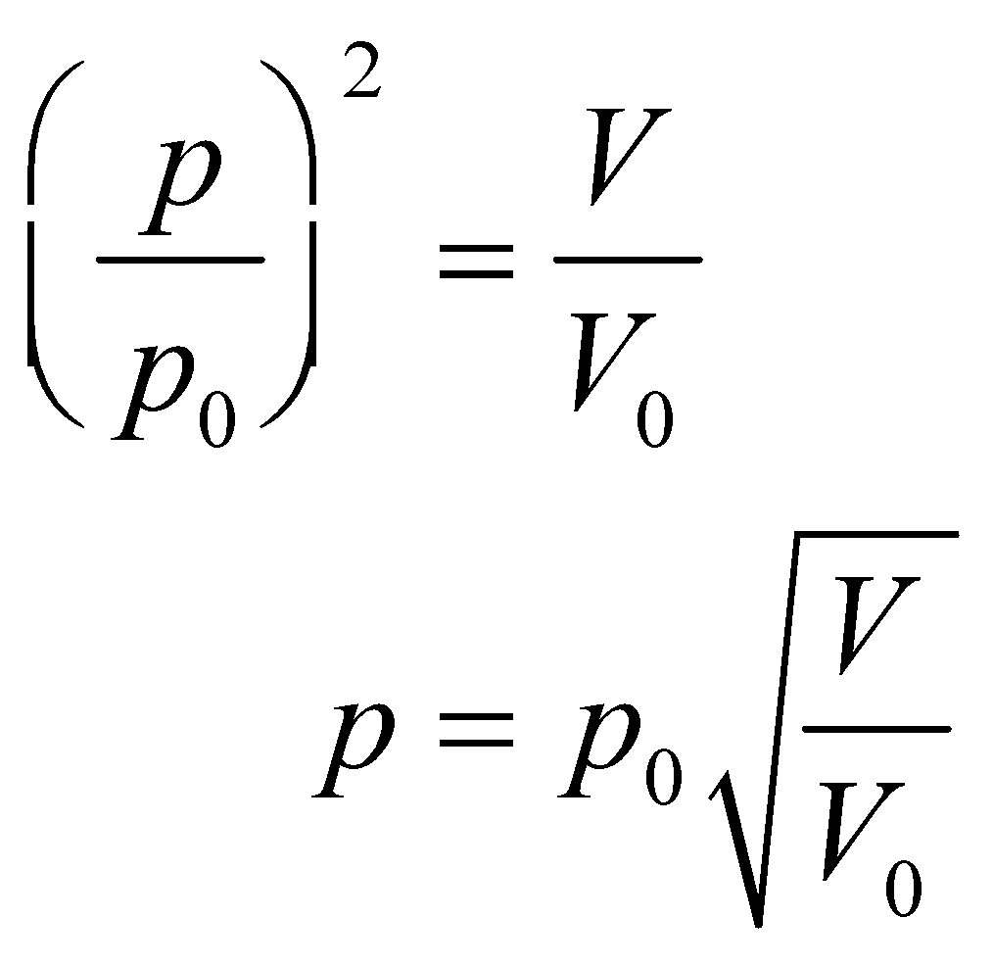

Insert this into Equation 18.3 and integrate from *V*0 to *V*f, where *V*f is given by

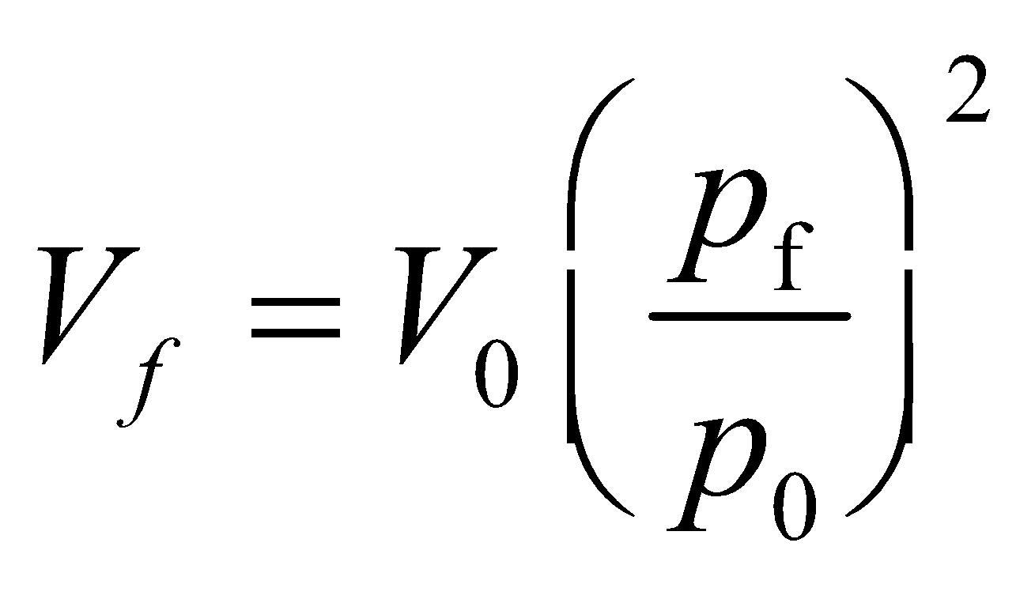

**Evaluate** Performing the integration gives

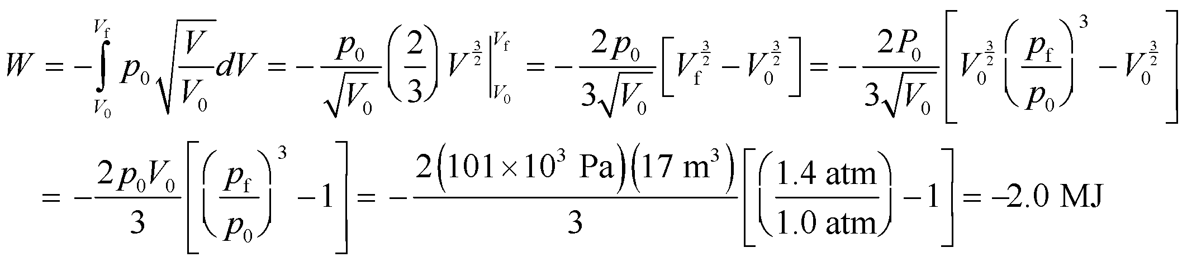

**Assess** Because the work is negative, the gas does 2.0 MJ of work on its environment in this process.

**68. Interpret** We are to derive an expression for the work done by a non-ideal gas in an isothermal process that follows the Van der Waals model. We are given the equation relating pressure and volume for a Van der Waals gas.

**Develop** Solving the Van der Waals expression for pressure gives

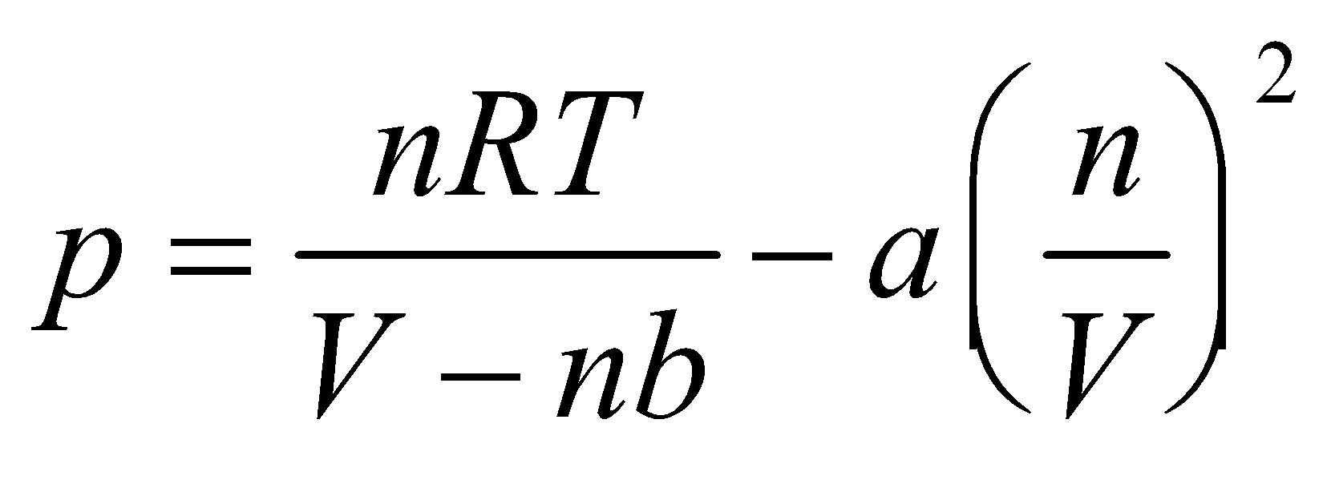

Insert this expression for pressure into Equation 18.3 and integrate from *V*1 to *V*2 to find the work done by the gas..

**Evaluate** Performing the integration gives

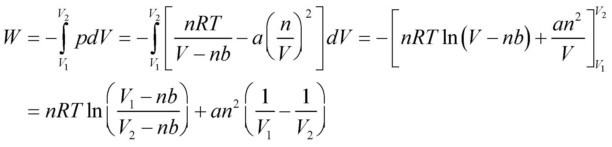

**Assess**For an ideal gas, *a* = *b* = 0, and this simplifies to 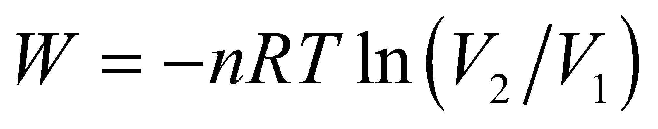 (Equation 18.4), as expected.

**69. Interpret**An ideal gas expands along a given path, and we are to find the work done by the gas. We can do this by using the general expression for work done by a gas that changes pressure and volume, Equation 18.3.

**Develop** The gas goes from (*p*1, *V*1) to (*p*2, *V*2) where *p*2 = 2*p*1 and *V*2 = 2*V*1. The path it takes is along

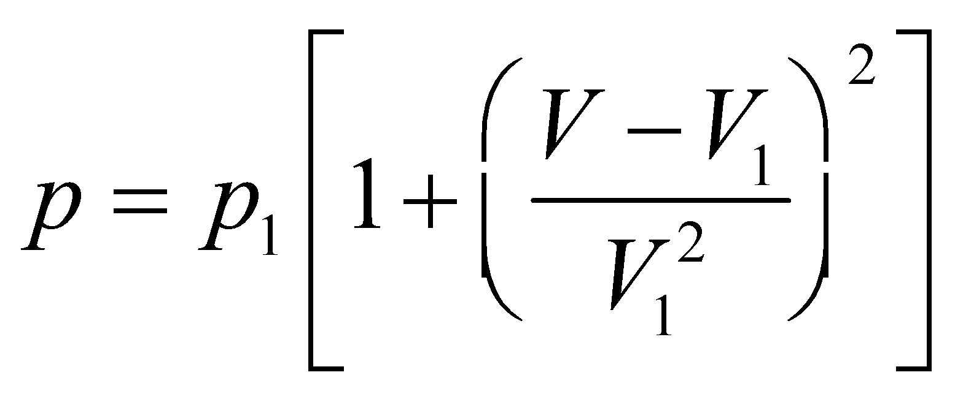

Insert this expression into the integrand of Equation 18.3 and integrate from *V*1 to *V*2 to find the work done on the gas. The work done by the gas will be the negative of this result.

**Evaluate** The work done on the gas is

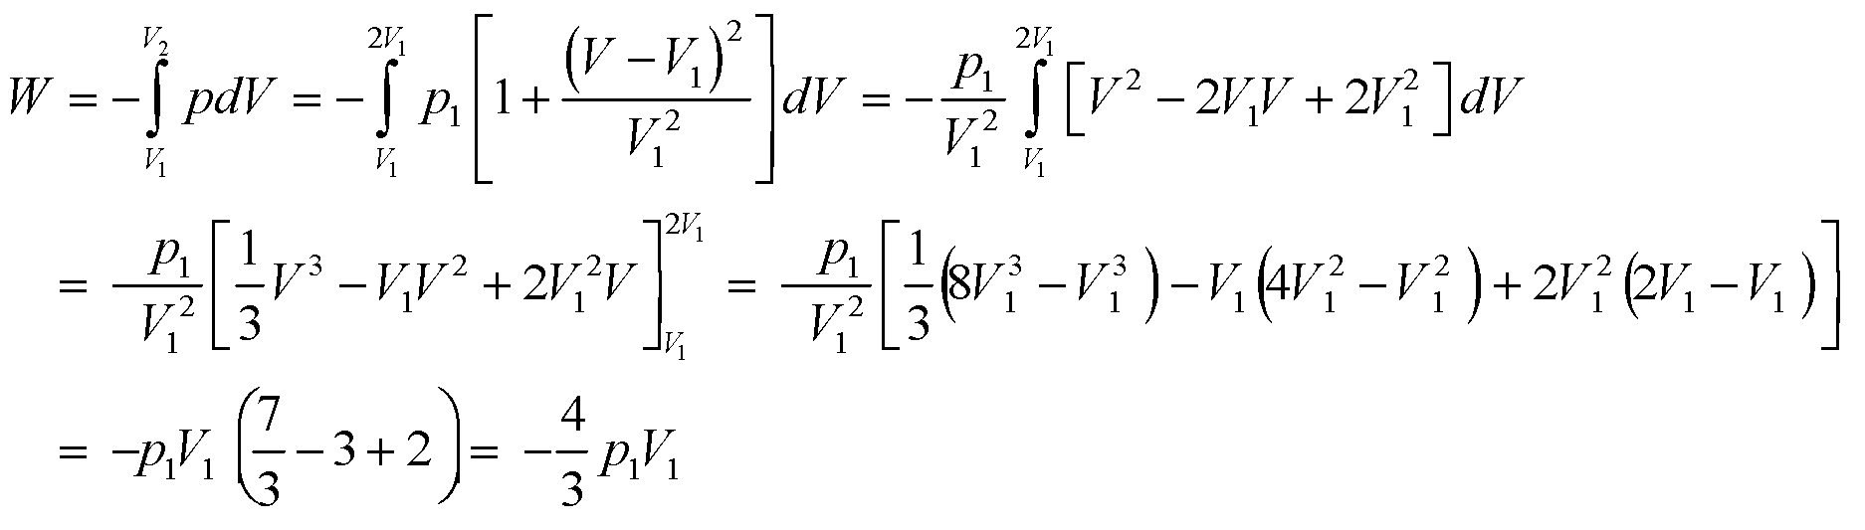

so the work done by the gas is 4*p*1*V*1/3.

**Assess** The units are pressure times volume, which is joules, as expected.

**70. Interpret** We calculate the rate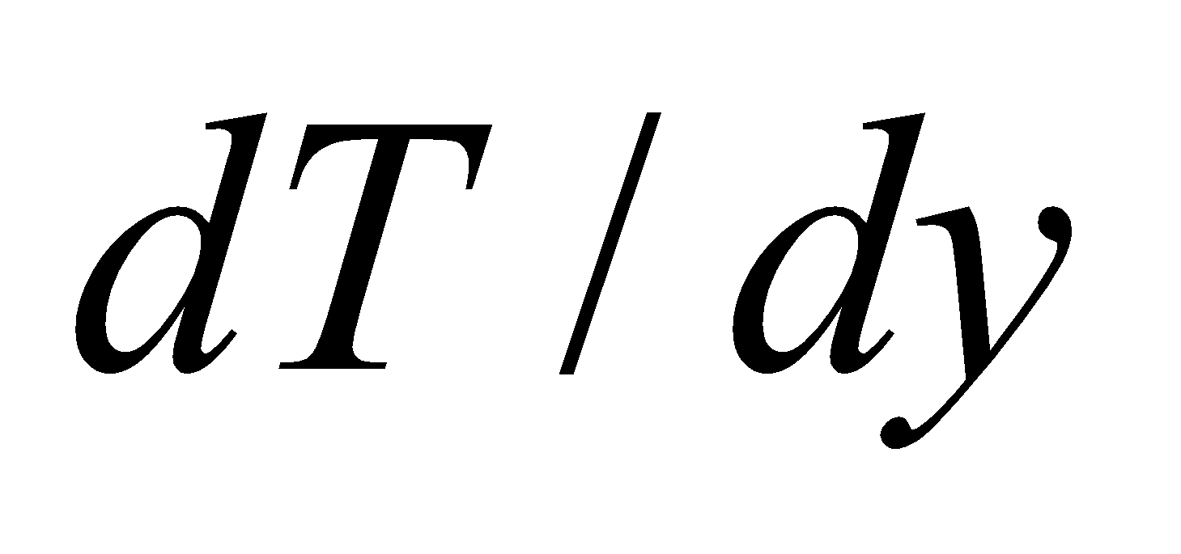at which air cools as it rises, approximating the process as adiabatic.

**Develop** To express *dT* in terms of *dp*, let's first differentiate the ideal-gas law: 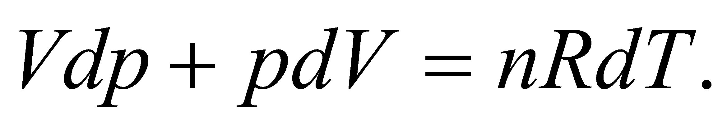For adiabatic processes, 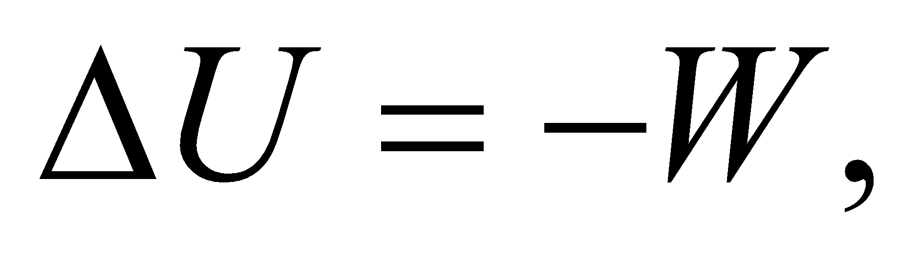which we can write in differential form as 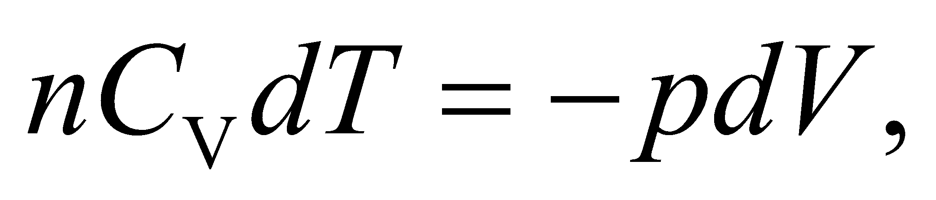 and insert into the differentiated ideal-gas law to obtain

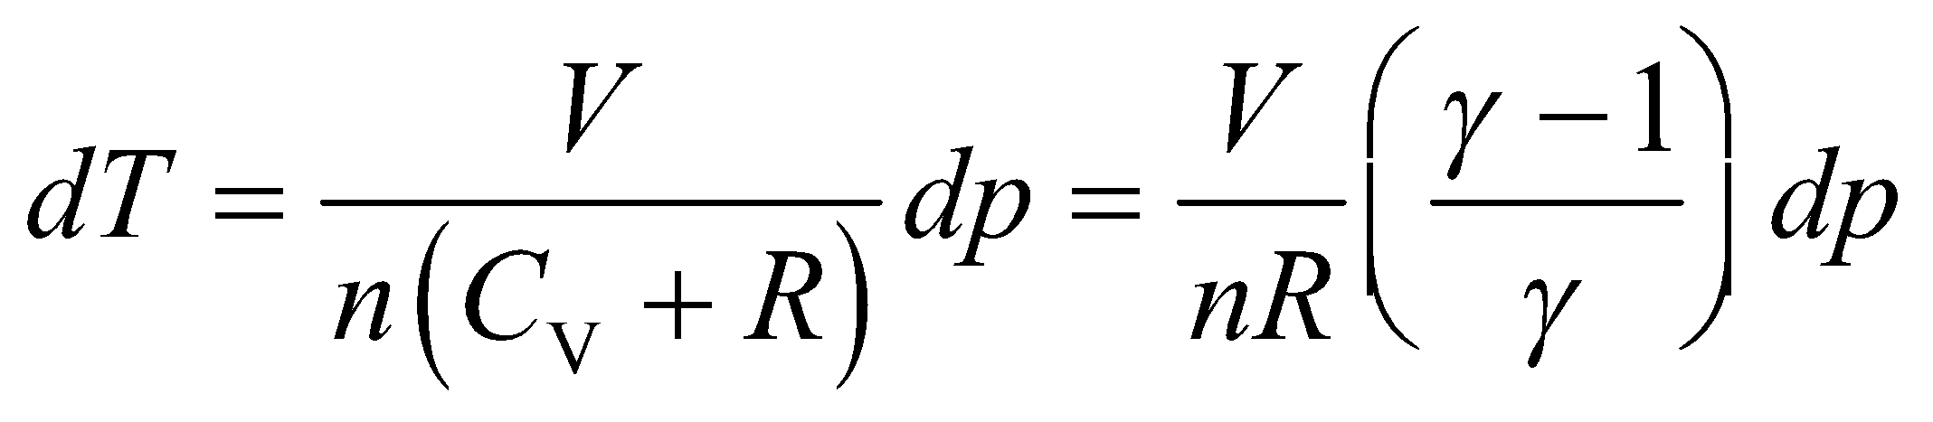

where we have used 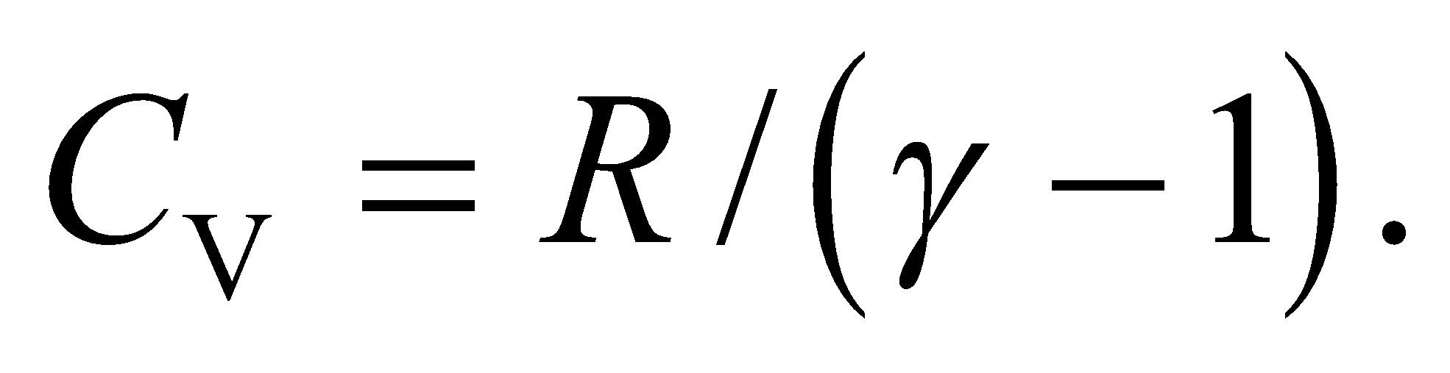

The hydrostatic equation shows how the pressure increases with depth: 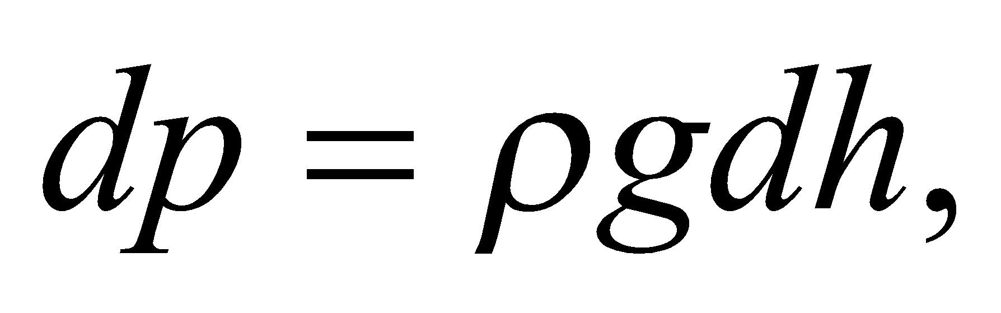but since we are considering altitude (the opposite of depth), we include a negative sign: 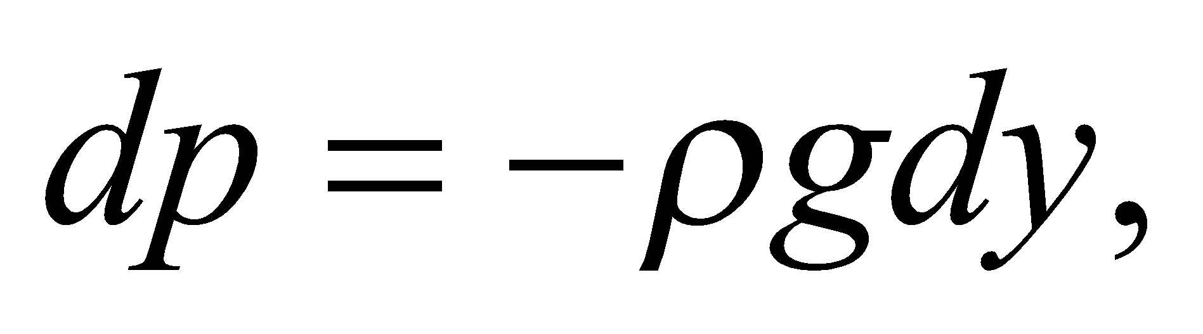so that the pressure decreases with increasing altitude.

**Evaluate** Combining the temperature/pressure relation to hydrostatic equation gives:

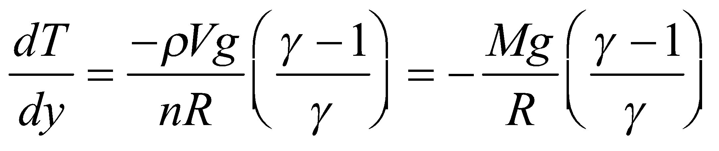

where *M* is the molar mass (the mass of one mole of the gas). We're told to assume that 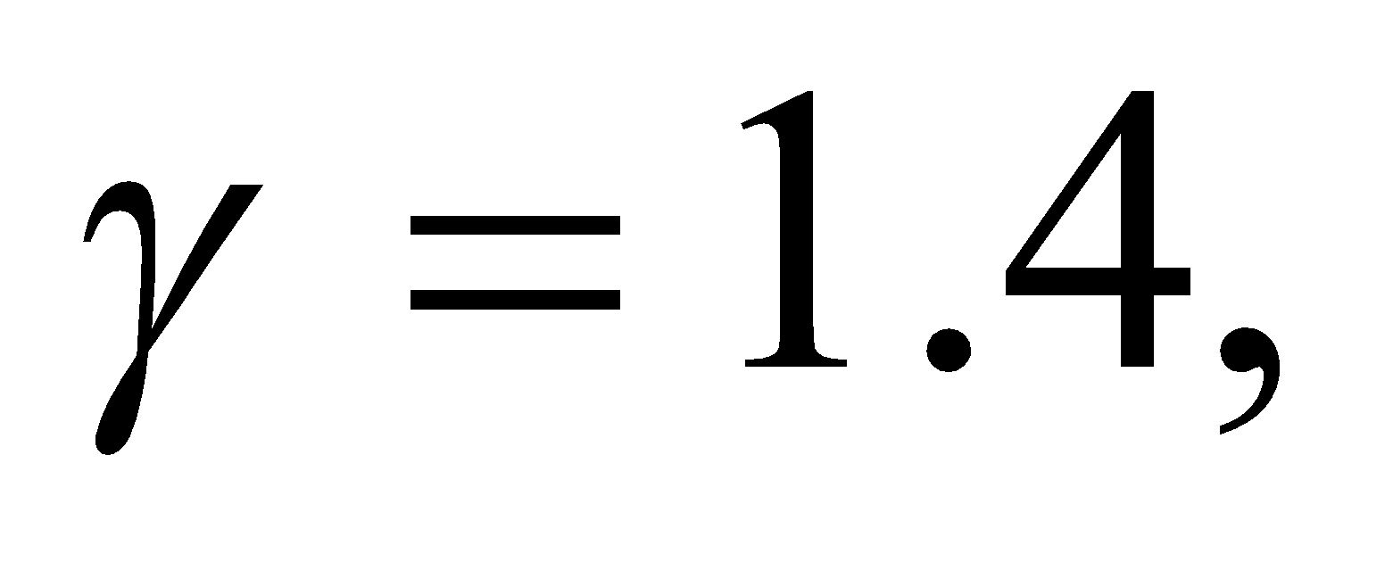and the average molecular weight is 29u, which is equivalent to saying that the molar mass is 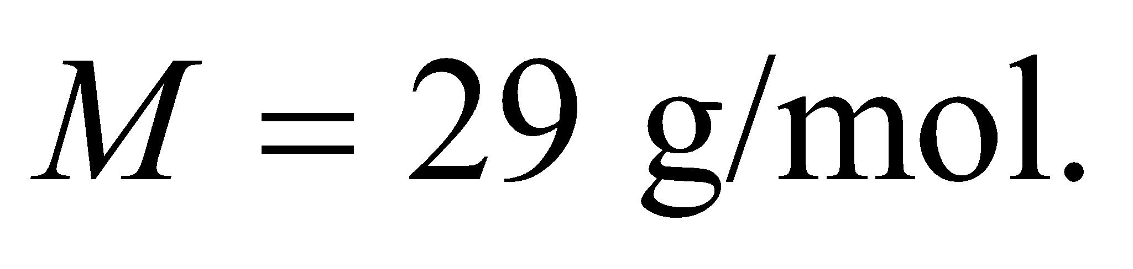 So the adiabatic lapse rate is:

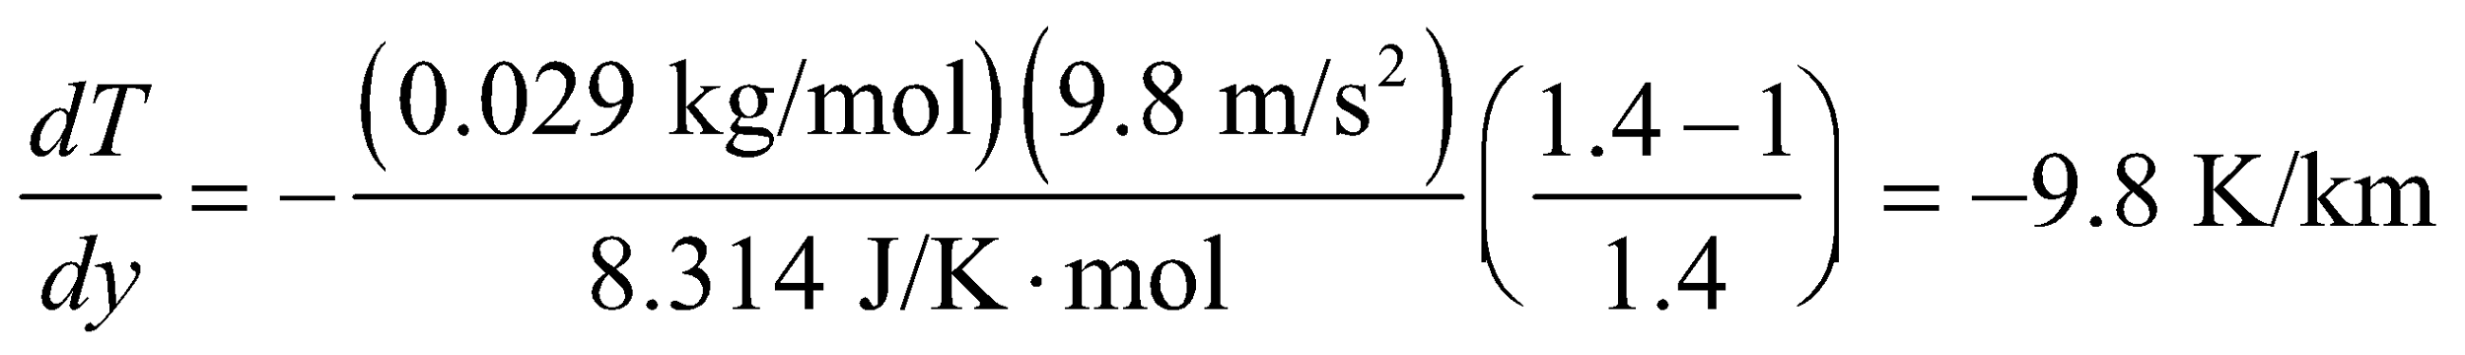

**Assess** The result seems reasonable: the temperature of an air mass drops by 10°C for every kilometer it rises. Note that the static temperature gradient of the atmosphere is actually smaller than this (about a 6°C drop for every kilometer increase in altitude). This is because other effects, like condensation of water molecules, contribute.

**71. Interpret** We are to calculate the efficiency and waste heat of a power plant, given the heat input and the power produced.

**Develop** The efficiency is

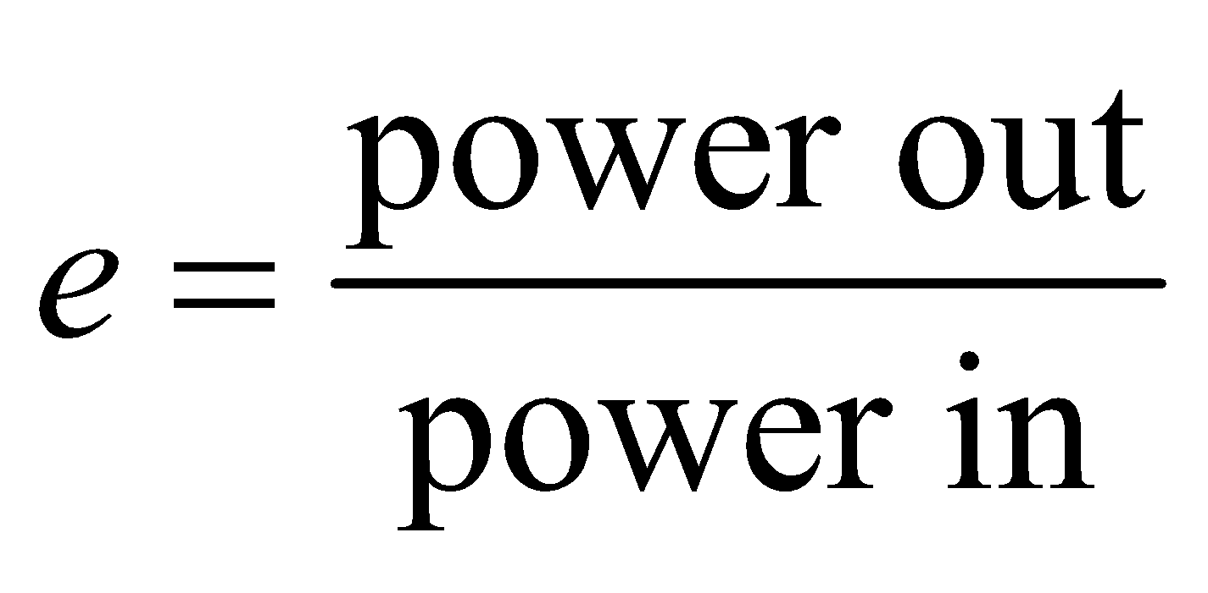

The waste heat is the difference between the power in and the power out. We need to know that the rate of waste heat produced is less than 400 MW, and the power plant has efficiency is 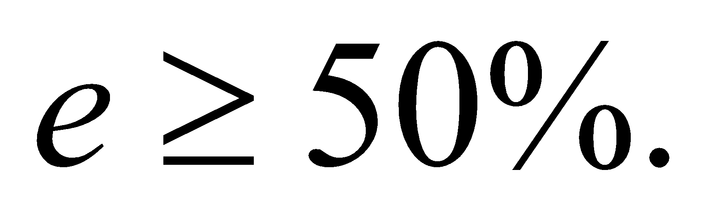

**Evaluate**The power-plant efficiency is

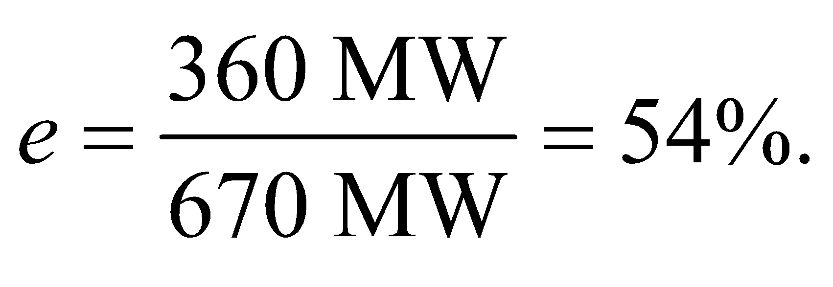

Heat is lost at a rate of



**Assess**This power plant meets the requirements.

**72. Interpret** We are to find the pressure and volume of air within a diving bell, given that the temperature varies in such a way that the pressure and volume are related by the given equation.

**Develop** The equation relating pressure and temperature is

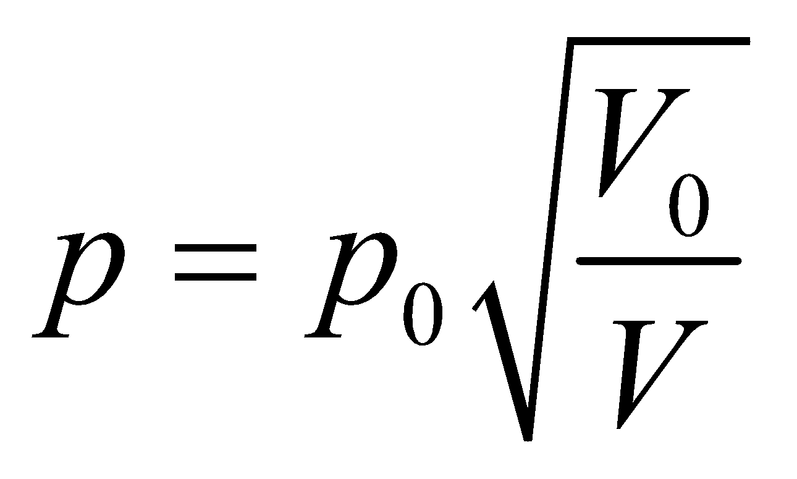

where *V*0 = 17 m3 and *p*0 = 1 atm. The maximum allowable pressure is 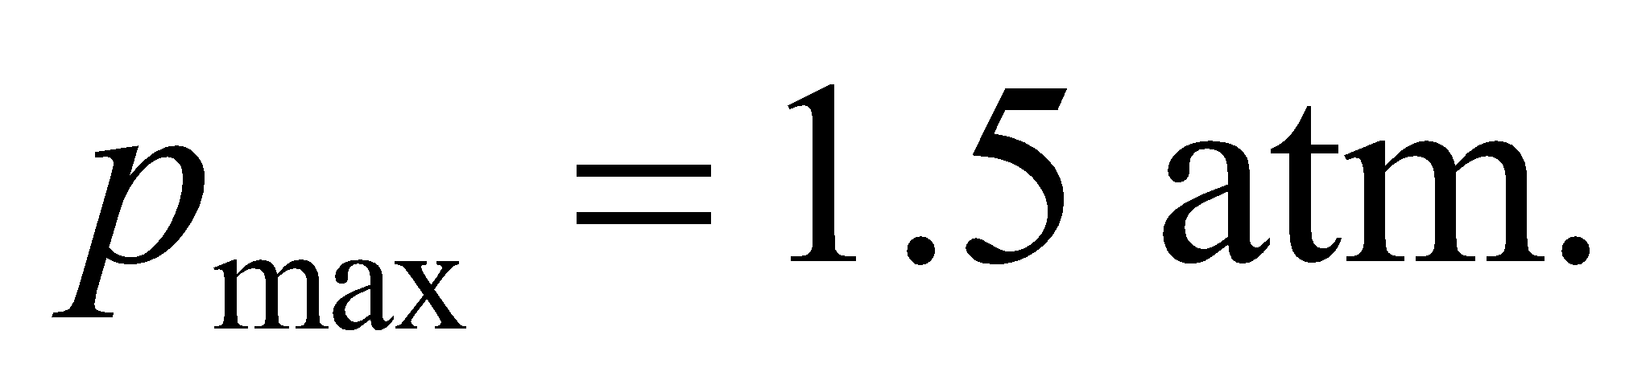 We can plug these values into the equation, and see what is the resulting volume *V*. If it’s greater than 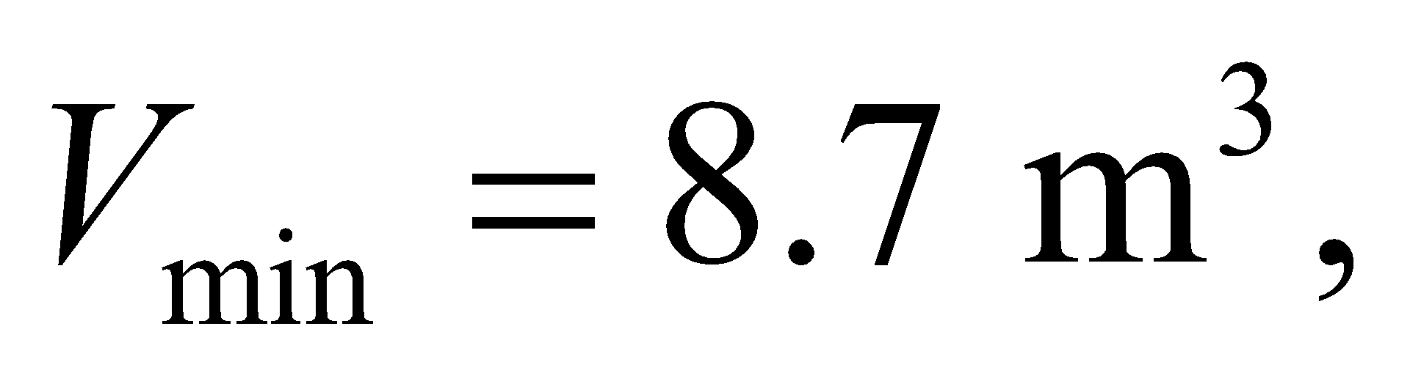 the design is ok.

**Evaluate** Solving the given equation for *V* gives

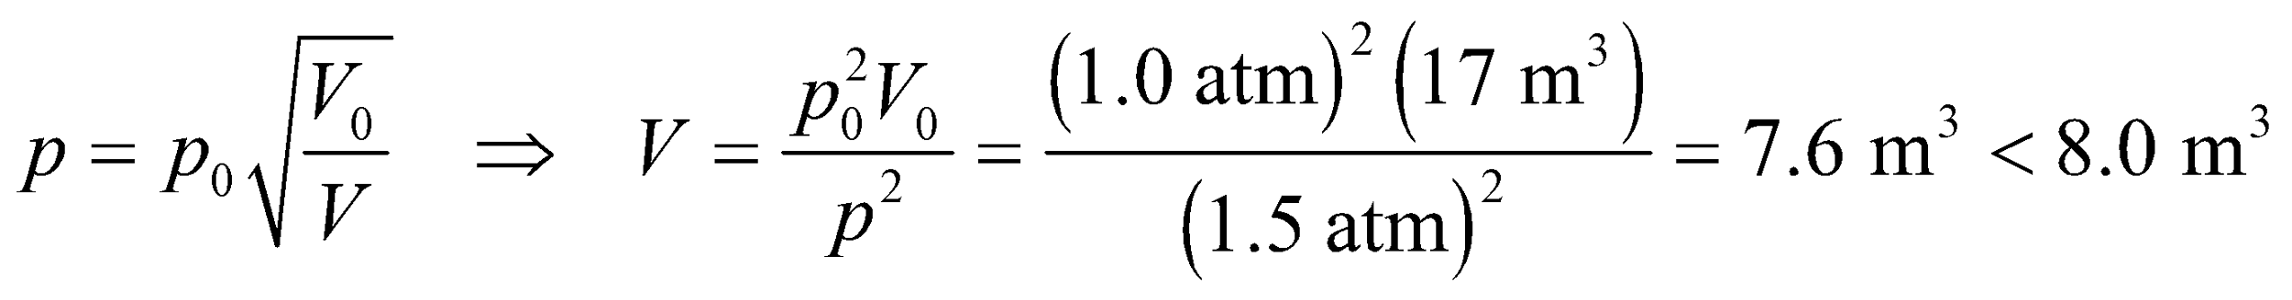

**Assess** The design needs work. Note also that since the pressure appears only in a ratio, we do not need to convert to SI units.

**73. Interpret** We consider the physics behind warm winds called Chinooks.

**Develop** We're told that the wind sweeping down from the mountain has no time to exchange heat with the surroundings.

**Evaluate** No heat exchange means the process is adiabatic.

The answer is (d).

**Assess** Recall that air has one of the lowest thermal conductivities in Table 16.2. So it's perhaps not surprising that a large mass of air might need a lot of time to exchange an appreciable amount of heat with its surroundings.

**74. Interpret** We consider the physics behind warm winds called Chinooks.

**Develop** For an adiabatic process, 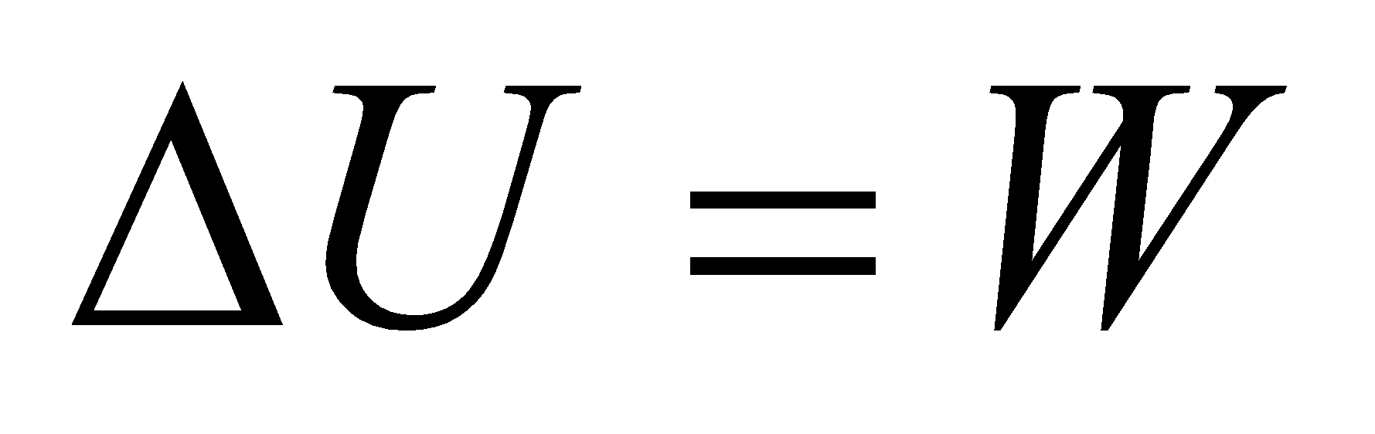from Equation 18.10. Here, *W* is the work done *on* the air mass.

**Evaluate** We're told that the pressure increases by 50% as the air descends from the mountain. If the pressure increases, there is positive work being done on the air (the opposite of Figure 8.11), so the change in the internal energy,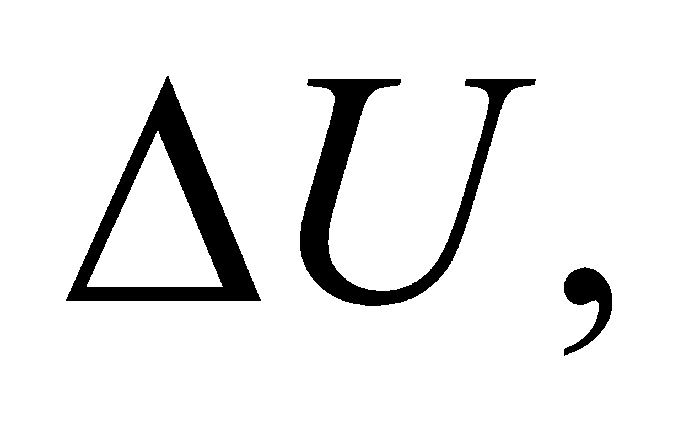 is positive.

The answer is (a).

**Assess** One can verify this result by combining Equations 18.11a and 18.12 to obtain: 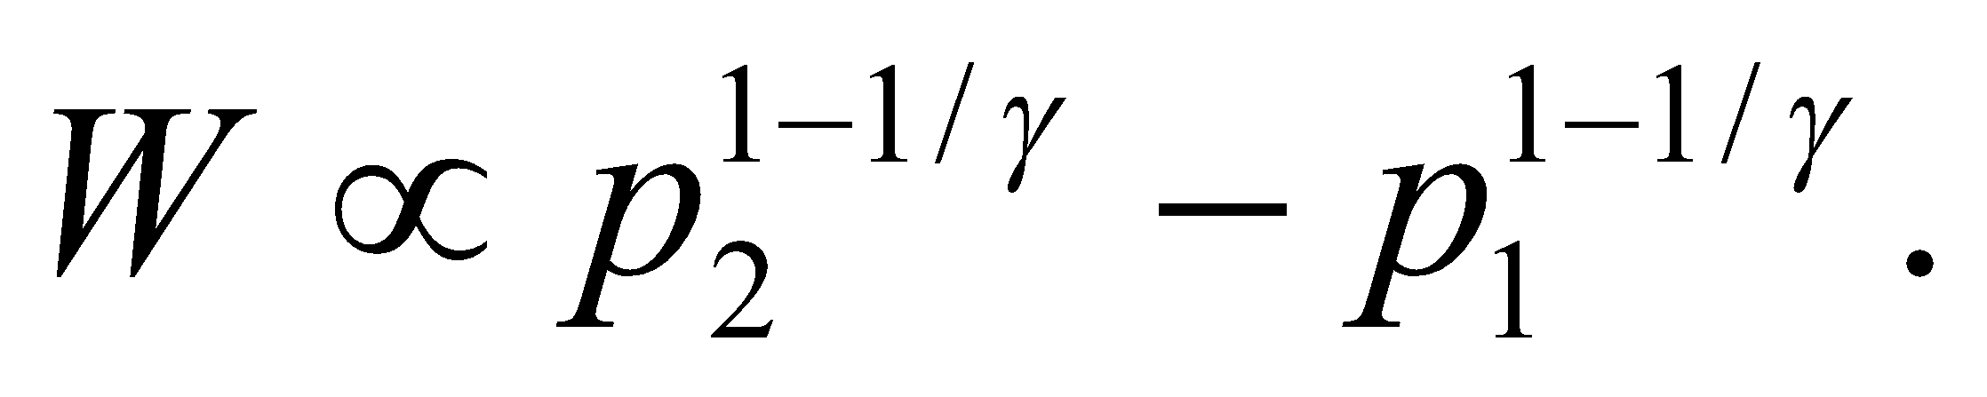 Since 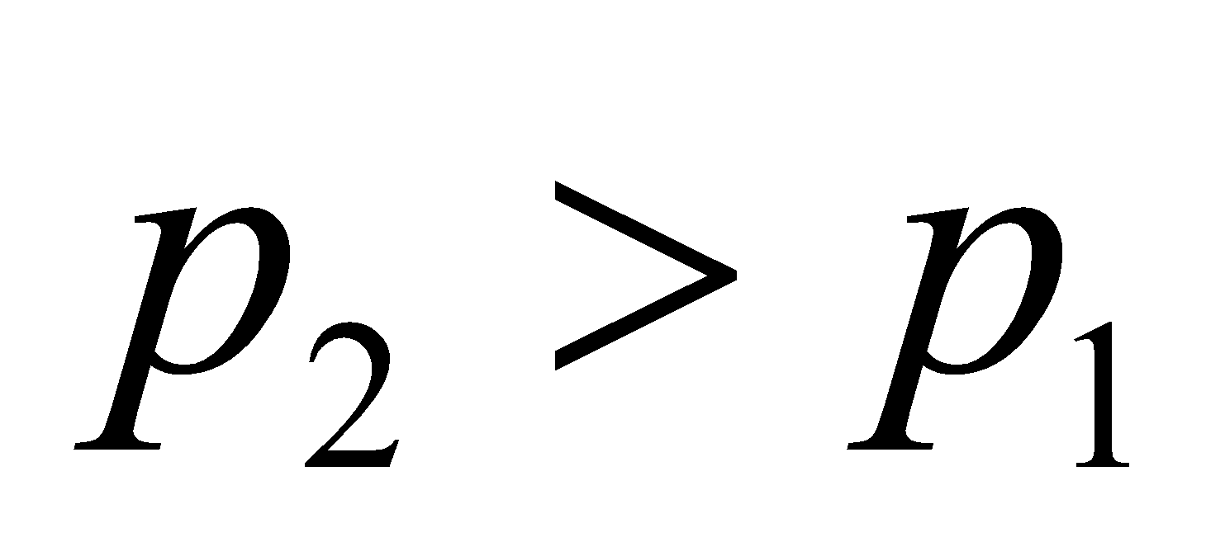 and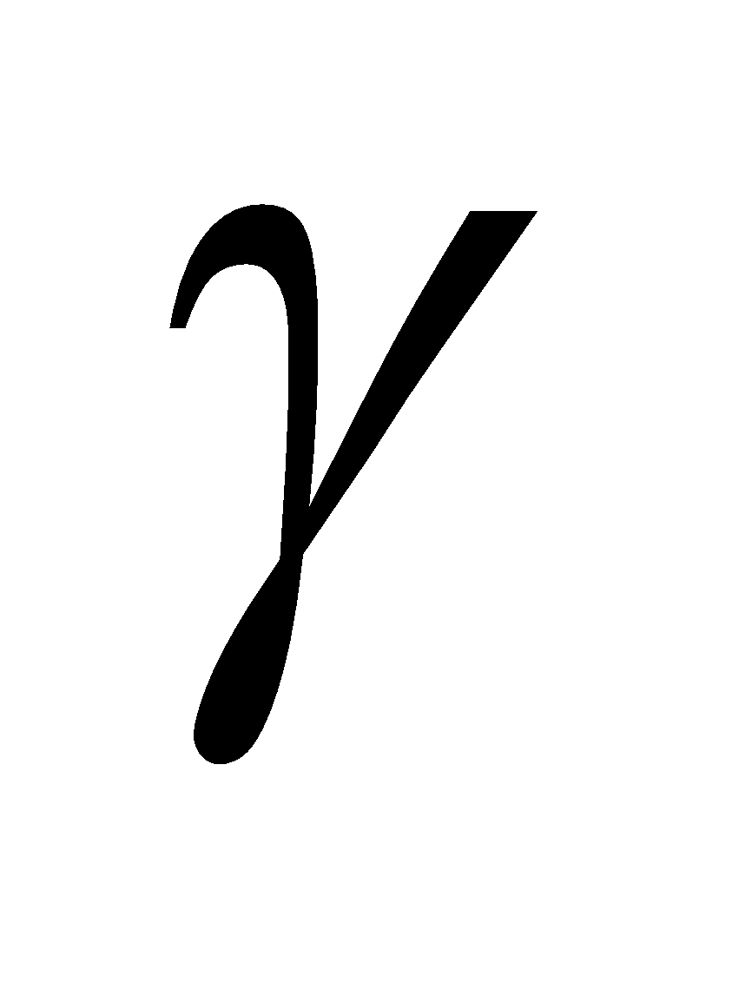 is always greater than one, the work done on the air mass is positive.

**75. Interpret** We consider the physics behind warm winds called Chinooks.

**Develop** From 18.11a, the pressure and volume in the mountains is related to that in the plains by We'll assume 

**Evaluate** Given the initial and final pressure, we can solve for the relative change in the volume:

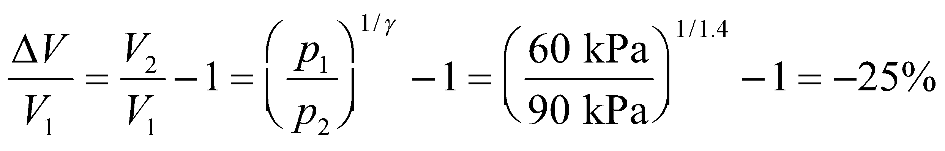

This implies the volume decreases by less than 50%.

The answer is (d).

**Assess** It makes sense that the volume of air decreases when exposed to the higher pressures at the base of the mountain.

**76. Interpret** We consider the physics behind warm winds called Chinooks.

**Develop** One could use the result from the previous problem and apply it to Equation 18.11b:  But we will use the expression derived in Problem 18.49, relating the pressure and temperature for an adiabatic process, 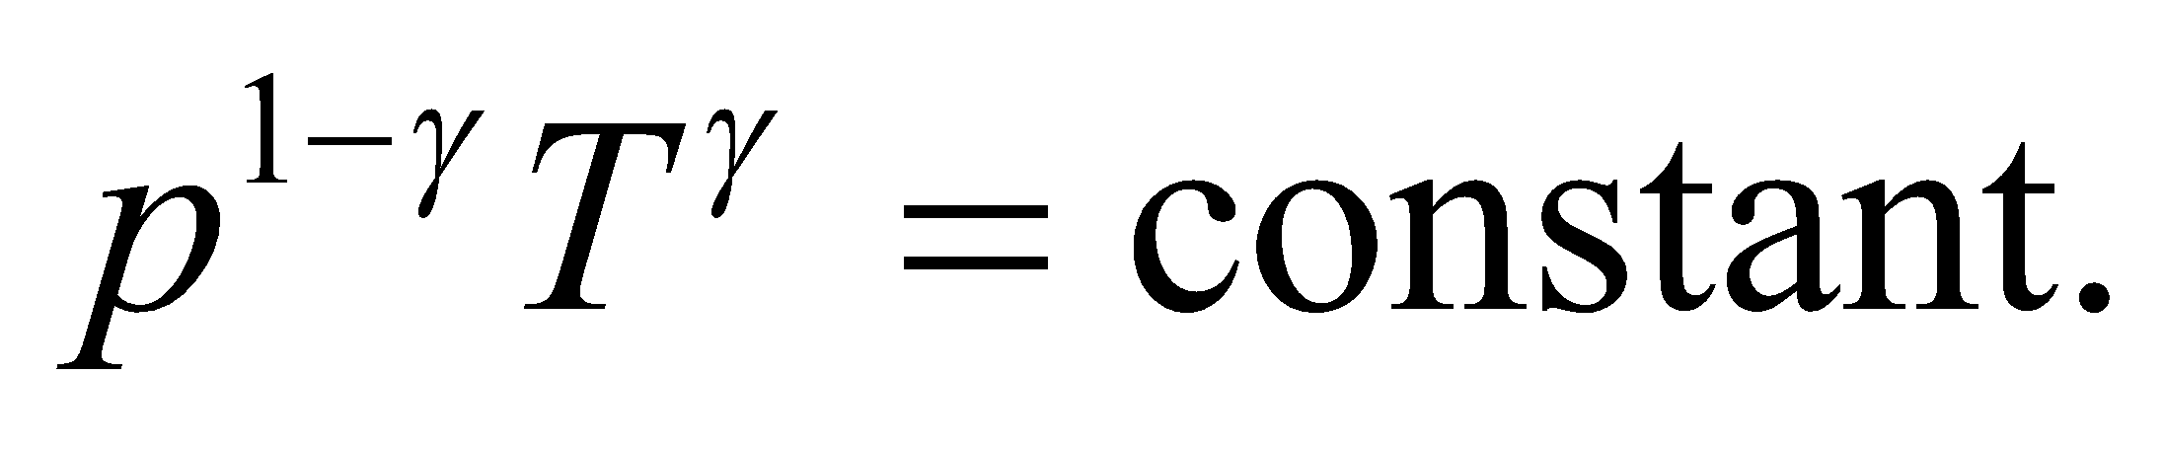

**Evaluate** We know the initial temperature up in the mountains is 260 K, so the temperature down in the plains must be:

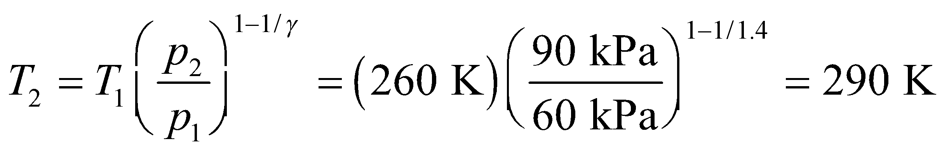

The answer is (c).

**Assess** As the name implies, the Chinook is a warm wind. In this case, there is a 30°C increase in going from the mountains (–13°C) down to the plains (17°C).